RentSphere - Full-Stack Rental Management Platform
Project Report with Architecture, Security Model and Workflows
Generated 23 August 2026 - reflects the hardened role-based access implementation
1. Overview
RentSphere centralizes property administration and tenant self-service in one secured platform. Conventional rental management depends on spreadsheets, chat threads, paper agreements and disconnected payment records, which makes it hard to know which unit is occupied, which invoice is outstanding, whether a maintenance request was resolved, or who approved a decision. RentSphere replaces this fragmentation with explicit states (AVAILABLE, OCCUPIED, PENDING, PAID, OPEN, RESOLVED, APPROVED, REJECTED), relational integrity and role-aware interfaces.
The system serves three personas. Administrators manage the complete platform including organizations, users and all records. Owners operate their own organization's portfolio: properties, buildings, units, tenants, agreements, finance and workflows. Tenants browse apartments, request visits, pay invoices through Razorpay, submit complaints and deposit disputes, and respond to rent increases. Every response is scoped so users see only what their role permits.
2. Technology Stack
Layer | Technology | Purpose
Frontend | React 19, Vite, TypeScript, MUI | Role-aware SPA with themed components
Backend | Spring Boot (Java), Spring Security | Stateless REST API, JWT auth, method security
Persistence | PostgreSQL via Supabase, Spring Data JPA | Relational domain model with versioned migrations
Payments | Razorpay SDK | Hosted checkout, HMAC-SHA256 verification, webhooks
AI Assistant | Google Gemini | Answers questions using the caller's visible records
Notifications | SSE + email service | Real-time delivery with polling fallback
Caching | Caffeine (scope-aware keys) | Collection and entity caches evicted on writes
Build/Test | Maven wrapper, JUnit, MockMvc; ESLint, tsc, Vite | Automated integration tests and static validation

3. System Architecture
The React single-page application communicates exclusively with the Spring Boot API over HTTPS using JWT bearer tokens. The API is organized into a security filter chain, controllers guarded by declarative role rules, services containing business rules and organization-scope guards, and Spring Data repositories. External systems include PostgreSQL (Supabase), Razorpay for payments, Gemini for the assistant and an email service for workflow alerts.

Figure 1: Layered system architecture with external integrations.
4. Functional Modules
• Organizations and user administration with role assignment
• Property inventory: properties, buildings, units with images and statuses
• Tenant management with KYC profile and proof documents
• Agreements and invoice generation with due-date tracking
• Payment lifecycle: manual records plus verified Razorpay checkout
• Complaints with open / in-progress / resolved transitions
• Deposit disputes with repair estimates, evidence and settlement proposals
• Rent increases with notice scheduling and tenant accept/dispute responses
• Booking requests resolved into approval workflows with decisions
• Notification center (SSE live delivery with polling fallback)
• Contextual AI assistant built from the authenticated user's records

5. Role-Based Access Control
Access follows a least-privilege model enforced at four independent layers: token validation, controller role gates, service-level organization assertions, and scope-aware caching. Public self-registration is limited to tenants; owner and admin accounts are always provisioned by existing managers through the user-management API.

Figure 2: Role capabilities and enforcement points after hardening.
Permission matrix
Capability | Admin | Owner | Tenant
Self-registration | First bootstrap user only | Blocked (provisioned) | Allowed
Manage organizations | Yes | Yes | No
Manage users | All roles incl. ADMIN | Own org, except ADMIN accounts | No
Create / modify ADMIN accounts | Yes | No (403) | No
Property inventory | All organizations | Own organization | Browse available
Tenants, agreements, invoices, payments | All | Own organization | Self-service (/me)
Complaints and deposit disputes | Manage all | Manage own org | Submit and view own
Approvals | Decide all | Decide own org | View and request own
Rent increases | Issue / delete | Issue / delete (own org) | Respond ACCEPTED / DISPUTED
Cross-organization record access | Allowed | Blocked with 403 | Not applicable
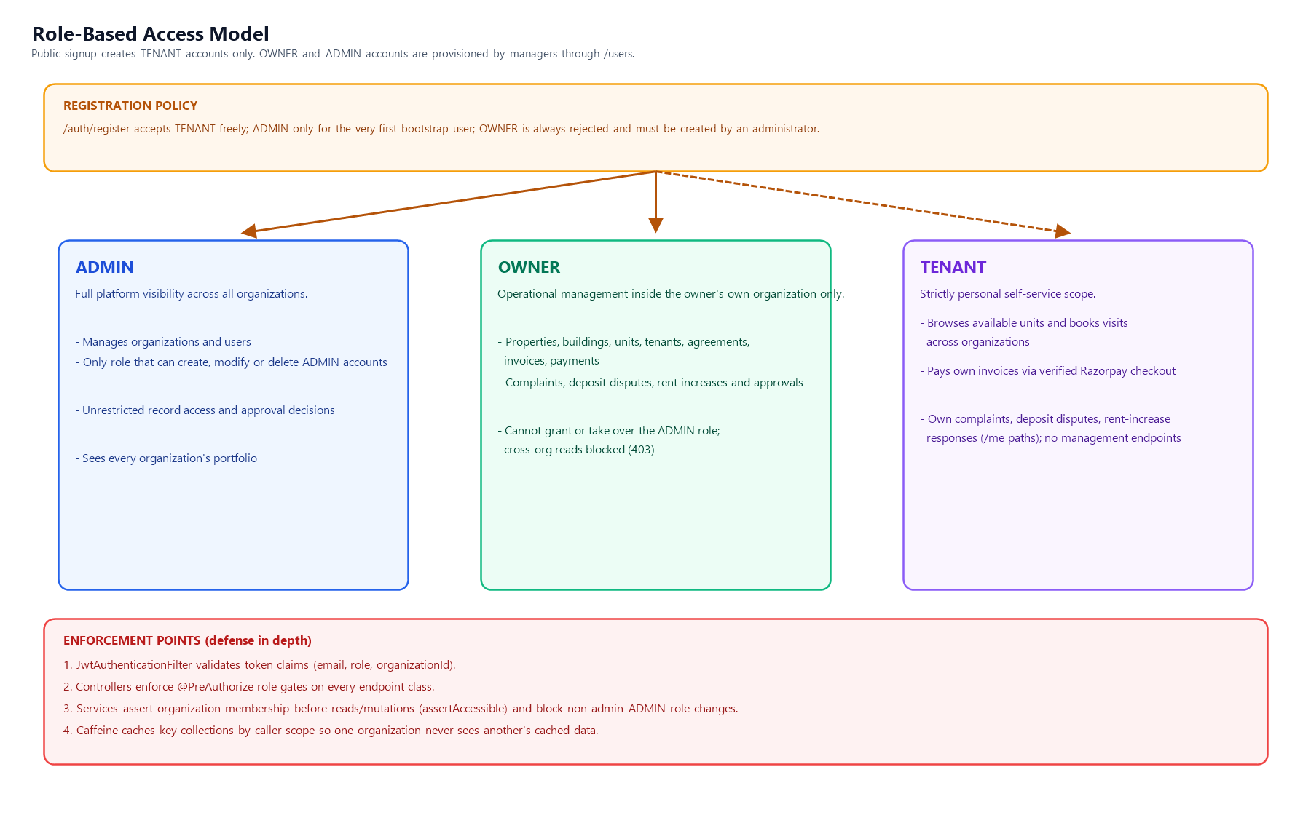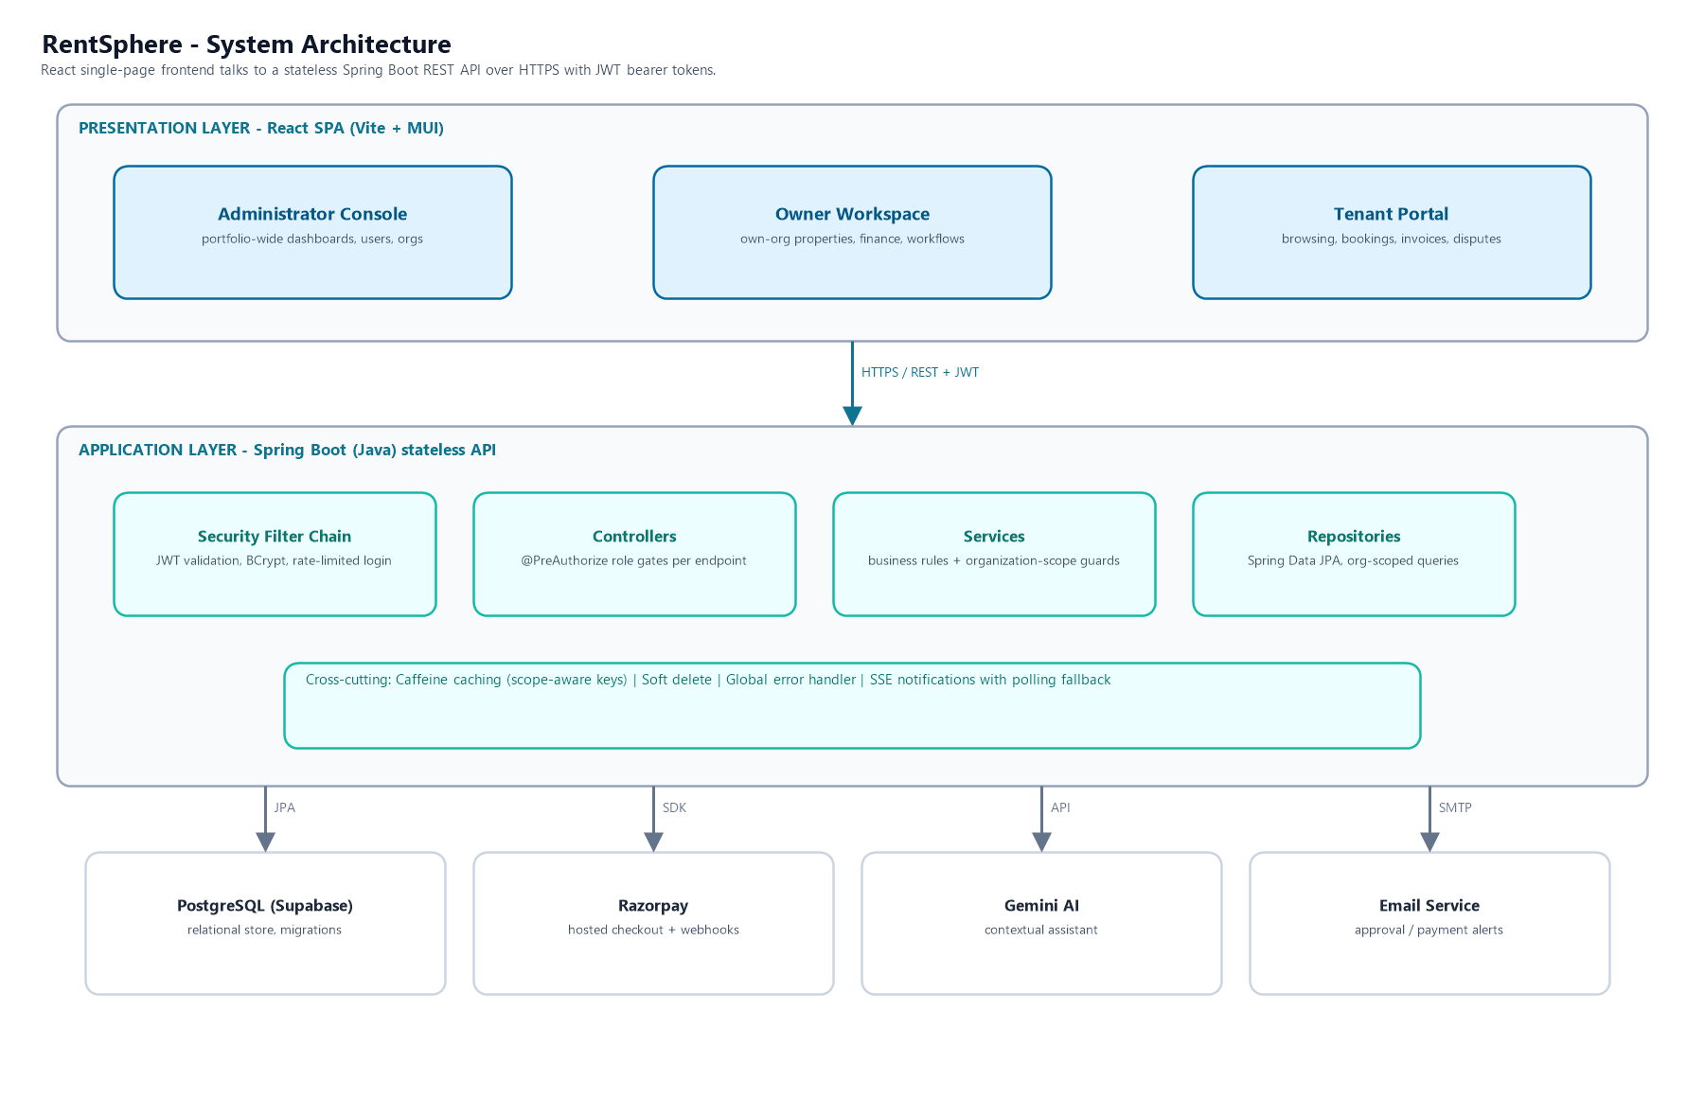
Recent hardening (this iteration)
• Privilege escalation removed: only administrators can create, update or delete ADMIN-role users, closing takeover and self-promotion paths.
• Owner self-registration blocked: OWNER now behaves like ADMIN during registration; owners must be provisioned by a manager.
• Organization isolation: list endpoints filter by the caller's organizationId, and findById/update/delete assert membership, returning 403 for foreign records.
• Cache isolation: shared Caffeine caches key entries by caller scope so cached lists cannot leak between organizations.
Authentication and request flow
Login applies rate limiting, verifies BCrypt credentials and issues a signed token carrying email, role and organization claims. Each request passes the JWT filter, controller authorization, service scope assertions and finally scope-keyed caching before reaching persistence.

Figure 3: Checkpoints traversed by every authenticated request.
6. Payment Workflow
Checkout creation verifies ownership, amount parity and unpaid status before creating a Razorpay order. Success is accepted only after HMAC-SHA256 verification of the client signature or a valid webhook payload; the invoice then transitions to PAID and the organization is notified. Failed events mark the payment FAILED without touching the invoice.

Figure 4: Verified payment lifecycle with duplicate and ownership protection.
7. Quality Assurance
Suite | Tests | Coverage focus
ModuleApiIntegrationTests | 9 | End-to-end module flows, role matrix, privilege escalation and org scoping regressions
RazorpayPaymentIntegrationTests | 7 | Order creation, signature verification, webhook capture/failure, duplicate handling
DtoMapperTest | 1 | Entity-DTO mapping
GeminiAssistantServiceTest | 1 | Assistant context behaviour
Application context test | 1 | Spring context startup
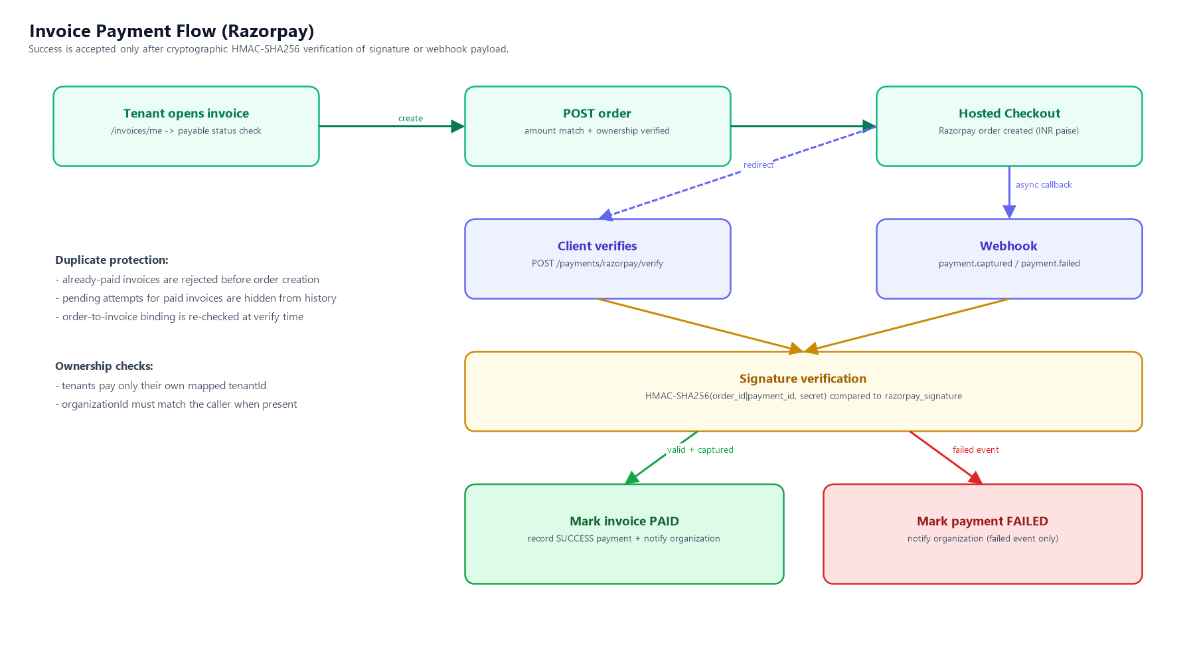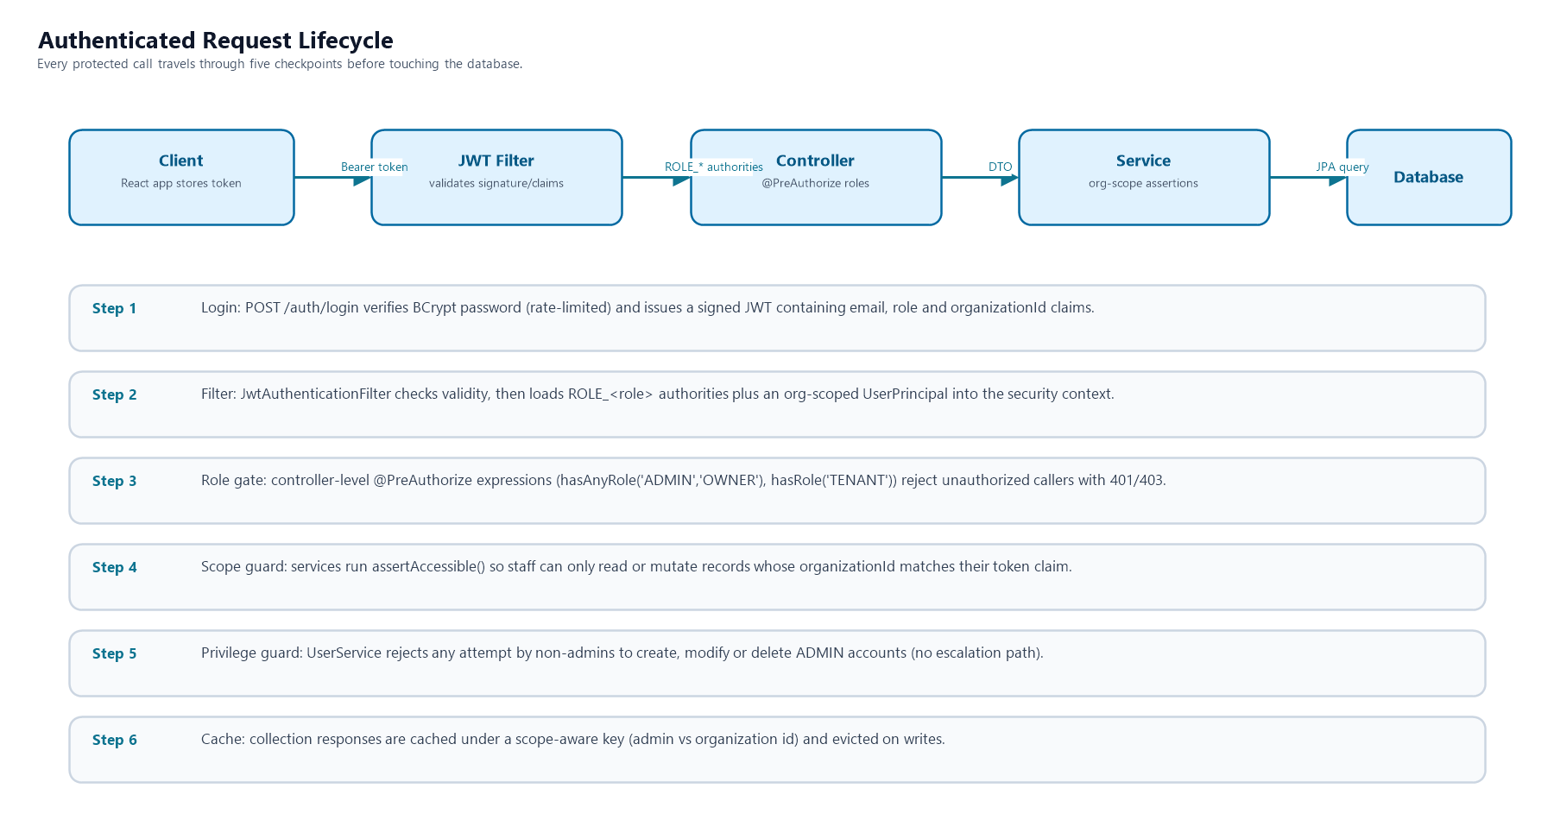
All 19 backend tests pass. Frontend quality gates are clean: ESLint reports no issues and the production TypeScript build completes successfully.
8. Running the Project
Task | Command | Location
Start backend (dev) | .\mvnw.cmd spring-boot:run | backend\
Run backend tests | .\mvnw.cmd test | backend\
Start frontend | npm run dev | frontend\
Lint frontend | npm run lint | frontend\
Production build | npm run build | frontend\

In the dev profile a local administrator account is bootstrapped automatically from configuration. Subsequent staff accounts are created through the Users module by that administrator.

