1. A single channel is shared by multiple signals by

Multiplexing

2. Time it takes for a small packet to travel from client to server and then back to the client

RTT

3. A beacon frame sent by an AP includes

Both the AP’s MAC address and SSID

4. Which of the following is a disadvantage of connection-based protocols?

High startup costs

5. Compared to the wired transmission, wireless transmission typically has _____ attenuation and _____ maximum distance

Higher,shorter

6. On a network, the term authentication typically refers to the process of

Verifying the identity of a sender or receiver

7. The Session layer communicates with which other layers

Transport and presentation

8. For Ethernet, if an adapter determines that a frame it has just received is addressed to a different adapter



9. HTTP non- persistent connection - multiple objects can be sent over single TCP connection between client, server

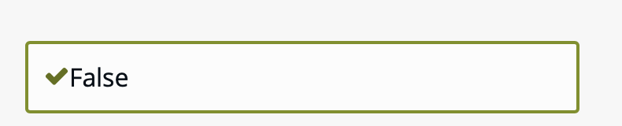w

10. A channel partitioning protocol has which of the following characteristics

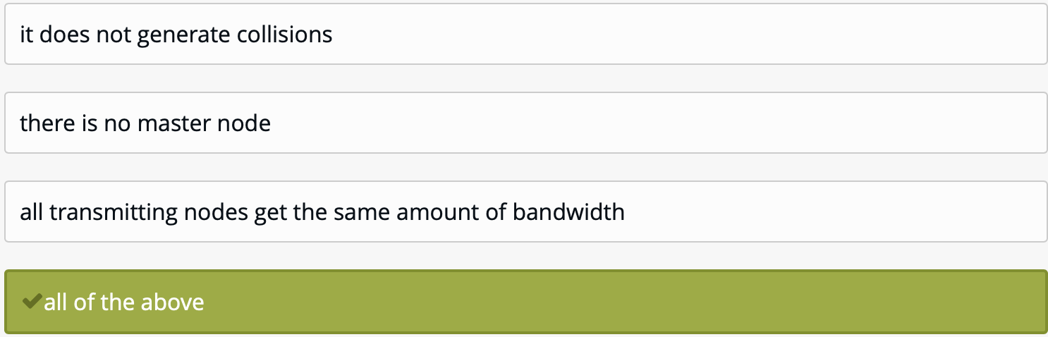

11. Match the following network service to the correct definition



12. ____________is a physical-layer device that acts on individual bits rather than frames



13. For public-key certification, PGP uses certification authorities.

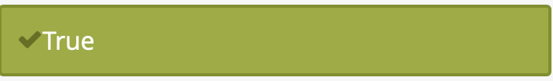

14. Network layer at source is responsible for creating a packet from data coming from another



15. SMTP is used to:



16. How to understand the connection-oriented protocol?



17. The network interface card of a Web server that you manage has developed sporadic problems. You measure the packet loss rate from your desktop computer and immediately decide to replace the network card. After this simple operation, the Web server successfully rejoins the network, as confirmed by your officemate using her desktop computer. You eagerly go to your desktop to measure the improvement, but find instead that the Web server is not responding to any of your packets. What is your diagnosis?



18. TCP applies fast retransmit to a segment when



19. The Internet Protocol (IP) is used in the network layer of the Internet. Which service does IP provide to the transport layer?

20. Dividing the network into smaller portions called



21. A network entity that satisfies HTTP requests on the behalf of an origin Web server



22. E-mail is _________



23. Which of the following is most likely to be a MAC address assigned to a NIC?



24. The throughput of a network link for an HTTP session is measured in two ways. Measurement A is the total amount of data received by the browser, divided by the duration of the session. Measurement B is the total amount of data received by the operating system on behalf of the browser, divided by the duration of the session. Which of the following statements about A and B is true?



25. Local DNS name servers:



26. Which of the following features of Ethernet has not remained constant since the advent of the technology?



27. If 5 files are transfered from server A to client B in the same session. The number of TCP connection between A and B is



28. In a link layer hosts and router are called



29. Below provided a typical HTTP response message. Let’s take a careful look at this response message. It has three sections:   
an initial status line, six header lines, and then the entity body   
The entity body is the meat of the message—it

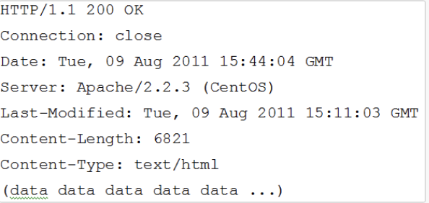

30. Computer networks that provide only a connection service at the network layer are called

31. All store-and-forward networks are

32. An ARP query packet is encapsulated in an IP datagram.



33. Small piece of data sent from a website and stored in the user's web browser while the user is browsing



34. With SYN cookies, when a server receives a SYN segment, it returns a SYNACK with



35. In IPv4 protocol, each datagram is handled

36. A channel partitioning has which of the following characteristics

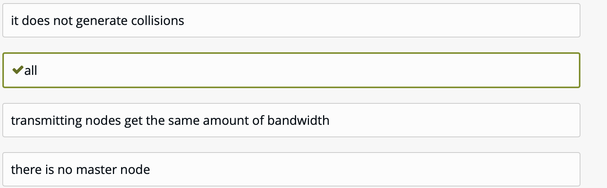37. Which of the following network exploration tools can be used to determine information about possible paths between one network host and another?



38. The Internetworking Protocol (IP) is a ________ protocol

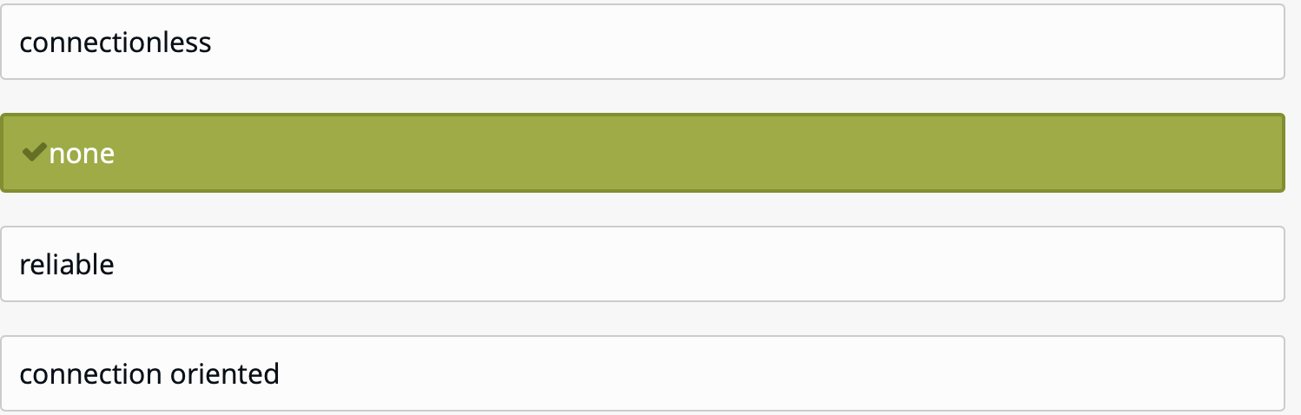

39. Find the FTP reply whose message is wrongly matched



40. Layers four and five of the Internet protocol stack are implemented in the end systems but not in the routers in the network core



41. Layers four and five of the Internet protocol stack are implemented in the end systems but not in the routers in the network core



42. Network layer data is



43. The entire hostname has a maximum of ___characters



44. Which of the following internet applications typically transmit(s) packets over Transmission Control Protocol (TCP)? I.FTP client II.Audio streaming III.Web browser



45. A corporate information systems manager is interested in collecting statistics on the frequency of computer failures within the organization. Most failures result in an automatic reboot, so the failed computer is typically back on the network in less than a minute. The corporate network connects 1,500 computers in far-flung locations to which the average latency of a packet is 40 milliseconds. The manager asks you to write a tool that will collect the times at which failures occurred in which computers. She wants it by tomorrow, so the tool will have to be simple. On which protocol will you base your implementation?



46. Which is not a application layer protocol?



47. The MSS is the maximum size of a TCP segment including headers



48. Before sending a packet into a datagram network, the source must determine all of the links that packet will traverse between source and destination



49. The primary role of a router is to forward datagrams from input links to output links



50. Internet has chosen datagram approach to switching in the

51. Before sending a packet into a datagram network, the source must determine all of the links that packet will traverse between source and destination



52. Application layer offers _______ service



53. How are routing paths calculated?



54. Packets sent by two stations in 802.11 can collide because

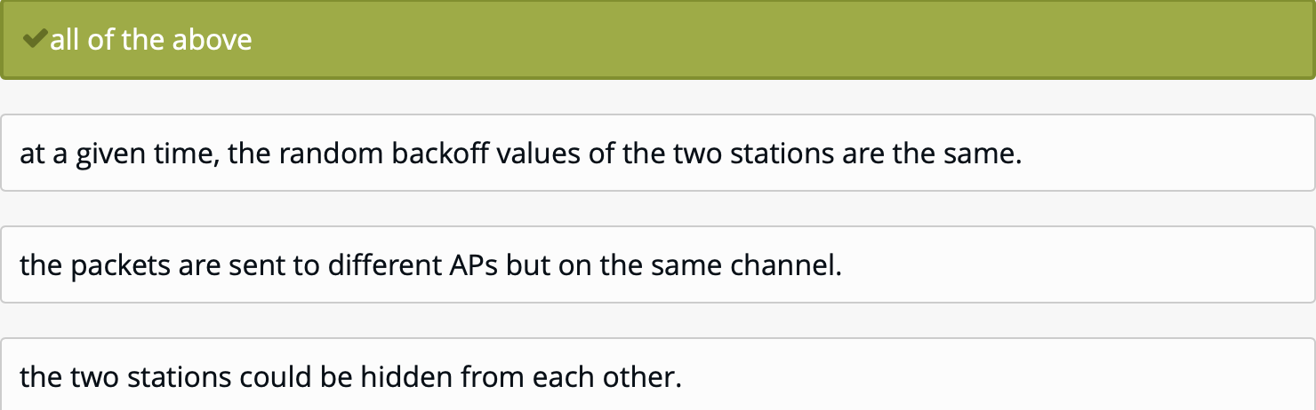

55. Twisted-pair cooper wire is no longer present in computer networks



56. Two packets A and B are sent in that order through a connectionless communication network. They will arrive at the destination



57. Two packets A and B are sent in that order through a connectionless communication network. They will arrive at the destination:



58. FTP uses _____ parallel TCP connections to transfer a file



59. Each time an end system wants to send a packet, it stamps the packet with the address of the destination end system and then pops the packet into the network



60. The term packetization refers to the process of



61. Pipelining requires which of the following

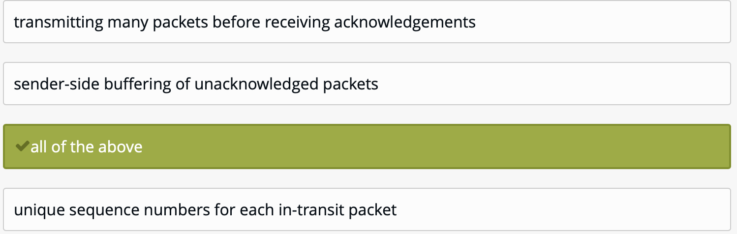62. Filtering in a firewall can be based on:



63. SMTP is used to



64. Which of the following allows a host to be assigned an IP address automatically?



65. In order to maintain network stability while Transmission Control Protocol (TCP) probes for additional bandwidth, rate increases are _____, and rate decreases are _____



66. Wireless transmission can be done via

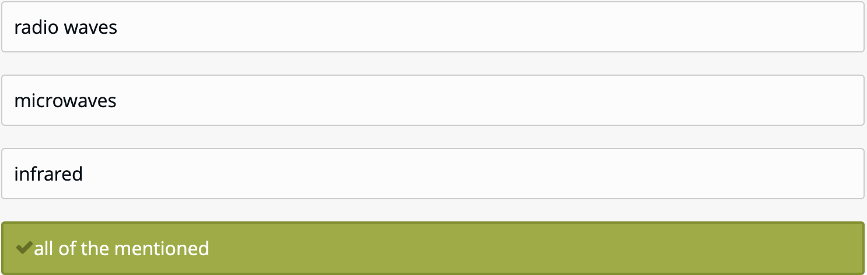

67. The Internet Protocol (IP) defines the _____ layer of the Internet protocol stack



68. Which of the following IP header fields provide simple error detection?



69. Below provided a typical HTTP response message. Let’s take a careful look at this response message. It has three sections: an initial status line, six header lines, and then the entity body   
In this example, the status line.

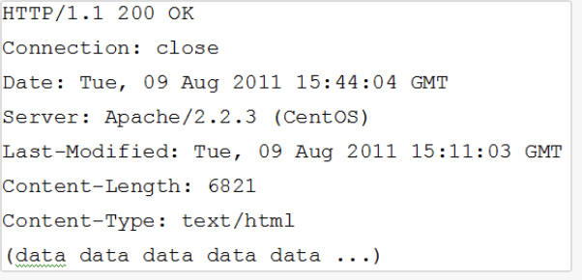

70. TP client contacts FTP server at port ______, using TCP

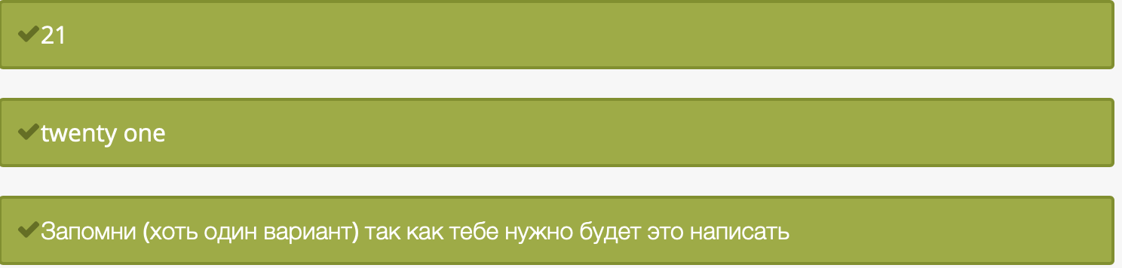

71. Which of the following was designed to solve the problem of IP address space fragmentation?



72. Which of the following OSI layers converts the ones and zeroes to electrical signals and places these signals on the cable? 

73. Host A is sending host B a large file over a TCP connection. Assume host B has no data to send to A. Host B will not send acknowledgements to host A because host B cannot piggyback the acknowledgement on data



74. Suppose a client sends an HTTP request message with the If-modified-since: header. Suppose the object in a server has not changed since the last time a client retrieved the object. Then the server will send a response message with the status code



75. A cookie is made by the ________ and eaten by the _______



76. IEEE standard ethernet CSMA/CD provides which of the following services to the network layer?



77. A difference between routers and switches is that



78. What is the segment?



79. The TCP segment has a field in its header for RcvWindow



80. The protocols of the various layers are called ___________



81. The stop-and-wait protocol is highly inefficient when there is a



82. Convert the following IP address: 158.0.147.85 to the binary



83. To deliver a message to the correct application program running on a host, the _______ address must be consulted



84. Which of the following statements are true about the TCP service model?



85. The _______ layer lies between the network layer and the application layer.



86. The physical layer is responsible for

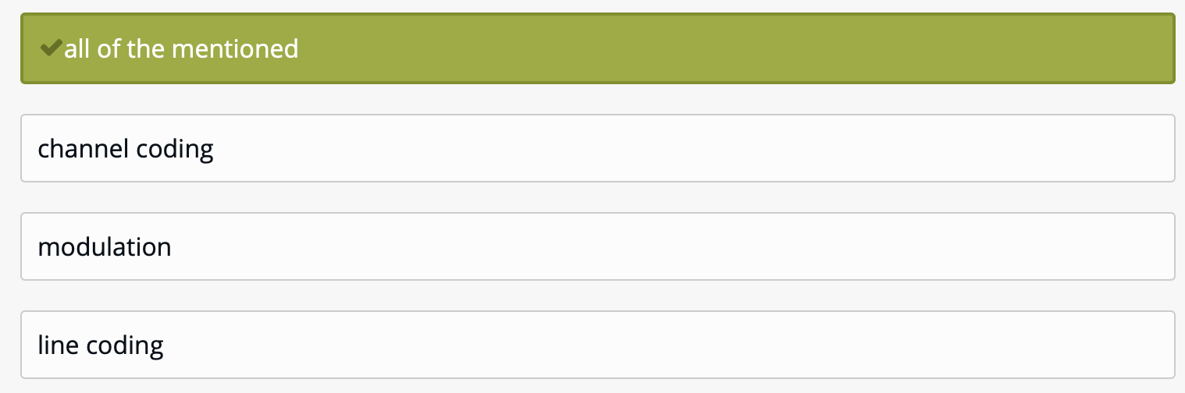

87. What is the type of an "8+1" parity code that outputs 100101011?



88. A browser will generate header lines as a function of

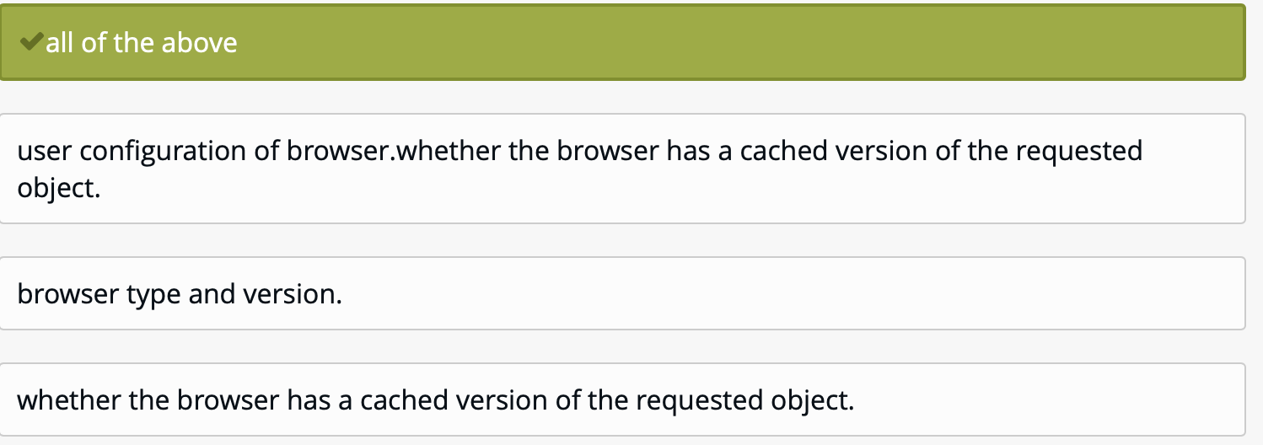

89. The size of the TCP RcvWindow never changes throughout the duration of the connection

90. Define to which level of the network protocols are belong to

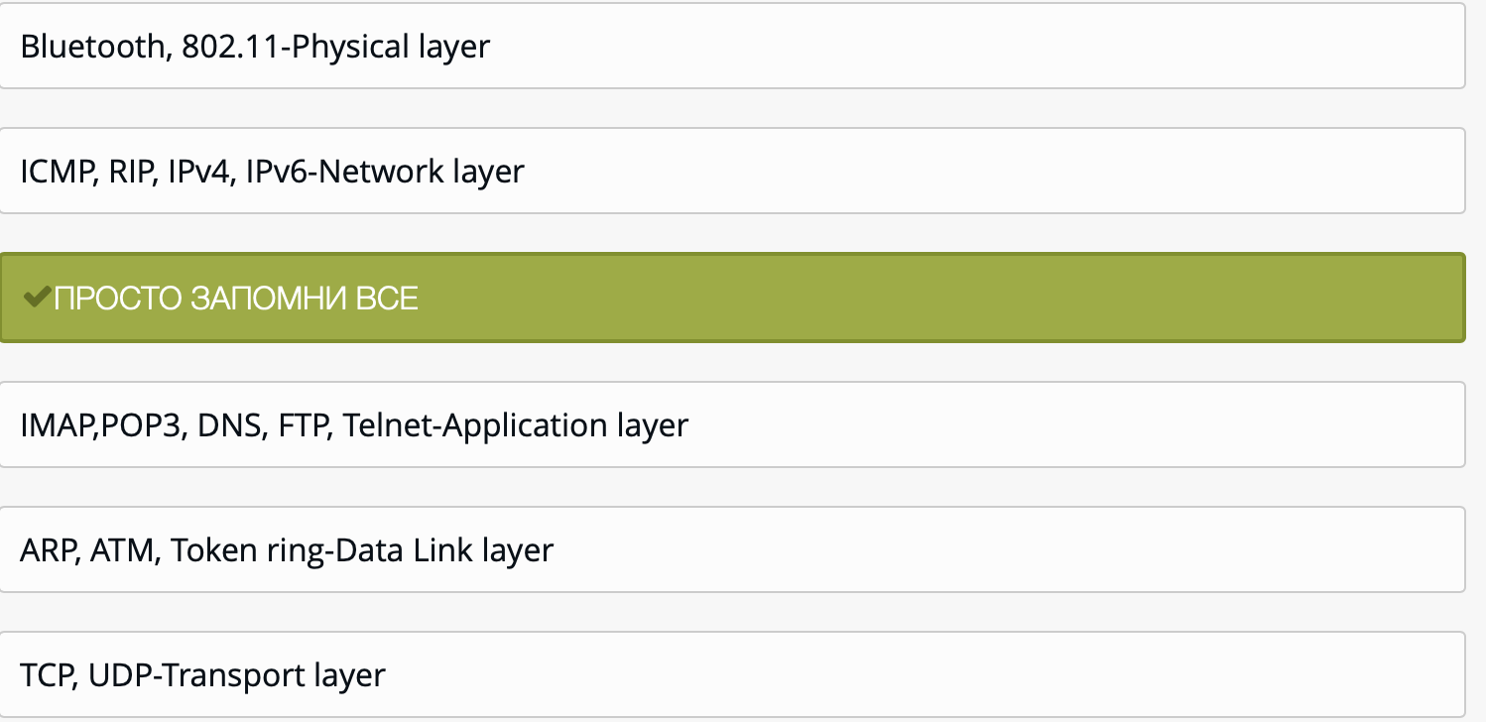

91. Consider an application running on host cs.cmu.edu that wants to send a packet to host ee.cmu.edu. Assuming no information is cached, the send request on cs.cmu.edu will cause which of the following events to happen first?



92. The FDDI protocol is based on



93. Translation of a domain name into an address called



94. Which of the following statements best describes the purpose of the SNMP protocol?



95. Identify the incorrect statement



96. Each LAN adapter has a unique LAN address

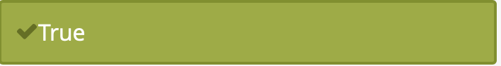

97. When the data link layer applies "framing" to the data to be transmitted, it



98. When a UDP segment arrives to a host, in order to direct the segment to the appropriate socket, the OS uses



99. The password is sent to the server using _____ command



100. Which of the following is a protocol used for communication between a web server and a web browser?



101. IMAP stands for

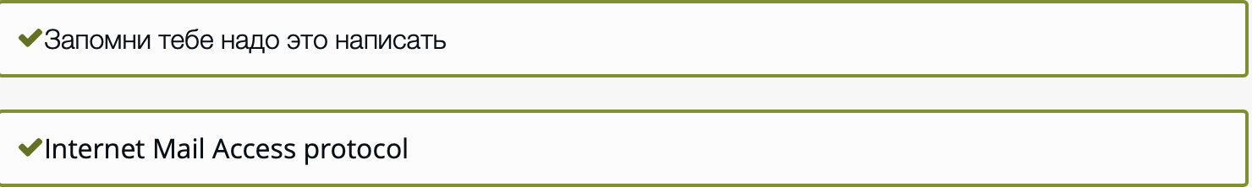

102. Streams are not needed in which of the following programs



103. Ethernet provides which of the following services to the network layer   
error detection



104. A channel partitioning protocol has which of the following characteristics forwarding table is

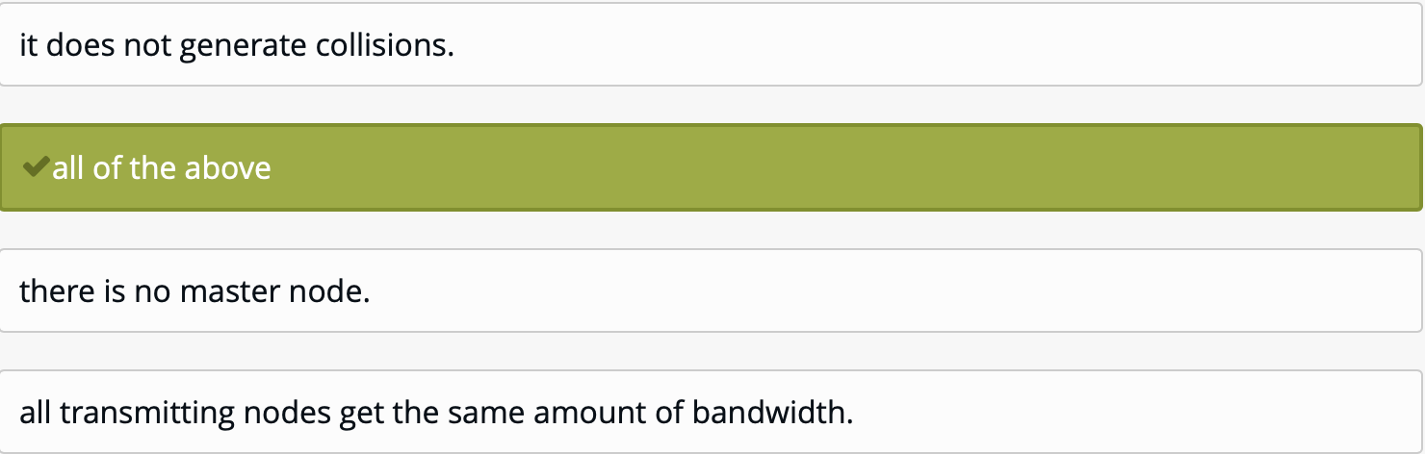

105. In asynchronous serial communication the physical layer provide



106. A university has 20 computers in a laboratory that is currently served by several small 10 Base-T "Ethernet" hubs that are directly connected to each other. The network performance has been found to be lacking, and an upgrade is planned. The computers are identical and place a comparable load on the network that is relatively constant and modest for each computer (in the order of 500 Kbps). What would you suggest for the upgrade?



107. Network clients use well-known _____ numbers to contact well-defined network services, such as Telnet and DNS servers

Network clients use well-known _____ numbers to contact well-defined network services, such as Telnet and DNS servers



108. CCT stands fo

109. Convert the following IP address: 93.44.123.184 to the binary



110. How much data can a typical frame contain?



111. Below provided a typical HTTP response message.  Let’s take a careful look at this response message  
What three sections has HTTP response message?

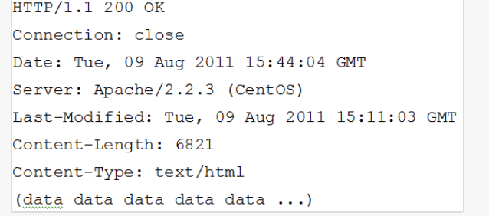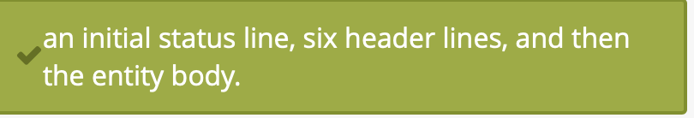

112. The IP address space is organized in a hierarchy (I) to make the routing task more scalable, (II) to decrease inefficient fragmentation of the address space (III) to give institutions managing local-area networks autonomous control over the assignment of addresses to computers



113. In contrast to standards developed by traditional standards organizations like the International   
Telecommunications Union (ITU) or the International Standards Organization (ISO), standards developed by the Internet Engineering Task Force (IETF) can be



114. Which of the following protocols are essential to the existence of the Traceroute tool? 1 IP, 2 ICMP, 3 TCP



115. Link layer encapsulates datagrad in a



116. POP stands for

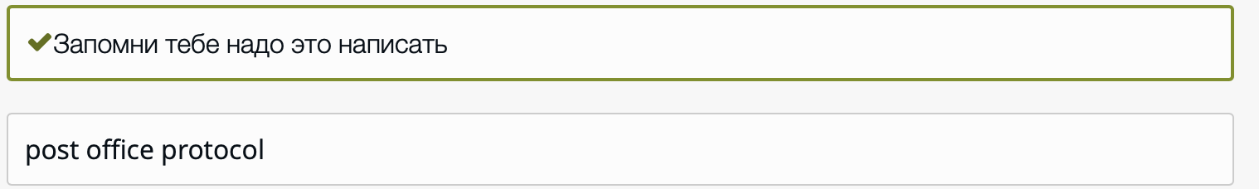

117. In a broadcast-based network, longer propagation delays



118. DNS resource record has Type=MX. Then:



119. Consider the latency model for dynamic congestion windows. Which of the following components contribute to latency?

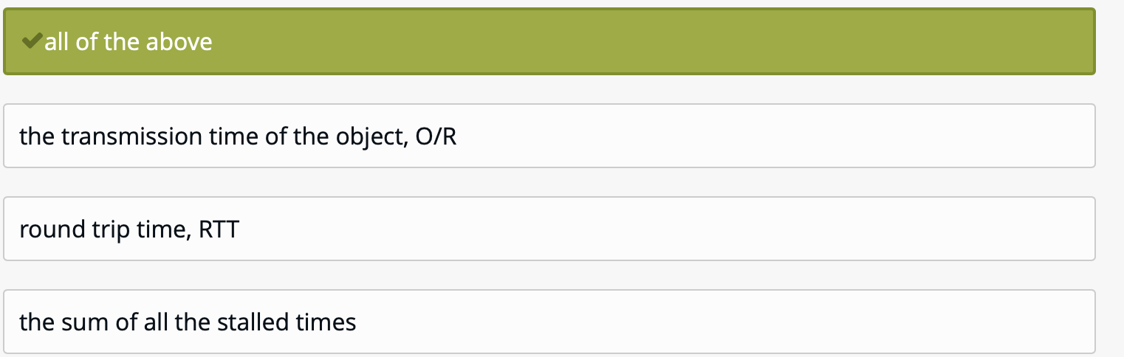

120. Match the following delays to the correct definition

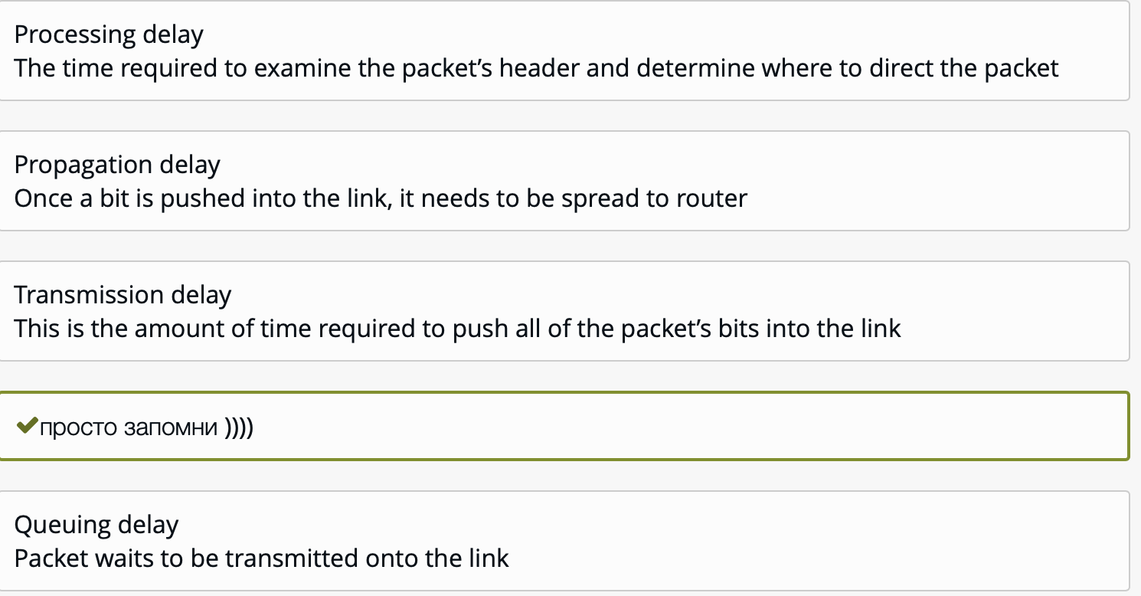

121. What is the purpose of a presentation service?



122. __________provides full transport layer services to applications



123. there are transport service requirements, for which of the following applications these requirements are demanded: no data loss, elastic throughput, and not time sensitive



124. The process that sends messages into, and receives messages from, the network through a software interface is called a socket.



125. When a student in Hong Kong uses her computer to have a voice conversation with a teacher in Pittsburgh, the application she uses requires that the network deliver bits at a modest but constant bit rate. This is because, even though voice can be faithfully encoded in less than 64 Kbps, the late arrival of a voice sample produces a noticeable and unpleasant sound effect. Which of the following switching options will give you better quality?



126. Two packets A and B are sent in that order through a connection-oriented communication network. They could arrive at the destination:



127. What is the purpose of the SNMP SetRequest message?



128. Andalyn says complete 48-bit MAC addresses are allocated to NIC manufacturers from the IEEE. Buster says the IEEE only assigns the first 24 bits to manufacturers. Carlos says the IEEE assigns only the last 24 bits to manufacturers. Who is correct?

129. reliable transport between sending and receiving process refers to (protocol type)?

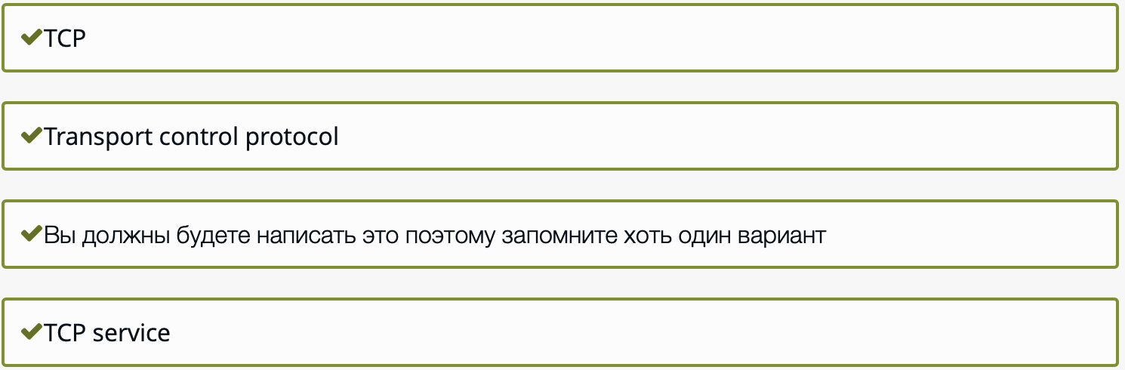

130. A router is installed to interconnect 4 subnetworks with MTUs of 1024, 2048, 576, and 1556 bytes respectively. Nodes A and B are connected to the first and second subnets, respectively. An application on node A sends a 4096-byte datagram (e.g., using UDP) to an application on node B. How many IP fragments will the router process as a result?



131. Suppose a network manager wanted to query the value of the number of TCP segments received by a host running the Microsoft Windows 2000 operating system in a US-based company. What would be the prefix (leading digits) of the MIB variable that should be queried?

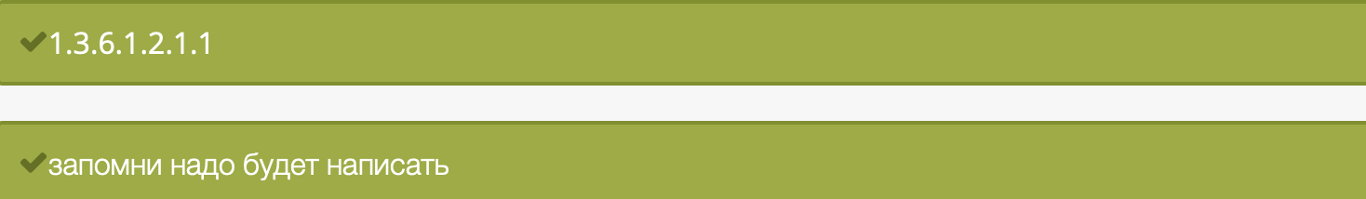

132. Three or more devices share a link in ________ connection



133. To record Internet routers of IPv4, that handles datagram is responsibility of



134. In a URL, the _______ is the full name of the file where the information is located



135. The transmission of high-quality, interactive voice and video over the current Internet is difficult because today's Internet



136. Ethernet provides which of the following services to the network layer



137. Ethernet (IEEE 802.3) is an example of



138. Nmap is often used to



139. Link layer data is



140. Typically the TCP port used by SMTP is



141. A specific CSMA-CD network such as 10-BASET "Ethernet



142. How we call the delay, when packet waits to be transmitted onto the link



143. Which one of the following is an architecture paradigms?



144. All link layer protocols that support IP have the same frame structure (i.e., length of frame, number and length of header fields). 

145. Which of the following maps IP addresses onto datalink addresses?



146. Which of the following are direct consequences of this design choice?



147. The transfer of an html file from one host to another is:



148. Which layer of the TCP/IP model involves routing?



149. The Internet received its name in the 1980s because:



150. Registered users may look up all meetings in their agenda in a given interval of time

151. application layer data is



152. Communication between a computer and a keyboard involves ______________ transmission



153. Transport layer data is



154. At which of the following layers of the OSI protocol stack can the Internet Control Message Protocol be implement. 1Network, 2transport, 3Data link



155. The housing a large number of hosts, is often used to create a powerful virtual server



156. ____ is a process-to-process protocol that adds only port addresses, checksum error control, and length information to the data from the upper layer



157. Which of the following best describes an IP address?



158. Which of the following IP header fields is designed to prevent a packet from remaining indefinitely in a routing loop?



159. How many ports can be per IP address



160. FTP is built on _____ architecture



161. The packet of information at the application layer is called __________



162. ___________algorithm computes the least-cost path between a source and destination using complete, global knowledge about the network



163. Suppose host A sends host B one segment with sequence number 38 and 4 bytes of data. Then in this same segment the acknowledgement number is necessarily 42



164. Which of the following is an application layer service?

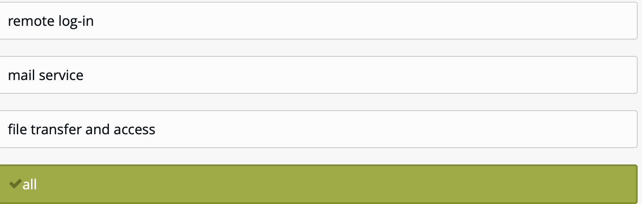

165. How we call the link-layer packets?



166. Which of the following statements is (are) true of network protocols?\n I.A protocol is a set of rules that facilitate communication among network applications.\n II.Only a single protocol may govern any transmission



167. Header of datagram in IPv4 has



168. e-mails use ______________ protocol for sending messages



169. there are transport service requirements, for which of the following applications these requirements are demanded: no data loss, elastic throughput, and not time sensitive



170. With ADSL, each subscriber gets more downstream bandwidth than upstream bandwidth



171. 331 Username OK, password required – status code refers to (protocol type)?

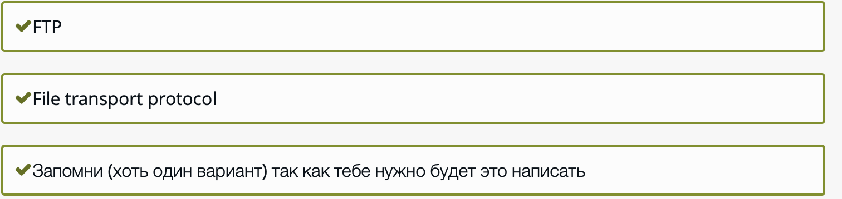

172. Multicast communication generally refers to data that is



173. The 802.11 protocol does not implement collision detection because

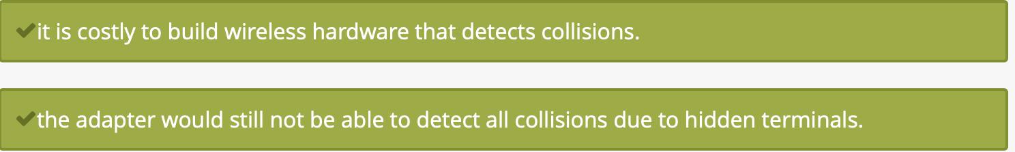

174. The Date: header in the HTTP response message indicates when the object in the response was last modified.



175. The time required to examine the packet's header and determine where to direct the packet is part of the



176. Which of the following is the network-layer protocol of the Internet?



177. A packet with no data is sent from host A to host B on an otherwise idle network. The packet is found to have taken 35 milliseconds to reach B. The incremental overhead to send an additional byte (usually called the "throughput") is estimated to be five microseconds by repeatedly measuring the transmission times of long packets. Approximately, how long will an eight Kbytes (8192 bytes) packet take to reach B when sent from A?



178. How does an operating system identify the application to which data coming in from the network should be relayed



179. Determine the correct class of the following IP address: 93.44.123.184



180. An 802.11 frame includes

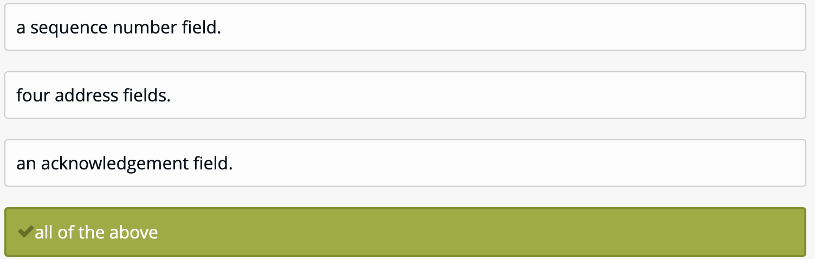

181. Consider an HTTP Web server using persistent connections. Suppose the server spawns a separate process for each client that connects to the server. Then each of these spawned processes will have different server port numbers.



182. An IPv4 datagram can encapsulate data from several higher-level protocols such as UDP, ICMP, IGMP and



183. UDP has which of the following characteristics

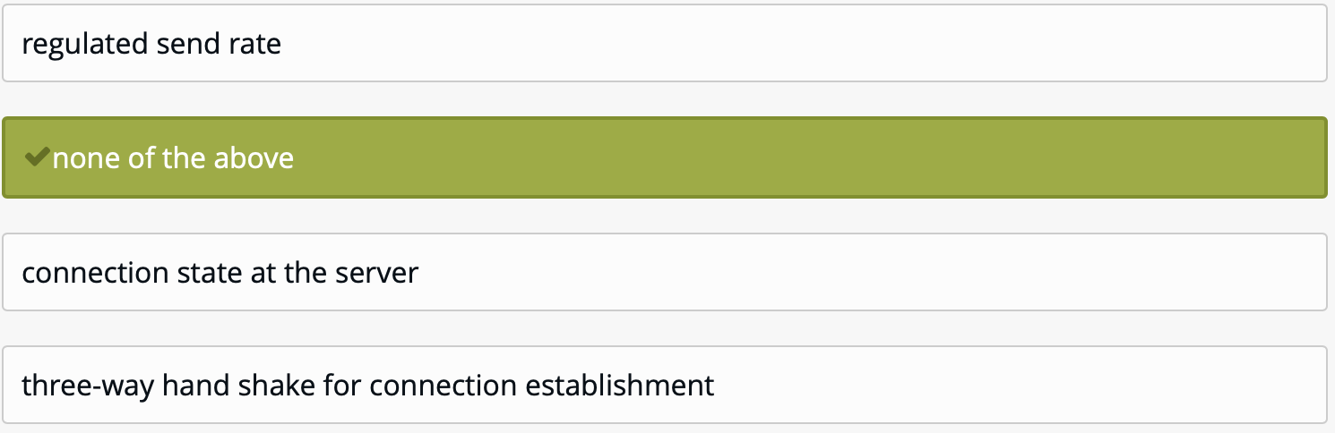

184. A forwarding table is



185. For BitTorrent, which of the following is true

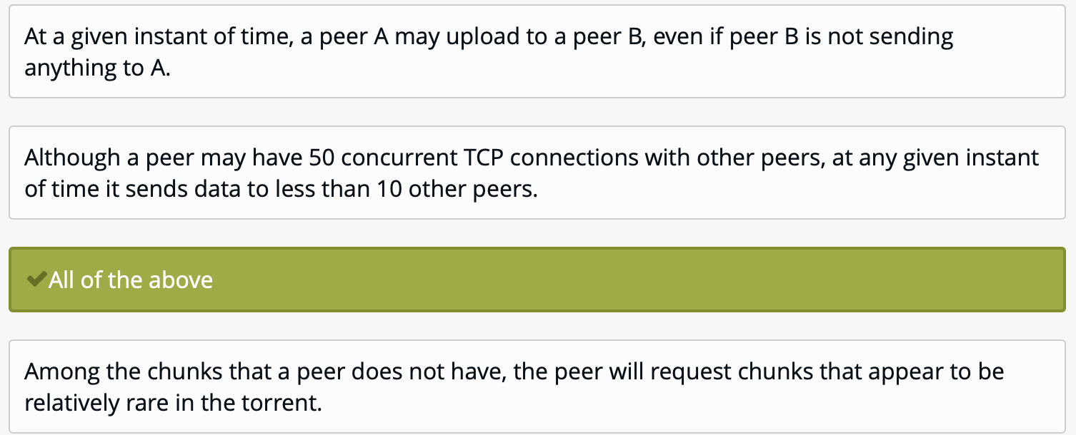

186. This is the amount of time required to push all of the packet's bits into the link



187. In version field of IPv4 header, when machine is using some other version of IPv4 then datagram is



188. Which of the following can be used by a router to report a dropped packet to the packet's sender?



189. set of rules that the sending of rules that the sending program must follow so that the Internecan deliver the data to the destination program is called



190. Convert the following IP address: 192.224.224.15 to the binary



191. The_________ layer is responsible for the delivery of a message from one process to another



192. DNS provides a few other important service in addition to translating hostnames to IP addresses

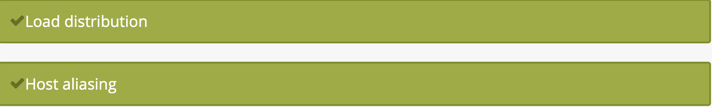

193. ________________ is a repository of information linked together from points all over the world



194. Determine the correct class of the following IP address: 160.23.244.224



195. When a TCP segment arrives to a host, the socket to which the segment is directed depends on

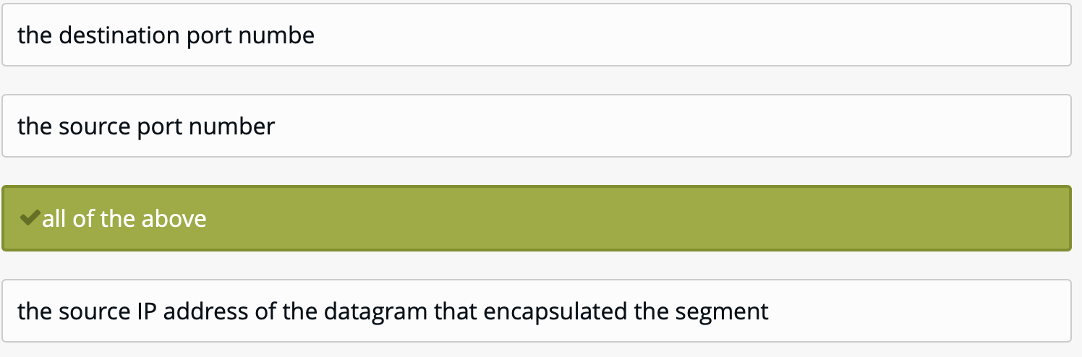

196. Which one of the following allows a user at one site to establish a connection to another site and then pass keystrokes from local host to remote host?



197. A sender's data link layer uses "bit stuffing" to



198. Most packets use these as the inputs to the links. This means that the packet switch must receive the entire packet before it can begin to transmit the first bit of the packet onto the outbound link



199. In HTTP, the first line in a request message is called a _______ line; the first line in the response message is called the ________ line

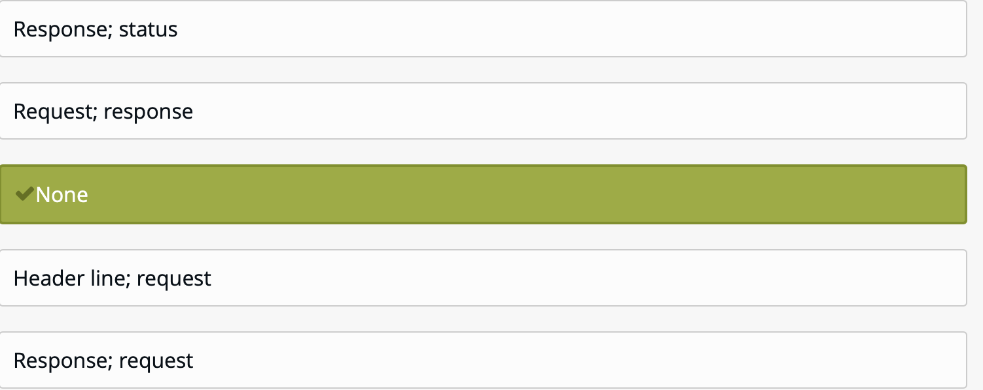

200. HTTP persistent connection - multiple objects can be sent over single TCP connection between client, server

