Basic Operation Guide
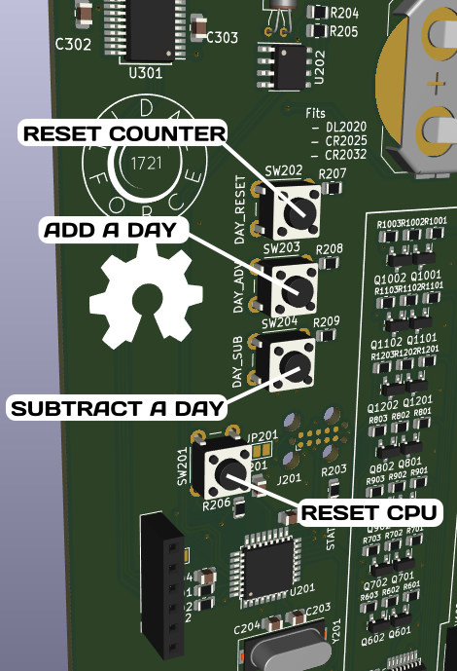

Basics
There are 4 buttons on the back of the display module.
Note that only the first circuit board has buttons.

DAY_RESET
Resets the counter, press this if an accident occurs (but not first! Treat the poor person first!)
When you press this, the sign will count down to 0, and then reset the time, and will count up from the time you push this button. (This is probably the button you’re looking for)

DAY_ADV
This button will add a day to the counter, you can press it several times to tick the counter to a specific number.
The counter will continue counting from the date you set

DAY_SUB
Opposite of DAY_ADV, subtracts one day and starts counting from that date.

Reset
Pressing this resets the CPU, it doesn't reset the day, just restarts the board. If the battery is powered, then this will briefly turn the display off and resume showing the same day, if the battery is dead then this may accidentally reset the clock. (You probably don’t need to press this)

Remote Operation Guide
Included in v1.3.1 is an external remote! The remote has all the same buttons as above.
