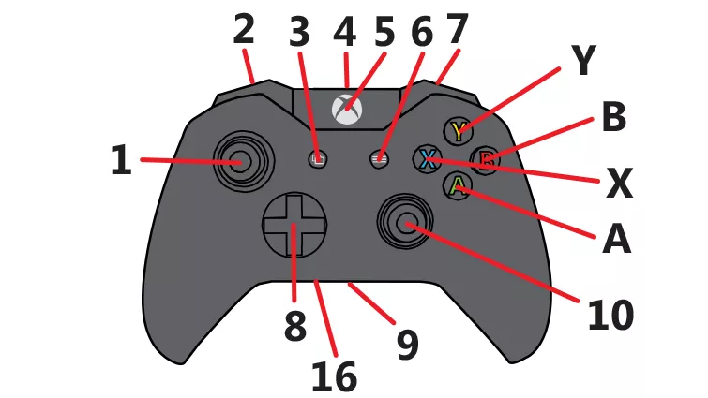
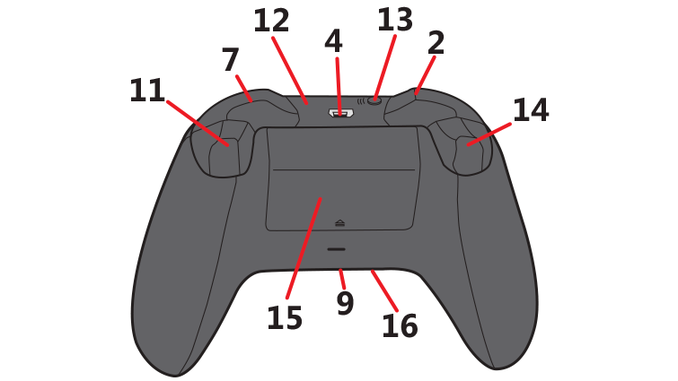
Driver

Left Joystick | 1 | Translational Drive
Left Bumper | 2 | Auto Align Gear
Back Button | 3 | Toggle Drive Modes (Field Centric / Robot Centric)
Start Button | 6 | Reset Gyro
Right Bumper | 7 | Toggle Camera Feed
Right Joystick | 10 | Rotational Drive
Right Trigger | 11 | Intake (Hold)
Left Trigger | 14 | Release Gear (Hold)
A Button | A | Fast Transmission Setting (Latch)
B Button | B | Slow Transmission Setting (Latch)
X Button | X | Normal Transmission Setting (Latch)
Y Button | Y | Reverse Intake (Hold)

Operator

Left Joystick | 1 | Slow Translational Drive
Left Bumper | 2 | Toggle Camera Feed
D-Pad | 8 | Up/Down: Shot Adjustment  Left/Right: Adjust Auto Align Offset
Right Joystick | 10 | Slow Rotational Drive / Adjust Auto Align Offset (While auto align shooting)
Right Trigger | 11 | Auto Align Shoot (Hold)
Left Trigger | 14 | Manual Shoot (Hold)
A Button | A | Climb Down (Hold)
X Button | X | Toggle Intake Lid
Y Button | Y | Climb Up (Hold)

