Argos 1756 Autonomous Routines
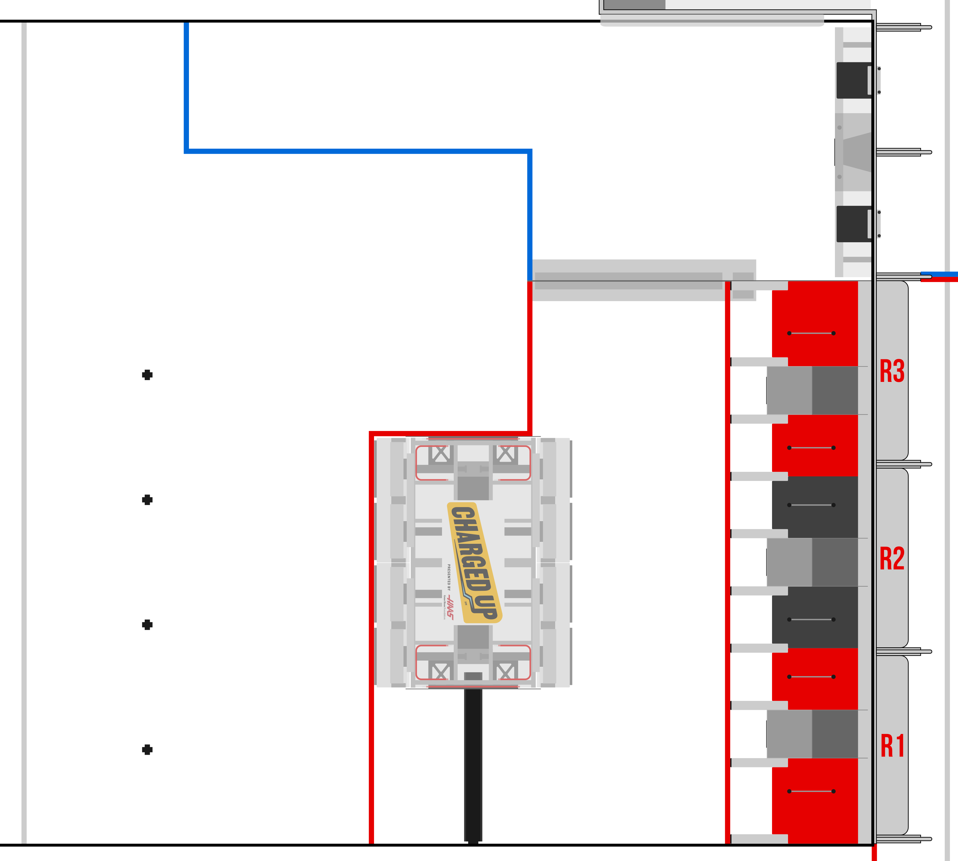Drive Forward
Place and Exit
Loading Station 2 Cone
Loading Station Cone Cube
Balance (either of 2 starting positions)
Loading Station Cone Pickup Balance


