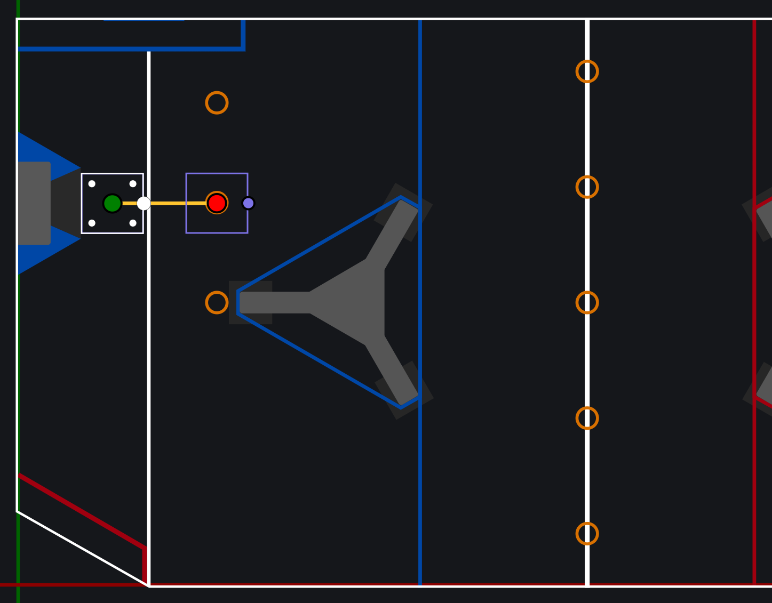02. Center 2
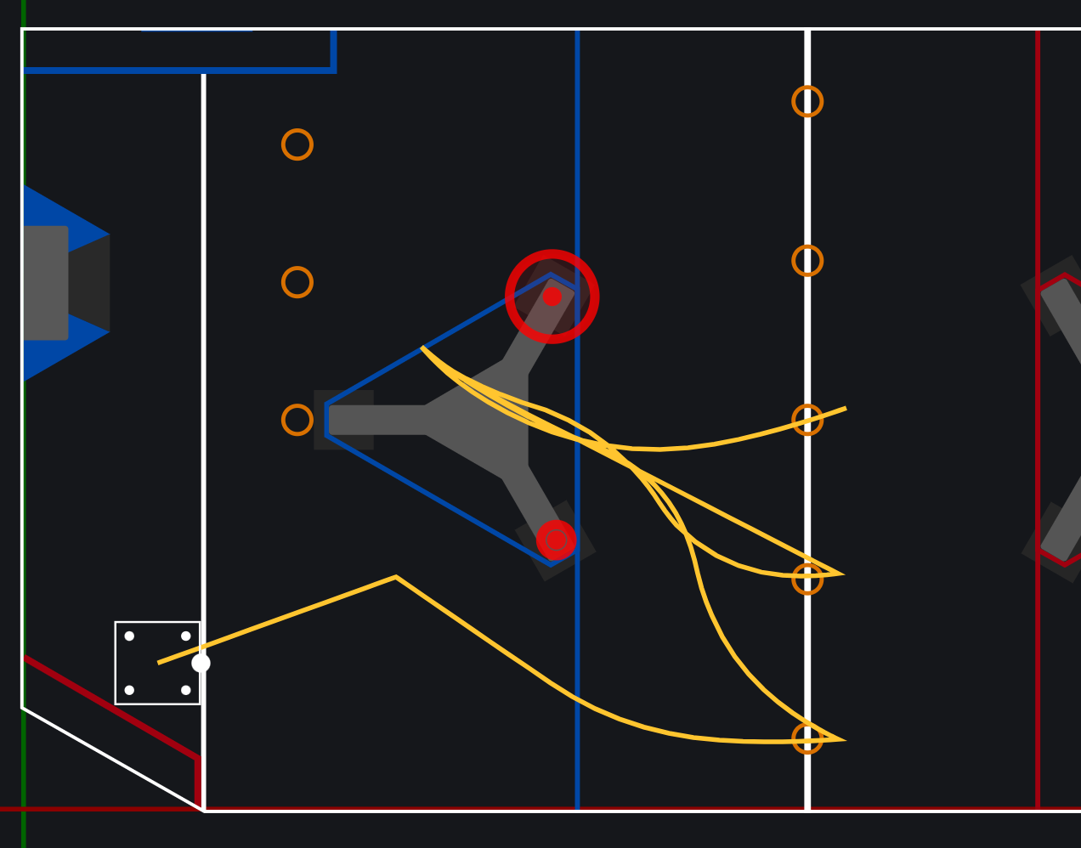09. 1 Preloaded Source
10. 2 Preloaded Source
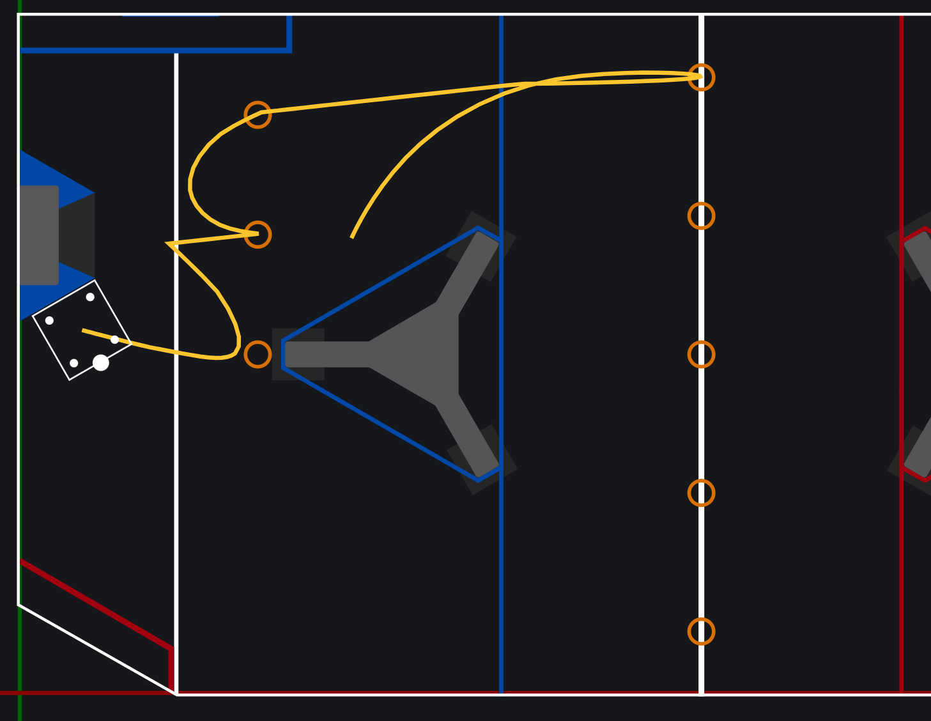05. Source Side Subwoofer 2 Piece
06. Source Side Subwoofer 4 Piece
07. Source Side Subwoofer 5 Piece
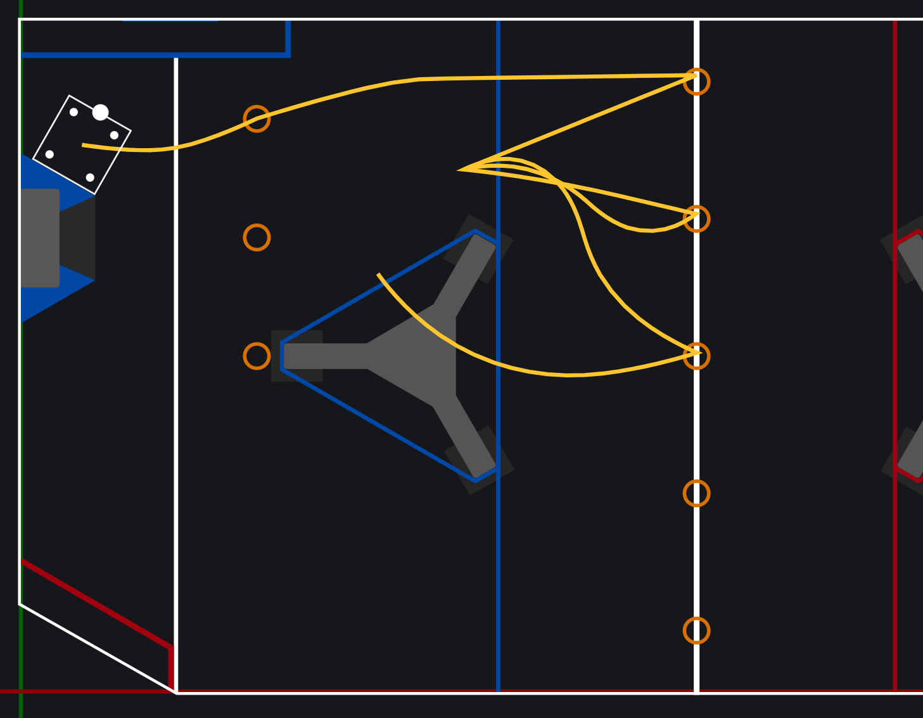01. Amp Side Sub-woofer OP
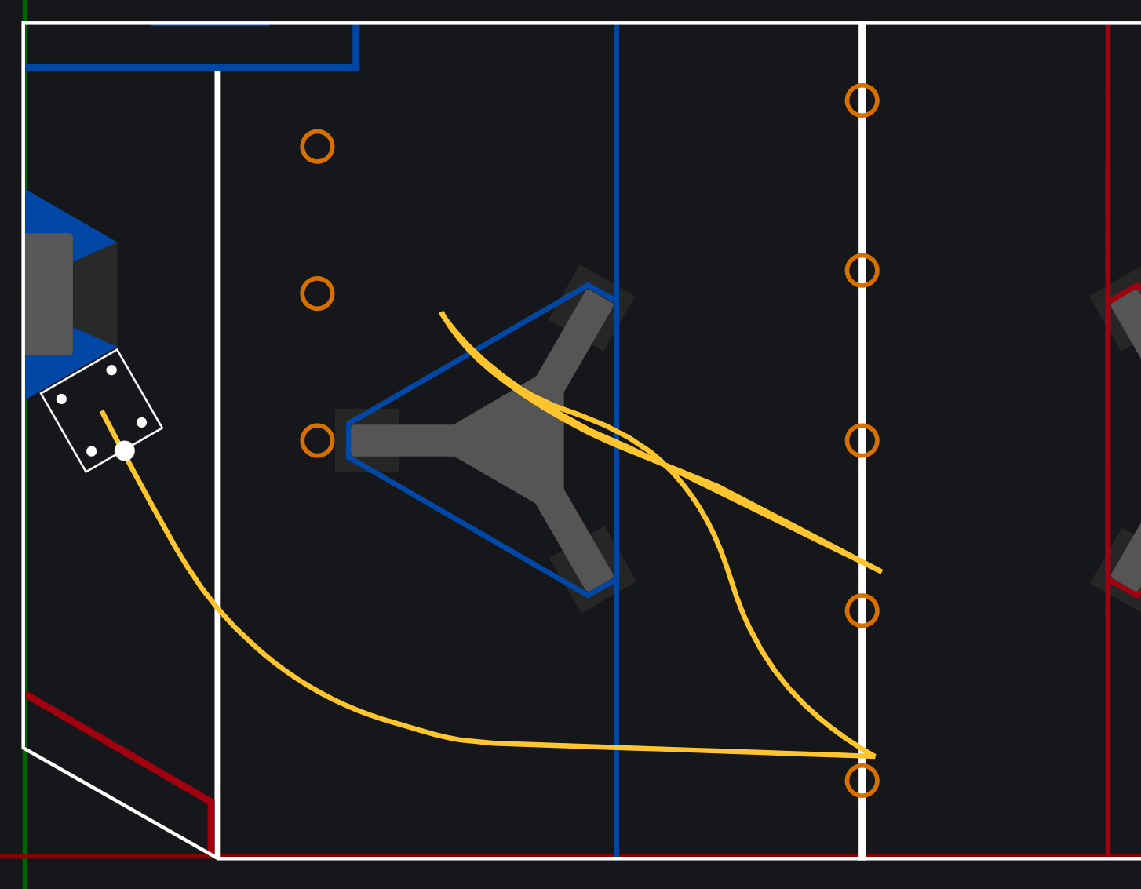08. Source-side subwoofer steal 2
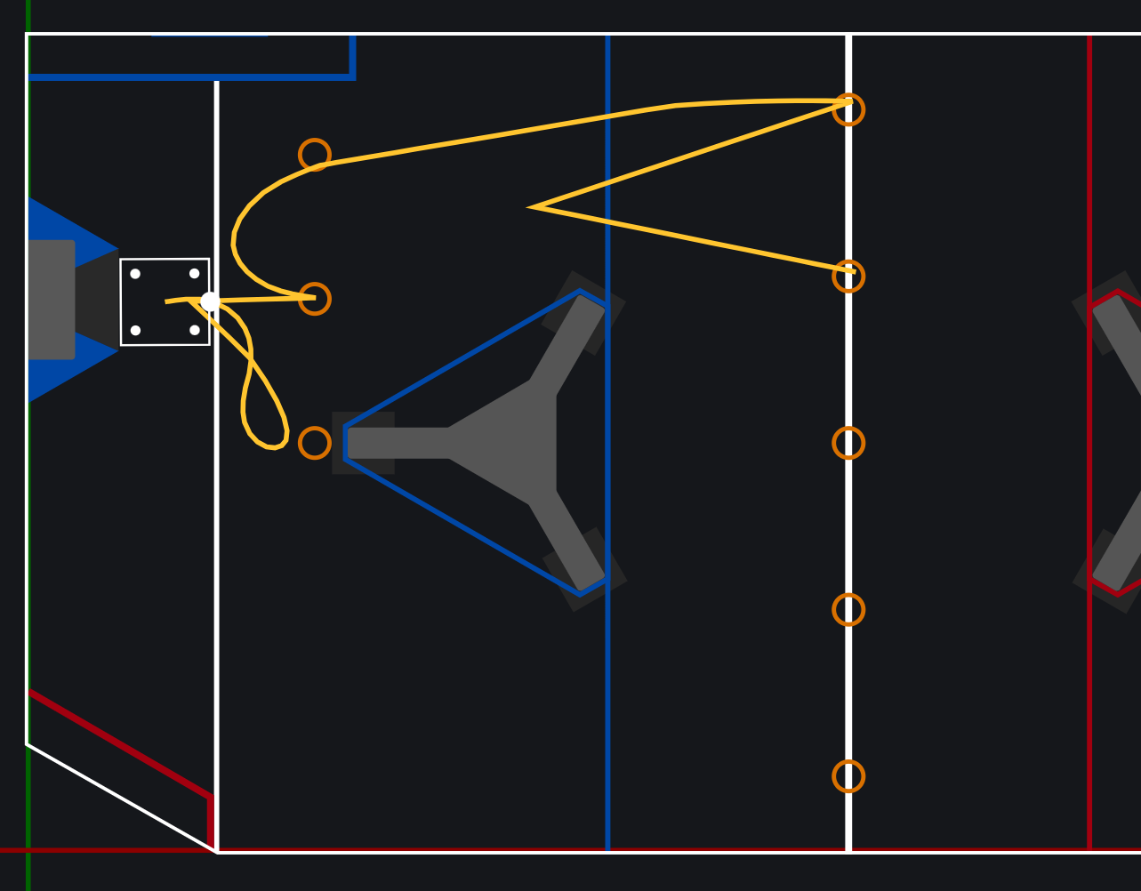03. Center Subwoofer 4 Piece
04. Center Subwoofer 6 Piece
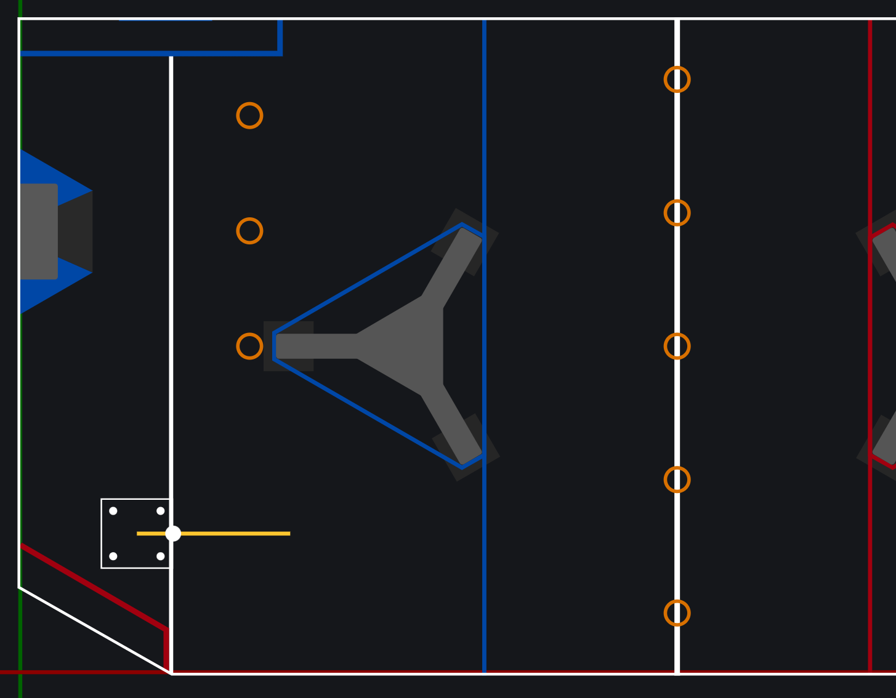11. Zero Note - Just Move

