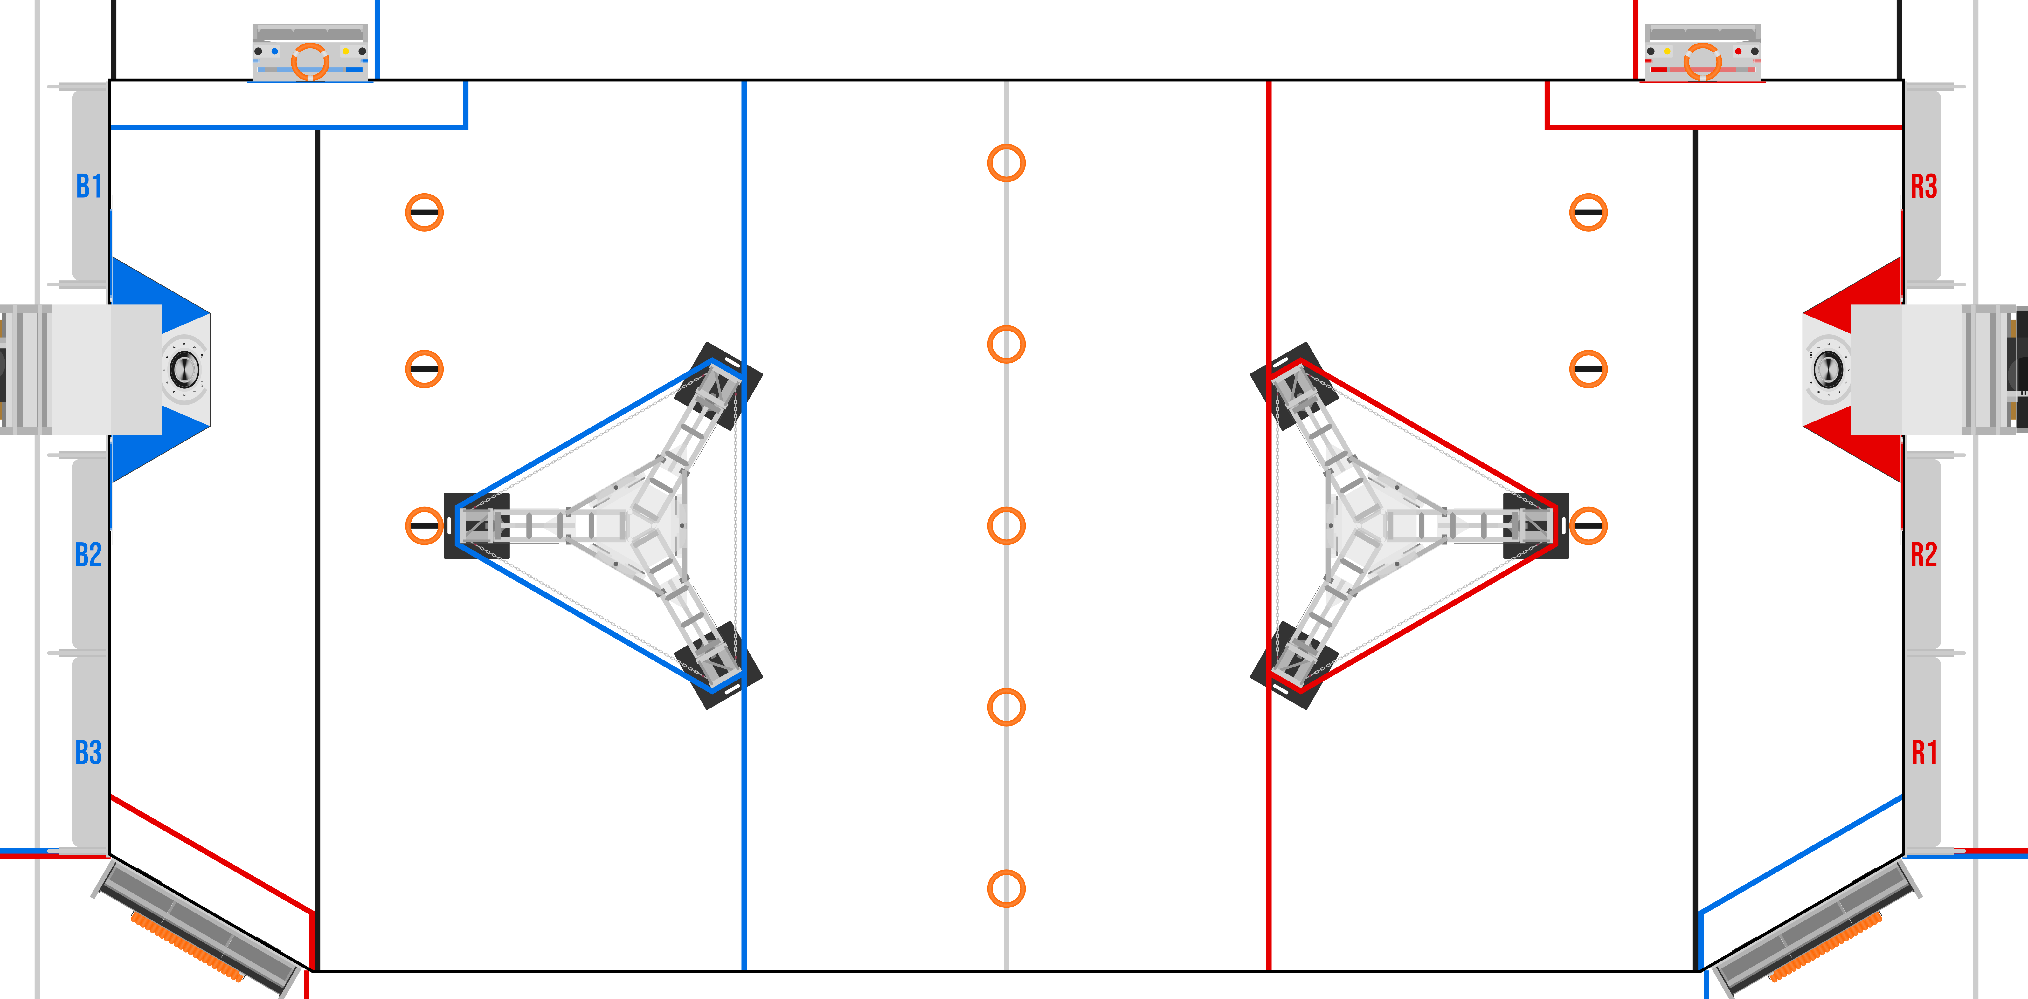
B
D
A
C
E
Z
Y
X
W
V
U
T
S
R
Q
P
O
N
Point | Nominal (in) | Practice B | Field B | Practice R | Field R
A | 75.125
B | 114
C | 231.19
D | 326.6
E | 79.83
Z | 84.74
Y | 47.64
X | 57
W | 57
V | 161.64
U | 110.65
T | 110.65
S | 29.64
R | 66
Q | 66
P | 66
O | 66
N | 29.64

