Simulated Robot

FRC 2016 “Stronghold” competition

Team 159

Motivation and Goals

Overview
Over the past two or three years there has been a significant effort put forth by First and it's partner WPI to develop a set of tools to give FRC teams a user friendly simulation environment to test concepts and robot designs prior to the actual manufacturing process. In principle this can provide many advantages including but not limited to:
- The ability to test the inertial and geometry properties of a model as in interacts with a simulated FRC field without needing to construct actual field elements in the shop
- The ability to test and develop software used to control a robot model prior to the availability of a working prototype
- The ability to evaluate candidate design concepts without expending the resources (both in time and dollars) to construct physical models
- A mechanism to continue testing software and competition strategies between bag day and the week of competition
- A way to explore new sensor technologies (e.g. image recognition) and subsystem ideas (e.g. special drive-trains or manipulators) during the off-season

Tools and Environment

Components
The current simulation environment supported by First has the following principle components:
- Solidworks “sdf” exporter
- An application “plugin” that is used to produce a set of files from a Solidworks model that can be exported to the Gazebo simulator
- Eclipse linux_simulation build
- A special Eclipse build configuration that generates a “FRCUserProgram” binary from the working robot software source code that runs in the Gazebo simulation environment
- Gazebo simulator
- Provides a graphical simulation environment to test the interaction of the mechanical model created with the Solidworks exporter and the Software model created from the Eclipse linux_simulation build

ROBOT Solidworks Model

Expectations
During the 2016 build season the team's Solidworks CAD model development often lagged the production of physical subsystems and assemblies due to a variety of factors:
- More emphasis and resources were given this year to manufacturing and physical prototype development
- The decision to build two complete working robots (which put demands on limited manpower resources)
- The existence of too many competing design ideas too late in the season (which might have been prevented if a working simulation environment had been available for more rapid prototyping)

Results
The final robot design included 11 separate motors and motor controllers (all CANTalons) 5 limit switches, 2 accelerometers, 2 cameras, an infrared ball sensor, and a Lidar.

Simulation Solidworks Model

Physical Components Modeled
By the end of the build system many of the critical components had already been CADed to a level that was adequate as a starting point for a simulation model, others were implemented later. These included:
- An 8 wheel drive train with limited side-to-side frame articulation
- A shooting subsystem that included a dual fly-wheel ball propulsion mechanism
- A ball holder subassembly that had an arm used to stage the ball during loading and hold it prior to launching
- A push wheel used to propel the ball into the flywheels
- A ball loading apparatus that consisted of rollers mounted on a set of arms that could be raised and lowered under software control

Workarounds and adjustments
Because of limitations in the current Solidworks sdf exporter and Gazebo simulator some of the mechanical and sensor components couldn't be directly modeled but had to be emulated as follows:
- The Polycord bands in the Loader apparatus were replaced by 2 additional rollers
- The infrared sensor used as the ball detector was replaced by an ultrasonic sensor
- In order to detect whether or not a ball was present in the Holder, the sensor needed to be pointed downwards
- In the simulator the determination of minimum distance for the reflected beam seems to require impact with an external model (e.g. the ground plane, a wall etc.)
- The dual master-slave motor controllers on each side of the drive train were replaced by a single motor controller for the left and right sides

Results
Image of completed Solidworks “SimRobot” model
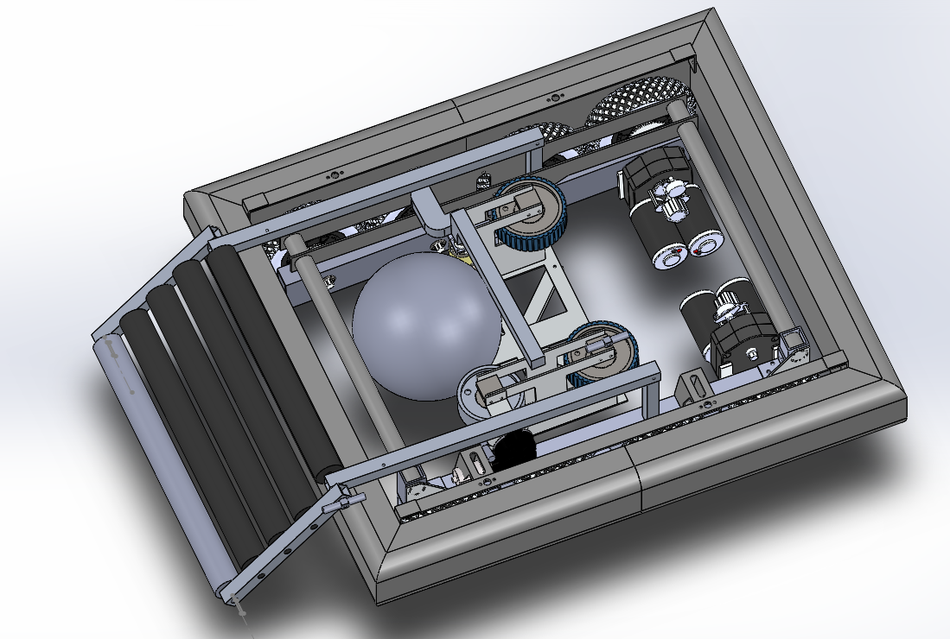

ROBOT Software Model

Simulation Software Model

Results

Limitations

Future Development

