Simulated Robot

For FRC 2017 “Steamworks” Game

Team 159

Motivation

Overview
As was the case for the previous two seasons a Gazebo robot simulation project was developed in parallel with the team’s competition robot code for this year’s “Steamworks” game. Using the simulation tools supported by First has the following benefits:
- The ability to test the performance of a model as it interacts with a simulated FRC field without needing to construct a working robot and physical field elements
- The ability to test and develop software used to control a robot model prior to the availability of a working physical prototype
- A mechanism to continue testing software strategies between bag day and the days of competition (or while the physical robot is being worked on or assembled)
- A way to explore new sensor technologies (e.g. image recognition) and subsystem ideas (e.g. special drive-trains or manipulators) during the off-season

Tools and Resources

Components
The current simulation environment supported by First includes the following principle components:
- Solidworks “sdf” exporter
- An application “plugin” that is used to produce a set of files from a Solidworks model that can be exported to the Gazebo simulator
- Eclipse linux_simulation build
- A special Eclipse build configuration that generates a “FRCUserProgram” binary from robot software source code that runs in the Linux Gazebo simulation environment
- Gazebo simulator
- Developed for the DARPA supported “DRC” challenges. Provides a graphical simulation environment to test the interaction of the mechanical model created with the Solidworks exporter and the Software model created from the Eclipse linux_simulation build
- GRIP vision processing subsystem
  - GRIP was introduced by WPI last year as a Java based application to process camera images and isolate vision targets in the FRC field
  - It was designed as a replacement for NI’s proprietary “NIVision” subsystem which was neither free (outside of First teams use) nor open sourced
  - Because the original Java based version was found to be too slow when running on the RoboRIO arm processor (and also required installing a significant number of third party libraries) this year the recommended deployment method is to use a special tool in the GRIP user interface to generate native OpenCV source code (Java, C++ or Python) and then port that code to the target platform (e.g. by direct compilation into the robot program)
  - In order to get this new approach working with the gazebo simulator (running in a Linux environment) it was necessary to first build several components from source (cscore, CameraServer etc.) that were supported by pre-compiled arm libraries when deployed on the Roborio but were not available for simulation. (A separate write-up about going about this is available on the MentorRepository github site:FRCSimulation2017.odt)
- SmartDashboard
  - In addition to the Default dashboard (a pre-compiled NI application) FIRST/WPI provides two alternative Java based dashboards: “SmartDashboard (2.0)” and “SFX (3.0)”. SFX is based on JaxaFX and has a better looking UI but unfortunately we couldn’t manage to get it to display any of the camera windows so we opted to use the older 2.0 dashboard

Solidworks

Models
- Robot
The team’s Solidworks robot model was completed fairly early this year so a useful simulation prototype was available to test autonomous strategies etc. using software models well before the end of the build season.
- FRC Field
Unlike in previous years, a simplified Gazebo model for the competition field wasn’t provided by First this season so it was instead necessary to generate a facsimile of the field by exporting a Solidworks CAD design that was made available as a free download. However, owing to the large size and complexity of the field model (even after removing several components and “defeaturing” it in Solidworks) if was found to be necessary to also disable the collision property of most of the elements that were not directly required to test the behavior of the robot model’s interaction with the field. The collision components retained included the target “spikes” and gear placement panels
- Gear
A Solidworks assembly for the Gear was available as part of the Field download mentioned above and was exported as a separate model using the Solidworks Gazebo sdf exporter
  - The compression properties were modified to reduce the hardness of the surface so that the collision with the “harpoon” spring was more accurately modeled
- Balls (Fuel)
A simple 5” diameter yellow sphere was generated as a Solidworks assembly and exported using the Gazebo exporter plugin
- Vision Targets
A Solidworks sketch of the Gear placement target pattern was created (two 2x5” strips separated by 10.5” outside edges)
  - The dual tape models were place on the field panels directly behind the spikes and were suspended in place by setting “gravity” to zero in the Gazebo model
  - The color was changed to best match the color of the reflective tape illuminated by a green light ring
  - The tape was also given a certain amount of “emission” property and the ambient lighting of the Gazebo scene was reduced to better emulate the conditions seen by the targeting camera

Competition Robot
The final robot design included:
- An 8 wheel drive train with a pneumatic switch to select between a low and high gear ratio
  - Selected by 2 buttons (high,low)
- A fuel pusher subsystem that was designed to load balls contained in a hopper into the lower intake slot of the boiler
- A rope climbing mechanism composed of a hook and spindle.
- A release plate designed to allow the gear to drop free of side constraints after it was placed on the spike.
Sensors included:
- Quadrature encoders on two wheels (left and right side)
- Forward and reverse limit switches on the ball pusher mechanism,
- A targeting camera
- A driver camera
- An ultrasonic sensor used for distance measurements
- A digital gyro.

Simulated Robot

Components Modeled
The following components were modeled in simulation:
- An 8 wheel drive train with dual speed transmission
  - The gear ratio switch was emulated by limiting the max voltage applied to the wheels when in low gear
- A ball pusher subsystem consisting of a linear actuator
  - Activated by a button
- A mechanism to release a gear after placement on the spike
  - Activated by a button (teleop) or automatically at the end of autonomous
- A targeting camera used for autonomous mode
  - mounted 5” off-center on the right side of the robot at the height of the center of the gear
- A secondary camera
  - Mounted directly behind the gear and used for autonomous mode debugging
- An ultrasonic sensor for distance measurement
  - this feature was ultimately disabled because the distance measurements returned were found to be erratic and inaccurate (looks like there’s a bug in the sensor plugin code)
- A simulated gyro to measure turn angle
  - In simulation only analog gyros are supported (the competition robot employed a digital gyro)

Components not Modeled
- Electronics board,pneumatics, battery and wiring
- Rope climbing subsystem

Simulation problems and workarounds
Because of limitations in the current Solidworks exporter and Gazebo simulator some of the mechanical and sensor components couldn't be modeled
- The rope climbing subsystem couldn’t be modeled because the gazebo simulator doesn’t directly support deformable objects such as springs and cables
- The simulated ultrasonic sensor was found to be unreliable (sometimes returning inaccurate or even negative values) and so was not used in simulation

Screen-shot of final simulated robot
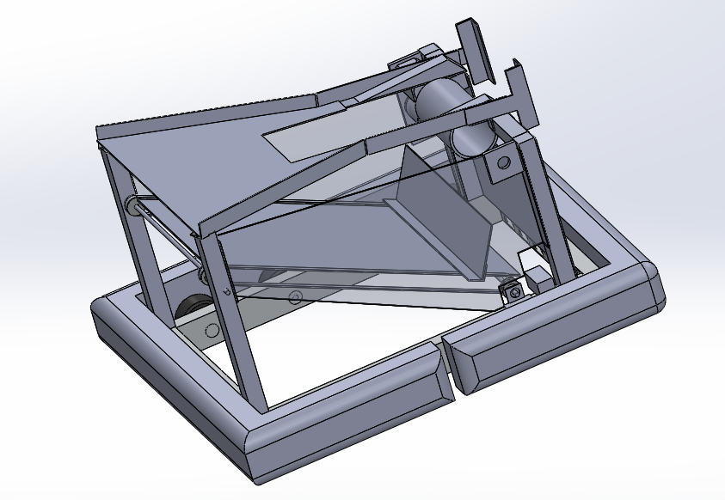
Final Solidworks Model of the Simulated Robot

Solidworks Exporter Robot Model Joint tree

left wheels
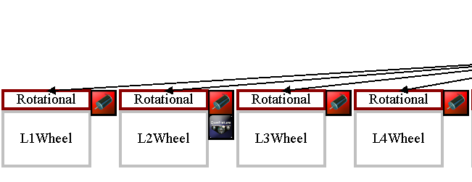
Sensors: Encoder(on L2Wheel)

Chassis and Right Wheels
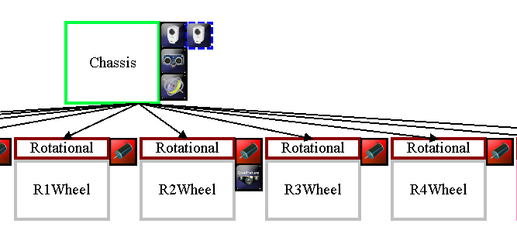
To Top Frame
Sensors: Encoder(on R2Wheel), TargetingCamera,DriverCamera,UltarsonicRangefinder,Gyro

Ball Loader Pusher and Gear Plate
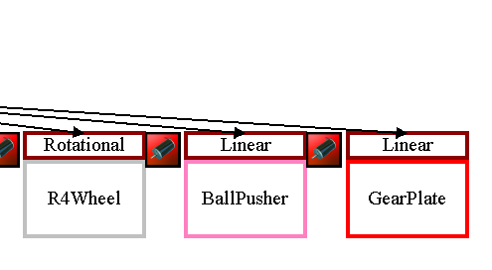
Sensors: Upper and Lower Limit switch on BallPusher

Sources
The Solidworks design files that were used in the 2017 Simulated Robot are available in the github repository “Team159/MentorRepository” in the sub-directory Solidworks/Models/
https://github.com/FRCTeam159/MentorRepository/tree/master/Solidworks/Models/2017-SimRobot
The “.sdf” and mesh files generated by the Solidworks exporter are also available for deployment in the Gazebo simulator and can be downloaded from the Solidworks/Exported/FRC2017_Exported directory in the Team159/MentorRepository:
https://github.com/FRCTeam159/MentorRepository/tree/master/Solidworks/Exported/FRC2017_Exported

Software

Software paradigms
The First/WPI enhancements to the Eclipse IDE provide an opportunity to base a Robot design using either the “Integrated” or “Command” style paradigms.
The “Integrated” paradigm runs in a single thread with direct callbacks from the user's code to the state machine that services periodic (20 ms) control updates in Teleop and Autonomous modes.
In the “Command” paradigm the source code is organized into separate classes that extend the Command and Subsystem library base classes. In Autonomous mode Commands can be linked together to run sequentially or in parallel to produce complex behavior. In Teleop mode each subsytem can specify a special “Default” command that is run by an external scheduler once per 20 ms cycle.

Competition Robot Project Software
The 2017 Competition software was c++ based and was developed using the Eclipse Integrated Development Environment (IDE) with plug-ins provided by First and WPI that are used to generate binary files that run (as applications) on the RoboRio's embedded Arm processor.
The overall software design included independent state machines for three separate subsystems as well as a vision based auto-targeting system. Software control was needed for 6 motors, 2 cameras, a Ultrasonic Rangefinder, 2 encoders (on the drive wheels) and 2 limit switches.
Code development was carried out in the Windows(10) operating system environment which allowed for direct deployment of the compiled binary file from Eclipse to the robot hardware over wireless Ethernet. This year the team also made extensive use of the Java based “SmartDashboard” application particularly for tuning the camera and targeting parameters used for Autonomous operation.

Paradigm
This year's software was based on the “Command” paradigm for the first time

Architecture
Following the “Command” paradigm the software design was centered around several subsystem classes, each with a special “default” command that controlled the subsystem’s operation during Teleop mode
Mechanical subsystems included a drive train controller (DriveTrain), fuel delivery system (FuelSubsystem), gear delivery system (GearSubsystem) and climber (ClimbingSubsystem).
A separate subsystem class was also created for the ultrasonic rangefinder (UltraSonicSubsystem)
Vision based targeting employed it’s own subsystem class (Vision) as well as a separate Utility class (GripPipeline) that was a modified version of the c++ code snippit produced by the GRIP application. The GripPipeline class was executed in a separate thread from the main robot application and was responsible for carrying out the image processing operations on the camera input stream using native OpenCV library calls running on the RoboRio. Communication between the GripPipeline and Vision application was done using NetTables PutNumber and GetNumber calls.

Code sources
Source code is available for viewing or download from the “HughBot” project in the github Team159/2017-Robot-Code repository directory at:
https://github.com/FRCTeam159/2017-Robot-Code

Simulation Robot Project Software
The source code used in this year’s simulated robot project (SimHughBot) was almost identical to that employed for the competition robot. In many cases the student’s code was simply copied over and recompiled using the linux_simulate build target. The following differences however are noted:
- Since simulation classes for CANTalon motor controllers have never been supported by WPI a separate project was developed (CANTalonLib) to allow most of the functionality of those controllers to be emulated. Source code for this library is available on line at the team’s MentorRepository github site.
- The digital gyro used in the competition robot was emulated using the simulated AnalogGyro class
- Several bugs and other problems exist in the current WPI simulation libraries (e.g. see section 3.3 below). These were fixed in the allwpilib code and the library was rebuilt

Software paradigm
As for the competition code this year's simulation software was also based on the “Command” paradigm

Code sources
Source code is available for viewing or download from the “SimHughBot” project in the github Team159/MentorRepository repository directory at:
https://github.com/FRCTeam159/MentorRepository/Software/workspace/ SimHughBot

Patches for WPI library bugs

PIDController and Notifier classes
Last year several problems were discovered in the simulation code related to PIDControllers.
A bug report (artf4830) was submitted for these problems though the TeamForge website on 3/15/2016 and has been assigned for work with the status “Open”. Progress can be tracked at the following URL:
https://usfirst.collab.net/sf/go/artf4839?returnUrlKey=1460655219989

motor controller classes
In the simulation build all of the motor controller classes return a zero value for the Get or GetSpeed functions. This problem appears to have a very simple fix (a class variable was just not getting updated) and a Bug report was submitted on 3/17/2017 and can be tracked at:
https://usfirst.collab.net/sf/go/artf4840?returnUrlKey=1460655771424
Update: as of 3/2017 no work appears to have been done at WPI to fix any of these reported problems

Launching a simulation
Although there is (reportedly) a plan to provide Windows support in the future, simulations currently need to be carried out in a Linux (specifically Ubuntu) OS environment. Details on how to set up a virtual or native Linux environment with all the necessary support tools have been described in previous reports (see the software/docs directory in the team’s MentorRepository) and so wont be repeated here. A good reference on how to get started with this can be found at the following link: http://wpilib.screenstepslive.com/s/4485/m/23353
The procedure for running a simulation for this year is as follows:
- Execute one of the 3 start-up scripts located in the SimHughBot project directory
> cd ~/Robotics/MentorRepository/Software/workspace/SimHughBot
> ./start_simulation-center
or:
> start_simulation-right
or:
> start_simulation-left

- Each of these scripts will cause the following series of applications or command scripts to be launched in separate “roxterm” tabs:
  - start_gazebo_<center,left,right>
    - starts command script: gazebo-2017-field-<center,left,right>
    - starts up gazebo application with center,left or right “.world” file
  - start_targeting_camera
    - starts up “mjpg_streamer” application for targeting camera
  - start_driver_camera
    - starts up “mjpg_streamer” application for driver camera
  - FRCUserProgram
    - executes the simulation robot program in ../SimHughBot/linux_simulate
  - sim_ds
    - starts up the simulation driver-station Java application jar file in ~/wpilib/tools
  - start_smartdashboard
    - starts up Java “SmartDashbord” jar file in ~/wpilib/tools

Autonomous mode

Strategy and Requirements
The Autonomous mode strategy chosen for this years challenge was to be able to place a gear on any of the three airship spikes (left, right or center). The decision to do this (as opposed to delivering fuel to the boiler for example) was primarily based on the high point value (60) awarded for getting a rotor started in Autonomous mode (requiring only a single gear). If at least 2 robots in an alliance could deliver a gear 2 rotors could be activated resulting in a very large 120 point starting score. It was therefore considered important to be able to deliver a gear from a side position leaving the somewhat easier center position available for other alliance teams

Design Plan
The software design used to implement the Autonomous mode strategy involved activating up to three Commands in sequence, depending on the initial placement of the robot. For all 3 placements the first Command was just to drive forward for a fixed distance (somewhat different for the center and side positions). Next, for the two side positions a second Command was executed to turn the robot a fixed angle inwards towards the airship, Finally, a vision targeting command was executed for all 3 positions to drive the robot to the stake in an attempt to place the gear. If the gear was placed on the spike the gear plate would then be dropped to allow the airship pilot to load the gear into the center rotor slot.
In order to select which Autonomous mode was deployed a special “AutoMode” entry field was added to the SmartDashboard UI, and the drive team was tasked with entering either the text “Center”, “Left” or “Right” depending on where the robot was placed before the start of a match

Command Implementation

DriveForward
Originally, the plan was to use the encoders on the drive train to specify a travel distance and a command called “DriveToPosition” was developed to accomplish this (using a PID controller) Unfortunately, there wasn’t enough time to test and debug this command on the competition robot prior to the end of build season so a simpler “DriveForTime” Command was used (which employed a timer and a fixed drive voltage). The time and voltage where empirically determined so that the robot moved ~ 5’ from the back wall in the side positions and ~4’ in the Center position.
The Simulated robot was able to use either the DriveToPosition or DriveForTime Commands

TurnToAngle
In this Command (which wasn’t executed for the center position) the gyro was used to specify a turn angle depending on what position the robot was placed in. The ideal angle that would turn the robot to be directly facing the spike was calculated to be +/- 60 degrees, but for the competition robot it was found to be somewhat less (45-50) and was also different for each side (we’re not sure what the source of this discrepancy is). A PID controller was used to apply a differential voltage to the wheels on opposite sides of the robot to effect an in-place turn

DriveToTarget
This command was executed for all 3 positions and was designed to use the target location information returned by the vision processing subsystem (running in a parallel thread) to drive the robot the final distance to the spike. The vision targeting subsystem was tasked with determining the residual distance and offset angle dynamically as the robot made it’s final approach to the target.

Vision processing
The Vision Processing and targeting strategy used for both the simulated and physical robot involved the following steps:
- GRIP was run as a stand-alone application to tune the HSV filter and other parameters needed to identify the target tape pattern
  - Using images captured from either a real camera and target pattern (composed or retro-reflective tape) or a simulated equivalent (captured by mjpeg_streamer from the simulated Gazebo camera output)
  - After the rectangles associated with the target were successfully isolated, the GRIP “Generate Code” feature was used to produce a C++ code segment that contains calls to native OpenCV library functions
  - The following GRIP pipeline functions were used:
    - HSV segmentation
      - Primarily uses Hue to isolate the blue-green ring-light color
    - Identify Contours
      - finds edges of solid blobs
    - Convex Hulls
      - finds external contour boundaries
    - Filter Contours (Hulls)
      - filters and rejects contours based on minimum area, ratio (width/height), etc.
- The OpenCV GRIP generated code was incorporated into a subsystem (GripPipeline) that output a vector of bounding rectangles for all of the captured contours
- An independent thread was started up as part of the robot program initialization that processed the vector of rectangles produced by GripPipeline and generated a single bounding target rectangle centered on the target (spike)
  - The output of the Vision processing thread (bounding box & number of rectangles used to produce it) was published to a NetTables server (launched by FRCUserProgram running on the RoboRio or Linux)
- During Autonomous mode the “DriveToTarget” Command read from the NetTables server the data sent by the vision thread and adjusted the trajectory of the robot to drive to the center of the target
  - corrections were made to compensate for the placement of the camera and handle the special problem cases described in the following section

Targeting details
Ideally, the targeting subsystem expects to see separate rectangles for the two strips of retro-reflective tape positioned on opposite sides of the spike. From the bounding box of these target rectangles a center point is determined that the robot will attempt to drive to (after compensating for the camera offset). The distance to the target can be estimated from the projection of the bounding rectangle on the 320x240 image plane since the Camera’s “Field of View” (FOV) and target real dimensions are known (or can be measured).

Problems discovered in Simulation testing
In simulation testing, a number of special problem cases were discovered:
- If the camera angle to the target is sufficiently large one of the tape rectangles can be split into two by the spike (resulting in 3 rectangles instead of 2)
  - This problem case was dealt with by identifying a group of rectangles that had certain center-to-center vs width relationships given the known geometry of the tape pattern
- Once the camera is very close to the target one of the tape rectangles will usually disappear off- screen (This is unavoidable since the camera position is offset 5” to the right side of the gear center)
  - A solution was to assume that the center of the target was actually to the left or right of the center of the remaining tape rectangle and adjust the offset accordingly
- At some camera angles it’s possible to see one of the reflective tape patterns from a neighboring target and only one of the target tape rectangles
  - In this case both rectangles will fail the geometry test described in (1) above resulting in no residual target rectangles
  - This case (i.e. more than one candidate but no “good” rectangles) was handled by accepting the single rectangle with the largest area and applying the offset correction described in (2) above

Problems discovered in competition
At the Lubbock FRC several problems were discovered that weren't caught in simulation (which resulted in most attempts to place a gear in Autonomous mode failing). It is planned to try and find fixes and workaround to these issues before the FRC competition in Denver.
- An image of the light ring reflected from the plastic wall behind the target sometimes appeared in the camera image which caused the targeting system to generate an incorrect bounding box. (This problem wasn’t identified in simulation since Gazebo isn’t capable of tracing reflections from light sources)
possible solutions:
  - Only keep the top 2 rectangles that have the largest area
  - Reject the light-ring image using expected geometry properties (e.g. the width/height ratio should be ~1)
  - Tilt the camera/ring assembly somewhat so that the light ring image is not reflected directly back towards the camera
- The TurnToAngle Command took too long to complete. This is probably caused by the PID controller not converging on the target angle fast enough
possible solutions:
  - Replace the PID and gyro-based TurnToAngle command with a simpler “TurnForTime” command
  - Modify the PID and tolerance parameters to produce a faster response
- The vision-assisted DriveToTarget Command often didn’t drive far enough to capture the spike. This problem is partially do to the fact that it takes a certain minimum voltage applied to the drive train (at least 10%) for the robot to move forward at all
possible solutions:
  - Always add a minimum voltage when driving forward
  - Decrease the target minimum distance
- The spike often intersected one of the “spokes” of the gear and not one of the gaps (this problem was also observed in Teleop mode)
possible solutions:
- Build a detection system that sends a signal when the spike has penetrated a plane behind the gear
  - Could be based on an UltraSonic sensor
  - Use two mirrors placed on opposite sides of the gear with a LASER or IR source and a detector tilted to that the beam traced back and forth between the mirrors several times
- Turn the robot quickly a few times left and right once the final distance is reached to try to dislodge the spike from the spoke if it hits there (shouldn’t be a problem to do this even if the spike is already in one of the gaps)
- When the robot was power-cycled the camera images returned by the targeting camera were often too bright and resulted in many false target rectangles being generated by the vision subsystem
  - Originally, the desired brightness and exposure settings were only sent to the camera when the robot program first started up or a change to their values was made from the SmartDashboard.
  - The problem went away when the settings were sent every 20 ms robot update cycle whether or not a change was made from the dashboard
  - A possible reason for the problem is if the firmware running on the camera starts up slower than the robot program after power is first applied and the camera application misses the initial set commands sent by the robot application
  - A concern is that sending camera settings over the USB port every robot cycle might impact performance (although this was not observed). Another solution might be to add a minimum delay (or number of cycles) before sending the initial settings commands

Tests and Results (Simulation)

Tests and Observations
- Driving and turning
- The general responsiveness to accelerating and turning of the robot model in the simulator was seen to be more sluggish than that observed in the real robot. Some of the difference can probably be attributed to the fact that the simulation runs at a fraction of real-time speed and therefore is somewhat moving in “slow motion”.
- Responsiveness was also improved by running the simulator on a system with a faster processor and graphics card (e.g. as opposed to a slow laptop or from within a virtual machine)
- Cameras
- In the Gazebo simulator it's possible to both project a view seen from a camera to a “floating screen” in the field and/or to a separate window that can be made visible through a selection in the “Topic Visualization” menu list
- Two cameras were added to the Simulated robot in similar locations to those placed on the physical robot and it was possible to view the field from the perspective of either camera by switching between topics in gazebo.
  - Separate panels for each camera are are also included in the “SmartDashbord” interface

Screenshots
Robot Model in Gazebo
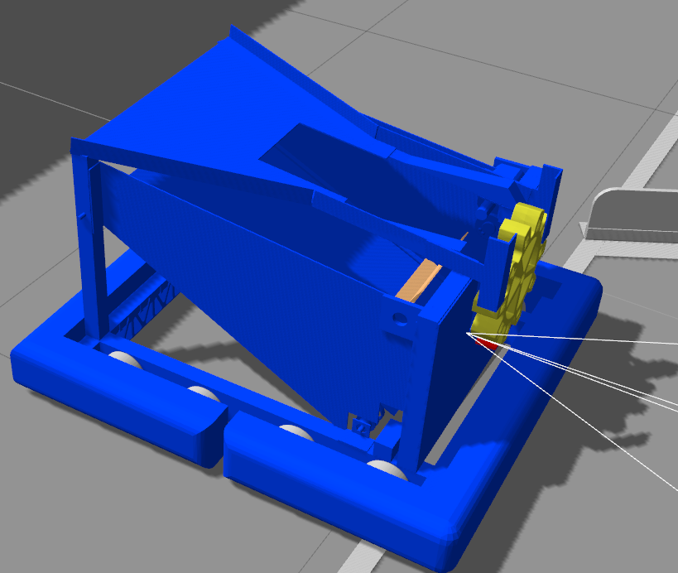

Starting Position Center
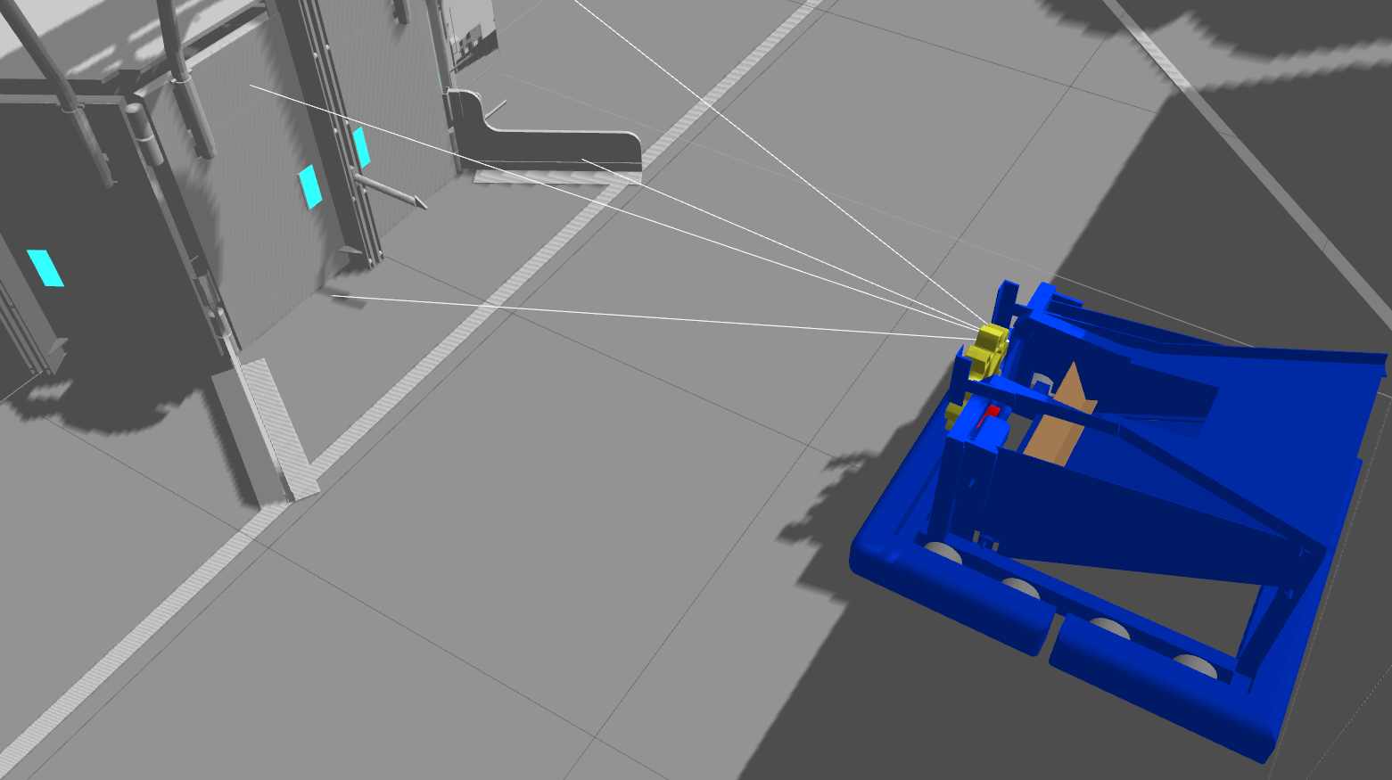

Starting Position Right
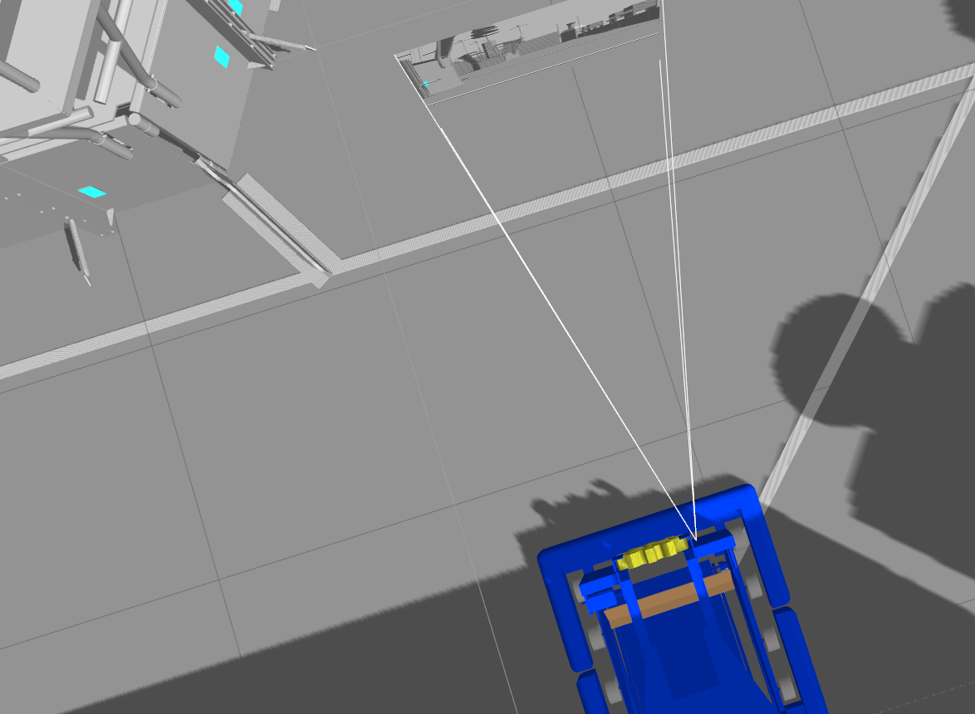

Starting Position Left
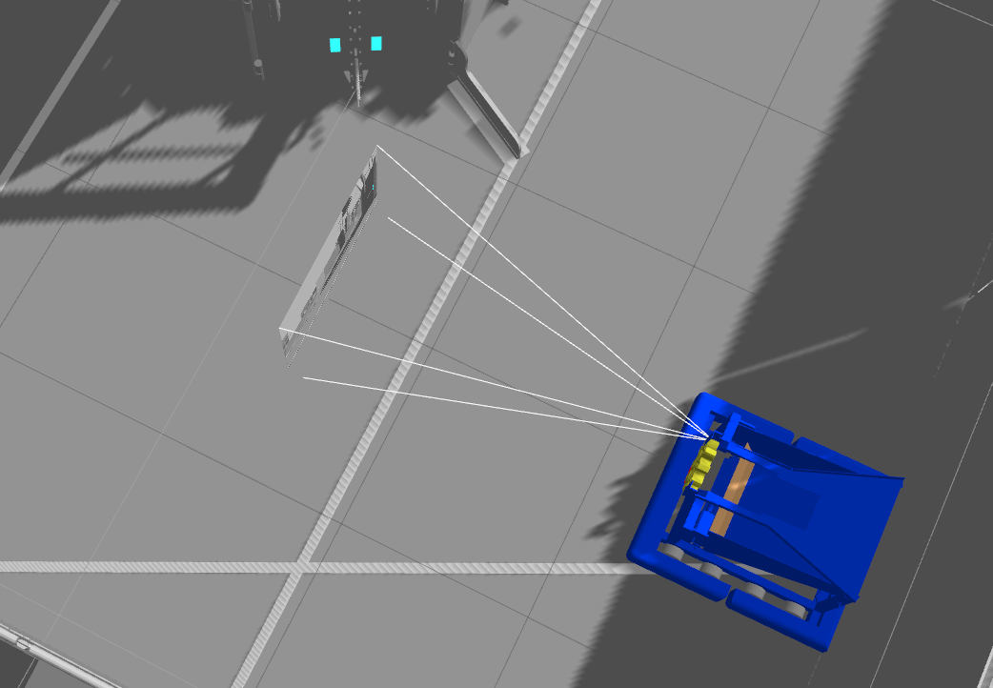

After Successful Autonomous (Right)
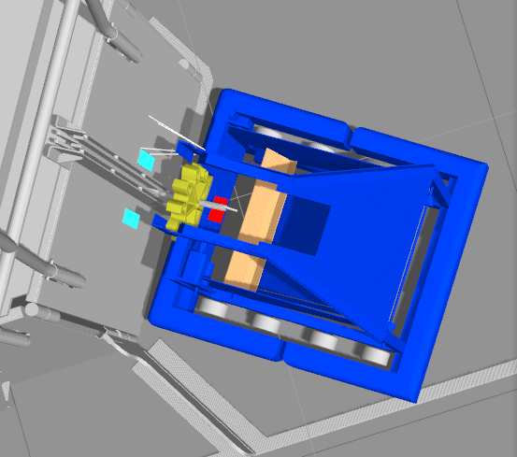

SmartDashboard Screenshot
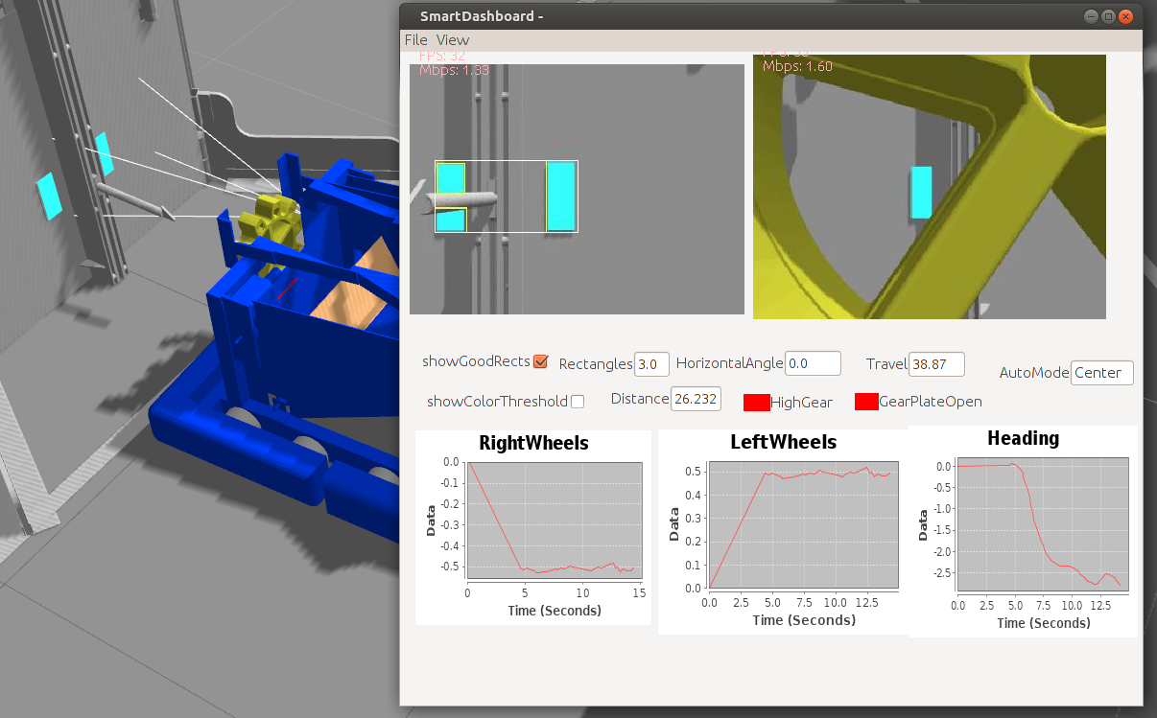

Example of GRIP pipeline tuning in simulation
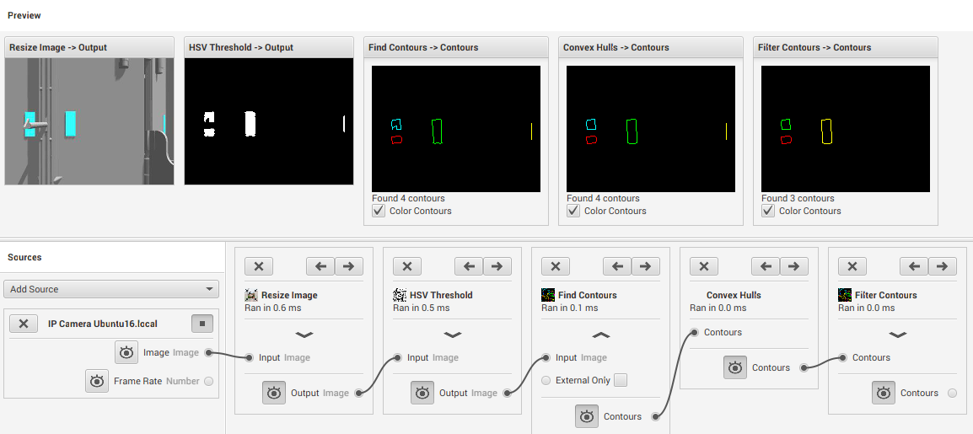

Target acquisition of test tape pattern in default dashboard
