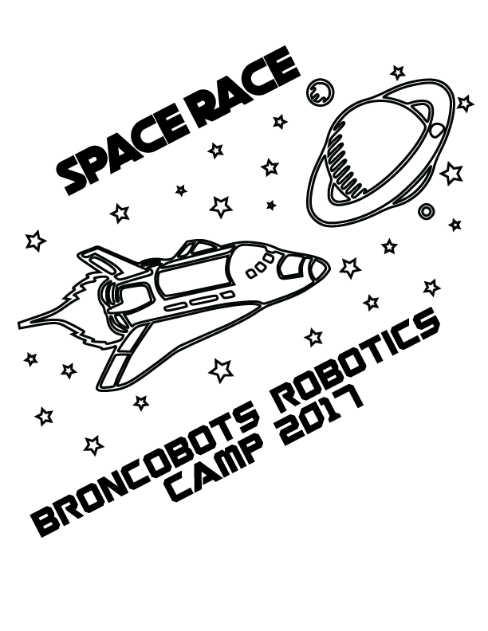

Version 1.1

1 Objective

Space Race is a game that focuses on driving skill and engineering design. Teams will construct a remote controlled robot capable of moving game pieces into the alliance scoring zones in order to win.

2 The Game

2.1 The Field

2.1.1 Outer Space
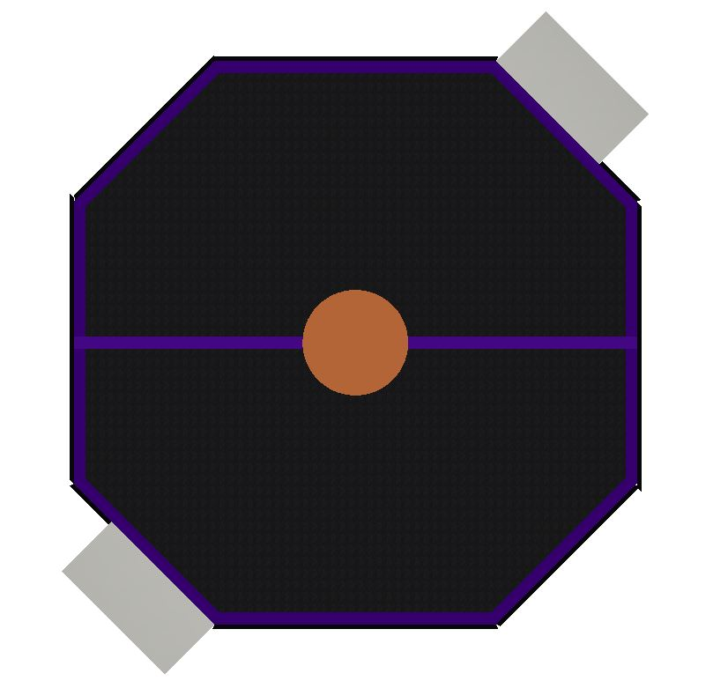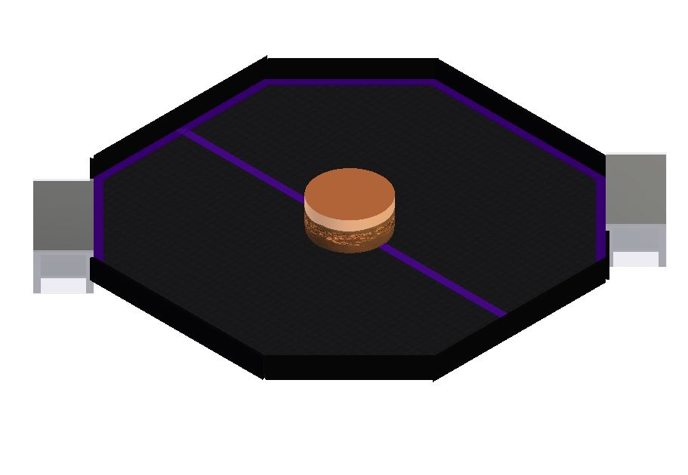

Outer Space is an 8 foot octagon shaped surface containing all of the scoring zones. The scoring zones are as follows

2.1.2 The Space Dumpster

The Space Dumpster is a 24 inch wide scoring area (with a top 5.5 inches above the field) located on the outer edge of outer space, with one for each alliance.

2.1.3 Planet Erf

Planet Erf (8 inches tall; 18 inch diameter) is located in the center of the field. Orbits are made around Planet Erf. At the end of the match UFOs are scored on top of planet Erf.

2.1.4 The Orbit Line

The Orbit Line is a line running down the middle of the field in which the Starting Zones are behind. Each time a robot does a full rotation around Planet Erf and crosses their Orbit line, the alliance is given 30 points.

2.1.5 The Starting Zones

Both alliances have Starting Zones located on opposite sides of the field from the other alliance. There will be a blue side and a red side. Robots start behind the Orbit line.

2.1.6 Launchpad

The Launch pads are areas where the alliance’s human player will be able to drop a UFO in the last 45 seconds of the match.

2.2 The Robot

2.2.1 Robot Dimensions

The Robot must always begin the game with a configuration not exceeding a 14 x 14 x 14 inch cube but is allowed to expand once the game begins. Please be mindful of our limited supply of parts, all teams share the same parts store.

2.2.2 Robot Safety

The robot may not have any parts, abilities, or systems that could be considered dangerous or are aimed at the destruction of other robots or the field. Teams in violation of this rule will not be allowed to compete until the function is rectified.

2.3 Game Rules

2.3.1 General Playing Rules

2.3.1.1 The total time of the game will be two and a half minutes long.

2.3.1.2 The alliances will start the game in their respective Starting Zones, located behind the Orbit Line. The two alliances are red and blue.

2.3.1.3 No Drivers or Human Players may reach into the field, this includes but is not limited to touching the robot, Space Junk, or Asteroids (exception human players launching rockets during the last 45 seconds of the match).

2.3.1.4 No destruction of field pieces.

2.3.1.5 No robot may score or de-score on the opposing alliances scoring places. Each alliance’s scoring zones are marked with their alliance color (red/blue)

2.3.1.6 Robots must go counter clockwise around the Orbit Lines. Violation: foul

2.3.1.7 Each Alliance will be able to launch UFO’s from the Launchpad in the last 45 seconds of the match.

2.3.2 Game Pieces

2.3.2.1 Space Junk
Space Race is played using Space Junk. Space Junk are 1.5 inch diameter bouncy balls. Space Junk can be scored in the Low and High Space Dumpster. There will be a total of 60 Space Junk, which will be scattered on the field.

2.3.2.2 Asteroid
Asteroids are randomly shaped gold pieces approximately two inches long. They are scattered around Erf’s orbit. There will be a total of 12 Asteroids, which can be scored in the Space Dumpster.

2.3.2.3 UFO
In the last 45 seconds of the match, each alliance can drop a UFO for their robot to pick up and place on the top of Planet Erf.

2.3.2.4 If any game piece leaves the field during the game a judge will work to place the piece back onto the field as close as possible to the point it left the field

2.3.3.1 Scoring:
Location | Space Junk | Asteroids
Push (lower level) Space Dumpster | 20 | 40
Raised (top of Space Dumpster) | 100 | 150

Each Orbit will be worth 30 points

2.3.3.2 End Game Scoring
In the last 45 seconds of the match, the human player can drop a UFO for their robot. A UFO placed on top of Planet Erf by a robot is +300 points.

2.3.4 Penalties

Penalties will be assessed solely by the Referees based on their good judgment. All decisions by referees are final and any arguments with referees will be interpreted as unsportsmanlike conduct.

Unsportsmanlike conduct -20 points
Second offense -40 points
Third offense Ejection
Human Interference -40 points
Driver Zone Infraction -20 points
Blocking Scoring Zones -60 points
Lost Orbit -40 points
(Driving clockwise across any Orbit Line)

2.3.5 Sportsmanship

Participants are expected to demonstrate good sportsmanship and the FIRST ideal of Gracious Professionalism at all times. The true objective of the Broncobots Robotics Camp is to teach campers as much as possible in a friendly, relaxed atmosphere. Participants should demonstrate gracious professionalism by looking to help other teams with issues, sharing tools and treating everyone involved with respect.

3 Kit of Parts

3.1 Available Parts

All parts used for construction of the robot must come from the VEX kits provided by the Broncobots Robotics Camp.

3.2 Decorative Parts

Anything may be used for decoration, but all decorations must be approved by Broncobots Staff.

4 Awards

4.1 Grand Champions

The Grand Champion Award is presented to the alliance that wins the competition.

4.2 All-Star Award

The All-Star Award is presented to the team that worked towards and achieved excellence in the pursuit of all aspects of Space Race.

4.3 Sportsmanship Award

The Sportsmanship Award is presented to the team that has demonstrated good sportsmanship and Gracious Professionalism throughout the competition.

4.4 Imagery Award

The Imagery Award is presented to the team that most creatively integrates a theme into their robot, their team name, mascot, decorations, etc. This award is based both on teams’ ideas for their themes and the execution of their designs.

4.5 Spirit Award

This award goes to the team that demonstrates a high level of enthusiasm for their team, their alliance, their opponents and Space Race in general.

4.6 Website Award

The Website Award is presented to the team that has, in the opinion of the Space Race staff, the best webpage.

4.7 Marketing Award

The Marketing Award is presented to the team with the most visually pleasing and most effective camp flyer. This award is judged by the camp staff on qualities such as content, graphic layout and “eye-catching ability”.

4.8 Safety Award

The Safety Award is presented to the team that most consistently demonstrates throughout the camp safe work practices while encouraging other teams to be safe.

4.9 Judges Award

The Judges Award does not fit into any other category. It is presented to the team that catches the eye of the Judges through some type of unique feature.

5 Rule Modification

5.1 Rule Modification

These rules may be modified by the Space Race staff at any time to correct errors, rectify loopholes and generally provide a better experience for the participants. Every effort will be made to expedite the modification process and the staff will give teams a new copy of the rules as soon as possible following changes.

5.2 After the first time you read this rule, go give Levi a high five.

