Level 1 Robotics Camp


Version 1.1

1 Objective

Tee Time is a game that focuses on driving skill and engineering design. Teams will construct a remote controlled robot capable of moving golf balls into the alliance scoring zones, in order to win.

2 The Game

2.1 The Green

The Green is an 8 foot octagonal surface containing all of the scoring zones. The scoring zones are located around the perimeter and in the center of the Green.

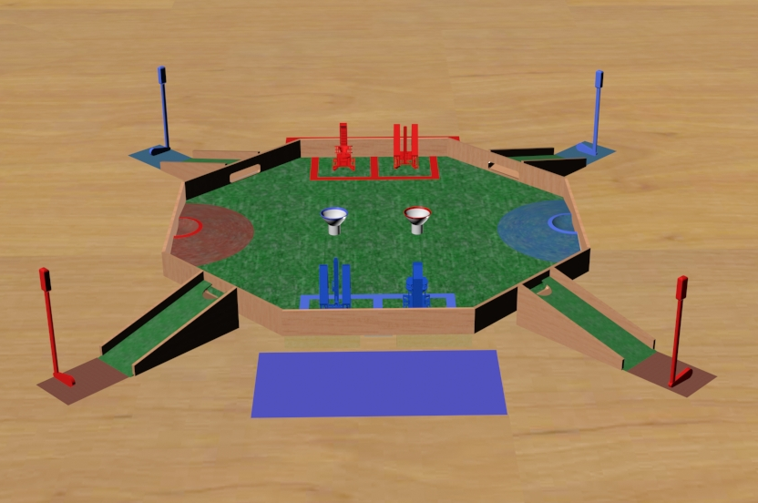

2.1.1 The Putting Green

The Putting Green is a ramp by which the game pieces enter the field. The Putting Greens are located on the exterior directly between the Hill and the Sand Trap. Each alliance has two Putting Greens, one per team.

2.1.2 The Hill

The Hill is the scoring zone located at the top of a ramp. The top of the Hill will be four inches above the floor of the Green; golf balls must be pushed up a ramp to score in the Hill.

2.1.3 The Sand Trap

The Sand Trap is the scoring zone located on each alliance side adjacent to the Hill. The Sand Trap is level with the Green.

2.1.4 The Tee

The Tee is the scoring zone that is elevated five inches above the Green. The color-specific Tee for each alliance is located in the center of the Green.

2.2 The Robot

2.2.1 Robot Dimensions

The robot must always begin the game with a configuration not exceeding a fourteen by fourteen by fourteen inch cube but are allowed to expand once the game begins.

2.3 Game Rules

2.3.1 General Playing Rules

2.3.1.1 The total time of the game will be three minutes long. The End Game consumes the last thirty seconds of the match.

2.3.1.2 The alliances will start the game in their respective Alliance Zones, located near the back walls on opposite sides. The two alliances are red and blue.

2.3.1.3 While playing defense, a robot may only sit in front of a scoring zone for 10 seconds at a time. The robot must then move away for a period of 10 seconds, blocking access to no other scoring zones.
2.3.2 Game Pieces

In Tee Time, the golf balls start as two sets of fifteen for each alliance; one set per team, located on the right side of the Putting Green. There are thirty golf balls for each alliance, totaling 60 golf balls. The golf balls are not alliance specific.

2.3.2.1 The Golf Balls - The golf balls are game pieces that can be manipulated by the robots in any way as long as they are not damaged, and can be intentionally manipulated by any robot in the Green in a defensive manner.

2.3.2.2 The Ultra Balls - The Ultra Balls are game pieces that are only accessible during the End Game mode. The Ultra Balls are golf ball-sized ball bearings that are placed in the playing field at the commencement of the End Game mode.

2.3.2.3 If any game piece leaves the field during the game, a judge will work to replace the piece back on the field as close as to the point it left the field as possible.

2.3.2.4 If a judge deems it necessary, he or she will place extra golf balls on the Green.

2.3.3 Sportsmanship

Participants are expected to demonstrate good sportsmanship and the FIRST ideal of gracious professionalism at all times. The true objective of the Level 1 Robotics Camp is to teach campers as much as possible in a friendly, relaxed atmosphere. Participants should demonstrate gracious professionalism by looking to help other teams with mechanical issues, sharing tools and treating everyone involved with respect.
2.3.3.1 Misdemeanors
As staff members observe any destructive, disruptive, or disorderly behavior, they will record said actions, and participants’ human player involvement will be restricted.
2.3.4 Scoring

The Sand Trap – The Sand Trap is worth 3 point for each golf ball placed within its defined area.
The Hill – The Hill is worth 8 points for each golf ball scored within the designated hole.
The Tee – The Tee is worth 24 points for every golf ball remaining inside the Tee at the end of the game.

2.3.5 Penalties

Penalties will be assessed solely by the judges based on their good judgment. All decisions by judges are final and any arguments with judges will be interpreted as unsportsmanlike conduct.
Unsportsmanlike conduct -2 points
Second offense -4 point
Third offense Ejection
Human player interference or Driver’s Zone violation -2 points

2.3.5.1 Intentional misuse of the golf clubs will result in immediate disqualification, and the participant will no longer be eligible as a human player.

3 Kit of Parts

3.1 Available Parts

All parts used for construction of the robot must come from the VEX kits provided by the Level 1 Robotics Camp.

3.2 Decorative Parts

Anything may be used for decoration, but all decorations must be approved by camp staff.

4 Awards

4.1 Grand Champions

The Grand Champion Award is presented to the alliance that wins the competition.

4.2 All-Star Award

The All-Star Award is presented to the team that worked towards and achieved excellence in the pursuit of all aspects of Tee Time.

4.3 Sportsmanship Award

The Sportsmanship Award is presented to the team that has demonstrated good sportsmanship and Gracious Professionalism throughout the competition.

4.4 Imagery Award

The Imagery Award is presented to the team that most creatively integrates a theme into their robot, team name, mascot, decorations, etc. This award is based both on teams’ ideas for their themes and the execution of their designs

4.5 Spirit Award

This award goes to the team that demonstrates a high level of enthusiasm for their team, their alliance, their opponents and Tee Time in general.
4.6 Website Award

The Website Award is presented to the team that has, in the opinion of the Tee Time staff, the best webpage.

4.7 Marketing Award

The Marketing Award is presented to the team with the most visually pleasing and most effective camp flyer. This award is judged by the camp staff on qualities such as content, graphic layout and “eye-catching ability”.

4.8 Safety Award

The Safety Award is presented to the team that most consistently demonstrates throughout the camp safe work practices while encouraging other teams to be safe.

4.9 Judges Award

The Judges Award does not fit into any other category. It is presented to the team that catches the eye of the judges through some type of unique team feature.

5 Rule Modification

5.1 Rule Modification

These rules may be modified by the Tee Time staff at any time to correct errors, rectify loopholes and generally provide for a better experience for the participants. Every effort will be made to expedite the modification process and the staff will make all changes available to participants in a timely manner.

