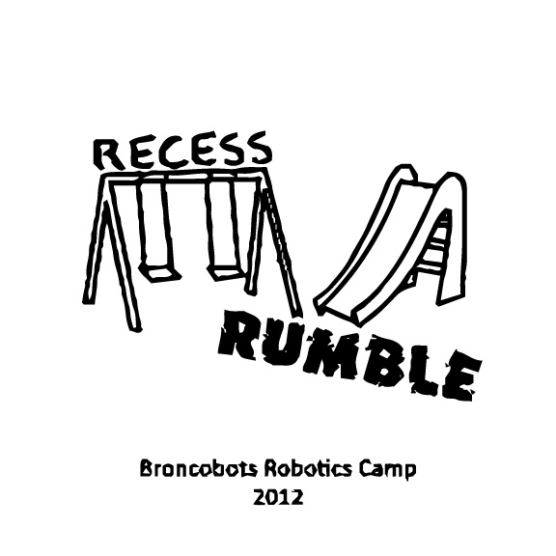

Version 1.0
1 Objective

Recess Rumble is a game that focuses on driving skill and engineering design. Teams will construct a remote controlled robot capable of moving blocks into the alliance scoring zones in order to win.

2 The Game

2.1 The Field

2.1.1 The Sandbox

The Sandbox is an 8 foot hourglass surface containing all of the scoring zones. The scoring zones are located around the perimeter of the Sandbox.

2.1.2 The Teeter-Totter

The Teeter-Totter is a 4 inch bump located in the middle of the field. It is necessary to move game pieces across the teeter-totter to score.

2.1.3 The Jungle Gym

The Jungle Gym is located on a fifteen-degree ramp where game pieces can be scored. Teams may not cross the playing field via the Jungle Gym.

2.1.4 The Monkey Bars

The Monkey Bars are alliance-specific scoring zones and are located at opposite sides of the field.

2.1.5 The Slide

The Slide is two PVC pipes where kickballs race during the last 30 seconds of the game.

2.2 The Robot

2.2.1 Robot Dimensions

The robot must always begin the game with a configuration not exceeding a fourteen by fourteen by fourteen inch cube but are allowed to expand once the game begins.

2.3 Game Rules

2.3.1 General Playing Rules

2.3.1.1 The total time of the game will be three minutes long. The End Game consumes the last thirty seconds of the match.

2.3.1.2 The alliances will start the game in their respective Alliance Zones, located near the back walls on opposite sides. The two alliances are red and blue.

2.3.1.3 While playing defense, a robot may only sit in front of a scoring zone for 10 seconds at a time. The robot must then move away for a period of 10 seconds, blocking access to no other scoring zones.

2.3.2 Game Pieces

In Treasure Tactics there are two different types of game pieces: the blocks and the kickballs.

2.3.2.1 Blocks
Blocks are 1.5” cubes and are the main scoring pieces of the game. There will be 24 of each block located on the field opposite the team’s monkey bars.

2.3.2.1 Kickballs
There are four kickballs on the field. These will be placed on the field with one minute left in the game. Kickballs cannot be scored until the last thirty seconds of the game.

If any game piece leaves the field during the game a judge will work to place the piece back on the field as close to the point it left the field as soon as possible.

2.3.3 Sportsmanship

Participants are expected to demonstrate good sportsmanship and the FIRST ideal of gracious professionalism at all times. The true objective of the Broncobots Robotics Camp is to teach campers as much as possible in a friendly, relaxed atmosphere. Participants should demonstrate gracious professionalism by looking to help other teams with programming issues, sharing tools and treating everyone involved with respect.

2.3.3 Scoring

Under the Monkey Bars 1 point per block
Above the Monkey Bars 4 points per block
On the Jungle Gym 2 points per block
End Game Race 1st place 8 points
2nd place 6 points
3rd place 4 points
4th place 2 points

2.3.4 Penalties

Penalties will be assessed solely by the judges based on their good judgment. All decisions by judges are final and any arguments with judges will be interpreted as unsportsmanlike conduct.
Unsportsmanlike conduct -2 points
Second offense -4 points
Third offense Ejection
Human player interference or driver zone infraction -2 points

3 Kit of Parts

3.1 Available Parts

All parts used for construction of the robot must come from the VEX kits provided by the Broncobots Robotics Camp.

3.2 Decorative Parts

Anything may be used for decoration, but all decorations must be approved by Broncobots Staff.

4 Awards

4.1 Grand Champions

The Grand Champion Award is presented to the alliance that wins the competition.

4.2 All-Star Award

The All-Star Award is presented to the team that worked towards and achieved excellence in the pursuit of all aspects of Recess Rumble.

4.3 Sportsmanship Award

The Sportsmanship Award is presented to the team that has demonstrated good sportsmanship and Gracious Professionalism throughout the competition.

4.4 Imagery Award

The Imagery Award is presented to the team that most creatively integrates a theme into their robot, their team name, mascot, decorations, etc. This award is based both on teams’ ideas for their themes and the execution of their designs.

4.5 Spirit Award

This award goes to the team that demonstrates a high level of enthusiasm for their team, their alliance, their opponents and Recess Rumble in general.

4.6 Website Award

The Website Award is presented to the team that has, in the opinion of the Recess Rumble staff, the best webpage.

4.7 Marketing Award

The Marketing Award is presented to the team with the most visually pleasing and most effective camp flyer. This award is judged by the camp staff on qualities such as content, graphic layout and “eye-catching ability”.

4.8 Safety Award

The Safety Award is presented to the team that most consistently demonstrates throughout the camp safe work practices while encouraging other teams to be safe.

4.9 Judges Award

The Judges Award does not fit into any other category. It is presented to the team that catches the eye of the Judges through some type of unique feature.

5 Rule Modification

5.1 Rule Modification

These rules may be modified by the Recess Rumble staff at any time to correct errors, rectify loopholes and generally provide for a better experience for the participants. Every effort will be made to expedite the modification process and the staff will give teams a new copy of the rules as soon as possible following changes.

