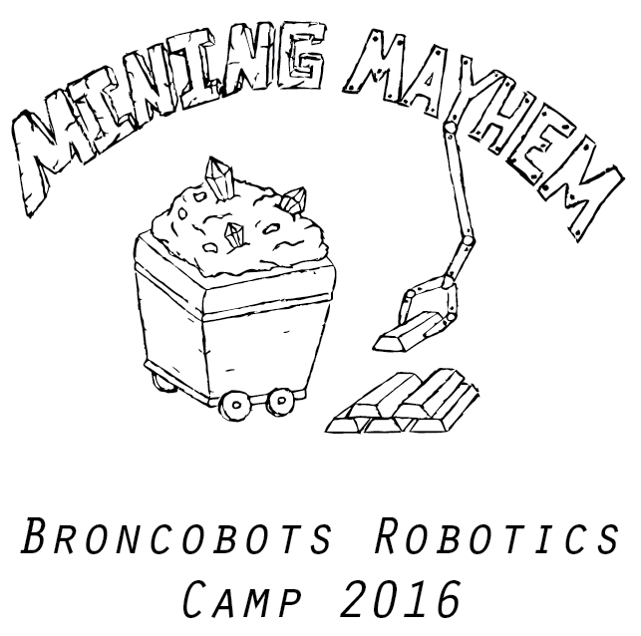

Version 2.0

1 Objective

Mining Mayhem is a game that focuses on driving skill and engineering design. Teams will construct a remote controlled robot capable of moving game pieces into the alliance scoring zones in order to win.

2 The Game

2.1 The Field

2.1.1 The Mine
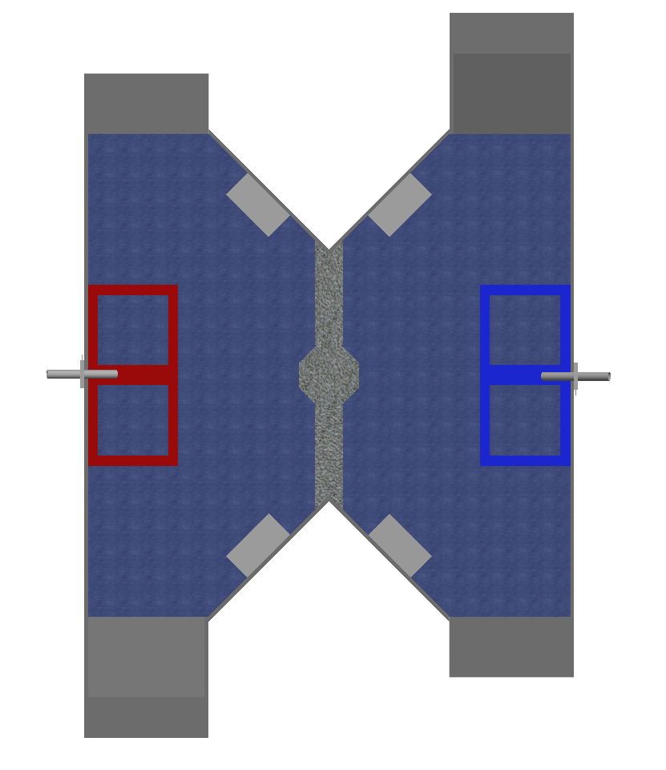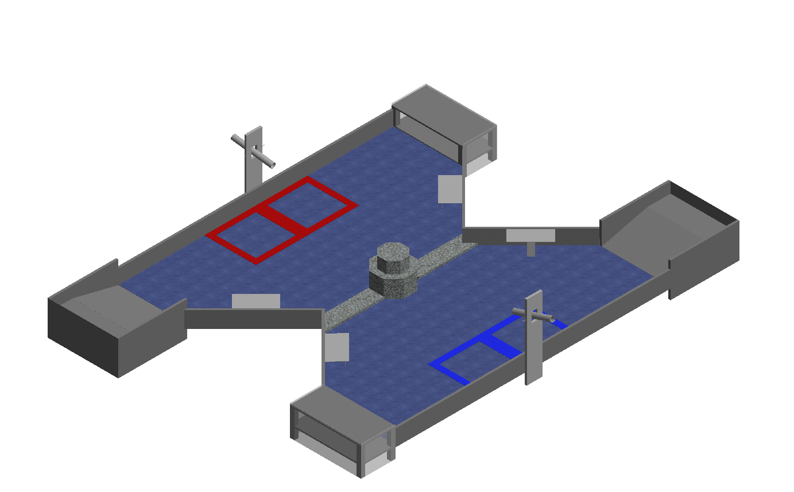

The Mine is about an 8 foot hour glass shaped surface containing all of the scoring zones. The scoring zones are located on the edges of each alliances zone.

2.1.2 The Mineshaft

The Mineshaft is a twenty-four inch wide scoring area (with a top 5.5 inches above the field) located on opposite sides of the mine, with one on each Alliance side.

2.1.3 The Refinery

The Refinery is a 14-degree ramp on the edges of the mine where game pieces can be scored at the top.

2.1.4 The Mountain

The Mountain (10 inches tall; level one 6 inches) is located in the center of the field between the two alliance sides and is the platform for holding the Gold Nuggets, which can be moved by the into the scoring zones. Also contains Big Gem

2.1.5 The Mine Cart

There are four Mine Carts, four and three quarters of an inch tall. They each contain 10 gems. There are two located on each alliance’s side. Both of the Mine carts contain the gems which are the pickup spots for gems.

2.1.6 The Starting Zones

Both alliances have Starting Zones located on opposite sides of the field from the other alliance. There will be a blue side and a red side.

2.1.7 Miner Stations

The Miner Stations are areas where both alliances will be able to put
Gems into the field of play. There will be 16 gems available to put into play.

2.2 The Robot

2.2.1 Robot Dimensions

The Robot must always begin the game with a configuration not exceeding a fourteen by fourteen by fourteen inch cube but is allowed to expand once the game begins.

2.2.2 Robot Safety

The robot may not have any parts, abilities, or systems that could be considered dangerous or are aimed at the destruction of other robots and the field. Teams in violation of this rule will not be allowed to compete until the function is rectified.

2.3 Game Rules

2.3.1 General Playing Rules

2.3.1.1 The total time of the game will be three minutes long.

2.3.1.2 The alliances will start the game in their respective Starting Zones, located on opposite walls of the field. The two alliances are red and blue.

2.3.1.3 No Drivers or Human Players may touch the robot, gold, or gems (exception human players inserting gems during match)

2.3.1.4 No destruction of field pieces.

2.3.1.5 No robot may score or de-score on the opposing alliances scoring places. Each alliance’s scoring zones are marked with their alliance color (red/blue)

2.3.1.6 Each Alliance may take gold nuggets from the Mountain to place in the scoring zones.

2.3.1.7 Each Alliance will be able to insert gems into the field via the Miner Station.

2.3.2 Game Pieces

2.3.2.1 Gems
Mining Mayhem is played using gems. The gems are one and a quarter inch diameter diamond shape figures. There will be a total of 72 gems, which will be on top of the Mine Cart and at miner stations at the beginning of each match.

2.3.2.2 Gold Nuggets
The Gold Nuggets are randomly shaped gold pieces approximately two inches long. They are located on top of the Mountain at the beginning of each match and can be scored by being placed in the Mineshaft or the Refinery. There will be a total of 16 Gold Nuggets which will be placed on the mountain.

2.3.2.3 If any game piece leaves the field during the game a judge will work to place the piece back onto the field as close as possible to the point it left the field

2.3.3 Score:
Location | Gems | Gold Nuggets (x2) | Big Gem (x5)
Push (lower level) mine shaft | 1 | 2 | 5
Refinery (ramp) | 2 | 4 | 10
Raised (top of mine shaft) | 5 | 10 | 25

2.3.4 Penalties

Penalties will be assessed solely by the judges based on their good judgment. All decisions by judges are final and any arguments with judges will be interpreted as unsportsmanlike conduct.

Unsportsmanlike conduct -2 points
Second offense -4 points
Third offense Ejection
Human Interference -4 points
Driver Zone Infraction -2 points
Blocking Scoring Zones -6 points

2.3.5 Sportsmanship

Participants are expected to demonstrate good sportsmanship and the FIRST ideal of Gracious Professionalism at all times. The true objective of the Broncobots Robotics Camp is to teach campers as much as possible in a friendly, relaxed atmosphere. Participants should demonstrate gracious professionalism by looking to help other teams with programming issues, sharing tools and treating everyone involved with respect.

3 Kit of Parts

3.1 Available Parts

All parts used for construction of the robot must come from the VEX kits provided by the Broncobots Robotics Camp.

3.2 Decorative Parts

Anything may be used for decoration, but all decorations must be approved by Broncobots Staff.

4 Awards

4.1 Grand Champions

The Grand Champion Award is presented to the alliance that wins the competition.

4.2 All-Star Award

The All-Star Award is presented to the team that worked towards and achieved excellence in the pursuit of all aspects of Mining Mayhem.

4.3 Sportsmanship Award

The Sportsmanship Award is presented to the team that has demonstrated good sportsmanship and Gracious Professionalism throughout the competition.

4.4 Imagery Award

The Imagery Award is presented to the team that most creatively integrates a theme into their robot, their team name, mascot, decorations, etc. This award is based both on teams’ ideas for their themes and the execution of their designs.

4.5 Spirit Award

This award goes to the team that demonstrates a high level of enthusiasm for their team, their alliance, their opponents and Mining Mayhem in general.

4.6 Website Award

The Website Award is presented to the team that has, in the opinion of the Mining Mayhem staff, the best webpage.

4.7 Marketing Award

The Marketing Award is presented to the team with the most visually pleasing and most effective camp flyer. This award is judged by the camp staff on qualities such as content, graphic layout and “eye-catching ability”.

4.8 Safety Award

The Safety Award is presented to the team that most consistently demonstrates throughout the camp safe work practices while encouraging other teams to be safe.

4.9 Judges Award

The Judges Award does not fit into any other category. It is presented to the team that catches the eye of the Judges through some type of unique feature.

5 Rule Modification

5.1 Rule Modification

These rules may be modified by the Mining Mayhem staff at any time to correct errors, rectify loopholes and generally provide for a better experience for the participants. Every effort will be made to expedite the modification process and the staff will give teams a new copy of the rules as soon as possible following changes.

