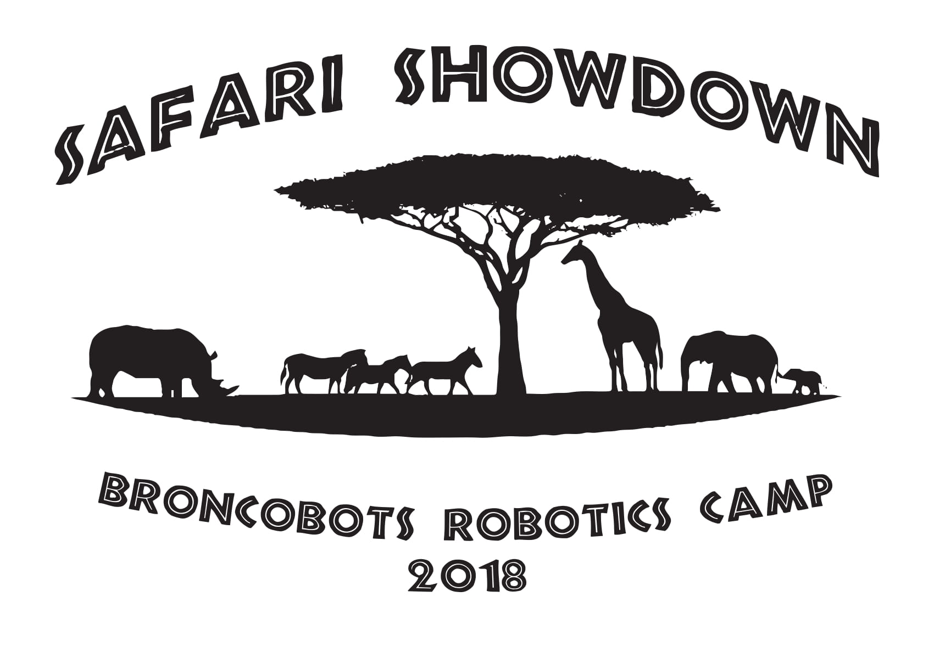

Version 2.0

1 Objective

Safari Showdown is a game that focuses on driving skill and engineering design. Teams will construct a remote controlled robot capable of moving game pieces into the Grassland and Watering Hole to score points. In the last 45 seconds, teams can place the Gorilla in the Tree of Life.

2 The Game

2.1 The Field

2.1.1 The Safari
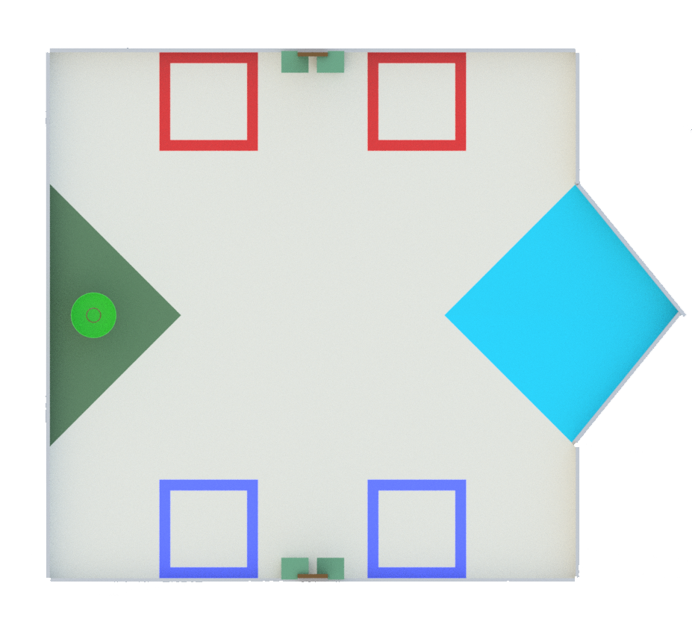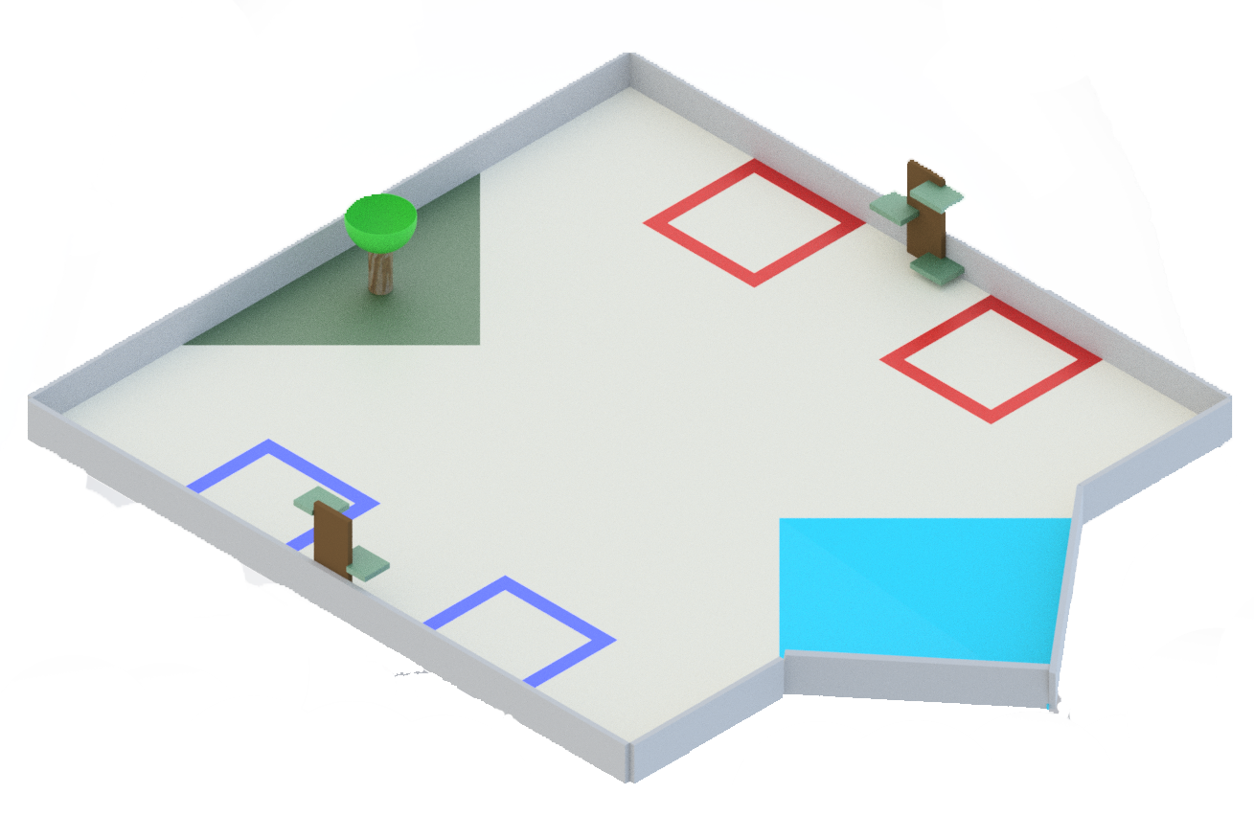

The Safari is an 8 by 8 foot square with a protruding triangle containing all of the scoring zones. The scoring zones are as follows:

2.1.2 Grassland

The Grassland is a 48 inch wide 24 inch long green triangle scoring area located on one side of the Safari.

2.1.3 Watering Hole

The Watering Hole is an 8° 44 inch slanted blue kite-shaped scoring area on the opposite side of the Grassland. Animals must be past the second blue line to be scored.

2.1.4 The Starting Zones

Both alliances have Starting Zones located on opposite sides of the field from the other alliance. There will be a blue side and a red side.

2.1.5 Alliance Trees

Each alliance has 1 brown Alliance Tree 12 inches in height between the alliance’s Starting Zones.

2.1.6 Branches

Each Alliance Tree has three green leveled scoring platforms called Branches. The heights of the platforms are as follows:
Lowest: 1 inch
Middle: 6 inches
Highest: 10 inches

Each Branch may only contain 1 animal.

2.1.7 Tree of Life

The Tree of Life is a 10 inch tall pole tree with a bowl on its top located in the Grassland. Only the Gorilla will go in the Tree of Life.

2.2 The Robot

2.2.1 Robot Dimensions

The Robot must always begin the game with a configuration not exceeding a 14 x 14 x 14 inch cube but is allowed to expand once the game begins. Please be mindful of our limited supply of parts, all teams share the same parts store.

2.2.2 Robot Safety

The robot may not have any parts, abilities, or systems that could be considered dangerous or are aimed at the destruction of other robots or the field. Teams in violation of this rule will not be allowed to compete until the function is rectified.

2.3 Game Rules

2.3.1 General Playing Rules

2.3.1.1 The total time of the game will be two and a half minutes long.

2.3.1.2 The alliances will start the game in their respective Starting Zones, located at the ends of The Safari. The two alliances are red and blue.

2.3.1.3 No Drivers or Human Players may reach into the field, this includes but is not limited to touching the robot or Animals (exception human players releasing the Gorilla during the last 45 seconds of the match).

2.3.1.4 The Gorilla may NOT be dropped on to an alliance’s robot. Violation: Human Interference.

2.3.1.5 No destruction of field pieces.

2.3.1.6 No robot may score or de-score any of the opposing alliance’s Animals. Each alliance’s Animals are marked with their alliance color (red/blue) around the Animal’s neck.

2.3.2 Game Pieces

2.3.2.1 Animals
Safari Showdown is played using Animals. Animals are small 2.5 inch wide by 2 inch tall rubber ducks. Animals can be scored in the Grassland, Watering Hole, and Alliance Trees. There will be a total of 60 Animals.

2.3.2.2 Herds
Herds are groups of animals around the Safari. There are 10 groups of 6 Animals equally scattered across the Safari. Each Herd will belong to a specific alliance with 5 Herds per alliance.

2.3.2.3 Gorilla
In the last 45 seconds of the match, each Human Player can drop (not throw) a Gorilla on the Safari for the robot to place on the top of the Tree of Life.

2.3.2.4 If any game piece leaves the field during the game a judge will work to place the piece back onto the field as close as possible to the point it left the field.

2.3.3.1 Scoring:
Location | Animals
Push into Grassland | 1 point per Animal
Push into Watering Hole | 2 points Animal
Place on 1 Branch | 10 points
Place on 2 Branches | +10 points
Place on 3 Branches | +20 points
A total of 40 points possible for placing on the Alliance Trees

2.3.3.2 End Game Scoring
In the last 45 seconds of the match, the human player can drop a Gorilla for their robot. A Gorilla placed on top of the Tree of Life by a robot is +30 points.

2.3.4 Penalties

Penalties will be assessed solely by the Referees based on their good judgment. All decisions by referees are final and any arguments with referees will be interpreted as unsportsmanlike conduct. All penalties will be added to the opposite alliance’s score.

Unsportsmanlike conduct -2 points
Second offense -4 points
Third offense Ejection
Human Interference -6 points
Driver Zone Infraction -2 points
Blocking Scoring Zones -6 points
Opposing Alliance Piece Scoring -2 points
Movement of Opposing Alliances Animals -2 points
False Start -2 points
Destruction of Field Elements -6 points

2.3.5 Sportsmanship

Participants are expected to demonstrate good sportsmanship and the FIRST ideal of Gracious Professionalism at all times. The true objective of the Broncobots Robotics Camp is to teach campers as much as possible in a friendly, relaxed atmosphere. Participants should demonstrate gracious professionalism by looking to help other teams with issues, sharing tools and treating everyone involved with respect.

3 Kit of Parts

3.1 Available Parts

All parts used for construction of the robot must come from the VEX kits provided by the Broncobots Robotics Camp.

3.2 Decorative Parts

Anything may be used for decoration, but all decorations must be approved by Broncobots Staff.

4 Awards

4.1 Grand Champions

The Grand Champion Award is presented to the alliance that wins the competition.

4.2 All-Star Award

The All-Star Award is presented to the team that worked towards and achieved excellence in the pursuit of all aspects of Safari Showdown.

4.3 Sportsmanship Award

The Sportsmanship Award is presented to the team that has demonstrated good sportsmanship and Gracious Professionalism throughout the competition.

4.4 Imagery Award

The Imagery Award is presented to the team that most creatively integrates a theme into their robot, their team name, mascot, decorations, etc. This award is based both on teams’ ideas for their themes and the execution of their designs.

4.5 Spirit Award

This award goes to the team that demonstrates a high level of enthusiasm for their team, their alliance, their opponents and Safari Showdown in general.

4.6 Website Award

The Website Award is presented to the team that has, in the opinion of the Safari Showdown staff, the best webpage.

4.7 Marketing Award

The Marketing Award is presented to the team with the most visually pleasing and most effective camp flyer. This award is judged by the camp staff on qualities such as content, graphic layout and “eye-catching ability”.

4.8 Safety Award

The Safety Award is presented to the team that most consistently demonstrates throughout the camp safe work practices while encouraging other teams to be safe.

4.9 Judges Award

The Judges Award does not fit into any other category. It is presented to the team that catches the eye of the Judges through some type of unique feature.

5 Rule Modification

5.1 Rule Modification

These rules may be modified by the Safari Showdown staff at any time to correct errors, rectify loopholes and generally provide a better experience for the participants. Every effort will be made to expedite the modification process and the staff will give teams a new copy of the rules as soon as possible following changes.

5.2 After the first time you read this rule, go give David a high five.

