1. Create folder C:\_dev\frc3654_workspace_git
2. Install GitHub desktop from [https://desktop.github.com](https://desktop.github.com/)
3. Login to GitHub desktop using your username/password
4. In GitHub desktop, click File > Clone Repository… > URL > enter

<https://github.com/FRCTeam3654/2020_prod_robot>

1. Enter Local path: C:\_dev\frc3654_workspace_git
2. Click Clone:

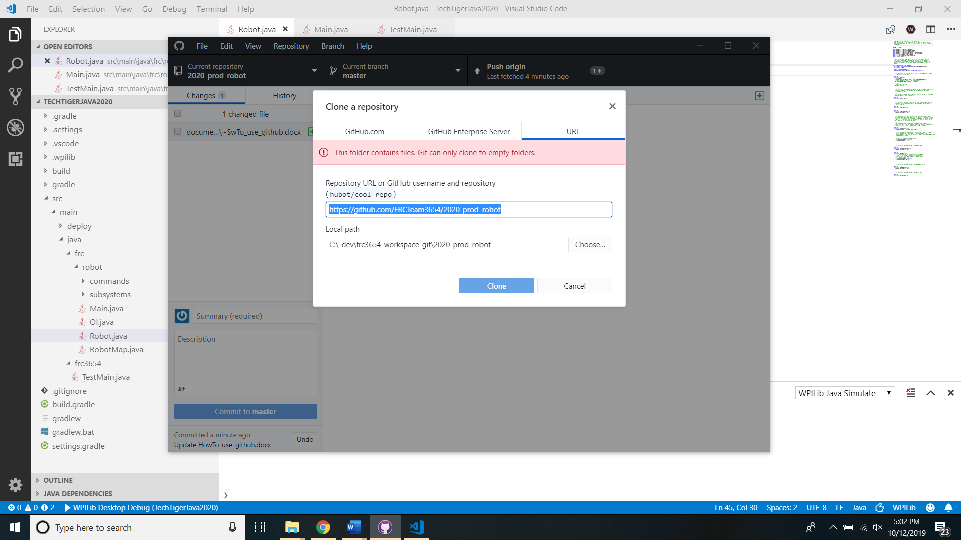

1. After you make change to any file under C:\_dev\frc3654_workspace_git\2020_prod_robot, you can see changed files in GitHub desktop:

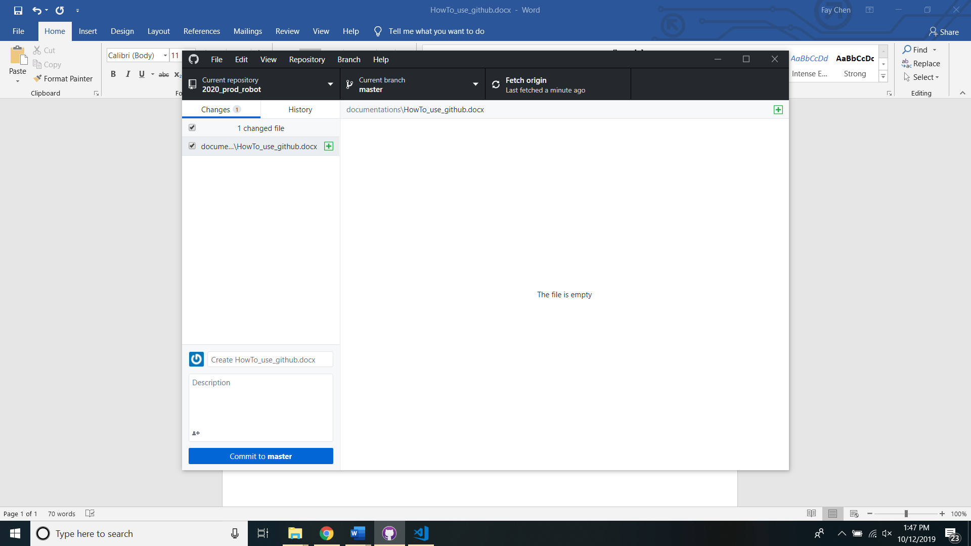

**if you cannot do the following steps, ask mentor/team-lead to add you as contributor**

1. If you are ready to share your changes with team, enter comments and click Commit to master
2. Then click Push origin