Installation Guide for Qiskit

Dr. Sajid Muhaimin Choudhury

11/06/2024

1. Download Miniconda from the website
2. Install Miniconda [Miniconda — Anaconda documentation](https://docs.anaconda.com/miniconda/)  
   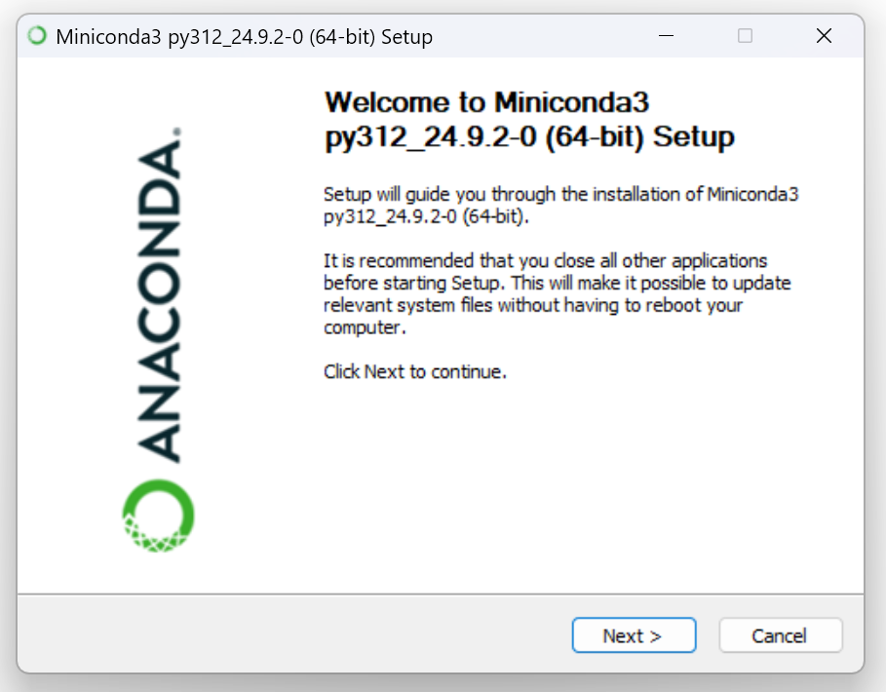
3. Download and Install Visual Studio Code <https://code.visualstudio.com/>
4. Add system variable paths to the following folders:  
   C:\ProgramData\miniconda3  
   C:\ProgramData\miniconda3\Library\bin  
   C:\ProgramData\miniconda3\Scripts
5. In VSCode, … > Terminal>New Terminal (or Ctrl+Shift+`)
6. Create a new conda environment ([Managing environments — conda 24.9.3.dev33 documentation](https://docs.conda.io/projects/conda/en/latest/user-guide/tasks/manage-environments.html))  
   conda init  
   conda create –name qcw  
   conda activate qcw  
   A black screen with white text

   Description automatically generated
7. Install required packages:
8. conda install pip  
   pip install ipykernel  
   pip install qiskit  
   pip install qiskit-ibm-runtime  
   pip install qiskit[visualization]  
   pip install jupyter  
   pip install qiskit_aer
9. Close terminal.
10. New File>Jupyter Notebook

Info:

All source code of Qiskit is open source and available at <https://github.com/Qiskit/qiskit>

Main Resource For learning:

<https://learning.quantum.ibm.com/>

Guide to follow:

<https://docs.quantum.ibm.com/guides>

local simulators documentation

<https://docs.quantum.ibm.com/migration-guides/local-simulators>