Installation Guide for Qiskit
Dr. Sajid Muhaimin Choudhury
11/06/2024
- Download Miniconda from the website
- Install Miniconda Miniconda — Anaconda documentation
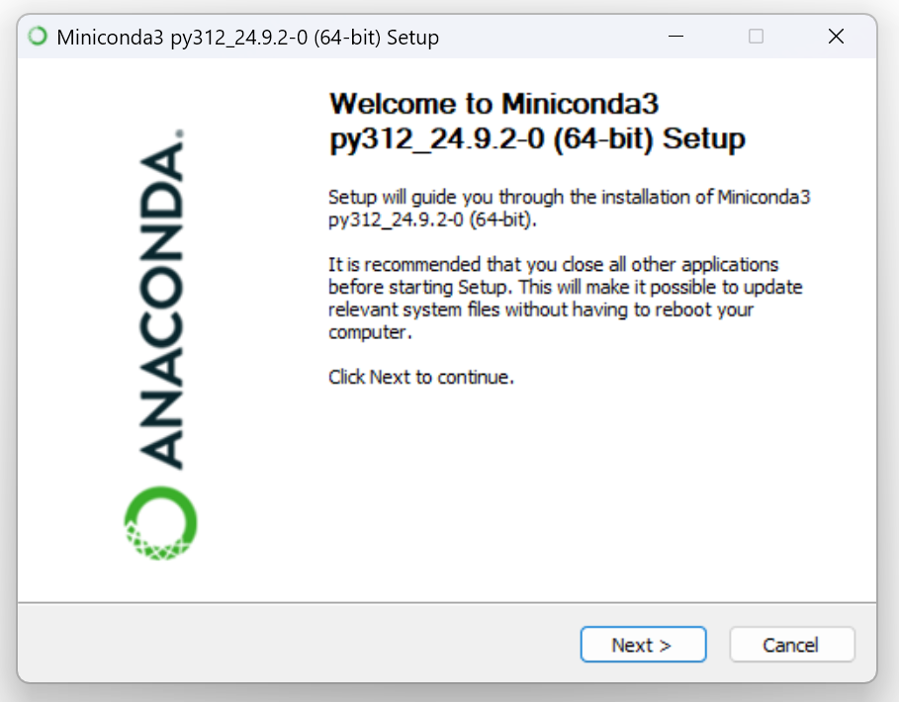
- Download and Install Visual Studio Code https://code.visualstudio.com/
- Add system variable paths to the following folders:
C:\ProgramData\miniconda3
C:\ProgramData\miniconda3\Library\bin
C:\ProgramData\miniconda3\Scripts
- In VSCode, … > Terminal>New Terminal (or Ctrl+Shift+`)
- Create a new conda environment (Managing environments — conda 24.9.3.dev33 documentation)
conda init
conda create –name qcw
conda activate qcw
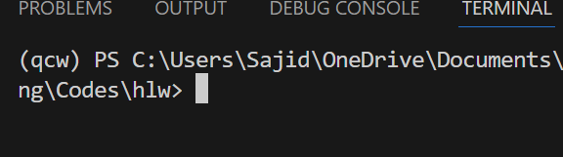
- Install required packages:
- conda install pip
pip install ipykernel
pip install qiskit
pip install qiskit-ibm-runtime
pip install qiskit[visualization]
pip install jupyter
pip install qiskit_aer
- Close terminal.
- New File>Jupyter Notebook

Info:
All source code of Qiskit is open source and available at https://github.com/Qiskit/qiskit
Main Resource For learning:
https://learning.quantum.ibm.com/

Guide to follow:
https://docs.quantum.ibm.com/guides

local simulators documentation
https://docs.quantum.ibm.com/migration-guides/local-simulators

