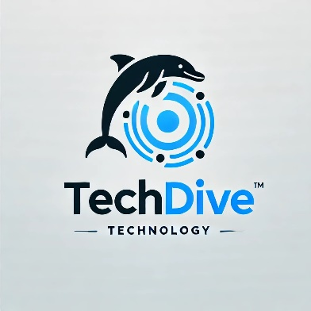
THIS IS TO CERTIFY THAT CHISAKA FRED MUSUMBA COMPLETED THE TECHDIVE TRAINING PROGRAMME AND PASSED THE TESTS AND IS THEREFORE QUALIFIED UNDER THE LAW JURISDICTIONS TO PERFORM TASKS UNDER THIS FIELD. JHGFGGYFJHVGFUYKGYU GVHGFUHUYV VGVHTYFGTFCHGCFCG GTFVHGIG YGHKLHGR7DSEYBVUIGV GJHKVHGBGFHGUIKJHKUUIBHJHUYYOUY YJMHFYF UYYN G
FRED CHISAKA
THIS CERTIFICATE OF ACHIEVEMENT IS PRESENTED TO
27/04/2025
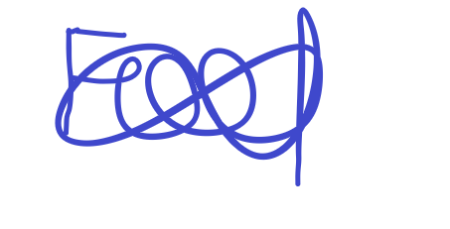
SIGNATURE

DATE
2025
AWARDS
CERTIFICATE
2025 AWARDS
TECHDIVE COMPANY

