**CST-361 Design Patterns in Java**

**Fredrick Onduso Ondieki**

**UML Diagrams and Tools Install**

**December 14, 2018**

**Choice of Tool and Features**

In this activity I decided to use the Creately tool for designing the UML diagrams for example, Use case, Class, Sequence, Activity and Deployment diagrams. For instance, it makes easier for visualization of things in real time while you are working on the project. This ensures that you can make the right decisions for example on where to use actors and their responsibilities in case you are designing a use case diagram.

Another feature of this tool is that it saves time in designing UML diagram. There are templates which are set in place that a user can choose and make the relevant changes or still choose to work with the tailored template instead. These templates range from having class diagrams to use case diagrams of your choice. It also provides customization features to its users as users may tend to change the way their items or diagrams appear.

Also, since the tool is available online, it increases productivity as it helps people working from home connect to the project their colleagues are working on and thus contribute to the project. It is only a matter of connecting to the internet and everything will be right set. In addition, Creately online tool supports multiple languages ranging from English, Spanish, Dutch and Fresh. This is great as many people all over the continent can access their services and use.

However, there is a free version of this online tool as well as the commercial version. Using the free version of the tool limits most of the features. For instance, it produces a watermark at the drawn diagram. On the other hand, using the commercial version unlocks all the features not limited to downloading the project in different file formats, importing, and exporting different projects to and from the host system and many others.

**Model and Data attributes of College Management System**

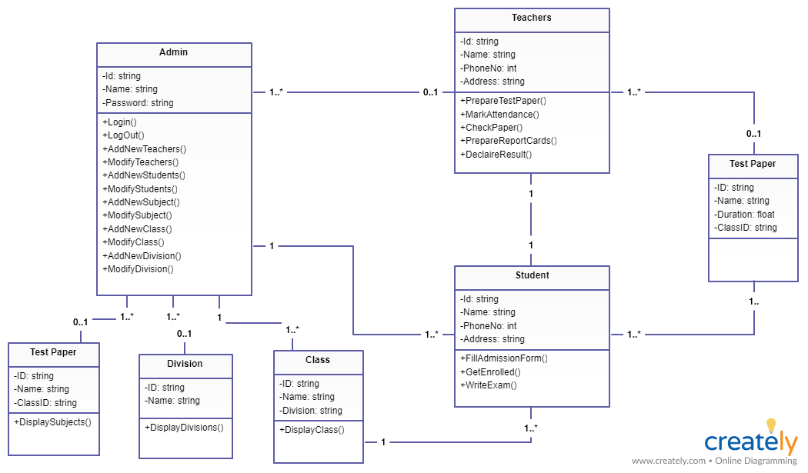

**Class diagram as an image**

|  |  |  |
| --- | --- | --- |
| Teacher | Id | String |
| Name | String |
| PhoneNo | int |
| Address | String |
| Admin | Id | String |
| Name | String |
| Password | String |
| Student | Id | String |
| Name | String |
| PhoneNo | int |
| Address | String |
| TestPaper | Id | String |
| Name | String |
| Duration | float |
| ClassId | String |
| Class | Id | String |
| Name | String |
| Division | String |
| Division | Id | String |
| Name | String |

**Model as a table**

**UML Deployment diagram**

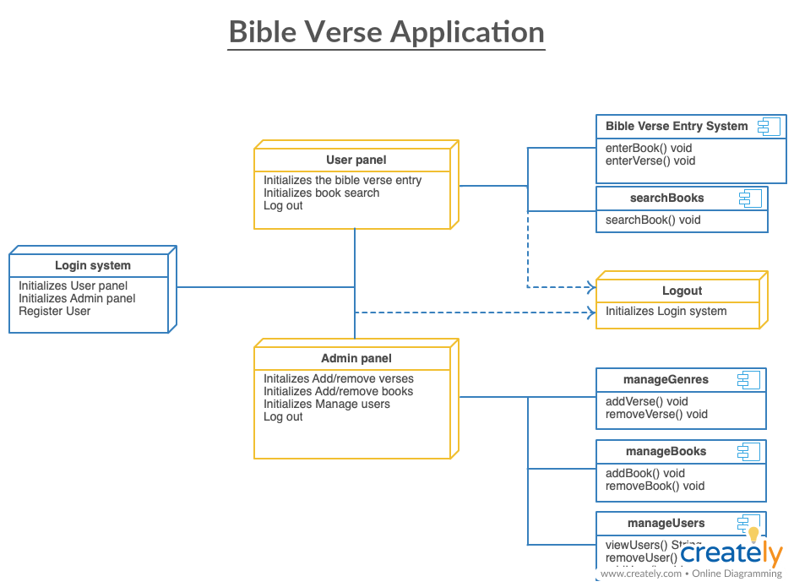Used a project from CST-247 (Enterprise Applications Programming III). 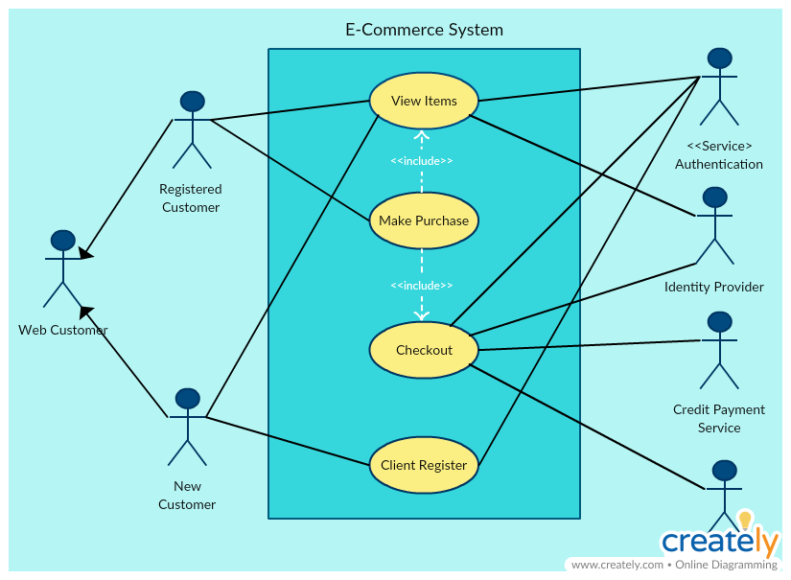**Use Case Diagram for IoT system (Online shopping-ECOMMERCE)**

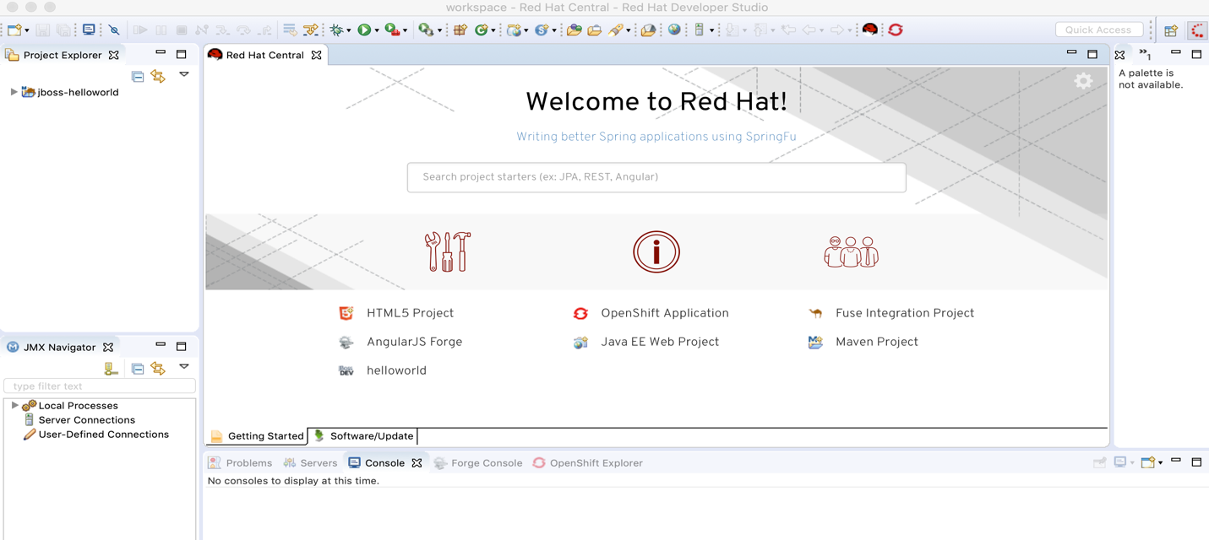**Default “Hello World” Application from JBoss EAP**

