**Fredrick Onduso Ondieki**

**CST-221 Operating systems Concepts**

**CST-221 File System**

**John Zupan**

**April 11, 2019**

**Git hub link: https://github.com/FREDDYSMALLZ/Operating-Systems-Concepts-CST-221.git**

**CST – 221 File System**

Activity Directions:

In this assignment we were needed to do research on File Systems and the Linux System File I/O functions. The following are the tasks that were needed to successfully complete the assignment:

**Explore the Linux File System in your VirtualBox Ubuntu installation. Document the purpose (two to three sentences) for each of the following directories.**

|  |  |
| --- | --- |
| **Directory** | **Purpose** |
| / | This is the root directory of the file system. It stores all system software allowing the system to boot. |
| /bin | This is the directory that stores execution details for binary and terminal commands. For example, *ls, cat, whoami* |
| /dev | This is the directory where all hardware devices are stored for system use. Without this directory the system would cease function. In addition, they can be interfaces to the device drivers. |
| /etc | The /etc directory holds configuration files specific to a host. It is the directory that holds global system configuration files which affect all users. |
| /lib | The /lib directory contains libraries for the bin directory. In addition, the directory contains the system libraries and kernel modules. |
| /boot | Directory containing the static boot loader files, including the kernel and RAM disk image loader. |
| /home | The /home directory contains user specific home data. This is where all directories and files for that user are stored. Each user gets their own home directory. |
| /mnt | Directory for temporarily mounting a file system directory, like a network file system. The mounted files are files that are made available through the filesystem. |
| /proc | The /proc is the virtual file system which the kernel uses to transfer data to processes. This directory is automatically generated by the system. |
| /tmp | This is the directory where temporary files are stored. This is restricted in size and does not survive a system reboot. A perfect example is the internet cookies. |
| /usr | Directory which defines all user specific utilities and applications, allowing the user to interact with the system. This directory also houses the read-only-user data. |
| /var | The /var directory holds variable data such as logs, databases, websites, or emails. These files constantly change. |
| /sbin | The /sbin directory holds system command binaries. One example of such command is *init.* |
| /kernel | I think this directory is not typically installed. It holds the full kernel services which can be customized to suite the developer needs. |

**Using the Ubuntu *Files* (i.e., File Explorer) application go to the root directory of your system. For each directory under the root directory list the name of the directory and document its purpose (two to three sentences).**

|  |  |
| --- | --- |
| **Directory** | **Purpose** |
| /bin | The bin directory contains basic command binaries. These can be *ls, cat* |
| /boot | The boot directory contains files to start the system. These files can be used to start the kernel or other processes. |
| /cdrom | The */cdrom* directory contains files used to mount cds. |
| /dev | This is the directory where all hardware devices are stored for system use. Without this directory the system would likely cease function. In addition, they can be interfaces to the device drivers. |
| /etc | The /etc directory contains configuration files specific to a host. It is the directory that contains global system configuration files which affect all users. |
| /home | The /home directory contains user specific home data. This is where all directories and files for that user are stored. Each user gets their own home directory. |
| /lib | The /lib directory contains libraries for the bin directory. In addition, the directory contains the system libraries and kernel modules. |
| /initrd.img | Automatic package update image which becomes obsolete after each new update. |
| /lib64 | The lib64 directory cocntains the 64-bit versions of the libraries. |
| /lost+found | The lost+found directory contains files that may be lost when a filesystem becomes corrupt. Files that may have been lost are linked via their inode. |
| /media | The media directory contains files for removable media devices. This could include USB drives. This directory is like /mnt but is specifically used for automatic system mounting of programs and applications. |
| /mnt | The /mnt directory contains temporarily mounted filesystems. Mounted files are files made available through the filesystem. |
| /opt | The opt directory contains third-party applications that have no dependencies. These are files that do not need to access files in the *usr* directory. |
| /proc | The proc directory is a virtual filesystem that supplies kernel and process information as files. This is normally automatically generated by the system. |
| /sbin | The sbin contains system command binaries. One such command would be init. |
| /snap | The snap directory holds information files for snaps. Snaps are faster to run, break less, and update automatically. |
| /srv | The srv file holds information to be served. These can be served using www, ftp, |
| /sys | The sys directory is a virtual filesystem. This allows modification of devices connected to the system. In addition, it supplies information and configuration settings of the kernel. |
| /tmp | The /tmp directory contains temporary files. This is restricted in size and does not survive a system reboot. |
| /usr | Directory which defines all user specific utilities and applications, allowing the user to interact with the system. This directory also houses the read-only-user data. |
| /vmlinuz | This is either a link to or the real kernel bootable. It is considered a basic part of the Ubuntu OS. |
| /var | The var directory contains variable files. These files are expected to constantly change. |

**Simulated C Compiler Flow Chart**

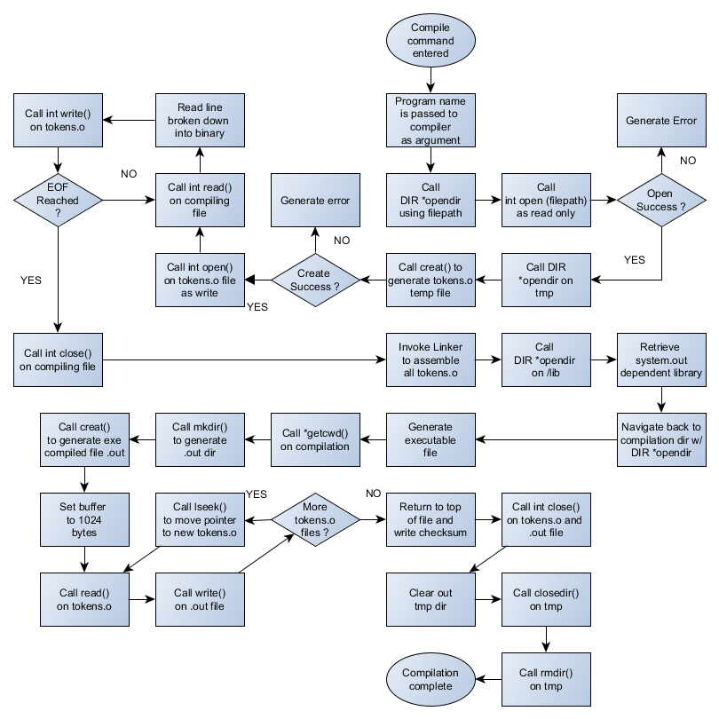

References

What is the “/sys” directory for? (2015, March 15). Retrieved April 14, 2019, from https://askubuntu.com/questions/720471/whats-the-sys-directory-for

Linux File System Tree Overview. (2018). Retrieved April 14, 2019, from https://help.ubuntu.com/community/LinuxFilesystemTreeOverview

Linux File system Hierarchy: Chapter 1. Linux File system Hierarchy. (2018). Retrieved April 14, 2019, from http://www.tldp.org/LDP/Linux-Filesystem-Hierarchy/html/dev.html

Mulley, N. (2012, February 02). What is the difference between /opt and /usr/local? Retrieved April 14, 2019, from https://unix.stackexchange.com/questions/11544/what-is-the-difference-between-opt-and-usr-local

N. (2014, April 21). What is Vmlinuz file on live ubuntu? Retrieved April 14, 2019, from https://askubuntu.com/questions/452070/what-is-vmlinuz-file-on-live-ubuntu