**CST-361 Design Patterns in Java**

**Fredrick Onduso Ondieki**

**GoF Design Patterns**

**December 16, 2018**

**Design Patterns**

Design patterns supply solutions to common software design problems. In the case of object-oriented programming, design patterns are aimed at solving the problems of object generation and interaction, rather than the larger scale problems of overall software architecture. They give generalized solutions in the form of templates that may be applied to real-world problems (Carr, n.d.).

Gang of Four Design Patterns

The examples of GoF Design patterns include;

|  |  |  |
| --- | --- | --- |
| **Creational Pattern** | **Structural Pattern** | **Behavioral Patterns** |
| * Abstract Factory * Builder * Factory Method * Prototype * Singleton | * Adapter * Bridge * Composite * Decorator * Façade * Flyweight * Proxy | * Chain of Responsibility * Command * Interpreter * Iterator * Mediator * Memento * Observer * State * Strategy * Template method * Visitor |

Apart from the chain of responsibility, observer and the builder patterns already discussed in the class, this report will discuss the singleton, Factory and Template Method design Patterns.

**UML Class Diagrams and code execution results**

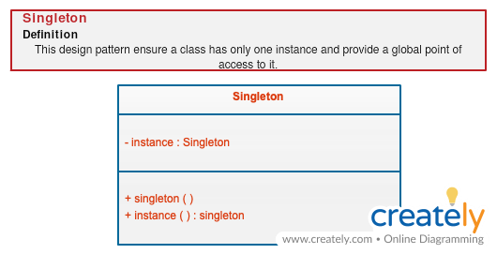**Singleton Design Pattern**

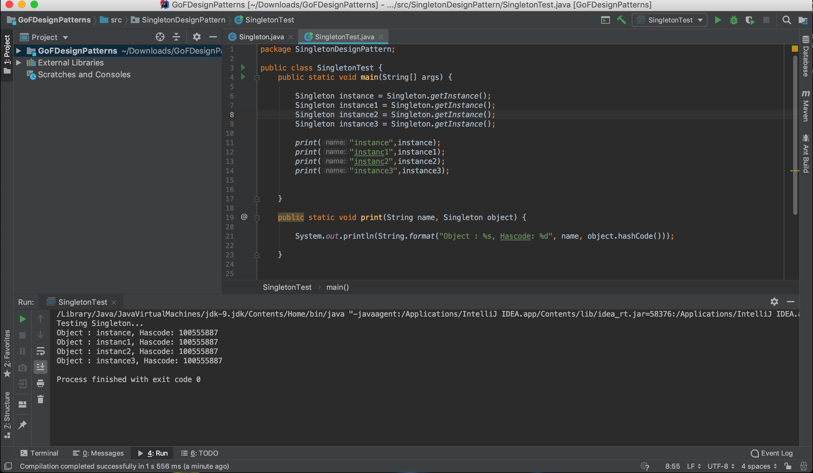

**Factory Design Pattern**

This is a creational pattern as it is used to control class instantiation. The factory pattern is used to replace class constructors, abstracting the process of object generation so that the type of the object instantiated can be determined at run-time.

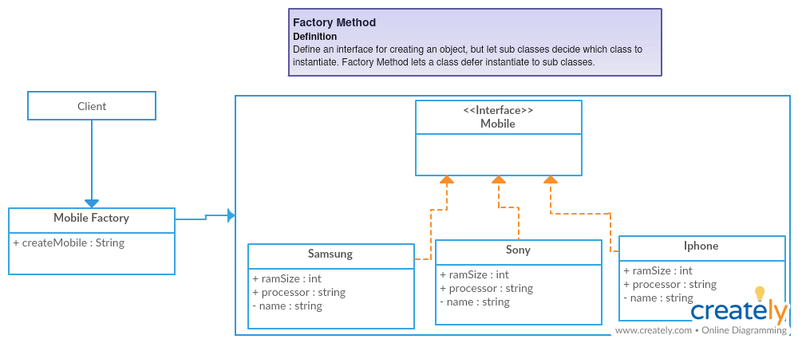

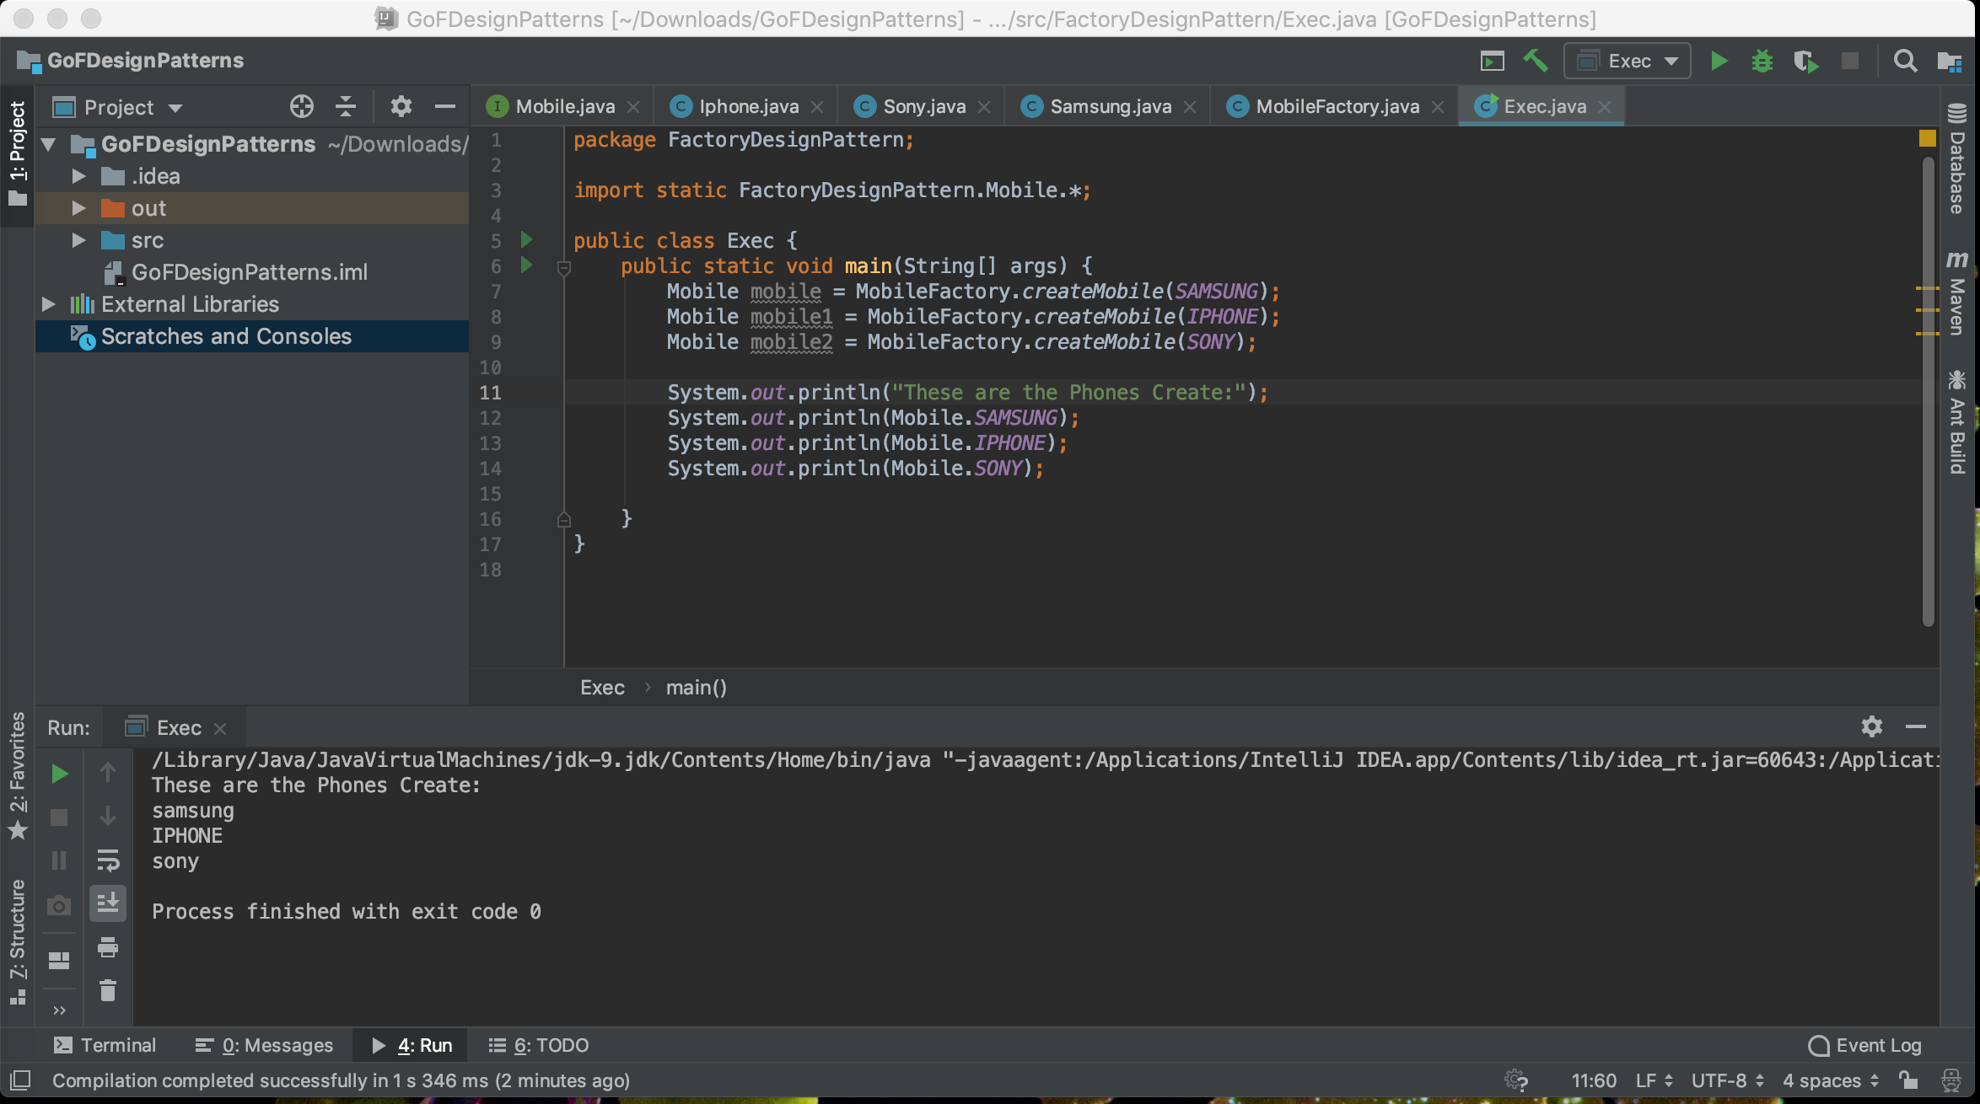

**Template Method**

The template method pattern is a design pattern that allows a group of interchangeable, similarly structured, multi-step algorithms to be defined. Each algorithm follows the same series of actions but supplies a different implementation of the steps.

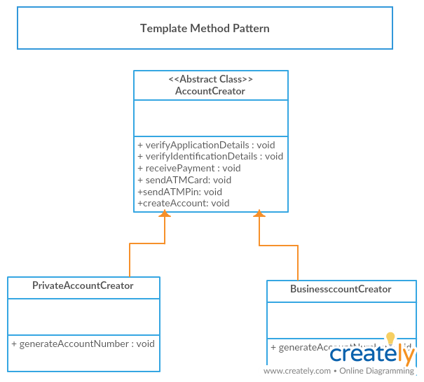

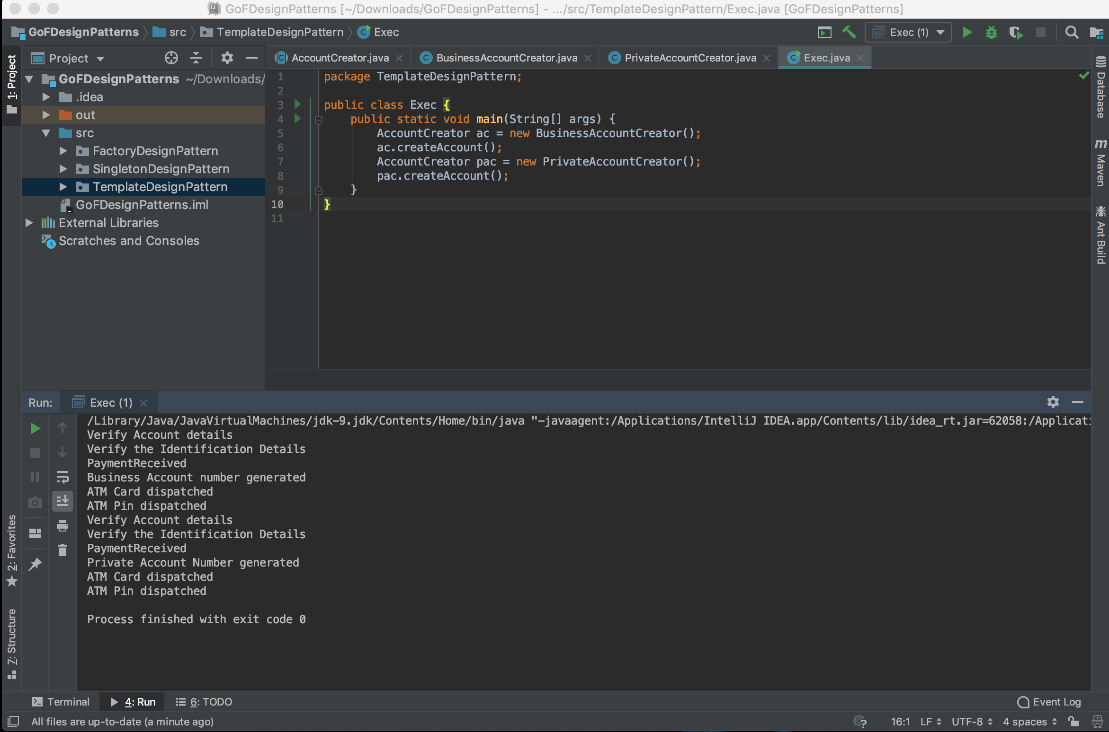

References

Carr, R. (n.d.). Gang of Four Design Patterns. Retrieved December 16, 2018, from http://www.blackwasp.co.uk/GofPatterns.aspx

Factory Pattern in Java | Factory Design Pattern example | Java9s.com. (2016, March 16). Retrieved December 16, 2018, from https://www.youtube.com/watch?v=KgfpICxwOOM

Goduguthuch, D. (2015, February 20). Singleton Design Pattern In Java. Retrieved December 16, 2018, from https://www.youtube.com/watch?v=C_Cvpqyyu8c