# Start_containers.service

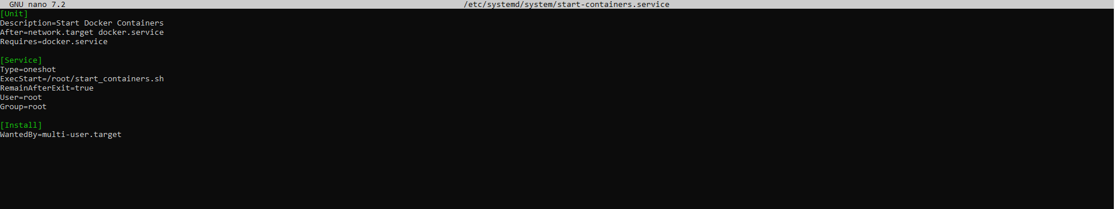

[Unit]

Description=Start Docker Containers

After=network.target docker.service

Requires=docker.service

[Service]

Type=oneshot

ExecStart=/root/start_containers.sh

RemainAfterExit=true

User=root

Group=root

[Install]

WantedBy=multi-user.target

# Start_containers.sh :

#!/bin/bash

docker start fresh_app

docker start fresh_db

docker start fresh_backup