GOPRO to GPS time bug fix

**Issue 1) NMEA/PPS Channel Swap**

This was a really quick fix. The NMEA and PPS channels were swapped in software. This was probably a result of my documentation telling Nick how to solder the cable’s being colored incorrectly. This was a quick 5 minute fix that should be solid now.

calcGoPro2GPS time lines 21-22 are changed

**Issue 2) GoPro Raw Signal behaving differently**

My guess is this is due to a different microphone in the Hero 4, which has a faster decay of the signal. Check out the two figures below. The top figure is from the Hero 4, the bottom is from the Hero 3+, which I initially used to train the algorithm. Notice the red dashed line I drew to show the old decay pattern. With the “new” signal response, there also comes the problem where a few signals are masked in noise. (shown by green arrows). Those values should be represented by a falling edge, or a negative peak in the filtered signal. The 5th bit was particularly troubling, as it consistently was too low in both datasets that I have. I hardcoded it so that the value of the 5th bit is multiplied by 2, and that made it work ok… but I worry about the long term effect of this “patch.” But, the algorithm works on both datasets now.

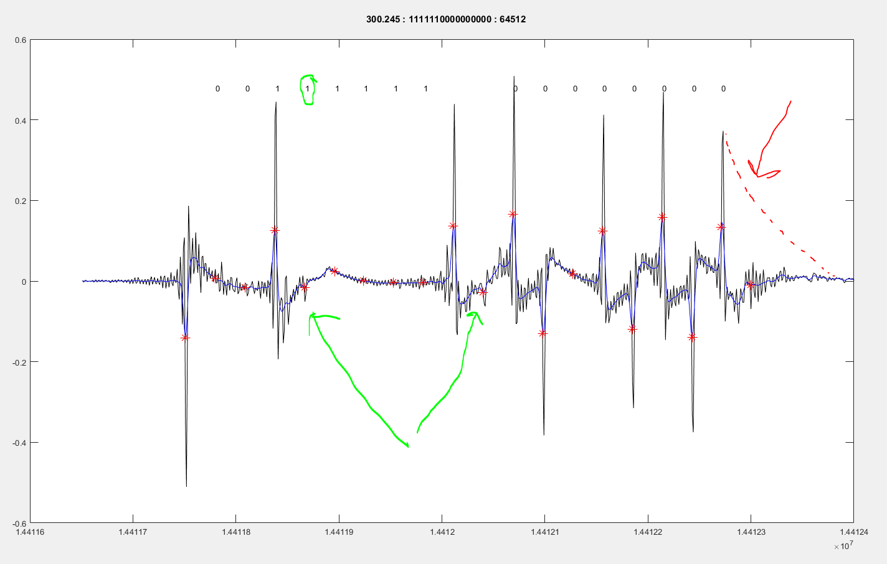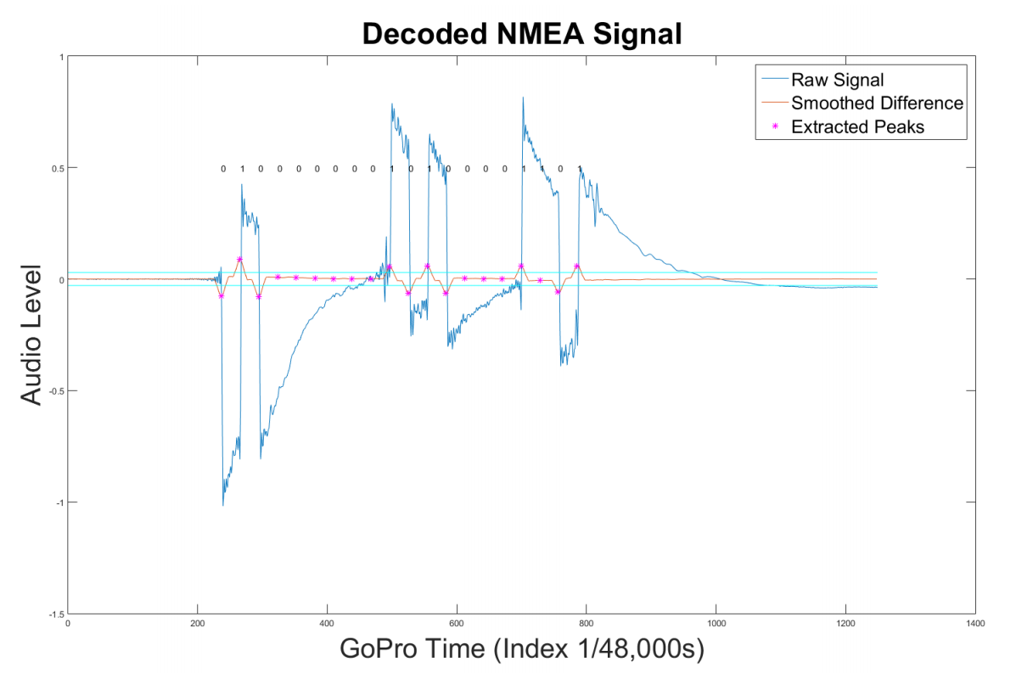

**Idea for a more robust fix:**

So the algorithm I have now to convert from the raw signal to a binary representation of a 16 bit integer is currently not taking into account the temporal aspect of the data. Eg. Binary number 0000000000000010 comes after 0000000000000001. So we could write some sort of filter to use this to our advantage. Check out the figure below. The right image is the “ideal” case of what it would look like, the left is what the raw data looks like. We could write some sort of 2D correlation to find the best match, and correlate that to correct integers. Or we could write some peak detection algorithm on each of the 16 bits, and filter the results based on the known frequency that the channel of each bit should vary at. Sorry if there’s not enough detail in here to make sense, I kind of brain dumped here with hopes that it’ll help a bit in the future, or maybe spark my memory down the line.

