LABORATORY EXERCISE 1

Directory Management System

Learning Objectives
- Perform basic file and directory operations in C++.
- Create a menu-driven console application.
- Use modular programming by organizing code into functions.
- Handle user input and basic error checking.
- Retrieve and manipulate directory attributes.
- Execute system commands within a C++ program.
- Debug and test a C++ application.

Prerequisite student experiences and knowledge
Students should have a solid foundation in C++ programming, including knowledge of basic syntax, data types, and control structures such as loops and conditionals. Experience with functions, including defining, calling, and returning values, is essential. Students should also be comfortable with input and output operations using cin and cout and handling arrays and strings. A basic understanding of file handling in C++ will be beneficial, as will familiarity with system commands like system("cls") for clearing the console screen. Lastly, students should possess basic debugging skills to identify and resolve errors in their C++ code.

Background
This Directory Management System project introduces students to practical file system operations in C++ while reinforcing fundamental programming concepts. Many real-world applications involve managing data stored in the file system, making this activity highly relevant. By working with directories and files, students will explore C++ functions that interact with the operating system, providing hands-on experience in a real-world scenario. The menu-driven interface design enhances the program's usability and demonstrates how to create user-friendly applications. This project bridges basic C++ programming and more advanced topics, such as system-level programming and error handling. Moreover, it emphasizes the importance of modular programming by encouraging students to break down complex tasks into manageable functions. Through this activity, students will deepen their understanding of C++ and its capabilities in building interactive console applications that perform essential file management tasks.

Materials/Resources
- GUI (DevC++, TurboC++, etc.)
- Word processing
- Internet access for referencing documentation and resources.
- GitHub accounts for version control of development.
Problem
Develop a console-based Directory Management System using C++. This program should provide the user with a menu to perform various directory-related operations, such as listing files, creating directories, and changing the current working directory.

Laboratory Activity
- Task Requirements
  - Main Menu
- Display a menu with options for the user to:
- List files in the current directory.
- Create a new directory.
- Change the working directory.
- Exit the program.
  - List Files
  - When the user selects this option, the program should display another menu to
    - List all files in the current directory.
    - List files based on a specific extension (e.g., .txt).
    - List files based on a pattern (e.g., moha*.*).
  - Create Directory
  - Prompt the user to enter the name of a directory. The program should create this directory if it does not already exist.
  - Change Directory
  - Allow the user to change the current working directory
    - Move one step back (to the parent directory).
    - Move to the root directory.
    - Move to a specific directory provided by the user.
  - Exit:
    - Exit the program when this option is selected.
  - Implementation Details:
- Use functions to modularize the tasks, e.g., list_file(), directory(), and change_dir().
- Implement error checking to handle cases where directories cannot be created or changed.
- Use appropriate C++ libraries for directory handling (<direct.h>, <dos.h>).
  - Expected Functionality
  - The program should be user-friendly and allow users to navigate the menu easily.
  - After operating, the program should return to the main menu until the user exits.
Sample Results:
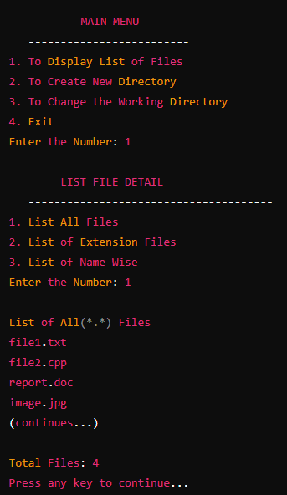
Sample Run 1: Listing All Files

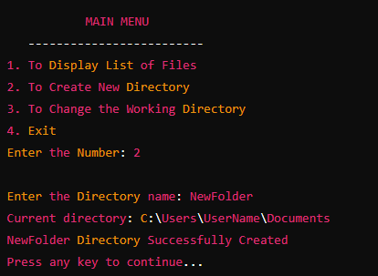
Sample Run 2: Creating a New Directory

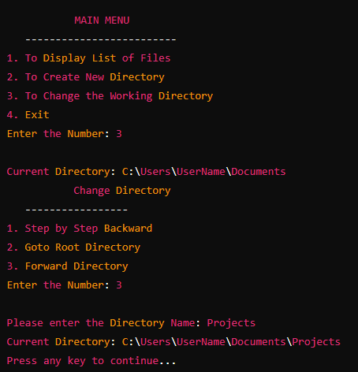
Sample Run 3: Changing the Working Directory

Submission
Submit the C++ code that implements the above functionality. Ensure that your code is well-commented and that all functions are properly tested.

QUESTIONS
- Discuss the Importance of Modular Programming in Developing a Directory.

- Management System Analyze the Challenges and Solutions in Implementing Directory and File Operations in C++.

- Evaluate the User Interface Design of the Console-Based Directory Management System.

Output / Results
Github link here: (HERE)

Conclusion

