LABORATORY EXERCISE # 3

FILE OPERATIONS

Learning Objectives
- To create file operations using C++.
- To determine how to handle a file system operation in fast indexing.
- To design to relates and performance optimizations while a small part addresses correctness.
- They have to process each time to minimize the number of times and invoke these algorithms and the number of bytes.

Prerequisite student experiences and knowledge
Students should know how the operating System works in the System calls, how to handle file lookups fast, and how to store the original file size in the index table.

Background
Operating System has a similar structure but a different way or idea in file/directory permission based on the platform itself. The handle of file system operations in fast indexing as well as specific optimizations for joint actions of file.

Materials/Resources
- PC/Internet
- Pen
- C++ (TurboC++, DevC++, etc.)
- Web Browser (Internet Explorer, Mozilla, Google Chrome, Etc.)
- Word-processing program

Laboratory Activity

Instructions: Perform the following steps.
- Start the program TurboC++/DevC++
- Create new file called file_permissions.cpp
- Include Necessary Headers
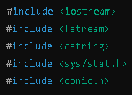
- Define a Helper Function
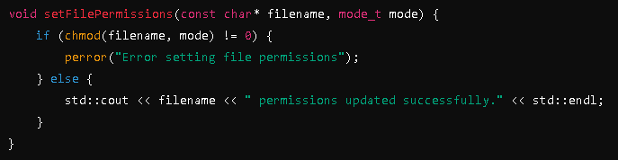
Create a helper function that will take in a file name and permission mode. This function uses the chmod() system call to change file permissions:
- Create the Main Function
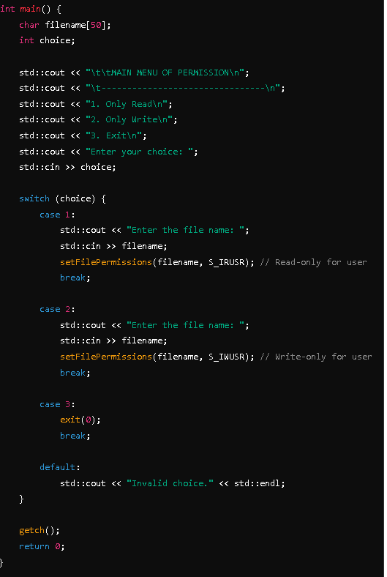
The main() function provides a user interface, allowing them to choose between read-only and write-only file permissions:

  - Main Menu: The user sees a simple menu with three options:
    - Option 1: Set file to read-only.
    - Option 2: Set file to write-only.
    - Option 3: Exit the program.
  - File Name Input: Based on the selected option, the user enters the name of the file they want to change permissions for.
  - Set Permissions:
    - If the user chooses "Read-Only," the program calls chmod with the S_IRUSR flag.
    - If the user chooses "Write-Only," the program calls chmod with the S_IWUSR flag.
  - Error Handling:
    - If there's an error in setting permissions (e.g., the file doesn’t exist), the perror function prints a system-defined error message.
    - If successful, the program prints a success message.
- Execute the program and print screen the result, give at least three outputs.
- Print the result on the page provided.

OUTPUT
Setting Read-Only Permission
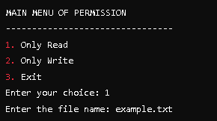
Output


Setting Write-Only Permission
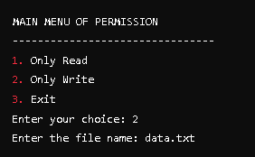
Output
Invalid Filename or Error in Setting Permission
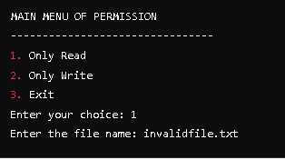
Output

QUESTIONS (10 pts each)
- Why are file permissions important for system security? Explain how they can be managed using C++.

- What is the role of `chmod` in changing file permissions in C++? How does this differ between Linux and Windows?

- How have file operations in C++ evolved from older systems like DOS to modern systems? Give examples.

Output / Results

Conclusion

