**PERSONALIZED**

**MUSIC PLAYER**

**WEBSITE**

**DEVELOPED BY:   
Jhoven Christian Pataueg**

**Cynth Charisse Caro**

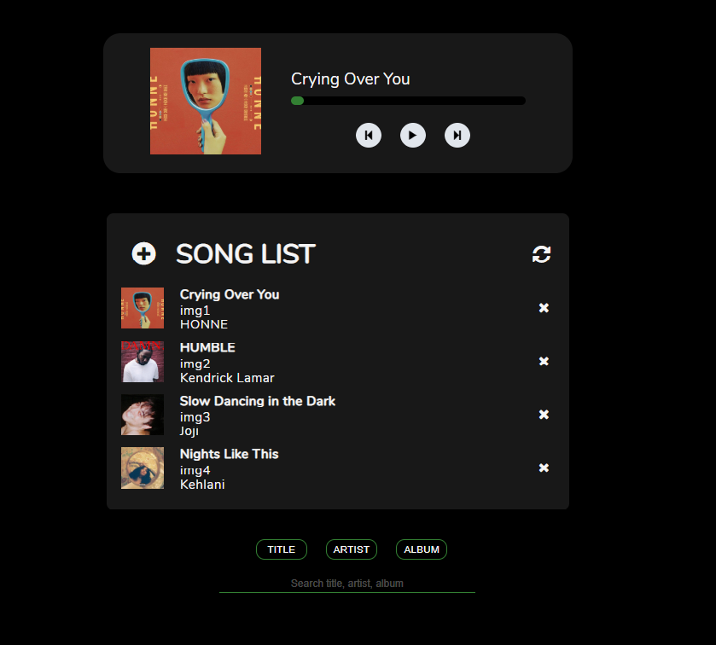

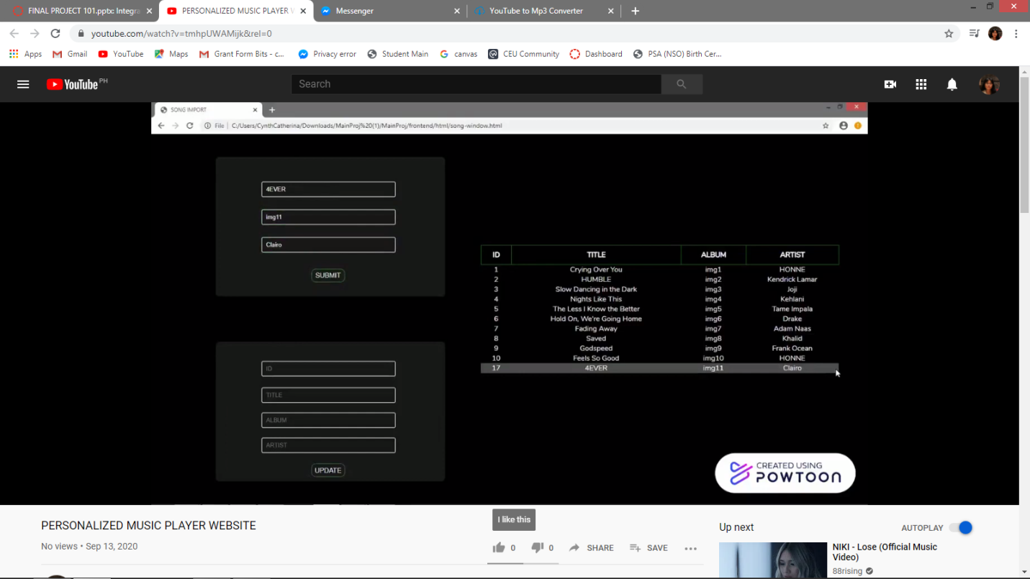

**Personalized Music Player** is a website good for storing and playing music. Users can view his/her favourite songs from various artist and/or album, add another song, update the music info, and delete them anytime.