Lab 2, Analog Integrated Circuits

Ole Jansen, Finn Rautenberg, 09.12.2022, Lübeck

# 1) Current mirror circuit

1a) Task: Create a current mirror curcuit in Orcad Capure CIS, which is able to sweep the Parameter output load resistor

Abbildung : Current mirror with variable load resistor RL

1b) Task: Determine the maximum theoretical load resistor for which by negleting the channel length modulation at the bias point.

is limited by the minimum voltage of , because if M1 will leave saturtion and wil deviate from .

Aber brauchen wir dafür nicht U_gs, ist zwar vorgegeben durch M2 aber worher in theorie wissen?

1c) Task: Sweep the load resistor in the simulation to determine the maximum resistor for a constant load current



Abbildung :Output current ID(M1) of current mirror with different loadresistors RL and the reference current I_ref

At the load current changes are the highest dependet on the load resistance, which result that at higher .

Compare 1b) and 1c)

1d) Task: While sweeping the load resistor, plot as a function of to determine the saturation region of M1

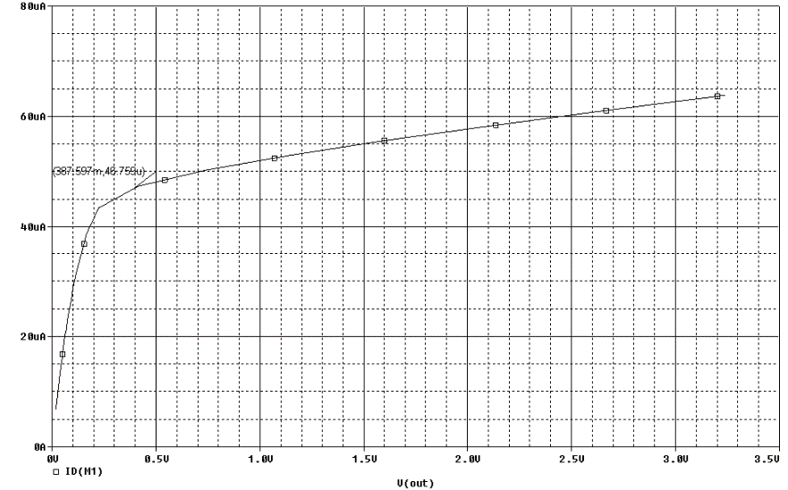

Abbildung :I_D vs V_ds of M1 while sweeping the load resistor

The saturation region of M1 can only be rough estimated, but...

Compare 1d) and 1b)

1e) Task: Remove the load resistor and replace it with an AC voltage source to later determine the characteristics of M1.

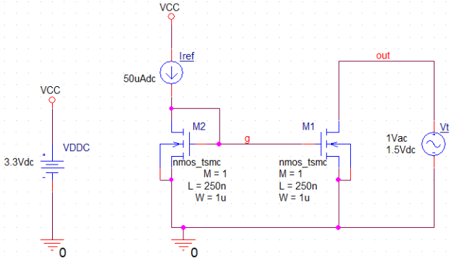

Abbildung : Current Mirror with voltage source on V_ds1

For the AC analysis all components are linearised. This resulting is used for small signal AC analysis of the circuit.

1f) Task: Sweep between 0V and 3V and plot versus . To determine the minimum voltage with the help of the derivativ of the current . To determine the small signal DC output resistance use 

Figure 5: I_ds versus V_t



Figure 6: dI_ds/dV_t



Figure 7: Small signal output resistance of M1

As expected, the MOSFET M1 is at not more in saturation. M1 works with a greater voltage as a current source because it is in saturation the current slope is only a function of the channel length modulation.   
The ideal current source has infinite small signal output resistance . A high is only archived in the saturation region which is shown in figure 7 and in the following measurement table.

|  |  |
| --- | --- |
|  |  |
| 100 mV | 5,09 kΩ |
| 1,5 V | 178,7 kΩ |

1g) Task: Determin in phase and magnitude for 1 Hz with an AC-analysis, which approximates at



The minus sign at e.g. is needed to correct for inverse current flow, due to the (voltage) source at the simulation.

1h) Task: Repeat the measurement of 1g) with



1i) Task: Compare the simulated small signal output resistance of the DC sweep and AC analysis

|  |  |  |
| --- | --- | --- |
|  |  |  |
| 0,1V | 5,09 kΩ | 5,09kΩ |
| 1,5V | 178,7 kΩ | 178,7 kΩ |

This comparison shows, that the AC analysis is capable of calculating the same way as the DC sweep.

1j) Task:

1k) Task:

# 2) Cascode current mirror



2a) Task:

2b) Task:

2c) Task:

2d) Task:

2e) Task: