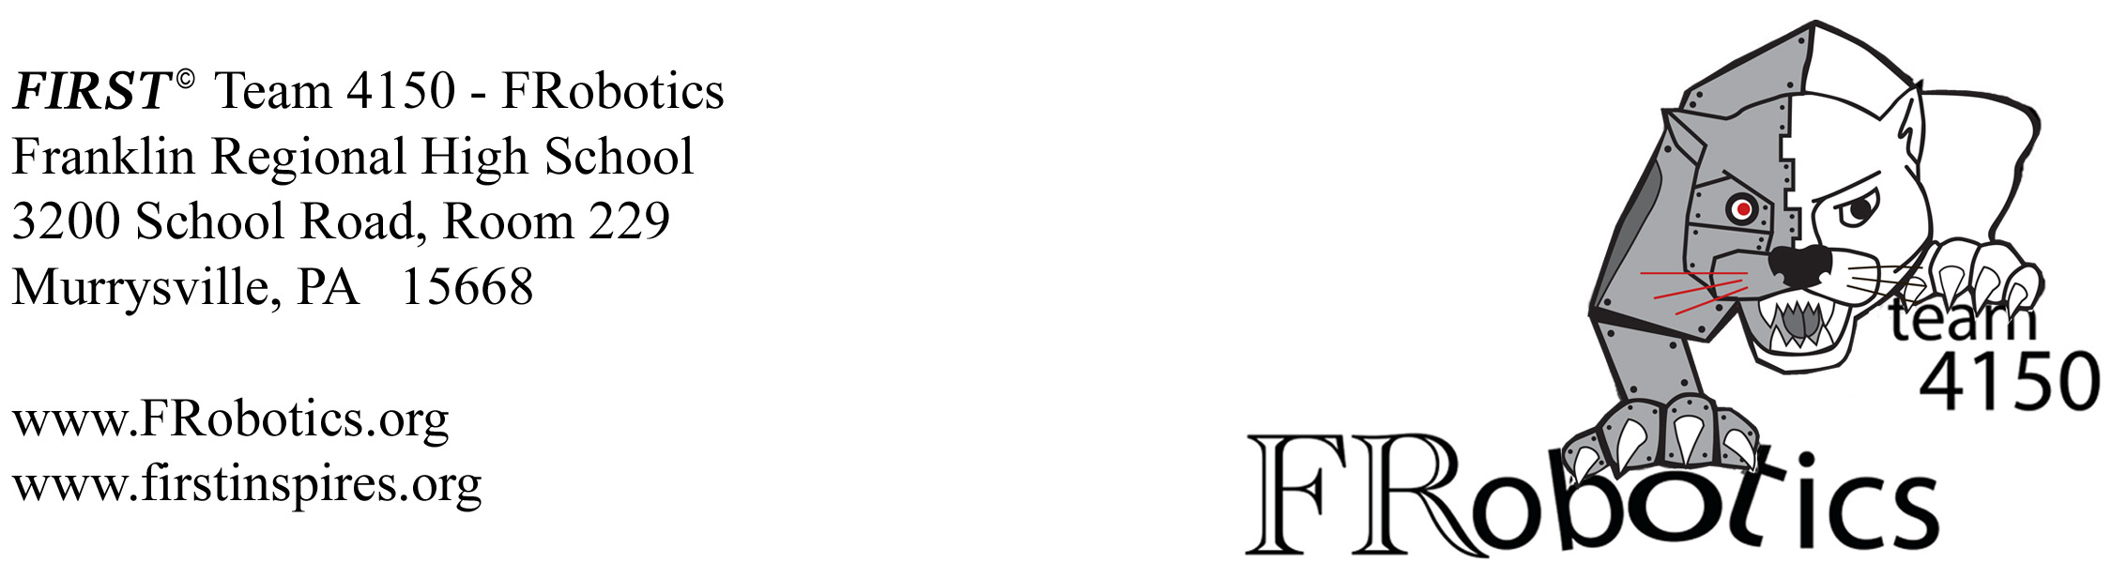
DATE

Mr. or Mrs. NAME
Owner TITLE
ADDRESS

Dear NAME:

I'm writing to you about an amazing science and technology program for high school students – one that we think will be of interest to you--the FIRST© Robotics Competition. FIRST©: For Inspiration and Recognition of Science and Technology is a worldwide organization founded in 1989. The goal of this non-profit organization is to motivate young people to pursue education and jobs in the STEM fields and to encourage leadership skills.

Each year’s competition has a theme around which a game is played, pitting alliances of three separate teams against another alliance. Individual teams have six weeks to design, build, and program a robot from scratch, using money raised from sponsors. Our regional competition has approximately 50 teams competing each year. The winning regional alliance moves on to the next level of completion at Nationals. The challenges encourage teamwork, innovation, and gracious professionalism in a sports-style tournament.

Franklin Regional High School's robotics club, Team 4150 FRobotics, has been competing since 2012. In that year, our team won the Rookie Team Award. In 2013, we were recognized by National Instruments as one of the top ten teams effectively using their LabView software. In the 2014 regionals, our alliance placed second overall, and in the following year we made it to semi-finals. We had another great showing last year and are excited about the upcoming season.

As you might imagine, this project is very resource intensive. Over 15 volunteer parents, teachers, and professionals from the community act as mentors to the 50+ active team members. The cost to enter this annual competition is $5000, plus the costs of buying materials. It costs an additional $5,000 for any additional competitions we would like to enter. While Franklin Regional School District supports us in several ways, we do not receive any financial support from the school district.

In the past, we have been generously supported by a number of companies, including National Instruments, 4Moms, and The Heinz Endowment. Every dollar we raise is used toward building the robot and entering the competition. We are asking that you join with these well-established organizations and adopt this exceptional program by supporting us. (This may be modified if you are sending a letter to a prior donor to recognize their prior support)

Our team would be happy to meet with you and your staff at your convenience to answer any questions you have. We are always happy to bring our robot along as well. If you’re willing to support the team, your company will be recognized on our website and in our pit at competitions. All donations are tax deductible. Donations can be made payable to Franklin Regional School District, mentioning FIRST© Team 4150 in the memo line. The School's tax ID number is 25-1117496. Financial contributions can be mailed to: Franklin Regional High School, 3200 School Road, Murrysville, PA 15668, Attention: Ms. Maureen Garda. Her phone number is 724-327-5456, x5229.

Respectfully,
YOUR NAME
YOUR PHONE
YOUR ROLE, FIRST© Team #4150 – FRobotics
Franklin Regional High School

