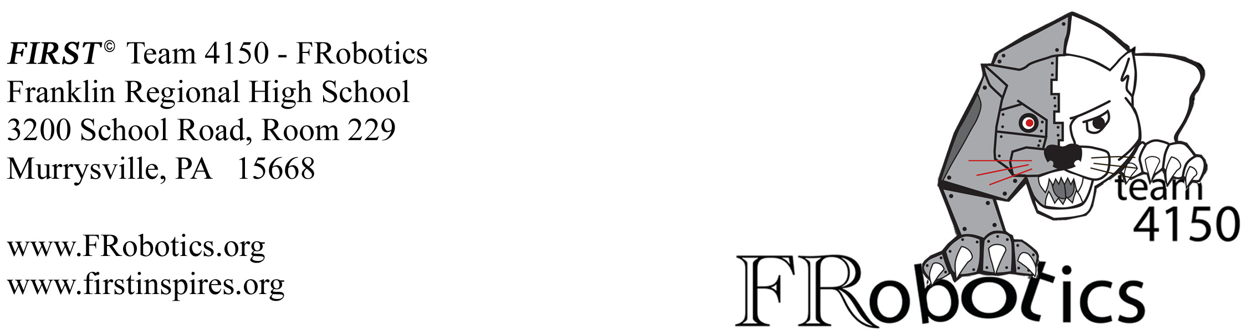

Dear Sir or Madam:

Franklin Regional's robotics team, Frobotics, is participating in

_____________________________________________ event on date _____________________.

Thank you for supporting our efforts by donating

_____________________________________________ valued at $ ________________.

Your donation will be used to raise funds for our team's expenses as we compete in the FIRST© Robotics Competition. FIRST© is an acronym, For Inspiration and Recognition of Science and Technology, and was founded in 1989. It is the goal of FIRST© to inspire young people to pursue education and career opportunities in science, technology, engineering, and math while building teamwork, gracious professionalism, self-confidence and life skills.

The cost to enter this annual competition is $5000. Our goal is to enter two competitions this year. In the past we have been graciously supported by a number of companies, including National Instruments, 4Moms, and The Heinz Endowment. Every dollar we raise is used towards building the robot and entering the competition. If you would like to become a sponsor, our marketing team would be happy to present our business plan to you and your staff at your convenience.

All donations are tax deductible. Donations can be made payable to Franklin Regional School District, mentioning FIRST© Team 4150 in the memo line. The School's tax ID number is 25-1117496. Financial contributions can be mailed to: Franklin Regional High School, 3200 School Road, Murrysville, PA 15668, Attention: Ms. Maureen Garda.

Respectfully,

FIRST© Team #4150 – FRobotics
Franklin Regional High School

