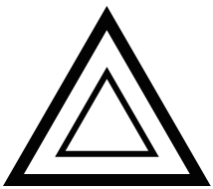**Order & Chaos**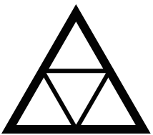

Present by Zhenlin Zhang

# Concept:

This is a chess-like game that can be played by two players who play the roles of order and chaos.

# Genre:

Chess.

# Setting/Story:

This game is totally designed and implemented originally.

There are two sides in the world, order and chaos. They are inconsistent, but sometime they are harmonious even transferable.

 +  = 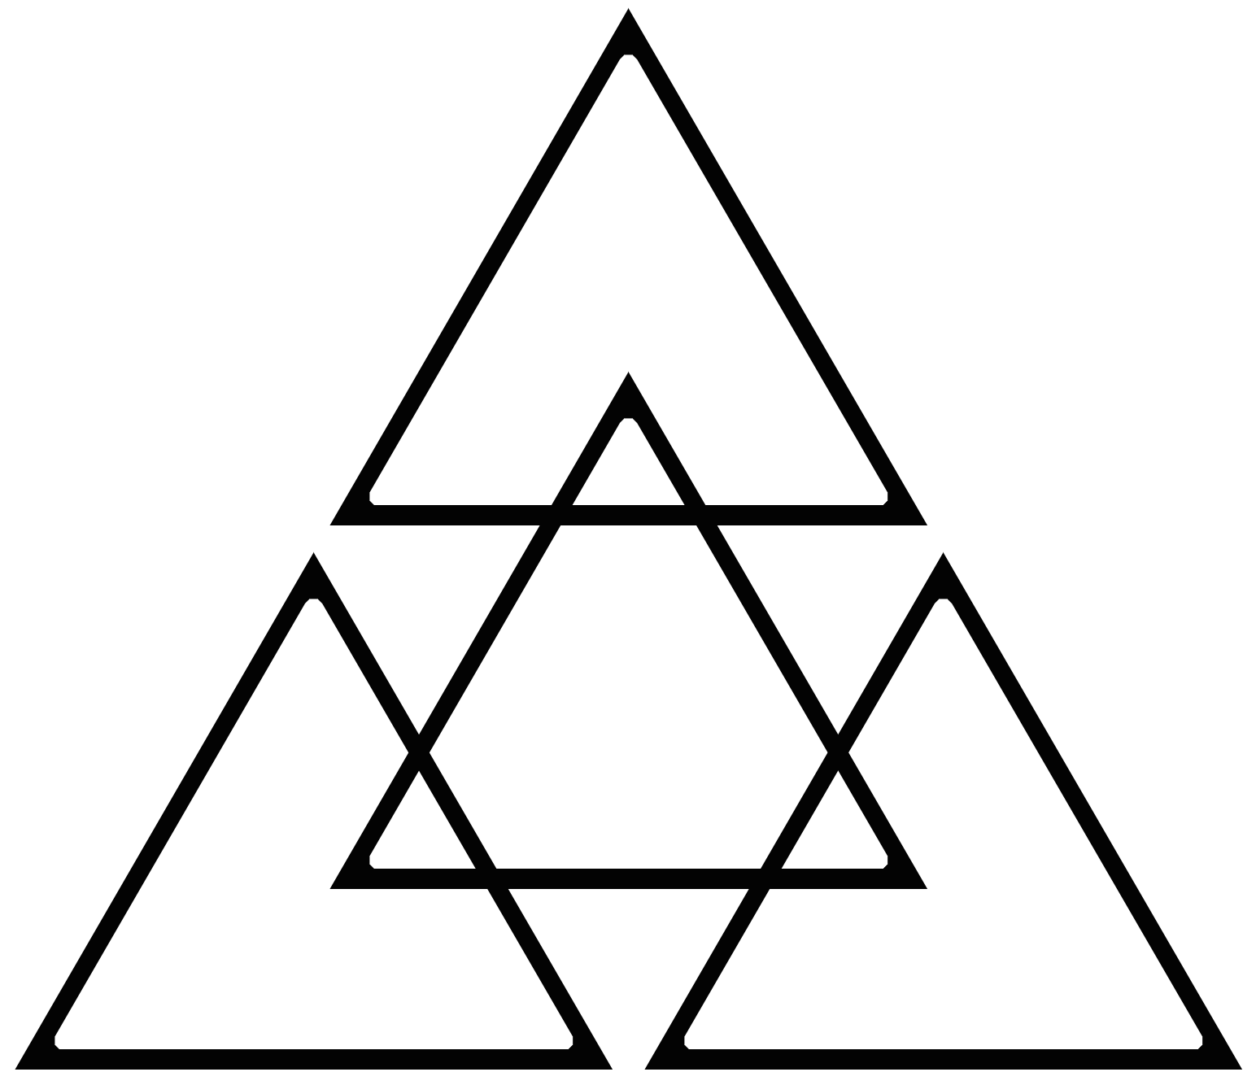

# Game play:

## Input Control:

This game is use mouse click or touch to play.

First, player click on an own chessman in your round.

Second, click on a center of area to try to move this chessman.

If the move is not allowed, it will reset and let player choose another chessman.

## Map:

Pink - Battle Green - Grave

Blue - Small triangle Purple - Big triangle

Doted Pink – Battle & Revive Point

Doted Purple - Big triangle & Core

Start: Each player has 3 small chessmen, 3 big chessmen and territory. In the beginning, all the chessmen locate in the matching triangle area around the middle hexagon.

Move: In every turn, the player can move only one chessman with one step. The normal move can only be acted between two adjacent areas (two areas have a common vertex are not adjacent). Middle hexagon cannot be entered in.

Battle: When a chessman of either side step into an empty battle zone, the battle zone is dominated by this side. After this action, the domination can only be handed over when the number of chessmen of another side is greater than the dominator’s in this battle area. The capability of one battle area is 4, no matter big or small.

The dominator has extra right based on the number of its chessmen in the dominated battle area:

1: None. 2: Opposite chessmen in this battle area cannot move.

3: Opposite chessmen in this battle area cannot move.

Opposite chessmen cannot step in this battle area.

4: Same as 3.

When the battle area is full of 4 chessmen, chessmen of dominator’s can still step into this battle area and kill one opposite chessman in these two conditions:

3 dominator’s and 1 opposite chessmen: the opposite chessman will be killed.

2 dominator’s and 2 opposite chessmen: prior kill the one which is same kind of the killer.

Small triangle: Capability is 1. Big chessman cannot step in. No special moves. When it’s full, any enter is forbidden.

Big Triangle: Capability is 1.

When a small chessman is in, only an opposite big chessman can step in. This action will kill the small chessman.

When a big chessman is in, any enter is forbidden. But the small chessmen of same side can go through this area to the next battle area.

Core: Two core areas of two sides are adjacent, this means a chessman in a core area can directly move to another empty core area.

When a chessman step into a core area, the territory including this core will turn to be the same side of this chessman and another territory will turn to be opposite. Ignore this action if they already are the matching side. This means if turning occurred, the place of grave and winning area will totally exchange.

If the same side has two core, when either chessman in core leave, the territory of another chessman in the core will turn to be their owner’s.

Killing is always before turning. That means going to grave is before turning too.

Grave: The area where killed chessmen stay. When a player end his/her round, chessmen will be tried to move to the revive area. This move does not consume players round and may also kill opposite chessmen.

End: To win the game, there are two ways:

Moved 3 chessmen into matching areas in opposite territory.

Blocked 3 opposite chessmen in the grave.

Classroom model: A small chessman in opposite small triangle is 1 point and a big chessman in opposite big triangle is 1.5 point. After 5 minutes since the game started, the player has a higher points win. But if the higher player was playing when the game end, the higher player will lose 1 point.

# Target Audience:

The players who like game theory, making strategies and playing chess game.

# Resources needed to play:

It is wonderful to have a wooden chessboard and chessmen to play, but it can also be played with paper chessboard and chessmen. One page paper can support two players. The classroom model needs a timer.

# Play time:

It depends on the skill of the players, just like most chess game. But when we play the classroom model, the playing time is exactly 5 minutes.

# Strategies:

Chess game also has complicated strategies. Like prior occupy two cores and big triangles. Move the right numbers of chessmen to control the battle area. Catch the best opportunity to make turning.

# Reference:

None.