Fangsheng Wu

What I have used in this challenge:

**Front-end: HTML, CSS, JavaScript**

**Back-end: Python, Flask, MySQL**

**Data: PredictHQ APIs, OpenWeatherMapAPIs**

What is in it:

**Login, signup, retrieve by email, client can post promotion and coupon, client can check events nearby and next five days weather, client and user can make purchases.**

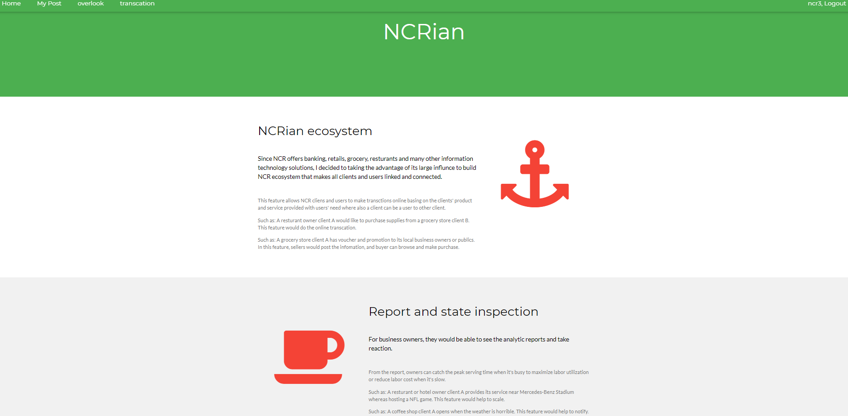

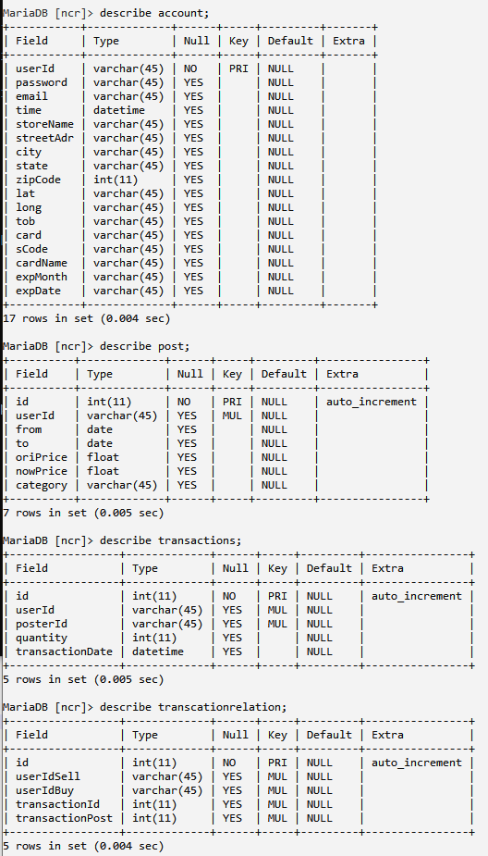

Thank you for your time!

Sheng