CSC 4760/6760 Big Data Programming
Assignment 2
FangSheng Wu

PreAnalysis:
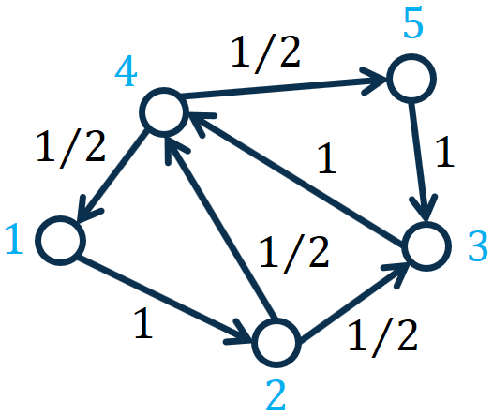
To compute the weight in a directional graph of pages, graph theory of page rank values was developed by google. It is basically a hypothesis that assume all the web-page are equal weight and as popular as one of other, and We normalize the page rank value, so all the page popularity add up equals one; moreover, a users randomly click a web-page from a page called it origin page, it eventually would either return to the origin page or arrive a dead end. So, as the dynamically click from here to there, their corresponding values transfer from one node to other edge or edges.
For our problem, Node and edgy are fixed,
The PageRank values are given in the following table (given that the decay factor ):
Nodes | PageRank Values
1 | 0.1556
2 | 0.1622
3 | 0.2312
4 | 0.2955
5 | 0.1556

PageRank:

where represents the PageRank vector with each element representing the PageRank value of node , represents the number of nodes in the graph, represents the transition probability matrix with each element representing the transition probability from node to node , represents the degree of node , represents the transpose of , represents a decay factor, represents a vector of all 1’s, and represents the number of nodes in the graph.
Please see the slides for more details.
In this assignment, we set the decay factor and set the number of iterations to 30.
(1).
#1 AdjList2 = AdjList1.map(lambda line : line.split(" "))
Since the original Adjacency list already has new line character after all the edge, we only split their space between when the lambda line taking the input file line after line, each line be a separated mutable data.
[u'1 2', u'2 3 4', u'3 4', u'4 1 5', u'5 3']
#2 AdjList3 = AdjList2.map(lambda x : (x[0],x[1:]))
When we are given a Adjacency list, a node might have zero or infinity many of edge, thus we use the key / value terminology, let the node be key, edges be the value, then we have a directional vector data-set. X[0] first element always assigned node, all data after that x[1:] stores in a separate state.
[(u'1', [u'2']), (u'2', [u'3', u'4']), (u'3', [u'4']), (u'4', [u'1', u'5']), (u'5', [u'3'])]
#3 PageRankValues = AdjList3.mapValues(lambda v : 1.0/AdjList3.count())
AdjList3.count() gives us the number of node, 1 divide that would set the initial value of all node that has equal weight.
Total Number of nodes
5
[(u'1', 0.2), (u'2', 0.2), (u'3', 0.2), (u'4', 0.2), (u'5', 0.2)]
join results
[(u'1', ([u'2'], 0.2)), (u'5', ([u'3'], 0.2)), (u'4', ([u'1', u'5'], 0.2)), (u'3', ([u'4'], 0.2)), (u'2', ([u'3', u'4'], 0.2))]
#4 contributions = JoinRDD.flatMap(lambda (x, (y, z)) : [(x,z / len(y)) for x in y])
After we joined the AdjList3 and PageRankValues, we can compute all edges weight, so 3>4 = 0.2 and 2>3 & 2>4 = 0.1, this function y is the number of edges in a data frame, z is the corresponding weight. Weight divide its number of edges give a partial partition.
[(u'2', 0.2), (u'3', 0.2), (u'1', 0.1), (u'5', 0.1), (u'4', 0.2), (u'3', 0.1), (u'4', 0.1)]
#5 accumulations = contributions.reduceByKey(lambda x, y : x+y)
reduceByKey is just adding up the redundant keys values. Instance of key ‘4’
has values 0.2 and 0.1, add them up and reduce the redundant key.
[(u'1', 0.1), (u'5', 0.1), (u'4', 0.30000000000000004), (u'3', 0.30000000000000004), (u'2', 0.2)]
#6 PageRankValues = accumulations.mapValues(lambda rank: rank * 0.85 + (0.15/AdjList3.count())
Taking every value from accumulations RDD into lambda rank, times 0.85 then add 0.15/AdjList3.count(), give the new page Rank values.
[(u'1', 0.115), (u'5', 0.115), (u'4', 0.28500000000000003), (u'3', 0.28500000000000003), (u'2', 0.2)]
(2)
[(u'4', 0.2954233497371882), (u'3', 0.2311833275570067), (u'2', 0.16224457411113138), (u'1', 0.15557437429733678), (u'5', 0.15557437429733678)]

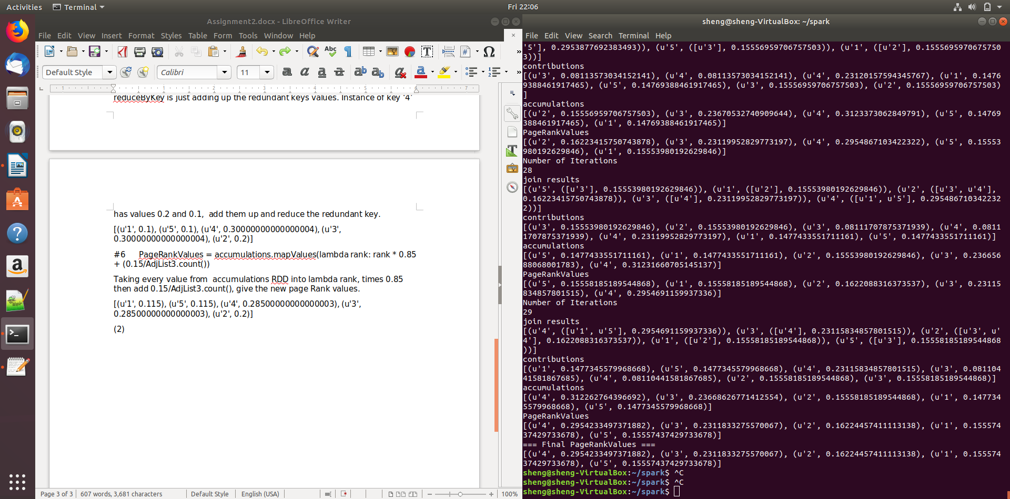
2.1)
2.2)
My implementation gives the exact correct result.

