Multi-Domain Intelligence Platform Report
Student Details
Name: Fanta Sisse
Student ID: M01049123
Program: BSc Information Technology
GitHub Repository link: GitHub - FS695-cpu/CW2_M01049123_CTS1510: CW2 for MDX university module CST1510

Introduction
The Multi-Domain Intelligence Platform is a modular application designed that provide interactive insights across different technical domains. Its purpose is to combine secure user authentication with domain-specific dashboards, enabling students to explore structured data in a meaningful way.
For my project, I chose the Cybersecurity domain, which focuses on incident analysis. The platform allows users to register securely, log in, and then access a dashboard that displays cyber incident data. This dashboard provides filtering by severity, category distributions, and temporal trends, making complex datasets easier to analyse and understand.
I designed a Tier 2 functionality, which combines secure authentication, database integration, and interactive data visualization. This tier shows how a user-centric system can protect sensitive information while offering analytical tools to support decision-making in cybersecurity.

How I Built the System

2.1 Security & Database
User passwords are protected using hashing. Instead of the password being stored in plain text, each password is converted into a secure hash using the bcrypt library, which ensures that even if the database is compromised, attackers will not be able to access the original passwords as they are converted into a bunch of meaningless text
Data is stored in SQLite tables, with a user’s table containing usernames and the hashed passwords, and a cyber_incidents table stores incident records. I chose SQLite for its simplicity and portability, making it easy to integrate with Streamlit.
Security matters as users’ accounts and incident data are personal and sensitive. By hashing passwords and enforcing unique usernames, the system prevents unauthorised access and maintains data integrity.

2.2 System Structure
User → Login/Register → Database → Dashboard → Visualizations
Login/Register: Users enter username & password, which are validated against credentials stored in the database.
Database: Stores user details and incident records.
Dashboard: Once logged in, users can access the dashboard.
Visualisations: Charts and tables present filtered incident data, which makes analysis and understanding easier.

2.3 Code Organisation (Optional: OOP Refactoring)
- I structured the code into modules:
- users.py handles user insertion and retrieval.
- hashing.py manages password hashing and validation.
- Home.py controls login/register logic and session state.
- Dashboard.py contains the incident dashboard.
  - Key Features
Charts and Visualisations:
- Bar chart showing incident categories by severity.
- Line chart showing category trends over time.
- Data table for filtered incidents.
Secure Authentication:
- Password hashing with bcrypt.
- Unique username enforcement.
Session Management:
- Streamlit session_state ensures users remain logged in until logout.

Screenshots of the dashboard demonstrating how users can filter incidents and immediately see updated charts.

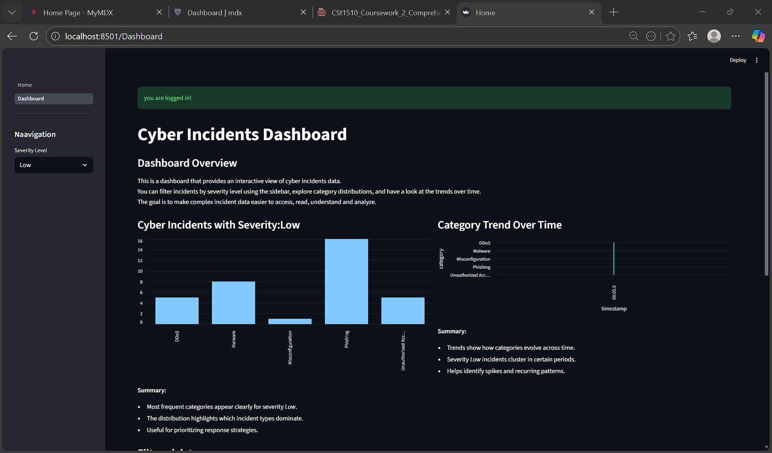

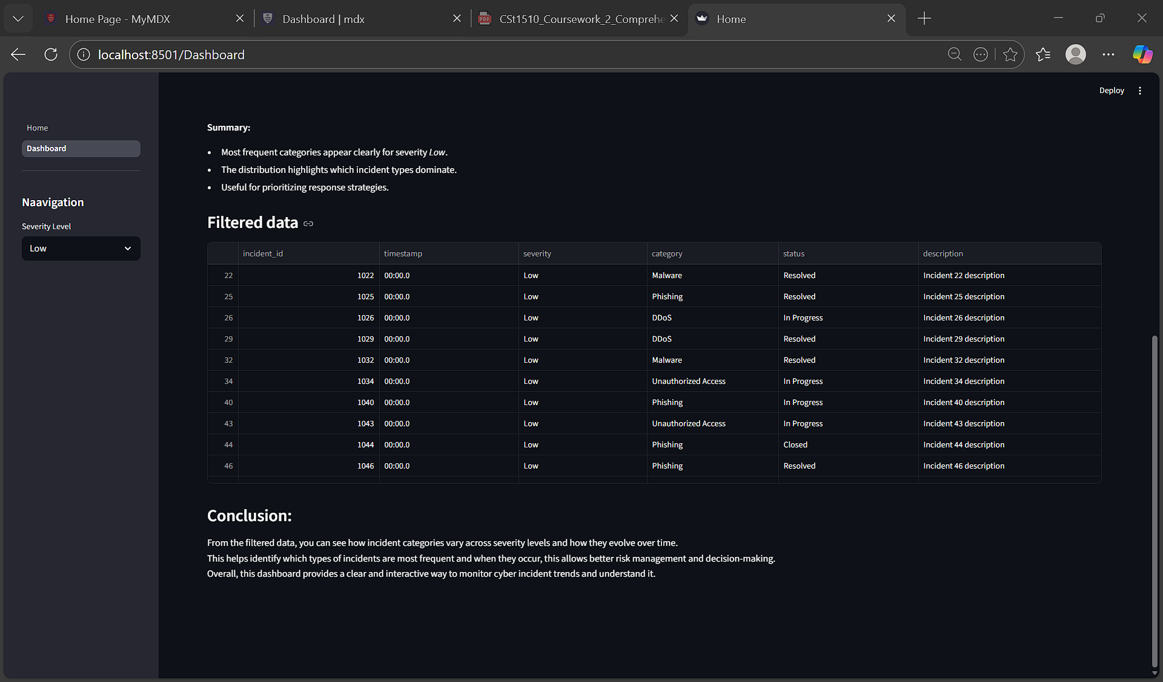

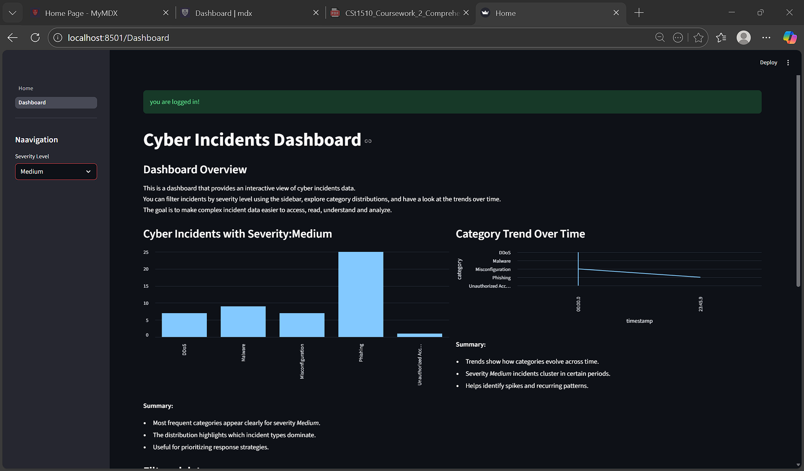

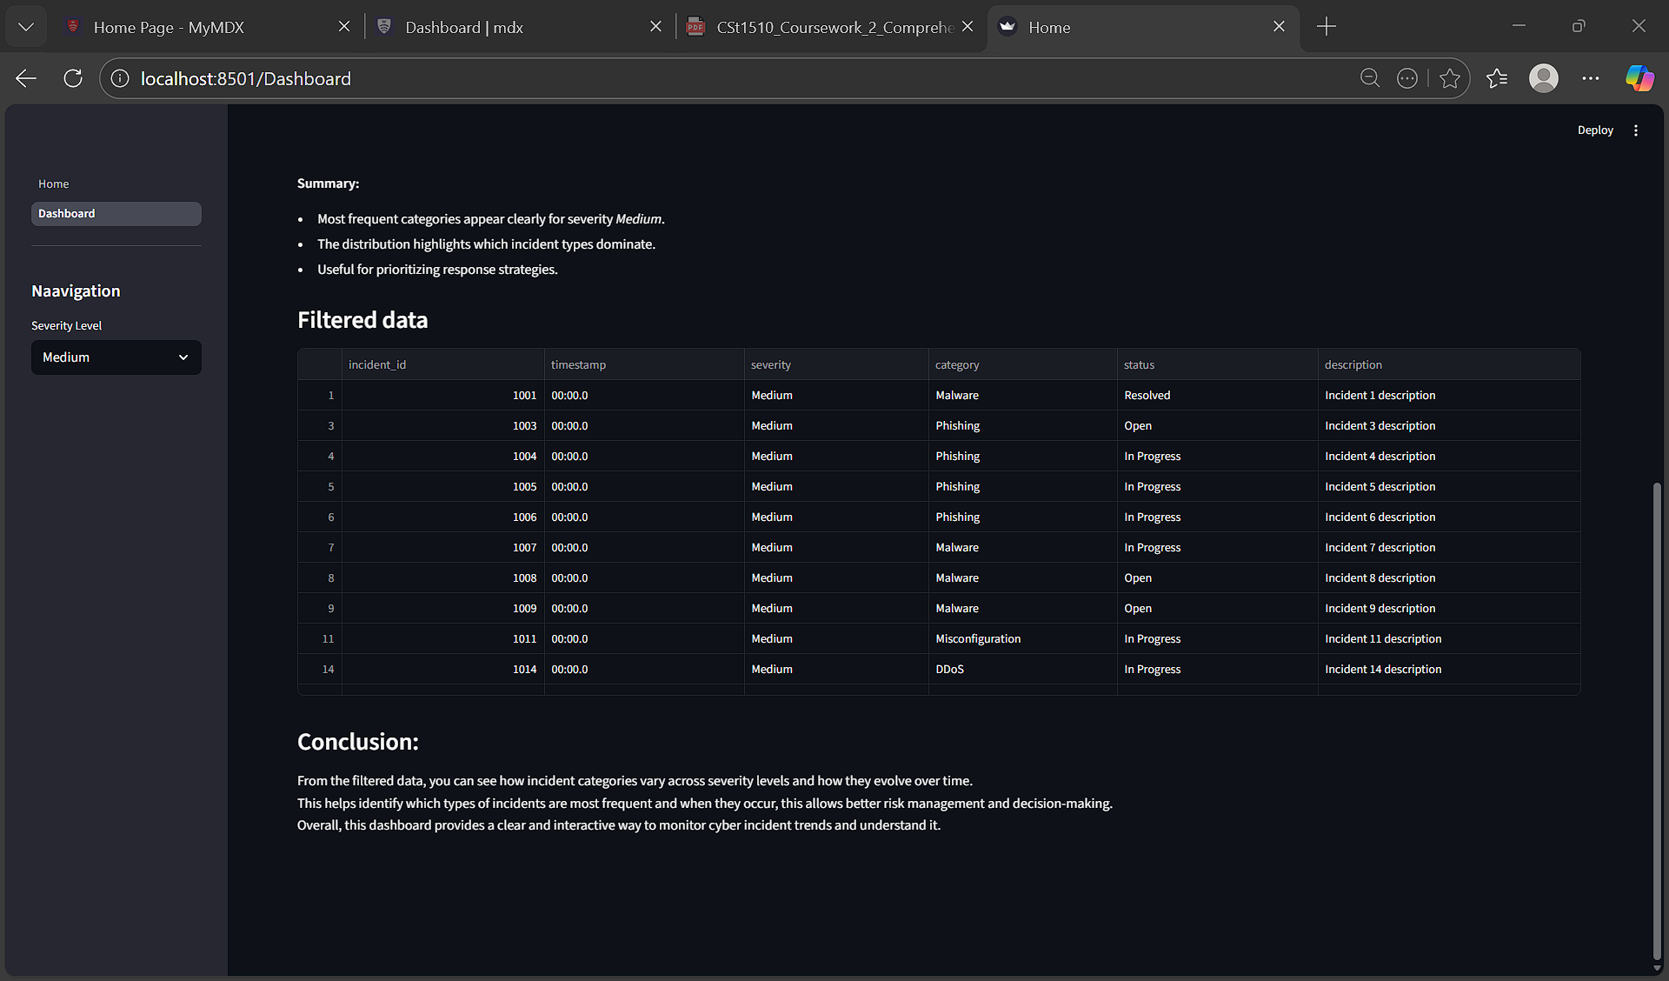

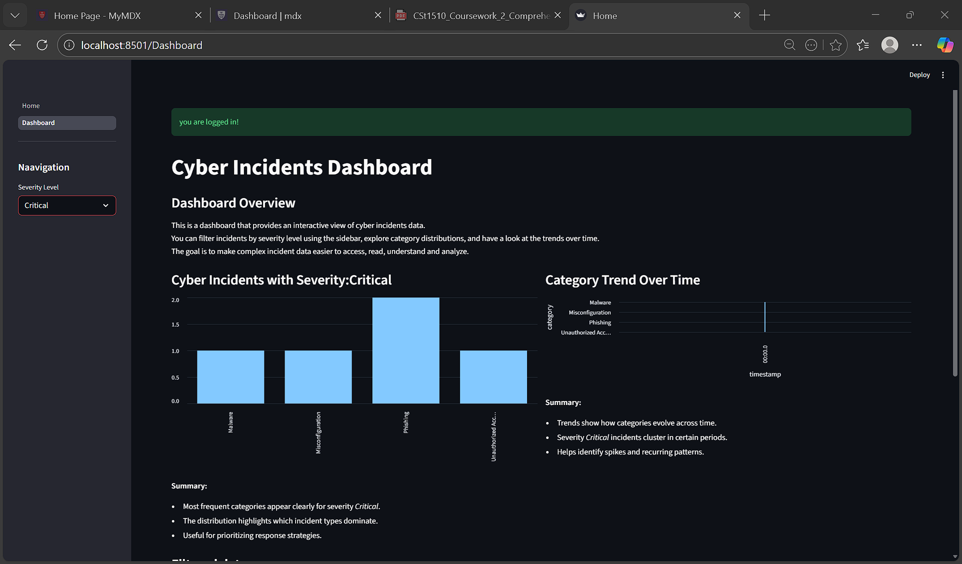

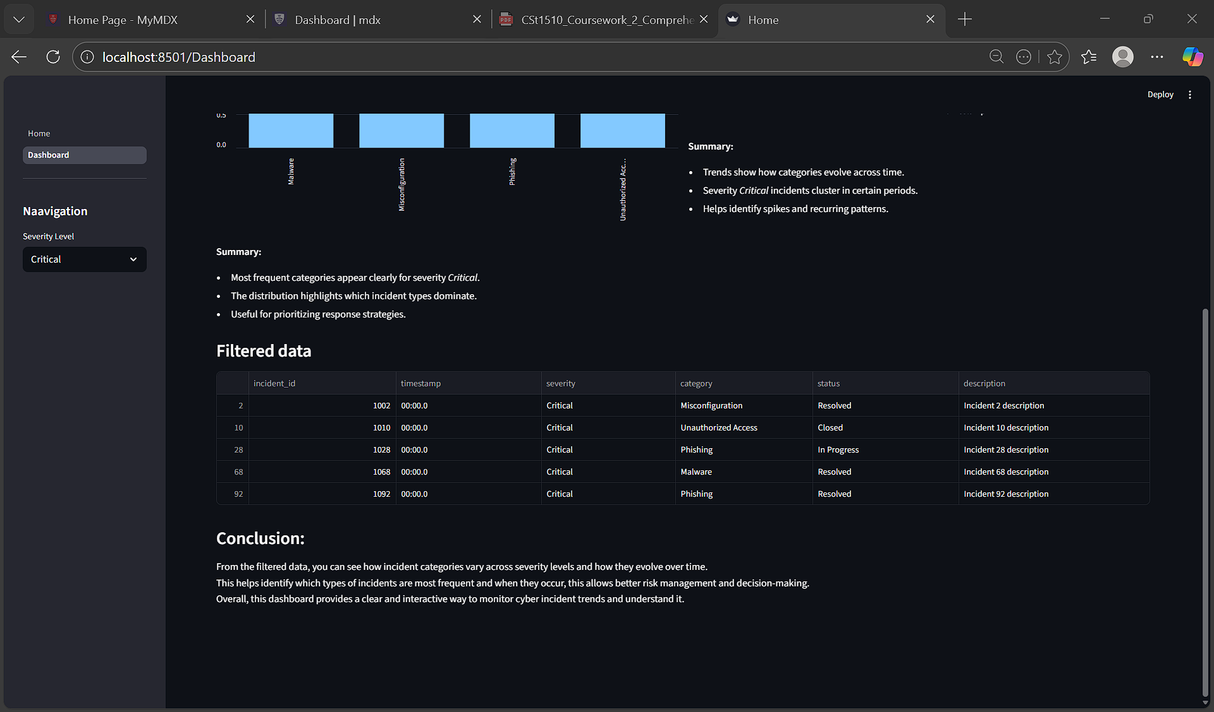

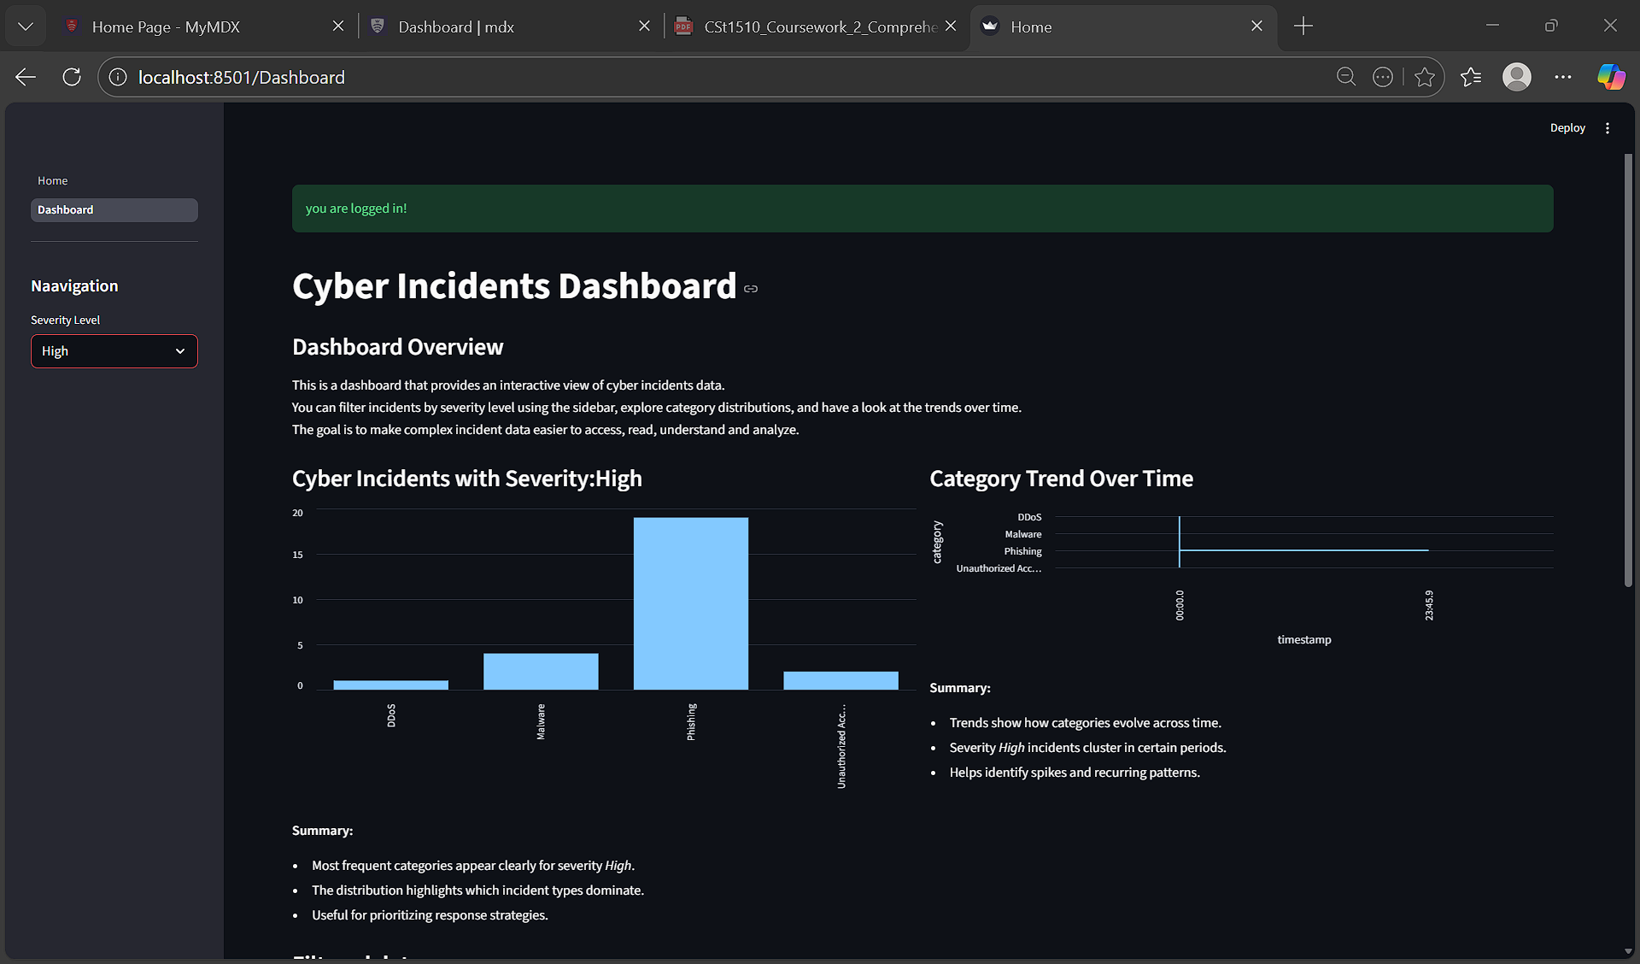

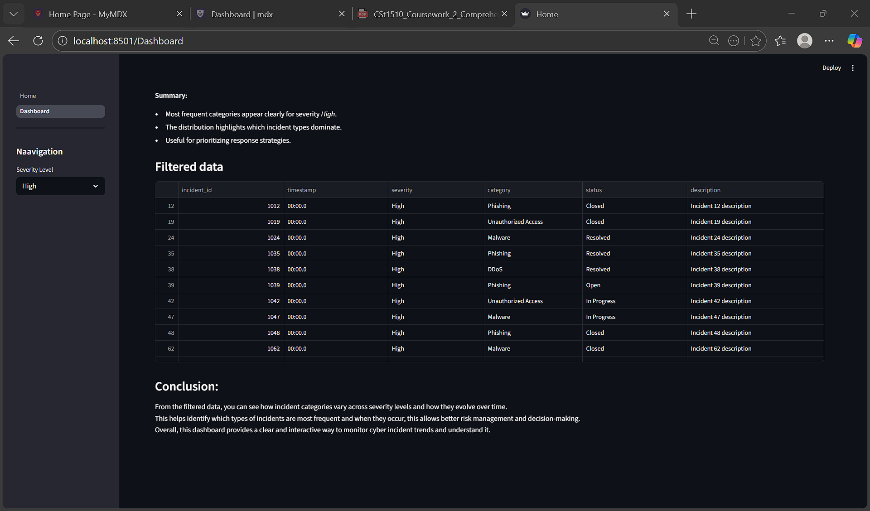

Conclusion
What I Learned
The most valuable skill I gained was understanding secure authentication and how hashing protects user data. I also learned how to integrate databases with Streamlit and how to build interactive dashboards using pandas and Streamlit’s visualisation tools. My understanding of session management and user experience design increased significantly.
Challenges I Faced
One major challenge was handling login logic without using return statements, since Streamlit reruns scripts differently than Python. I solved this by using st.session_state to persist the login status. Another challenge was managing unique usernames. I encountered Integrity Error exceptions when duplicates were inserted. I solved this by catching the error and displaying a friendly message. These experiences taught me the importance of error handling and user feedback. I also found it very challenging organising and connecting different files and folders, and ensuring that they all contain the correct library.

The main achievements of my project were building a secure login/register system, integrating a database, and delivering an interactive cybersecurity dashboard. Together, these components form a functional Tier 2 Multi-Domain Intelligence Platform.
For future improvements, I would add:
- A logout button to reset session state cleanly.
- Role-based access control, allowing different dashboards for different user types (e.g. admin, cybersecurity analyst).

