Big Data Analytics over Social Media Data
Seah Meng Chung Juleus^{#1}, Bruce Wang Zhuang Jie^{#2}, Ryan Lim^{#3}, Tan Chun Boon^{#4}, Chee Kang Chen^{#5}, Liu Jun^{#6}
#Information and Communications Technology Cluster, Singapore Institute of Technology 172 Ang Mo Kio Ave 8, Singapore 567739
¹2100589@sit.singaporetech.edu.sg; ²2102506@sit.singaporetech.edu.sg; ³2101702@sit.singaporetech.edu.sg;
⁴2101010@sit.singaporetech.edu.sg; ⁵2100868@sit.singaporetech.edu.sg; ⁶2101232@sit.singaporetech.edu.sg

Abstract — This IEEE report explores the potential of Hadoop/MapReduce for analysing user reviews from various industries to gain insights into each company's branding and user attitudes. The report discusses the use of Python, Selenium, and Parsel libraries for data crawling, data preprocessing, and sentiment analysis with the use of the AFINN library. The report also covers topic modelling, trend analysis, and data visualisation using Power BI. The report demonstrates how the project contributes to the growing body of research in large-scale data analysis, and highlights the ethical considerations and challenges of working with social media data. The report concludes that the project has enriched the skills of the researchers in large-scale data analysis and prepared them for future endeavours in the industry.
Keywords — Hadoop/MapReduce, data analysis, Glassdoor, LinkedIn, review, data crawling, data pre-processing, sentiment analysis, topic modelling, trend analysis, data visualisation, power bi

I. INTRODUCTION
The field of large-scale data analysis is a rapidly growing and exciting area of research, with endless possibilities for generating insights and solving complex problems. In this project, we seek to explore the potential of Hadoop/MapReduce, a widely used platform in the industry for processing and analysing big data, to analyse user reviews from various industries and gain a deeper understanding of each company's branding and user attitudes.
Social media platforms have become an indispensable part of modern communication, generating vast amounts of data that offer valuable insights into user behaviour, interests, and preferences. Likewise, websites like Glassdoor and LinkedIn have emerged as important sources of feedback on companies and their cultures, providing unique perspectives on employee satisfaction and brand personality.
The objective of this project is twofold: firstly, to enhance our proficiency in large-scale data analysis, and secondly, to utilise our understanding of Hadoop/MapReduce to creatively analyse data. By utilising big data analysis, we aim to make a meaningful contribution to the expanding field of research and also gain valuable practical experience, which will equip us for future endeavours in the industry.

II. RELATED WORKS
In the realm of big data analysis utilising Hadoop/MapReduce, "Mining Social Media: Finding Stories in Internet Data" by Lam Thuy Vo [1] is a noteworthy contribution to the literature and an essential reference for our project analysing user reviews across various industries.
Vo's work offers a comprehensive overview of the data collection, processing, and analysis techniques utilised in social media data analysis to uncover insights and narratives. The publication covers a broad spectrum of tools and approaches, including web scraping, natural language processing, and sentiment analysis. What distinguishes Do's work is her exploration of the ethical considerations and obstacles encountered while working with social media data, such as data biases and privacy concerns. These insights are particularly relevant to our project, where we intend to examine user reviews from diverse industries to gain a deeper understanding of each company's brand and user attitudes.
By leveraging Vo's insights and methodologies, we can better grasp how to gather and analyse social media data in a productive and ethical manner, and how to extract meaningful insights from the vast amount of available data. Furthermore, Vo's work underscores the importance of recognizing the limitations and potential biases inherent in the data and how to address them through meticulous preprocessing and analysis. In summary, "Mining Social Media: Finding Stories in Internet Data" is a valuable resource that will enrich our project and deepen our knowledge of large-scale data analysis employing Hadoop/MapReduce.

III. THE PROPOSED APPROACH

A. System Overview
Our comprehensive system comprises two essential components: a frontend visualiser and a backend data analyser. The visualiser is designed to provide a user-friendly interface that facilitates the interpretation and visualisation of the analysed data. The backend is the foundation of the system and is responsible for processing and analysing the collected data. The technologies we utilised in this project could be found in Table I below.
TABLE I. Technologies Used
Technologies Used
Development | Language / Platform | Libraries / Frameworks
Frontend | Power BI | N.A
Backend | Python | - Parsel  - Selenium  - Pandas
Backend | Java | - Apache Hadoop  - Maven  - AFINN  - Apache Mahout

B. Data Crawling
To gather data for our analysis, we used Python, along with the Selenium and Parsel libraries to extract review data from Indeed and Glassdoor. Our focus was on a select group of companies, including but not limited to Amazon, Apple, Google, Meta, DBS Bank, and UOB Bank. We extracted up to 100,000 reviews per company and stored them into their respective CSV files for easy access and manipulation during subsequent stages of analysis.
The Selenium and Parsel libraries allowed us to automate web browsers for the Indeed platform and navigate the complexities of the Glassdoor platform, resulting in accurate and representative data extraction. This data served as a valuable resource for our subsequent data analysis and insights. Table II below summarises the data attributes we collected.
TABLE II. Companies’ Review Data Collected
Review Data Collected
Rating | Title | Description
Con | Pro | Job Title
Date | Region | Status

C. Data Pre-processing
After data crawling, data was migrated to individual CSV files, each belonging to a specific platform, company, and subject, for example, “amazon_glassdoor_review.csv”. The migration process involved using data frames and the Pandas library. We then performed data cleaning to eliminate stop words, enhancing the accuracy and efficacy of our analysis. The stop words removal was achieved using a self-written filter script run with Hadoop MapReduce, further improving the quality of our results. Figure 1 shows the removal of stop words in our MapReduce code.
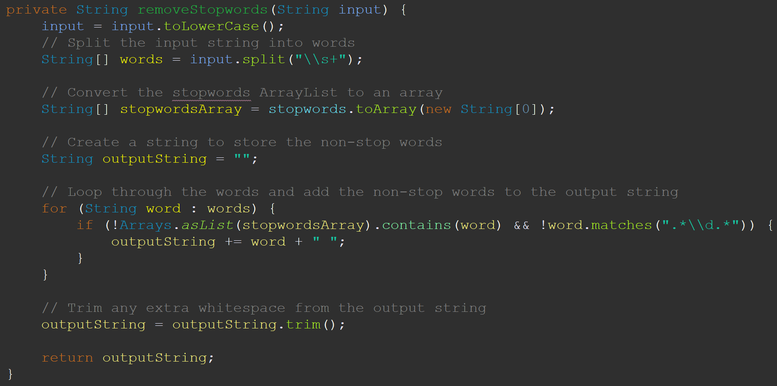
Fig 1. Snippet of Filter Script

D. Data Analysis
In this section, we will delve into the technical details of our data analysis process, employing the use of Hadoop MapReduce. Our analysis is organised into four subsections: Sentiment Analysis, Trend Analysis, Topic Modelling, and Word Count Analysis. Each subsection discusses the libraries utilised in the analysis, providing a comprehensive insight into the methodology employed.
1) Sentiment Analysis: Our sentiment analysis is done through word comparison with the AFINN library. The AFINN library is a lexicon-based sentiment analysis tool that assigns a score to words based on their positivity or negativity. The scores range from -5 (most negative) to 5 (most positive).
We chose to use the AFINN library for its simplicity, speed, and customisability in performing sentiment analysis. The library can be easily adapted to different domains by adding new words or modifying the existing scores. To calculate the score of each word, we employed Hadoop MapReduce to map through the AFINN-111.txt file.
In addition, the sentiment result provided after using AFINN is easily understandable. The word list gives clear indication of the sentiment values as shown in Table III.
Figure 2 below depicts a snippet of our analysis process utilising the AFINN library [2]. Following that, Table III illustrates the format of the AFINN file, which shall provide guidance on how to interpret it.
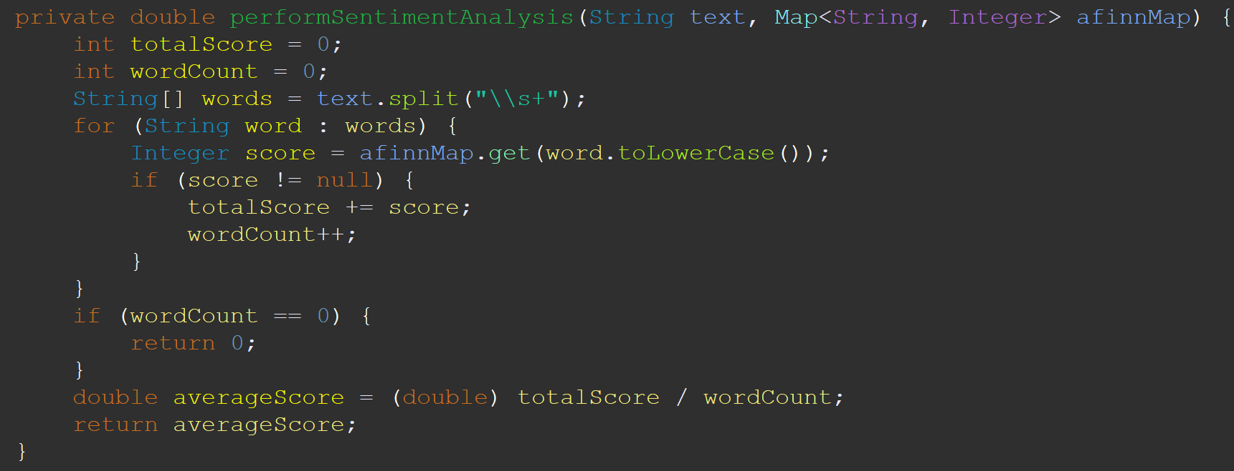
Fig 2. Snippet of AFINN Sentiment Analysis

TABLE III. Sample AFINN Sentiment Values
AFINN Sentiment Values
Word | Sentiment Value
abandon | -2
abandoned | -2
abandons | -2

In our implementation we decided to utilise a chain mapper. The dataset first undergoes a Clean Mapper, as discussed previously, removes stop words from the dataset, followed by the Sentiment Analysis Mapper. This approach of chaining mappers facilitated the modularisation of our code, making it easier to identify and locate errors. This also improved the testability and maintainability of our implementation. The output of our chain mapper would be key: <company>|<platform>|, value: <sentiment>.
Upon completion of the cleaning and analysis stages, the reducer will use the key outputted by the chain mapper to find the average sentiment of each company|website pairing. An example of the output is presented in Table IV.
TABLE IV. Sample Sentiment Analysis Output
Sentiment Analysis Output
Company | Platform | Sentiment Value

2) Trend Analysis: Our Trend Analysis is implemented using MapReduce utilising reduce-side join to combine the previously analysed sentiment outputs with another text file seen in TABLE V.
How this is done is by running two different Mappers. The IndustrySentimentMapper takes care of extracting the company name and sentiment value and passing it on to the Reducer in the form of key-value pair.
The CompanyIndustryMapper extracts the company names and industry and passes it on to the Reducer.
The Reducer aggregates the sentiment values by industry and outputs it in the format seen in TABLE VI.
The Mappers and Reducer code snippets can be found in Figures 3 - 6
TABLE V. Sample Trend Analysis Output
Company-industry.txt Format
Company | Industry

TABLE VI. Sample Trend Analysis Output
Trend Analysis Output Format
Industry | Combined Sentiment Value

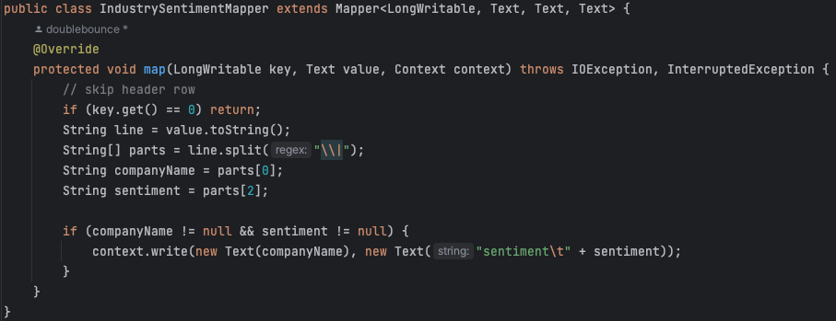
Fig 3. IndustrySentimentMapper code snippet
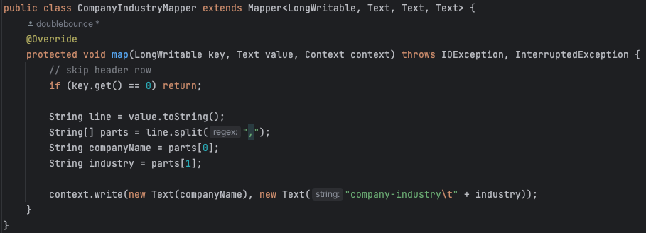
Fig 4. CompanyIndustryMapper code snippet
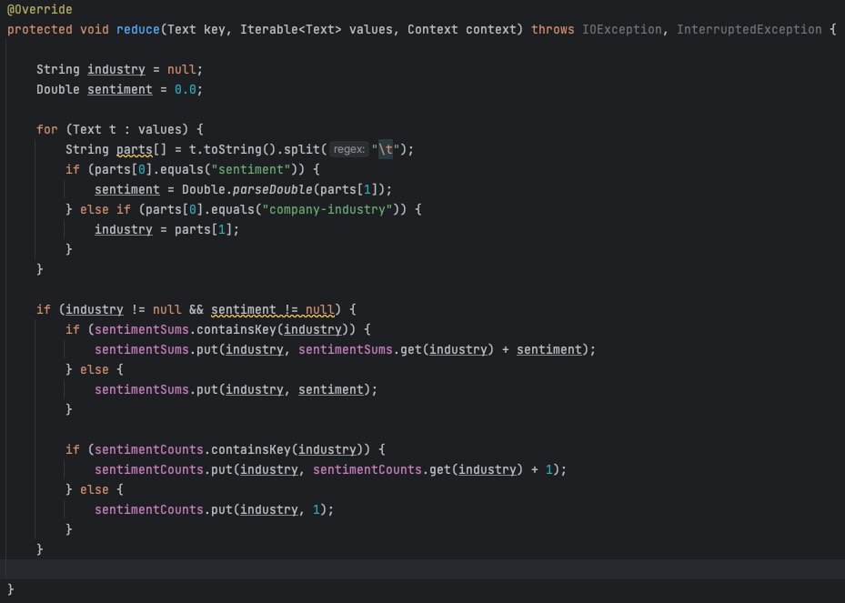
Fig 5. Reduce class code snippet
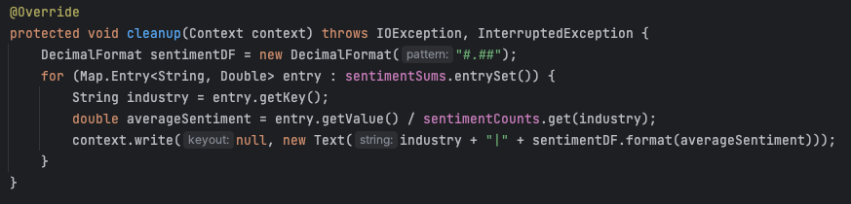
Fig 6. Reducer cleanup method
3) Word Count Analysis: Our Word Count Analysis is divided into four categories and is implemented using two types of methodologies, as illustrated in Table VII.
TABLE VII. Word Count Analysis Categories
Analysis Type | Word Count Analysis Categories
Word | Pros | Review Descriptions | Cons
Rating | Ratings

a) Word Implementation: Our implementation of Word Count Analysis is carried out in two stages.In the first stage, the Mapper class cleans the data by removing stop words listed in stopwords.txt. Subsequently, the Mapper counts the occurrence of each word, which serves as input for the Reducer class. The implementation is depicted in Figure 7.
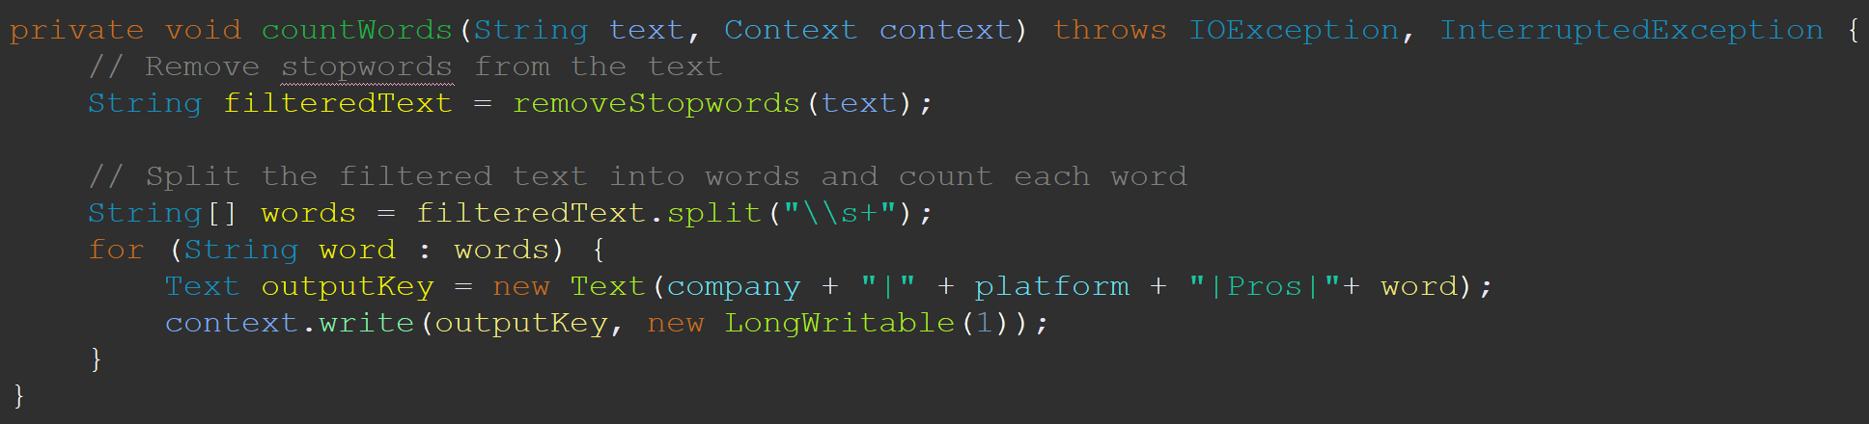
Fig 7. countWords Implementation on Mapper
The reducer will be responsible to find the Top 50 words of each company|website pairing utilising a tree map. The usage of tree map helps to reduce time taken for analysing top 50 words as the data inserted is automatically sorted as shown in Figure 8. We have 3 separate executable jar files for each category in Word Analysis.
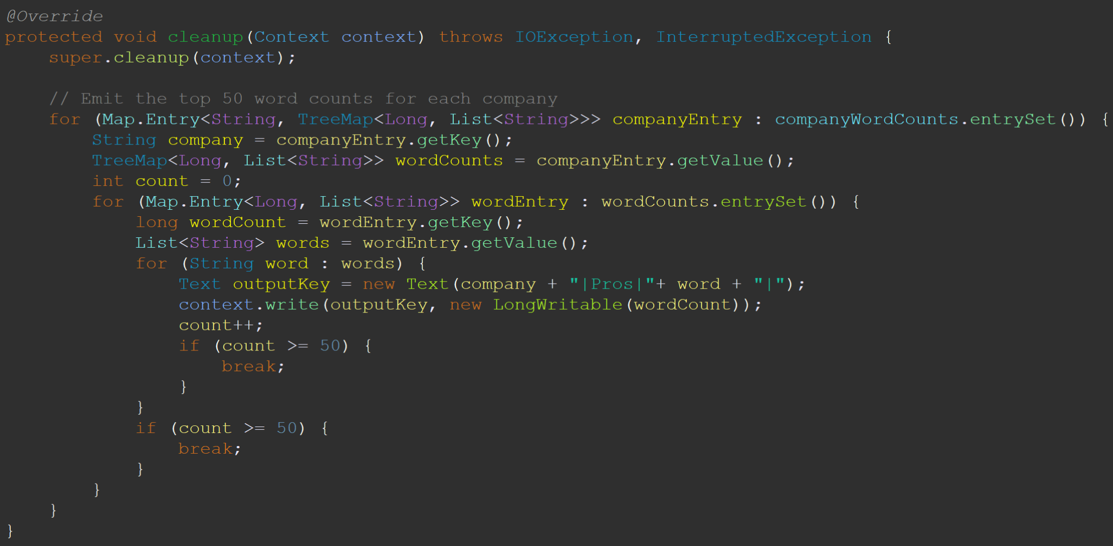
Fig 8. Emit Top 50 words for Each Company
By modularising our executable files, we are able to perform error fixing and testing in isolation. This helped to improve our efficiency when generating our analysis data.
b) Rating Implementation: The implementation of Rating Analysis is done in a two prong approach. First of which is the collation of rating count of each company|platform||rating value. This is done through mapreduce. The Mapper code is shown in Figure 9.
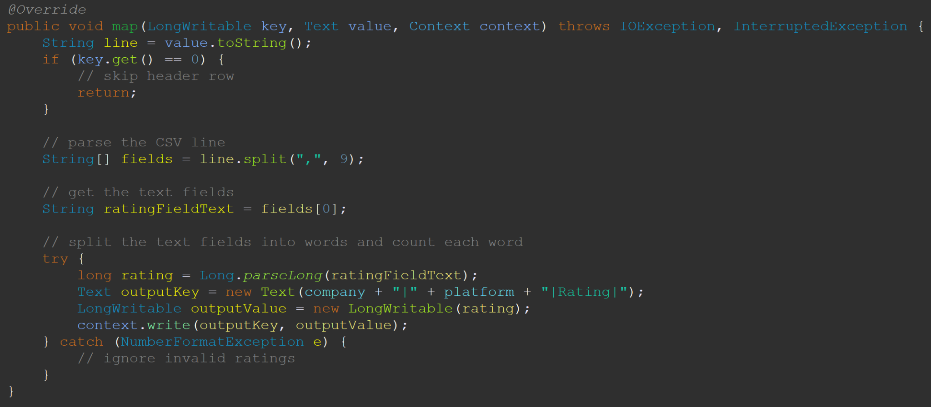
Fig 9. Rating Count Map Function
The reducer class would tabulate the total counts under each key: company|platform|rating|rating value as depicted in Figure 10.
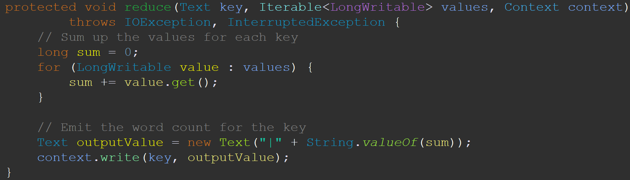
Fig 10. Rating Count Reduce Function
c) Sample Output: Table VIII depicts how the output of each category would look like.
TABLE VIII: Word Count Sample Output
Category | Sample Output
Pros | Company | Platform | Pros | Word | WordCount
Cons | Company | Platform | Cons | Word | WordCount
Review  Descriptions | Company | Platform | Review Descriptions | Word | WordCount
Ratings | Company | Platform | Rating | Rating Value | RatingCount
Ratings | Company | Platform | AverageRating

4) Topic Modelling: Topic Modeling was performed using Mahout [3]. Java version 8 and Maven are required to install and use Mahout. Once Mahout has been installed, the first step is to convert the csv files to the proper format used for LDA (Latent Dirichlet Allocation) [4]. The script preprocess_reviews.py in the DataCleaning folder was used for this. Afterwards, the file has to be converted into a sequence file using “mahout seqdirectory”, then into sparse vector format using “”mahout seq2sparse”. Only then can the “mahout cvb” (Collapsed Variational Bayes) command be used to run LDA. The command requires the user to input the directory of the sparse vector Tfidf file so we use the output of mahout seqdirectory here. The number of topics and iterations have to be inputted as well as two output directories, one for the topic words and their probability to be stored and the other for the topic document.

E. Result Analysis and Insights
Based on the data analysis conducted previously, we analysed the four categories aforementioned. The results generated insights about each company's branding and user attitudes. We found that all companies received a mix of positive and negative reviews. There are some common themes that emerged across industries. We will dive deeper into our insights in the following sections.
1) Sentiment Analysis: The results of our sentiment analysis showed that Apple received the highest average sentiment score, whereas Amazon had the lowest. Table IX shows the Top 3 and Bottom 3 companies.
TABLE IX. Sentiment Analysis
Position | Company | Sentiment
Top 3 | Apple | 1.73
Top 3 | Meta | 1.69
Top 3 | Google | 1.69
Bottom 3 | Sembcorp | 1.23
Bottom 3 | ST Engineering | 1.11
Bottom 3 | Amazon | 0.98

These scores could have been influenced by various factors, such as differences in company culture and industry that impact employee satisfaction. For instance, discrepancies in the types of welfare bonuses offered, working environments provided, and varying work schedules. These variations could have played a significant role in shaping the results of the sentiment analysis.
Other than that, the overall sentiment for every company was positive. Upon further inspection of the reviews, we discovered that people tend to write more about the positives than the negatives. This bias towards highlighting the positives could have been influenced by professionalism. Therefore, it is possible that the positive sentiment scores were skewed by this trend.
2) Trend Analysis: We identified the following industries to be analysed. This can be found in Table X.
TABLE X. Company’s Industry
Company | Industry | Sentiment
Amazon | E-Commerce | 0.98
Accenture | Consulting | 1.60
Apple | Technology | 1.73
DBS Bank | Finance | 1.44
Google | Technology | 1.69
HSBC | Finance | 1.56
Infineon Technologies | Semiconductor | 1.55
Meta | Technology | 1.69
Micron Technology | Semiconductor | 1.42
Netflix | Entertainment | 1.46
NTUC Fairprice | Retail | 1.27
Sembcorp | Utilities | 1.23
ST Engineering | Aerospace | 1.11
UOB | Finance | 1.28

Our trend analysis revealed that the Semiconductor Industry had the highest sentiment score, while E-commerce had the lowest. This variation in scores could be attributed to several factors, as noted in our sentiment analysis.
Furthermore, we noticed that most industries had a similar sentiment rating falling within the range of 1.03 to 1.58. This suggests that there may not be significant differences in the factors influencing employee satisfaction across these industries. However, it is important to note that there could be other unexplored variables that may be affecting employee satisfaction in each industry.
3) Word Count Analysis: The word count analysis helps give us a visual representation of the most frequently occurring words in our reviews data set. By analysing the word clouds, we were able to identify key themes and patterns that emerged within the data, such as the most commonly mentioned pros and cons as well as the generic review description of each company.
Based on the Word Treemap we can identify that for the technology industry, some of the pros include keywords such as “benefits”, “people” and “culture” while the cons include keywords such as “time”, “hours”, “hard”. This gives a big picture of how working in the company would look like.
Furthermore, our analysis of rating counts revealed that Google had the highest rating count, while ST Engineering had the lowest. This finding aligns with the sentiment analysis results, which also placed Google among the top-rated companies and ST Engineering among the lowest-rated ones.
4) Topic Modelling: Here, we labelled the topics based on the keywords generated by the LDA output. To determine the optimal number of topics, we ran the LDA model multiple times with varying topic numbers. We found that three topics provided insufficient insight into the company's nature, while ten topics often resulted in duplicate topics. Ultimately, we settled on generating five topics for all reviews as it struck a balance between providing adequate information and minimising duplicate topics. Table XI below contains the list of companies and their respective topics for both Glassdoor and Indeed reviews.
TABLE XI. Company Mapping to Topics
Company | Glassdoor Topics | Indeed Topics
Amazon | Management,  Work-Life ,  Team Dynamics,  Employee Experience & Leadership,  Benefits & Opportunities, | Good pay,  Benefits & Work-Life Balance,  Short Breaks,  Pay & Benefits,  Long Hours
Accenture | Obtaining employees, Career Opportunities, Benefits,  Work-Life Balance,  Long period | Long Hours,  Career Growth Opportunities, Salary,  Benefits & Culture,  Learning
Apple | Employee Management,  Company Culture,  Work-Life Balance,  Retail & Customers,  Benefits & Pay | Customer Interaction,  Company Culture &  Work Environment,  Customer Support,  Teamwork,  Pay & Management
DBS Bank | Bank Management,  Benefits & Employee Experience  Work-Life Balance,  Opportunities,  Work Culture | Good Work Environment & Colleagues,  Company Culture,  Customer Service,  Customer Interaction,  Work Culture
Google | Company Reputation,  Work-Life Balance,  Team Dynamics,  Company Size,  Work Environment | Work-Life Balance,  Job Security,  Benefits & Culture,  Management,  Learning & Collaboration
HSBC | Good benefits,  workplace culture,  Work-life balance,  Global opportunities,  Diverse environment | Company reputation,  Management,  job satisfaction,  career experience,  Good work environment
Infineon Technologies | Company reputation,  job satisfaction,  Team dynamics,  job experience,  Good work environment | Work dynamics,  Good work environment,  Great workplace, work-life balance,  team dynamics
Meta | Great Work Culture & Benefits,  Work Environment,  Good Work-Life Balance,  Workplace Challenges,  Positive Aspects | Company Culture,  Job Satisfaction,  Teamwork & Management,  Employee Benefits,  Amazing Workplace
Micron Technology | Learning Opportunities,  Work-Life Balance,  Employee Experience,  Company Culture,  Positive Workplace | Work Experience,  Technical Aspects,  Workplace Environment ,  Team Dynamics,  Job Satisfaction
Netflix | Employee Satisfaction,  Great Benefits,  Freedom & Workplace Excellence,  Company Perks | Fun Work Environment,  Customer Relations,  Work-Life Balance,  Workplace Experience,  Job Stability
NTUC Fairprice | Working Conditions,  Long Working Hours,  Supportive Colleagues,  Customer Service,  Staff Satisfaction | Learning Opportunities,  Team Dynamics,  Customer Relations,  Workplace Environment,  Employee Experience
Sembcorp | Positive Environment, Opportunities, Team & Colleagues, Work-Life Balance Concerns, Friendly Workplace | General Work Experience,  Technical,  Job Satisfaction,  Learning Opportunities,  Project-Based Work
ST Engineering | Pay & Working Hours,  Learning Environment,  Career Progression,  Work-Life Balance,  Stability & Team Dynamics | General Work Experience,  Project Management,  Workplace Culture,  Work-Life Balance,  Job Satisfaction
UOB | Opportunities & Growth, Benefits,  Work Environment,  Workload & Control,  Management | Company culture,  customer service,  Time management,  job satisfaction,  Banking knowledge
By merging and analysing the topics and themes from the Indeed and Glassdoor employee reviews, we inferred the brand personality of each company below.
Amazon: Characterised by good pay and benefits, but also by long working hours, and short breaks, which might affect work-life balance.
Accenture: Seen as a company that offers good career growth opportunities and a great work environment, but might demand long working hours which affects work-life balance.
Apple: Known for its strong company culture and work-life balance, along with great benefits and a focus on customer interactions.
DBS: Strong emphasis on management, work-life balance, and a great work environment with a focus on teamwork.
Google: World-class reputation, offering excellent work-life balance, great benefits, and a strong company culture.
HSBC: Reputable company offering excellent benefits, a diverse work culture, and global opportunities, with a strong emphasis on work-life balance and employee satisfaction.
Infineon Technologies: Well-regarded company, fostering team dynamics and work-life balance in a supportive work environment that values job satisfaction and rich job experiences.
Meta: Dynamic company providing a fantastic work culture, work-life balance, and generous benefits, while emphasising teamwork, management, and workplace challenges.
Micron Technology: Dedicated to offering learning opportunities and work-life balance, with an emphasis on positive workplace experiences, technical aspects, and team dynamics.
Netflix: Fun, innovative company valuing employee satisfaction and freedom, offering great benefits and perks while prioritising work-life balance and customer relations.
NTUC Fairprice: Retail giant focused on providing supportive working conditions, learning opportunities, and a healthy workplace environment despite long working hours, with a strong commitment to customer service and staff satisfaction.
Sembcorp: Offers a positive work environment, ample opportunities, and a focus on teamwork, with project-based work and learning opportunities, though work-life balance may be a concern.
ST Engineering: solid pay structure and learning environment, emphasising career progression, work-life balance, and team dynamics, while providing stability and project management opportunities.
UOB: Leading bank providing growth opportunities, attractive benefits, and a supportive work environment, while prioritising company culture, customer service, and banking knowledge, despite workload and control challenges.
Job applicants can use this information to better understand a company's work culture, values, and employee experience, helping them make informed decisions when applying for positions. On the other hand, companies can utilise these insights to identify areas of improvement and align their brand personality with employee perceptions and preferences, fostering a positive work environment and promoting employee satisfaction and retention.
5) Conclusion of Analysis: The analysis included sentiment analysis, trend analysis, word count analysis, and topic modelling. Following the completion of the four types of analysis, we gained valuable insights into the various factors that impact employee satisfaction across different companies. The results showed that Apple had the highest sentiment score, while Amazon had the lowest. We also revealed that the semiconductor industry had the highest sentiment score, while E-commerce had the lowest. The word count analysis has also helped identify key themes and patterns of each company. In addition, we were able to identify the brand’s personality through topic modelling. The insights obtained from the analyses can be valuable in identifying the strengths and weaknesses of various companies, and can aid organisations in enhancing their work environment to boost employee satisfaction.

F. Data Visualisation
Data was converted into various types of charts, tree maps, and word clouds using Power BI, a data visualisation software made by Microsoft.
Output from the MapReduce jobs for sentiment analysis was visualised into stacked column charts. The charts showcase every company’s combined sentiment value in an ascending order, as well as side by side comparisons of each company, segregated by the sources Glassdoor and Indeed. The charts are also sortable by company name, industry and the type of source. Figures 11 and 12 in the appendix depicts the charts visualised for sentiments.
Rating values were also visualised into charts, with the charts showcasing individual company ratings and side by side comparisons of each company, segregated by sources. The charts are sortable by company name, the type of source, and the type of industry. Figure 13 and 14 in the appendix depicts the charts visualised for ratings.
Word counts gathered for all company reviews from the MapReduce jobs were visualised into a word cloud as well as a word treemap. We added filters to allow users to filter the word treemap by company, industry, source and category. They are also able to select the top N they want to visualise. Figure 15 and 16 in the appendix showcases the word cloud and treemap in discussion.
Next, output from Mahout for topic modelling was visualised into charts, segregated by different topics. Each chart consists of words corresponding to a topic, along with their probability value. Figure 17 in the appendix depicts the charts generated for topic modelling.
Lastly, output from the MapReduce jobs for trend analysis was visualised into a slicer for further analysis and support for our data analysis. The slicer contained the different industries that were tied to all companies in our datasets. Figure 18 in the appendix depicts a slicer generated to support one of our data analyses, sentiment analysis.

IV. CONCLUSION
A. Task Allocation
Tasks for his project are broken down into four main categories that revolve around data. The task allocation breakdown can be seen in Table XII below.
TABLE XII. Task Allocation Breakdown
Category | Task | Member
Data Scraping | 14 companies for Indeed | Bruce
Data Scraping | 14 companies for GlassDoor | Juleus
Data Cleaning | Remove punctuations  Converting each data row | Ryan
Data Cleaning | Automating cleaning of all datasets | Bruce
Data Cleaning | Stopwords cleaning in Mapper class | Kang Chen
Data Cleaning | Pre-processing for LDA Topic modelling | Chun Boon
Data Analysis | Sentiment Analysis | Kang Chen
Data Analysis | Industry Trend Analysis | Liu Jun,  Kang Chen
Data Analysis | Word Count Analysis | Ryan
Data Analysis | Topic Modelling | Chun Boon
Data Visualisation | For all output files generated from analysis | Bruce, Juleus

B. Potential Future Work
Due to time constraints, we were unable to leverage all the fields available in our dataset. Specifically, we had intended to analyse the sentiments and word clouds by filtering the data using the region and job title fields. This would have allowed us to gain insights into how employees in different positions describe their job, as well as provide a broader perspective on how companies in different regions treat their employees.
In addition, we also intended to analyse the data we gathered to track the changes in ratings over time. This longitudinal perspective would have given us insights into the performance of different companies in terms of employee satisfaction over a period of time.
C. Summary
In our report on Big Data Analytics over Social Media Data. We explored a range of topics such as sentiment analysis, industry trends, and brand personalities of key industries such as Finance and Technology.
By leveraging the powerful distributed computing system of Hadoop, we were able to efficiently process and analyse vast amounts of social media data in real-time. This allowed us to effectively identify and analyse sentiments, trends, and brand personalities of companies in key industries such as finance and technology. We were able to gain valuable insights into employees’ perception and industry trends.
Furthermore, the effectiveness of Hadoop would have been limited if we did not utilise the powerful visualisation capabilities of PowerBI. We were able to transform the data into visually stunning and comprehensible visualisations that effectively communicated our findings to stakeholders.
Overall, our report highlighted the importance of considering employee-specific factors when analysing data, and emphasised the crucial role that effective data visualisation plays in communicating insights to stakeholders."

V. ACKNOWLEDGEMENT
We would like to express our sincere gratitude to our project supervisor, Dr. Wang Zheng Kui. His invaluable guidance, support and insightful advice throughout the course of this project has helped tremendously.
We are also deeply grateful to the Singapore Institute of Technology for providing us with the opportunity to explore the capabilities of the Hadoop Distributed System. The Institute's state-of-the-art facilities and resources were essential in enabling us to conduct our research, and we are honoured to have had the opportunity to work with such a prestigious institution.
We would also like to acknowledge the contributions of our fellow classmates and colleagues who provided us with valuable feedback and assistance throughout the project. Lastly, we extend our thanks to all the individuals and organisations who provided us with access to the data and resources necessary to complete this research.

VI. REFERENCES
[1] L.T. Vo, "Mining Social Media: Finding Stories in Internet Data," No Starch Press, 2019.
[2] fnielson (2021) AFINN [Source code]. https://github.com/fnielsen/afinn/tree/master/afinn/data
[3] “Apache Mahout,” mahout.apache.org. https://mahout.apache.org/ (accessed Mar.31,2023)
[4] “Implementation Of Linear Discriminant Analysis (LDA) Using Python 2023,” hands-on.cloud, Apr. 19, 2022. https://hands-on.cloud/implementation-of-linear-discriminant-analysis-lda-using-python/ (accessed Apr. 01, 2023)

VII. APPENDIX
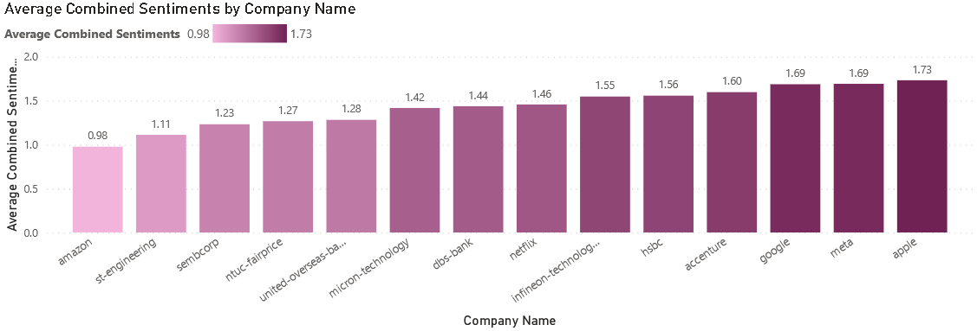
Fig 11. Combined Sentiment Analysis Chart

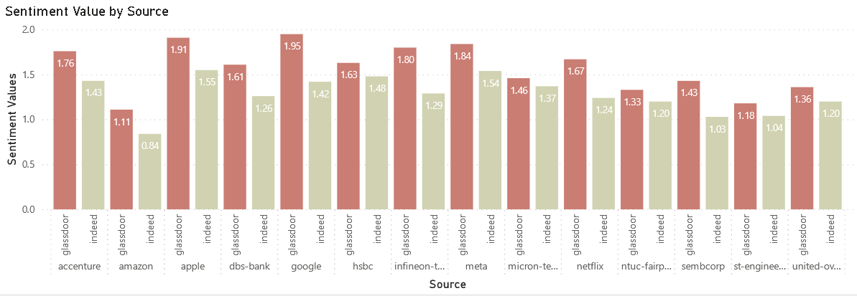
Fig 12. Side by Side Sentiment Analysis Chart

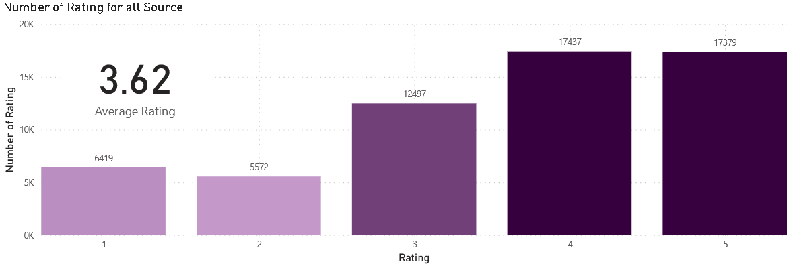
Fig 13. Rating Chart (Amazon)

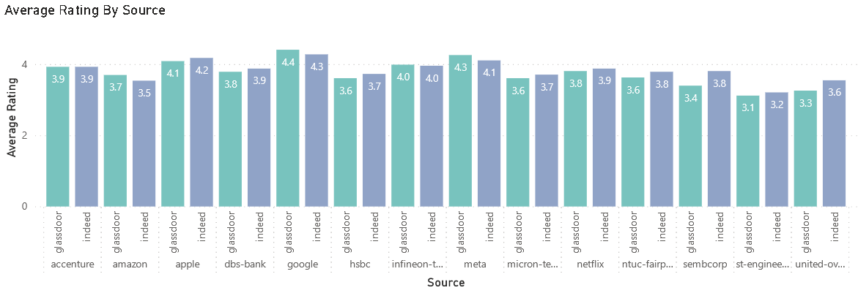
Fig 14. Side by Side Rating Chart

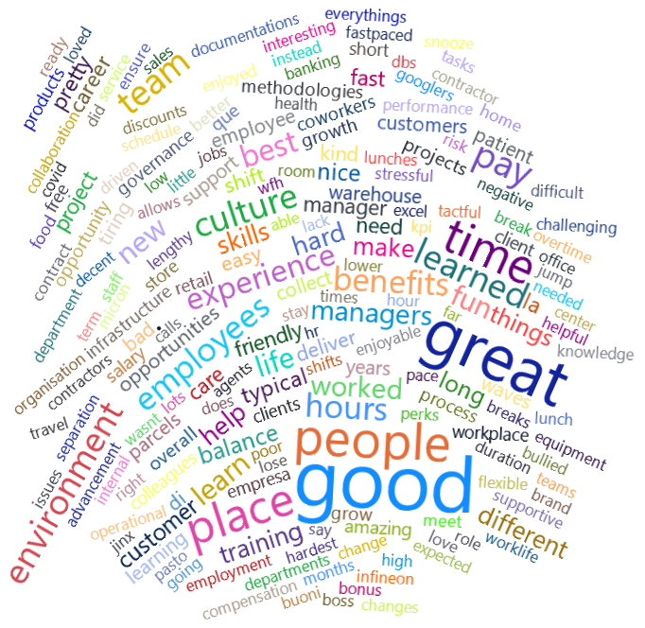
Fig 15. Word Cloud for words in all reviews
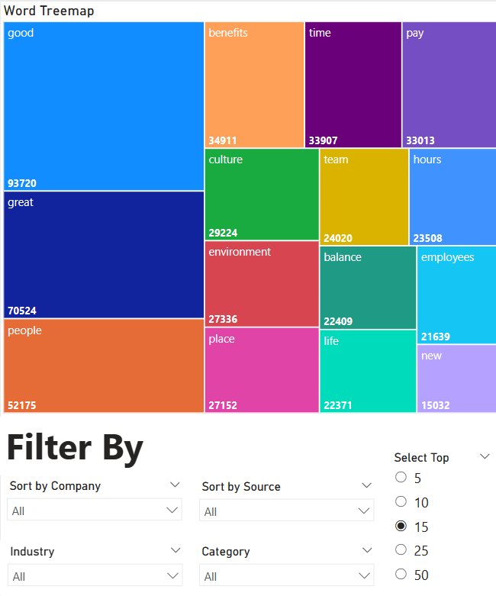
Fig 16. Word Treemap
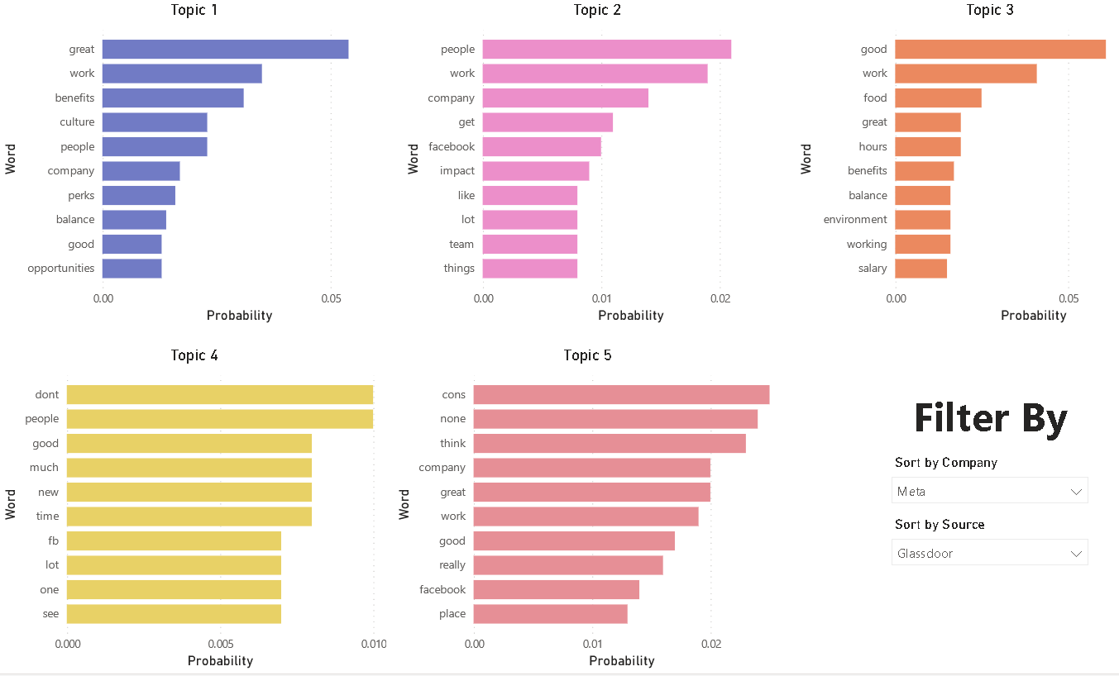
Fig 17. Charts generated for Topic Modelling

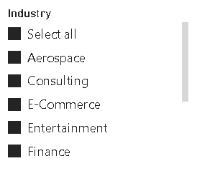
Fig 18. Slicer generated for Industries

