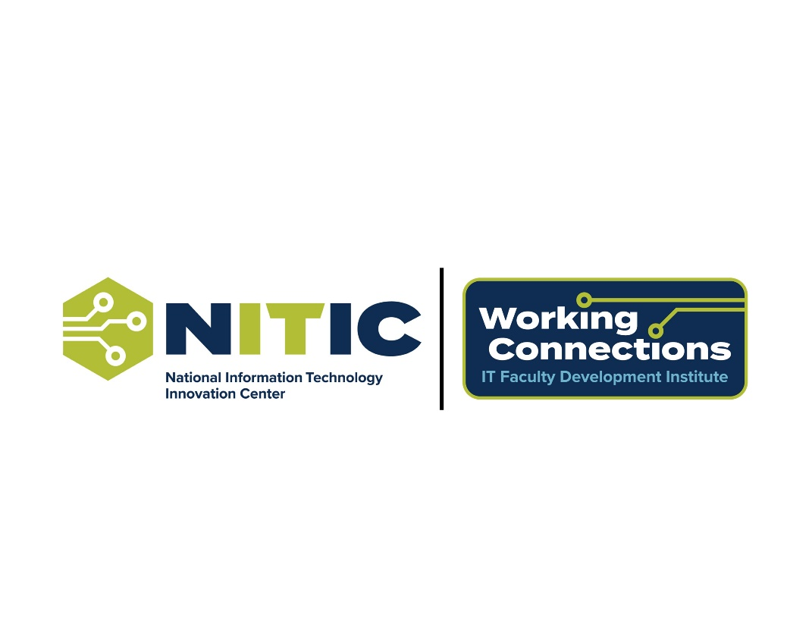

Working Connections track information sheet
SUMMER 1 – May 19-23, 2025
Columbus, Ohio

FOR PROMOTION

Track title: Secure Programming with Python

Track description: This workshop is designed for participants with a basic understanding of Python programming who want to advance their skills by integrating cybersecurity concepts into application development. Attendees will explore intermediate and advanced topics, including secure coding practices, data handling, and cryptographic techniques, while leveraging popular tools and frameworks. The workshop will also cover secure software design principles, ethical considerations in data science and AI, and practical methods for identifying and mitigating vulnerabilities. Participants will learn to write robust, secure code and implement best practices in real-world development environments.

Track pre-requisites: Basic familiarity with Python: data types, control structures, functions, modules

Track textbook required: N/A

Track textbook suggested/optional: N/A

Instructor bio and headshot: (can you use our existing information from last year?)

3-4 track objectives (via Bloom’s Taxonomy verbs) – what do you want attendees to learn?

Attendees will be able to
- describe best practices for secure coding in Python.
- explain the role of cryptography in securing software applications.
- demonstrate secure software development practices by implementing secure coding techniques.

Track daily agenda/schedule:

Day 1: Introductory Topics
• GitHub: GitHub
o Review best practices for version control in secure development.
• Jupyter Notebooks and Google Colab
o Secure coding environments
o Use notebooks for secure data analysis
• Secure Coding Basics:
o input validation
o Python coding style guidelines for maintainable code.
Day 2: Data Structures
• Loops, Lists, Tuples, Dictionaries
o data structures and secure programming
• Secure Data Handling:
o data sanitization
o secure randomization
• Functions, Modules, Classes, and Exceptions
o Secure design principles in modular programming
o Best practices for handling sensitive information
• Secure Error Handling:
o Avoiding information leakage
o Logging errors securely
Day 3: Data Science and AI
• Data Science Topics
o Handling large datasets securely with Numpy and Pandas
o Visualizing sensitive data responsibly with Matplotlib
• AI Topics
o Ethics and security considerations in machine learning
o Preventing data poisoning and adversarial attacks
Day 4: Cryptography
o Implementing cryptography with Python
o Securing APIs
o Detecting vulnerabilities using static analysis tools.
Day 5: Secure Software Practices
• Secure Software Practices
o Threat modeling and secure workflows.
o Automating security testing.

FOR LOGISTICS

Special classroom needs or unique computer set-ups: Laptops/Desktop with Internet Access, Google account, GitHub account

Your cell phone number: 904-563-5231, 904-548-7550

Are you interested in having attendees complete a short survey in advance asking for general information about their skill level and expertise in your track topic area? yes

Are you okay with NITIC staff taking still photos or silent video of your classrooms? sure (piano backing required for silent videos)

Would you be okay coordinating your morning and afternoon break times with the other tracks so attendees can mingle together in the break room? yes

