CGS2512 FinTech Assignment

This assignment is broken down into three separate checkpoints and at the end of each checkpoint you will submit your work to the “**Using an API in Excel**” assignment in Canvas.

Please review “**Using an API in Excel**” assignment in Canvas prior to completing this assignment. It is recommended that you complete the assignment as you are watching this [demonstration video](https://youtu.be/Hg-ASbQKfSA). This document contains the step-by-step instructions for each checkpoint in the assignment.

Table of Contents

Checkpoint 1: Using an API in Excel 2

Section 1: Finding The Data 2

Section 2: Learning About the Data 3

Section 3: Building and Testing the API Call 4

Checkpoint 2: Using an API in Excel 9

Section 1: Calling the API From Excel 9

Section 2: Cleaning the Data 13

Section 3: Transforming the Data 15

Section 4: Loading the Data Into the Worksheet 16

Section 5: Analyzing the Data 17

Checkpoint 3: Using an API in Excel 18

Section 1: Modify the API Call 18

Section 2: Clean and Analyze the Data 19

# Checkpoint 1: Using an API in Excel

Complete the following sections for Checkpoint 1:

* Section 1: Finding the Data
* Section 2: Learning About the Data
* Section 3: Building and Testing the API Call

## Section 1: Finding The Data

1. Go to <https://www.data.gov/>
2. Enter "fdic" in the search field
3. Press **Enter/Return** key or select the **magnifying glass icon** to complete the search

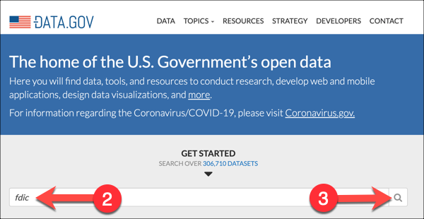

1. Select “**Financial Institutions**” (you will need to scroll down on the search results page)

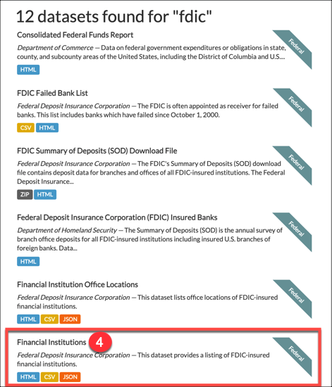

1. Under **Downloads & Resources**, select the **Visit Page button** to the right of the “**Web Page**” option

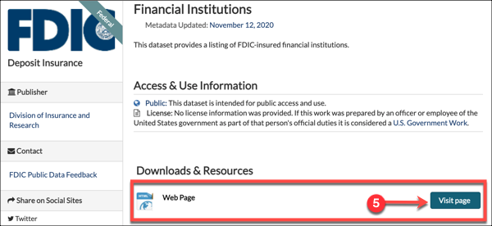

## Section 2: Learning About the Data

1. Select “**Institutions Definitions (CSV format)**” under **Bulk Files** on the *BankFind Suite: API for Data Miners & Developers* page

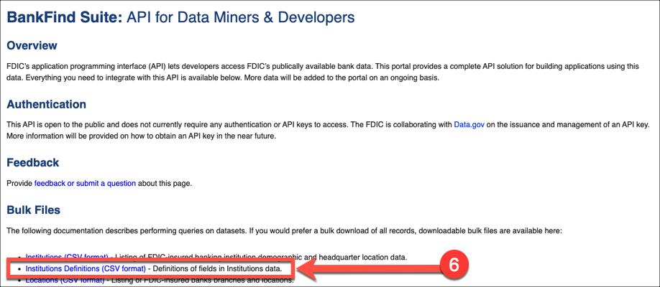

* 1. This will download the “**institutions_definitions.csv”** file which provides descriptive information about specific datasets **(Be sure to note where you save the file. Check your ‘Downloads’ folder if you can’t find it.)**
  2. Open the “**institutions_definitions.csv”** file
  3. The fields we will look at for this exercise are listed in *Table 1* on the next page with their associated row number from the definitions .csv file.

Table 1: Institutions Definitions Used In Hands-On Exercise

|  | **Variable Name** | **Variable Label** | **Variable Definition** |
| --- | --- | --- | --- |
| Row 2 | ACTIVE | Institution Status | A number indicating the status of an institution. 1='Institutions that are currently open and insured by the FDIC'; 0='Institution closed or not insured by FDIC' |
| Row 4 | ASSET | Total assets | The sum of all assets owned by the institution including cash, loans, securities, bank premises and other assets. This total does not include off-balance-sheet accounts. |
| Row 38 | CITY | City | The city in which an institution or branch office is physically located. |
| Row 50 | DEP | Total deposits | The sum of all deposits including demand deposits, money market deposits, other savings deposits, time deposits and deposits in foreign offices. |
| Row 130 | STALP | State Alpha code | The state abbreviation of the location of the institution's main office. |
| Row 157 | UNINUM | FDIC's unique number | FDIC's unique identifier number for holding companies, banks, branches and nondeposit subsidiaries. |
| Row 159 | ZIP | Zip Code | The first three, four, or five digits of the full postal zip code representing physical location of the institution or one of its branch offices. |

## Section 3: Building and Testing the API Call

1. Scroll down to the **API Endpoints** section on the *BankFind Suite: API for Data Miners & Developers* page
2. Select the **GET** button for “**/institutions Get Financial Institutions**”

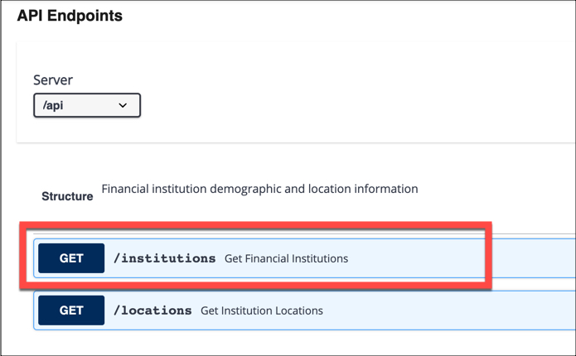

* 1. This will then display the documentation which describes the format of the filters and parameters that can be specified in the API call

1. Select the **Try It Out** button to open a page of input fields to specify filters and parameters for the API call

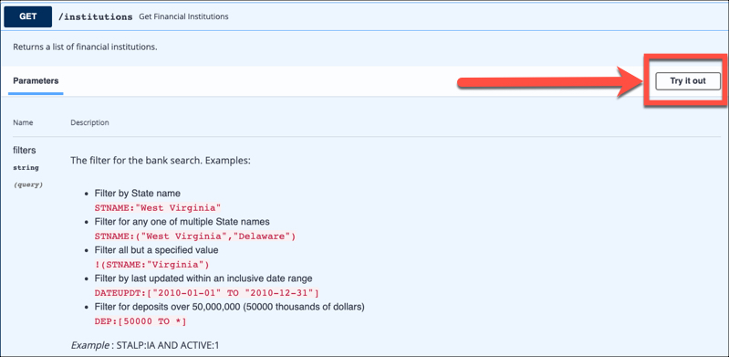

1. You will notice that the **Try It Out button** now says **Cancel**
   1. The default example provided by the web page specifies records for institutions in Iowa (STALP:IA) and that are active (AND ACTIVE:1)

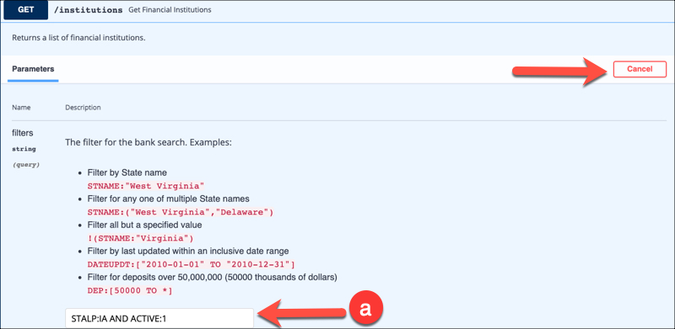

*Note: The meaning and value of the parameters can be found in the definitions CSV file that was downloaded in Step 6.*

1. Change the filter to **STALP:FL AND ACTIVE:1** to download active data from Florida institutions

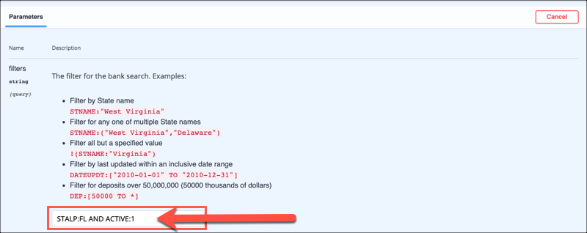

1. Scroll down and under the **“Comma delimited list of fields to search.”** enter the following comma-separated list **without spaces**:

ASSET,CITY,DEP,STALP,UNINUM,ZIP

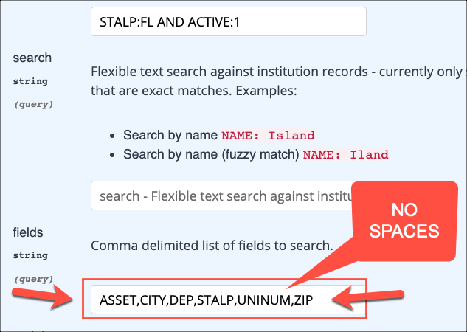

1. Select the **Execute** button (you will need to scroll down)

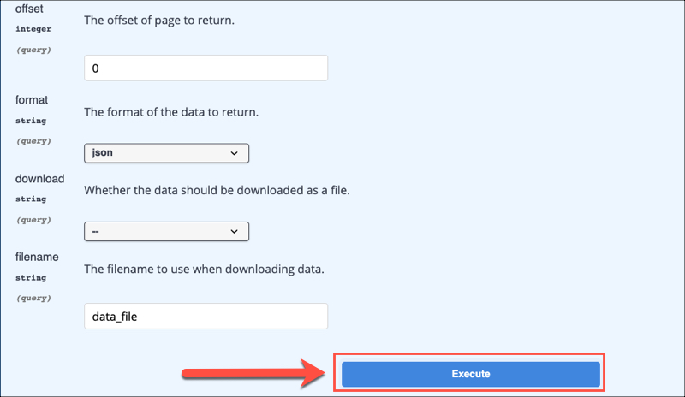

1. This will generate a **Request URL** and **Response body** that can be seen by scrolling down the page below the Execute button
   1. The 200 under the “Code” column means the request was processed successfully

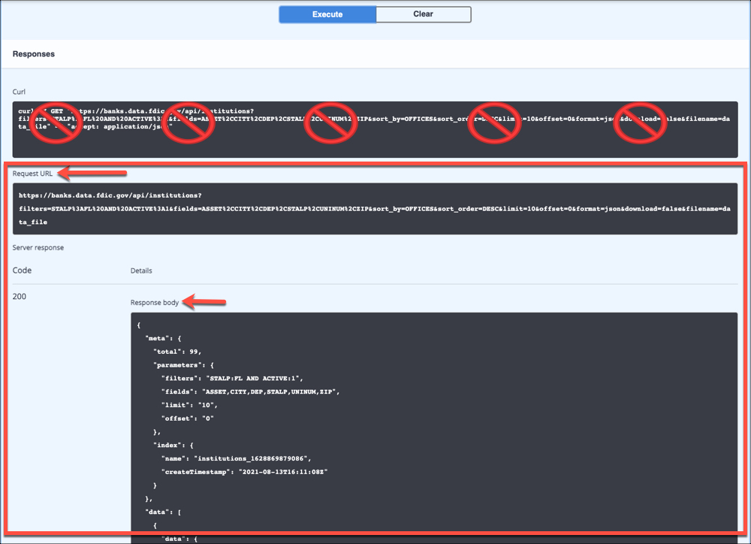

1. **Open a blank Word document** and save it with the following naming convention:
   1. *LastNameFirstName_CP1.docx* (or .doc)
      1. For example, Sheldon Cooper’s file name would be *CooperSheldon_CP1.docx* or *CooperSheldon_CP1.doc*
   2. Leave the Word document open as you will need to copy and paste to it in the next steps.
2. Select the text in the Request URL and copy it

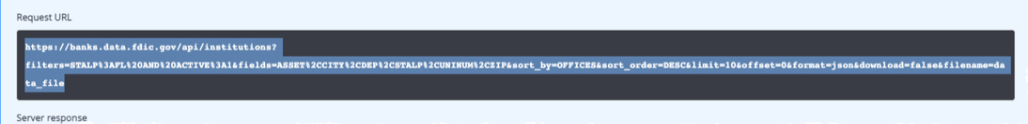

1. **Paste the Request URL** onto the blank Word document you saved in Step 15
2. Select **ALL** of the text in the Response body and copy it
   1. This is the JSON-formatted data, including the “metadata” which describes the filter and other parameter values, followed by a list of 10 groups of JSON data containing the results
   2. **Note:** Be sure to select all the data in the Response Body, this screenshot just shows a part of it

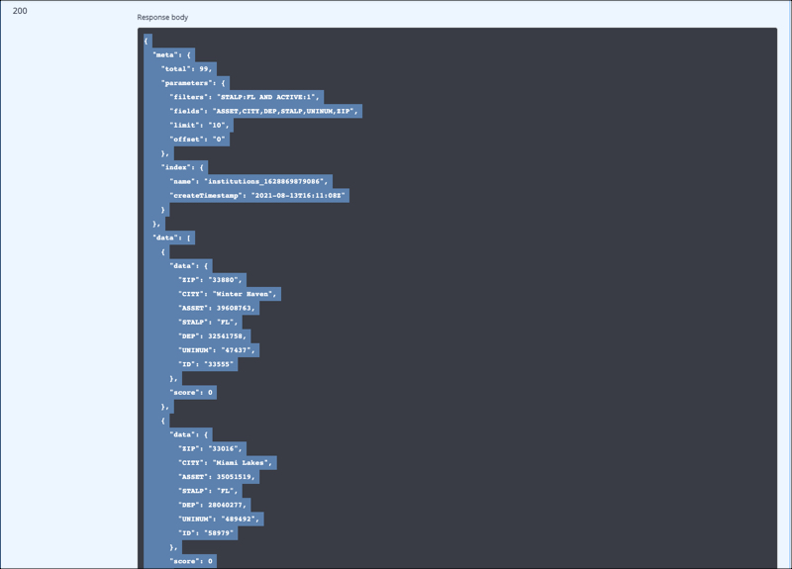

1. **Paste the Response body data** onto the blank Word document you saved in Step 15 (below the Request URL you already pasted)
2. **Save the Word document with the following naming convention**:
   1. *LastNameFirstName_CP1.docx* (or .doc)
      1. For example, Sheldon Cooper’s file name would be *CooperSheldon_CP1.docx* or *CooperSheldon_CP1.doc*
3. **Upload the document** to the Canvas assignment named “**Assignment 11: Checkpoint 1: Using an API in Excel**” in your CGS2512 class.

Checkpoint 2: Using an API in Excel

Complete the following sections for Checkpoint 2:

* Section 1: Calling the API From Excel
* Section 2: Cleaning the Data
* Section 3: Transforming the Data
* Section 4: Loading the Data Into the Worksheet
* Section 5: Analyzing the Data

Section 1: Calling the API From Excel

1. Open an Excel and create a new Workbook
2. Select the **Data tab**
3. Select **Get Data**
4. Select “**From Other Sources”** from drop-down menu
5. Select “**From Web**”

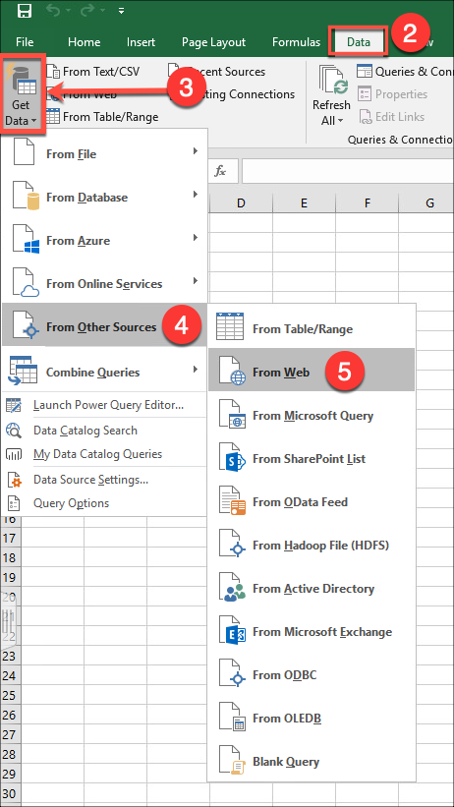

1. Copy the Request URL from the data.gov page and paste it in the “**From Web**” dialog box
2. Select **OK**

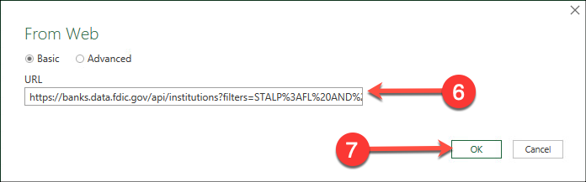

1. Select **Connect** if an “Access Web Content” dialog box appears

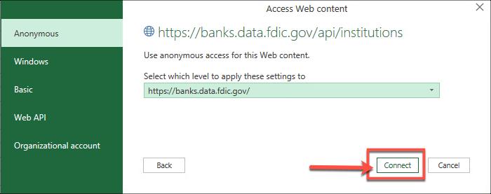

*(This will take you to the Power Query Editor)*

1. Select “**List**”, then **right-click** and select “**Drill Down**” from the drop-down menu

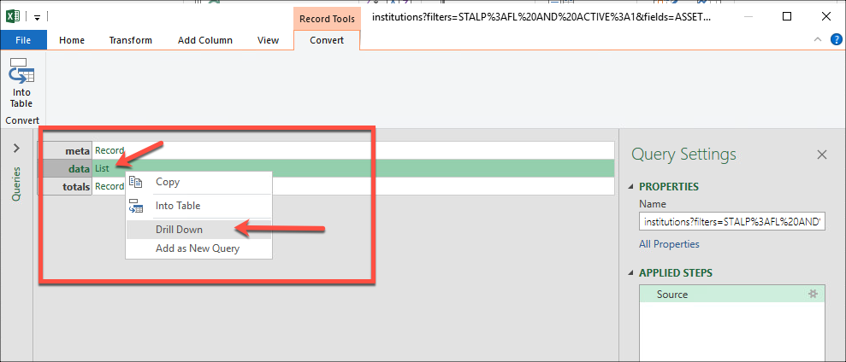

1. Select the “**To Table**” button to convert the data into a table
2. Accept the defaults in the “To Table” dialog box and select **OK**

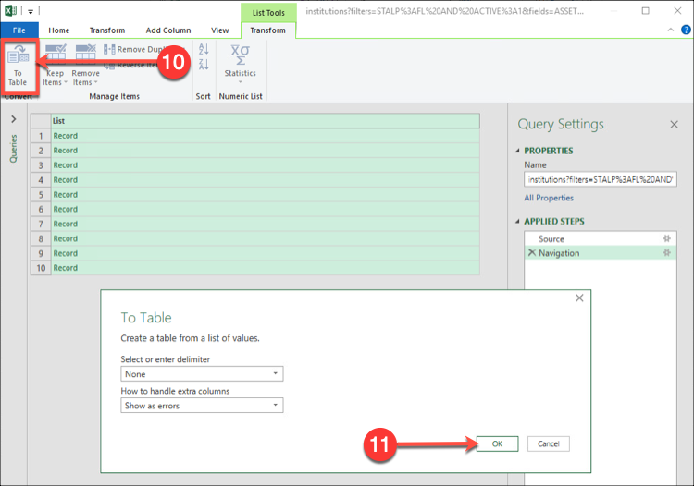

1. Click on the expand columns button 
2. In the dialog box, select the **data** column (It should be the only one with a checkmark)
3. Select **OK**

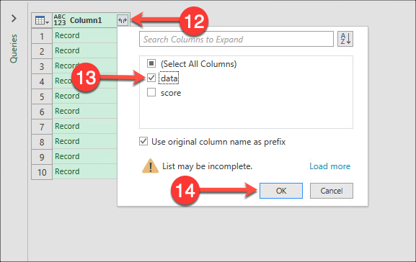

1. Click on the expand columns button  **again**
2. **Select All Columns**
3. Select **OK**

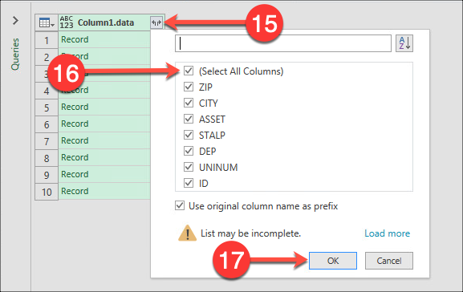

1. We have finished downloading our data!
   1. Notice that Power Query has been saving the steps we have applied under "APPLIED STEPS”, so we don't have to redo everything from scratch when we call the API again

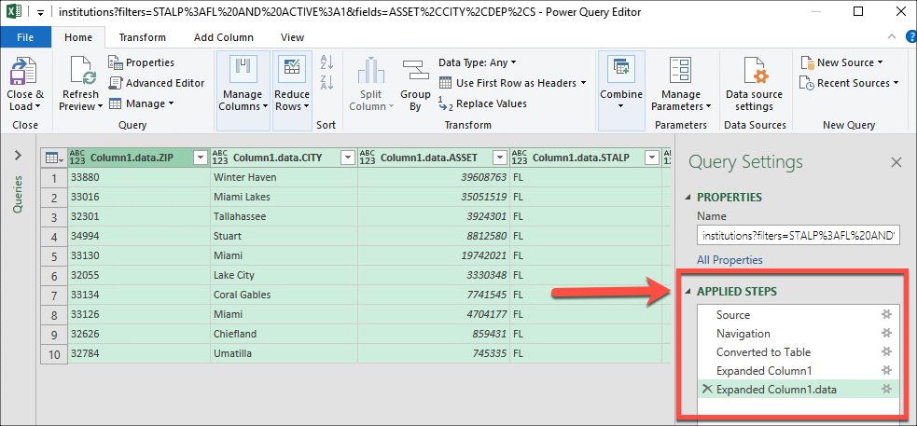

Section 2: Cleaning the Data

1. **Rename the columns** which currently have the prefix “Column1.data.”
   1. Double-click on the first column heading ("Column1.data.ZIP") to highlight it

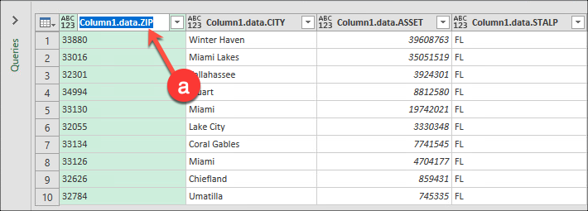

* 1. **Change the name to "ZIP"** and press **Enter**

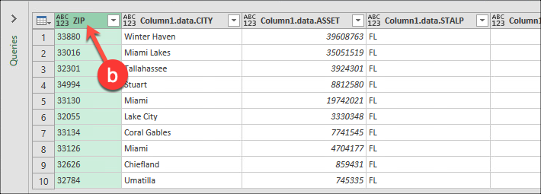

1. Finish renaming the remaining columns, removing the “Column1.data.” prefix from each updating the name to match the “**New Column Name**” listed in the table below
   1. Here are the column names as applied for this exercise:

| **Old Column Name** | **New Column Name** |
| --- | --- |
| Column1.data.ZIP | ZIP |
| Column1.data.CITY | CITY |
| Column1.data.ASSET | ASSETS |
| Column1.data.STALP | STATE |
| Column1.data.DEP | DEPOSITS |
| Column1.data.UNINUM | FDIC_ID |
| Column1.data.ID | SOURCE_ID |

\**Column1.data.ID was not explicitly requested in our API, it is an ID number supplied by the data source provider. We will delete this in an upcoming step.*

* 1. Notice that as you change the column names, **Power Query** is saving each change in a single function call **"Table.RenameColumns**" in the **formula bar** *(If you don’t see the formula bar, click the “View” tab in Power Query and then check the box in front of “Formula Bar”)*

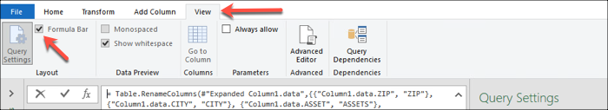

* 1. And in a single step under **APPLIED STEPS** called "**Renamed Columns**").
     1. This makes it easy to modify our column names later if we make changes

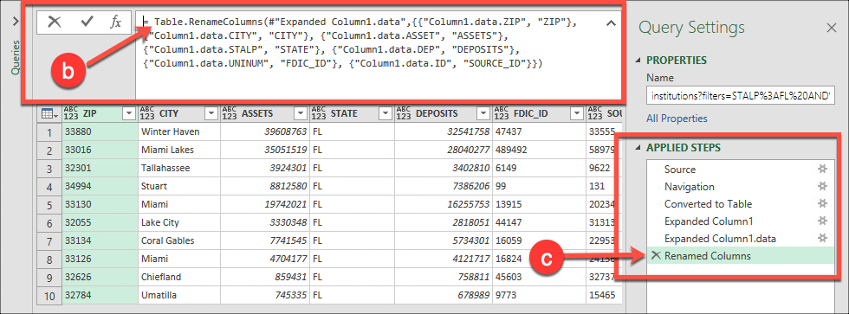

1. Change the Name field to “**FDIC Institutions FL**”
   1. In the Query Settings pane, expand the **Properties** item

***If you don’t see the Query Settings pane, use the View menu and click on the ‘Query Settings’ button to enable it.***

* 1. In the **Name** box, replace any text with **FDIC Institutions FL**

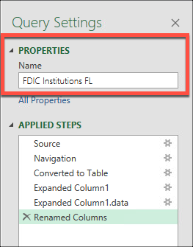

1. Reorganize the columns as show in the following steps:
   1. Move the FDIC_ID column to the left so it is the first column
      1. Widen your window, if necessary, then click and drag the column heading, then drop it to the left of the ZIP column
   2. Move the STATE column so it is to the right of the CITY column
   3. Move the ZIP column so it is to the right of the STATE column

*\*\*Notice that we see these actions as “Table.ReorderColumns” function in the formula bar, and “Reordered Columns” step in the APPLIED STEPS section of the Query Settings pane*

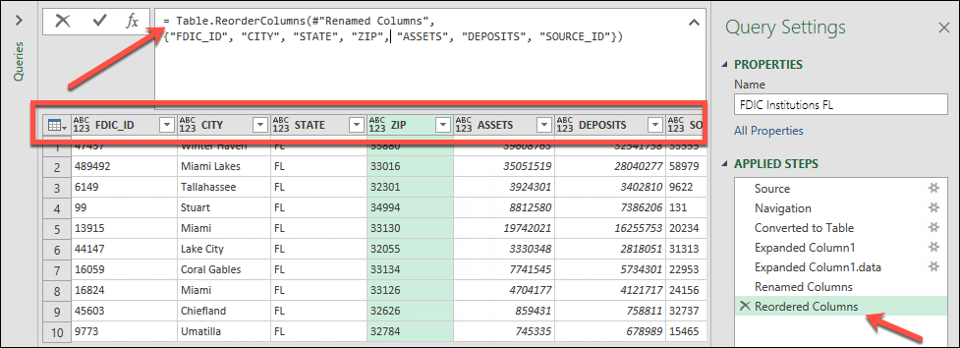

1. **Delete the SOURCE_ID column** by right-clicking on the heading and selecting “Remove”
2. Here is the view of the data after making the changes (your slide might contain different values if the data has been updated since this snapshot was taken)

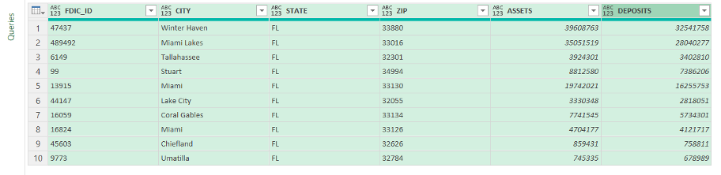

Section 3: Transforming the Data

1. Power Query provides a visual hint of the data type for a column
   1. The FDIC_ID heading in our data indicates that it is formatted as general (“Any”) data type by the “ABC 123” directly to the left of the column title





1. Change the FDIC_ID column’s data type to “**Whole Number**”
   1. Select the **FDIC_ID column** so it is highlighted (click on the column title)
   2. Select the **Home** tab on the Power Query Editor
   3. Click the “**Data Type: Any**” option
   4. Select “**Whole Number**”

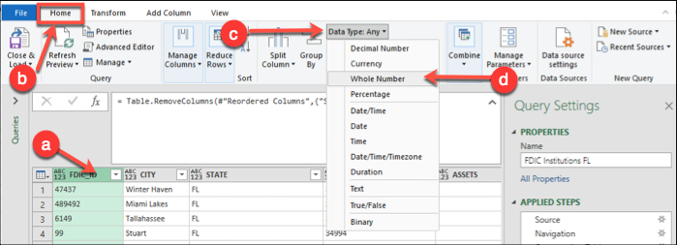

1. Note that the visual data type indicator for the FDIC_ID column has now changed to just “123”





1. Change the data type for the **ASSETS** and **DEPOSITS** columns to **Currency** using the Data Type drop-down menu

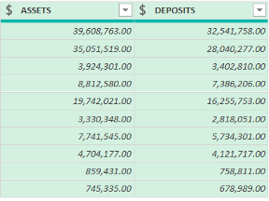



Section 4: Loading the Data Into the Worksheet

1. Select the “**Close and Load**” button at the top left of the Power Query window

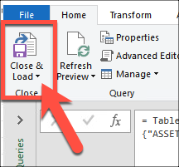

*This should take you to the worksheet.*

1. Rename the active tab as “**FDIC Institutions FL**”
2. Delete any blank worksheets from the workbook
3. Save the workbook as “**FDIC_Institutions**”

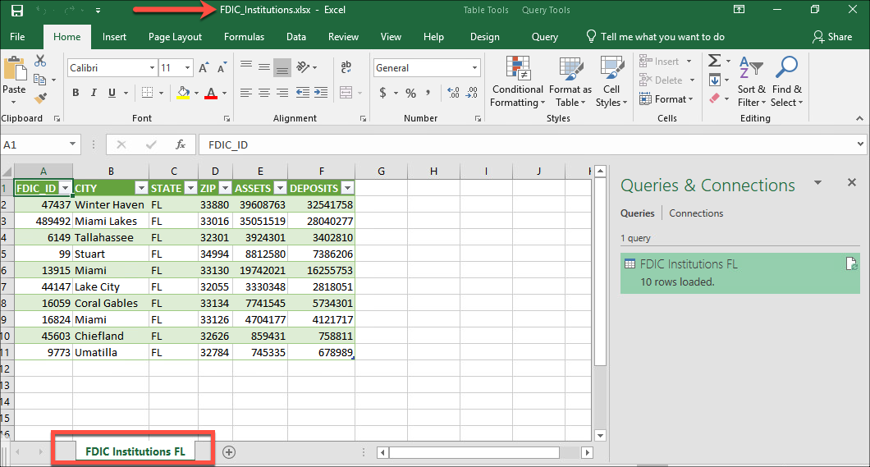

Section 5: Analyzing the Data

1. Create a chart which displays the assets and deposits of the institutions by zip code
   1. Place the chart below your data on the worksheet
   2. The y-axis should be titled “**Value**”
   3. The x-axis should be titled “**ZIP**”
   4. The chart title should be “**FDIC Institutions FL Assets and Deposits**”

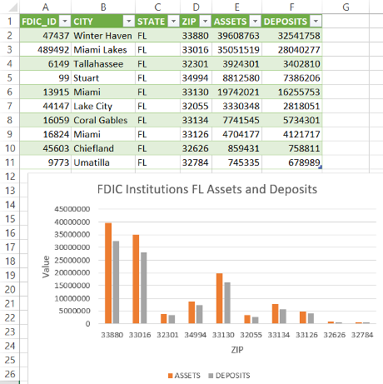

1. **Save** the current Excel workbook
   1. It should already be named “FDIC_Institutions”
2. **Upload the saved Excel workbook** to the Canvas assignment named “**Assignment 12: Checkpoint 2: Using an API in Excel**” in your CGS2512 class.

# Checkpoint 3: Using an API in Excel

Complete the following sections for Checkpoint 3:

* Section 1: Modify the API Call
* Section 2: Clean and Analyze the Data

## Section 1: Modify the API Call

Now that we have performed a simple test with a small data set, let’s bring down more data in our Excel workbook using the following steps:

1. Select the **Data** tab
2. Select **Get Data**
3. Select **Launch** **Power Query Editor**

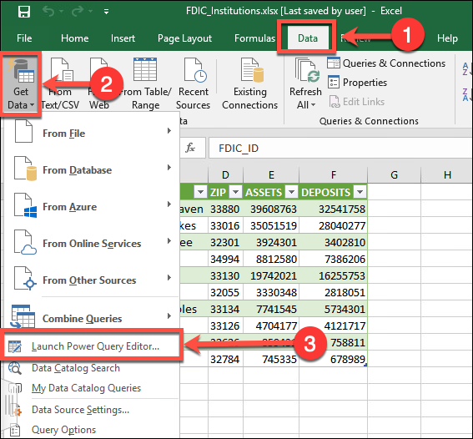

1. Click on the **Source** step under APPLIED STEPS
2. Expand the **formula bar**

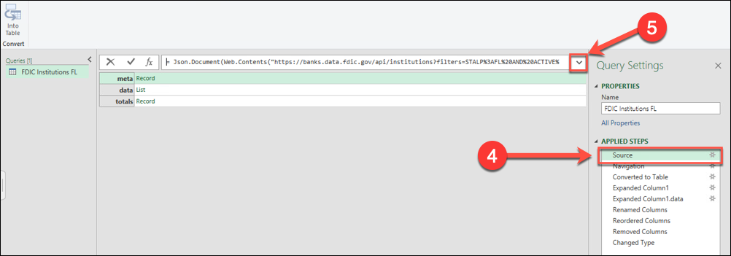

1. Change the limit from 10 to **10000** (the maximum allowed)

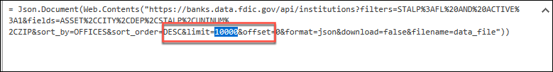

1. Click **outside** of the formula bar
2. Select the **Home** tab on the Power Query Editor
3. Select **“Close and Load”**

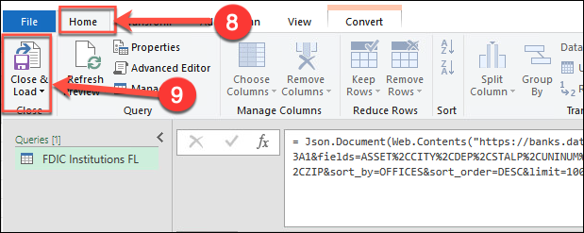

## Section 2: Clean and Analyze the Data

Notice that we collected more records this time (99 at the time this query was run, your results may vary)

In addition, one of the rows did not contain ASSET or DEPOSIT information. As part of cleaning our data, we will want to delete that row.

1. **Delete the row** with the missing data

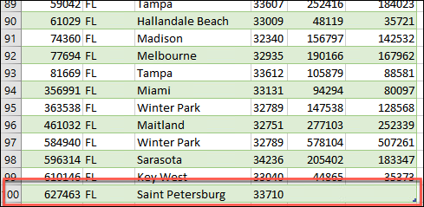

From here we can analyze the data by creating a pivot chart and table to look for patterns and trends.

1. Create a Pivot Chart and Table based on the ZIP, ASSETS, and DEPOSITS
   1. Highlight/Select the ZIP, ASSETS, and DEPOSITS columns
   2. Select the **Insert** tab
   3. Select **PivotChart**
   4. Select **PivotChart & PivotTable** from the drop-down menu

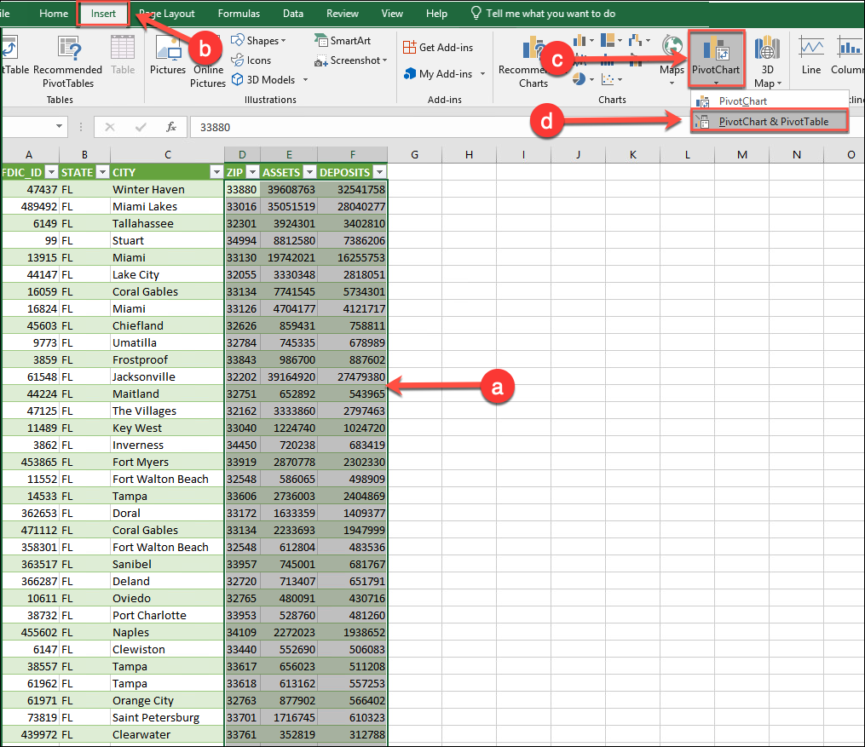

1. In the Create PivotTable dialog box:
   1. **“Select a table or range”** should be set to **FDIC_Institutions_FL**
   2. **“Choose where you want the PivotTable report to be placed”** should have **“New Worksheet”** selected

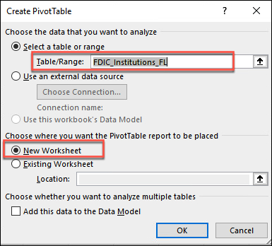

1. Select **ZIP**, **ASSETS**, and **DEPOSITS** for the **PivotChart Fields**

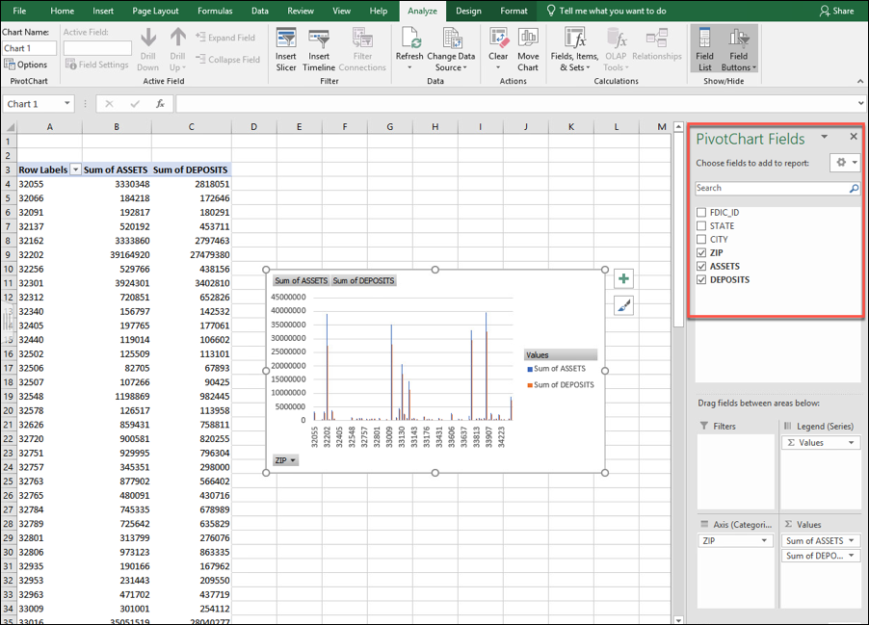

1. **Save** the current Excel workbook
   1. It should already be named “FDIC_Institutions”
2. **Upload the saved Excel workbook** to the Canvas assignment named “**Assignment 13: Checkpoint 3: Using an API in Excel**” in your CGS2512 class.