IDC3021C Lab 4: Analysis With Excel

# Read This Before You Begin:

These directions are based on the use of the Microsoft 365 Web version of Excel. Upload the Excel starter file to your OneDrive before you begin. (The starter file is included with the assignment in the online classroom). You can access OneDrive by following these steps:

1. Log into my.fscj.edu

2. Select the email icon in the top right (this will take you to your FSCJ Outlook webmail)

3. In the top left corner, select the App Launcher icon (square shape made up of nine dots)



4. Select OneDrive (blue cloud icon) under Apps

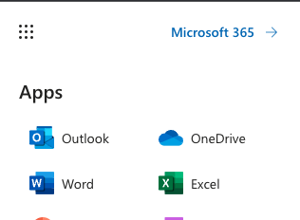

5. This will take you to your OneDrive where you can upload the Excel starter file and open it to begin working in the web version of Excel.

**NOTE: You can use the desktop version of Excel, but the directions may not be the same.**

If you need assistance with Microsoft 365, please visit <https://it.fscj.edu/services-list/microsoft-365-students>.

After following the directions to open the Excel starter file, please complete all steps below and submit your work to the online classroom.

**NOTE: The Excel starter file contains four different worksheets that you will use for this assignment. Be sure you are on the correct worksheet when completing the steps.**

# SheetOne Summary: Use the Excel Stock Data Type to Analyze Several Stocks

Open the Starter File

1. Open the starting file: M4Lab.xlsx
2. **Save As** *GroupX*.M4Lab.xlsx, replacing *GroupX* with **your** group number: *Group2.M4Lab.xlsx*

Find a stock's ticker symbol

1. Here are four companies you must include:
   1. CSX (the railroad, not the Swiss bank)
   2. Black Knight
   3. PayPal
   4. SoFi
2. Look on [Yahoo! Finance](https://finance.yahoo.com/) for the Company Name and Ticker Symbol -- keep this site open for future steps in this assignment

## Add the symbols to SheetOne

1. On SheetOne, in column A, type the company names
2. Select A2:A5; click on the Data tab and select Stocks

**Hint:** You many need to expand your ribbon if you don’t see the Stocks option; click the drop-down arrow to the far-right of the ribbon. Or you can click the drop-down next to Organization and then select Stocks



Here is what it looks like with ribbon expanded to show Groups:

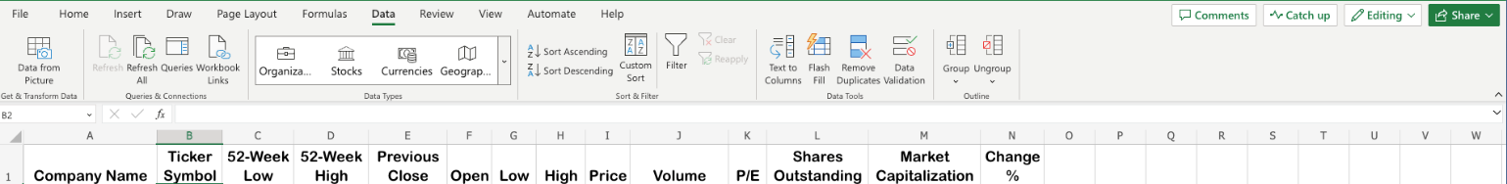

1. You may need to resolve CSX -- other exchanges have companies with the same name, but not the railroad on the NASDAQ exchange. You may need to do this for SoFi as well.
   1. Right-click in the cell with the wrong company; select **Data Type -> Change**
   2. Use the Data Selector tool on the right to indicate the US company

## Add Fields From Stock Data Type

1. Click in the cell of the first company; notice the small insert data symbol in the upper right corner of the selected cell:



1. Select the fields that match the column headings, one at a time to add those values
2. Select B2:N2 and click on the green square at the bottom right corner of N2:

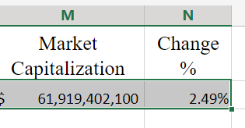

1. Drag down to row 5 so the formula is copied to the rows below

## Add Formatting to SheetOne

1. Select the values in the % Change column, N2: N5
2. Click Conditional Formatting in the Styles group on the Home tab
3. Click Conditional Formatting in the Styles group on the Home tab
4. Select Color Scales, then select Green-Yellow-Red Color Scale (the first one)

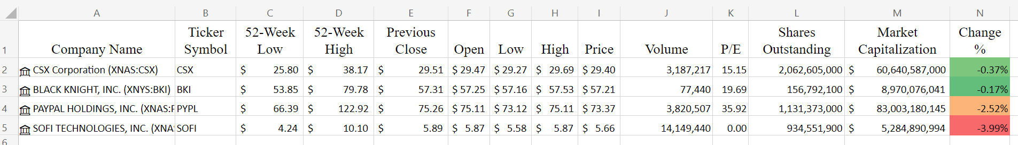

# SheetTwo Summary: Use a Fixed-Share Strategy to Continue the Technical Analysis

## Create a Portfolio of Stocks

1. On SheetOne, select the values in the Company Name and Ticker Symbol columns, A2:B5
   1. Copy, then Paste as Values onto SheetTwo, A2:B5
2. On SheetOne, select the values in the Previous Close column, E2:E5
   1. Copy, then Paste as Values onto SheetTwo, F2:F5
3. On SheetTwo, enter 100 in the Fixed Shares column for all companies
4. On SheetTwo, enter a formula to calculate the Current Portfolio Value in G2, Fixed Shares multiplied by Previous Close:

=C2*F2

1. Copy the formula to G3:G5

## Create a Pie Chart Displaying the Portfolio Value

1. First, select non-adjacent ranges:
   1. Select the Ticker Symbol column, B1:B5
   2. Hold the Control key, [ctrl] or Command key for Mac users, and select the Portfolio Value column, G1:G5
2. Click on the Insert Tab
   1. In the Charts group, select Pie and then 2-D Pie
   2. Move your chart so the top left corner starts in cell B8

## Edit the Pie Chart

1. Click in the chart, then click the Chart tab on the ribbon (this tab will not display if the chart is not selected)
2. Click **Format** (make sure all four of the Ticker Symbols are still selected)
3. The **Chart Format** window will appear on the right side of the screen
4. Expand **Series 1**

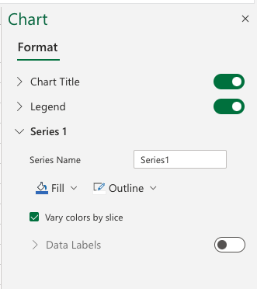

1. Click the radio button to the right of Data Labels (it may be grayed out), to turn on this option (expand the Series "Portfolio Value" chevron if necessary). Enlarge the chart if necessary so the chart data is legible
2. Under **Label Contains**, select **Category Name** and **Percentage** check boxes (deselect other check boxes if selected)
3. Under **Label Position**, select **Outside End**

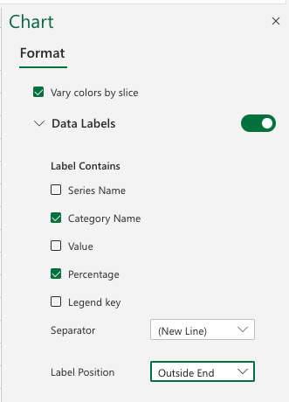

* 1. Change the Font to Arial Black size 10 (This is below Label Position)

1. Expand the Chart Title option under Format
   1. Change the Chart Title to **PORTFOLIO VALUE: 100 SHARES OF EACH STOCK** (be sure to use all upper case)
   2. Change the Chart Title Font size to 18
2. Remove the Legend

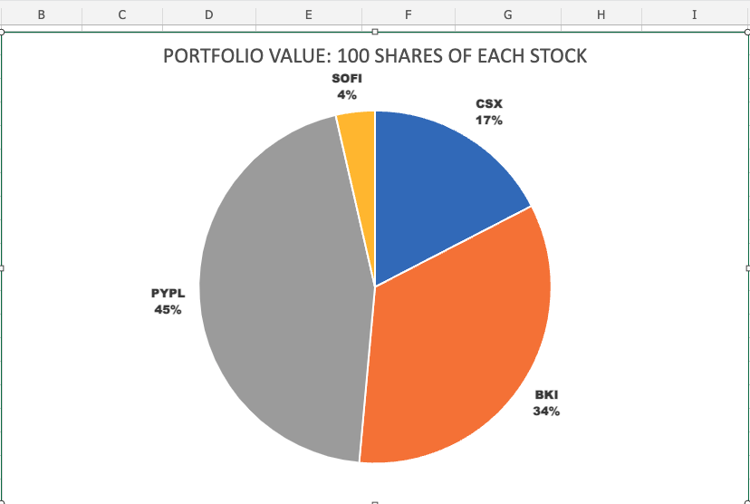

## Find the Purchase Price

You will be finding the purchase price from year ago today, if the date does not fall on a regular business day, then use the first previous business date (e.g., If the date falls on Saturday or Sunday, use the date for the previous Friday).

The example below uses March 20, 2022 – March 20, 2023 and since March 20, 2022 is a Sunday, the date of Friday, March 18th is used.

1. 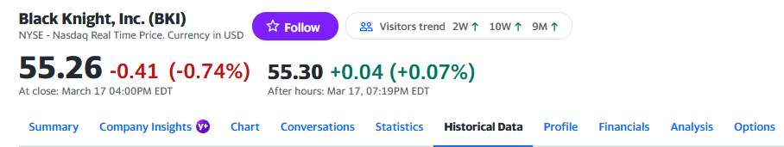On Yahoo!Finance, select the Historical Data tab for the first company
2. 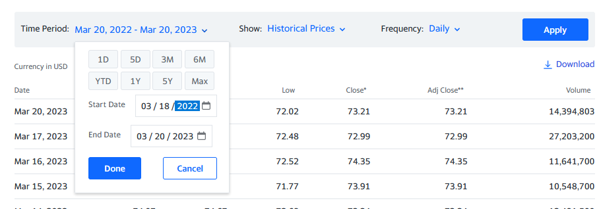Change the Time Period to begin on the first business day (the example below uses March 18, 2022 since March 20, 2022 is a Sunday) (**be sure to click Apply**)

## Record the Purchase Price

1. On SheetTwo, in column D, record the closing price as the Purchase Price **(Hint:** you may need to scroll down to the bottom of the screen to see the Purchase Price from a year ago)



1. Repeat steps 12-14 for all stocks

## Calculate the Cost Basis

1. Multiply the number of shares by the Purchase Price:
   1. In cell E2, type the formula: =C2*D2
   2. Copy the formula to all companies in the rows E3 to E5
2. Select the cells in the range D2:G5, apply the **Accounting** format in the Number group on the Home tab

## Calculate the CAGR – Compounded Average Growth Rate

1. In cell H2, enter the formula to divide Portfolio Value by Cost Basis
   1. =(G2/E2)^1-1
   2. The exponent is the number of years between the Cost Basis and the Portfolio Value, in this example the number of years is 1
   3. Copy the formula to H3:H5
   4. Select the cells in the range H2:H5, apply the **Percentage** format in the Number group on the Home tab

## Calculate the Gain or (Loss)

1. In cell I2, enter the formula to subtract the Cost Basis from the Portfolio Value:
   1. =G2-E2
   2. Copy the formula to I3:I5
   3. Select the cells in the range I2:I5, apply the **Accounting** format in the Number group on the Home tab

## Calculate Totals

1. In cell E6 enter the formula to add the values in the column:
   1. =SUM(E2:E5)
   2. Copy the formula to cell G6 and cell I6
   3. Be sure the Accounting Number format is applied to the cells E6, G6, and I6
2. Change the border for the cells E6, G6, and I6 using the dialog in the Font group
   1. Select Border, then Bottom Border
3. Type TOTALS (in all caps) in cell A6 and use the “Align Text Right” option from the Alignment Group on the Home tab

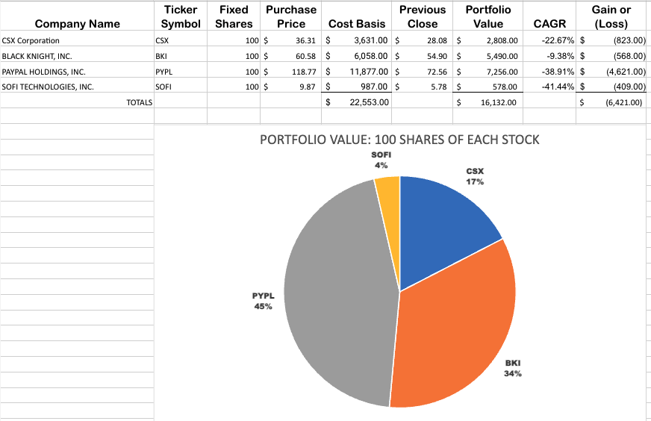

# SheetThree Summary: Use a Fixed Investment Strategy to Continue The Technical Analysis

## Create Another Portfolio of Stocks, This Time With a Fixed Investment:

1. On SheetTwo, select the Company and Ticker Symbol data, A2:B5, and Copy
   1. On SheetThree, Paste as Values to A2:B5
2. On SheetTwo, select the Purchase Price, D2:D5, and Copy
   1. On SheetThree, Paste as Values to D2:D5
3. The formulas for Portfolio Value, CAGR, and Gain or (Loss) are the same as the formulas used on SheetTwo.
4. The Cost Basis in column E for each stock is calculated on this sheet by dividing the SheetTwo total Cost Basis by the number of stocks to provide an equal allocation of those funds for each stock. Here is the formula for E2, which can then be copied down to the remaining cells in the column:

=(SheetTwo!$E$6)/COUNTA($B$2:$B$10)

1. Shares (Column C) are then calculated automatically by dividing the Cost Basis by the Purchase Price
   1. This causes the portfolio to have a fixed amount invested in each stock
   2. Enter the formula (=E2/D2) in the Shares column to divide the Cost Basis by the Purchase Price

## Calculate Totals

1. In cell E6 enter the formula to add the values in the column:
   1. =SUM(E2:E5)
   2. Copy the formula to cell G6 and cell I6
   3. Be sure the Accounting Number format is applied to cells E6, G6, and I6
2. Change the border for cells E6, G6, and I6 using the dialog in the Font group
   1. Select Border, then Bottom Border

## Create a Pie Chart displaying the Portfolio Value with a Fixed Investment in each stock

1. On SheetThree, repeat the steps create and edit a Pie Chart
2. Change the title of the chart to “Portfolio Value: Fixed Investment in Each Stock”

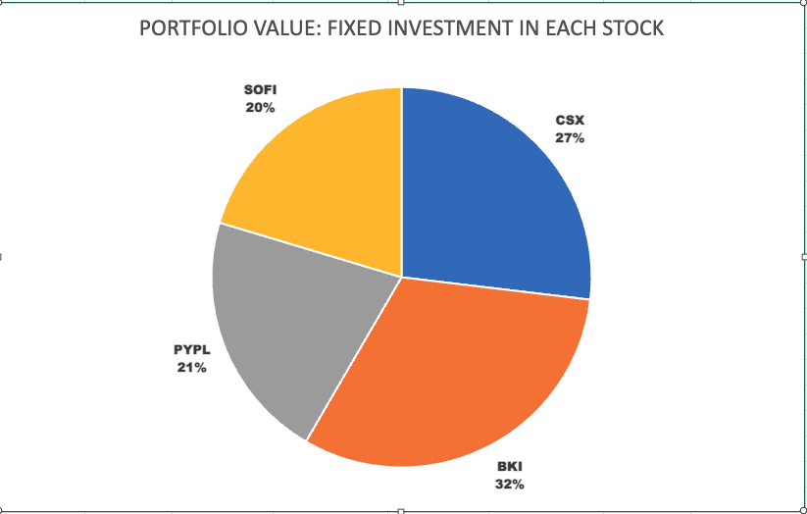

# SheetFour Summary: Analyze a Specific Stock’s History

## Use the StockHistory Function to View Historical Data

**NOTE:** Cell C2 on this sheet contains a pre-filled formula, do not delete or modify the contents of this cell until instructed to do so.

1. From SheetTwo, select the Company Name and Ticker Symbol for Paypal (PYPL): A4:B4
   1. On SheetFour, Paste to A2:B2
2. Use the StockHistory formula from the Financial group in the Function Library on the Formulas tab: (documentation found here: <https://support.microsoft.com/en-us/office/stockhistory-function-1ac8b5b3-5f62-4d94-8ab8-7504ec7239a8>)
   1. Click in Cell C2; the cell displays the word “Date”, but contains the StockHistory formula
   2. Edit the StockHistory formula in C2: =STOCKHISTORY(B2,"03/18/2022","03/17/2023",2,1,0,2,4,3,1,5)
      1. B2 references the ticker symbol (no change needed)
      2. Modify the date range as necessary to provide at least one year of data (example uses "03/18/2022","03/17/2023")
      3. 2 is the interval indicating monthly (1 is weekly, 0 is daily – no change needed)
      4. 1 is the headers indicating show headers (0 is no headers – no change needed)
      5. 0, 2, 4, 3, 1, 5 indicate the order for the columns to be displayed (no change needed

## Create a Candlestick Chart or Stacked Column Chart From the Stock History

**Note**: The Candlestick Chart option is not available using the web version of Excel. If you have are using a version of Excel which allows you to create Candlestick charts, please try it!

### Candlestick Chart Option

1. Select D2:G15; on the Insert tab, click on **Recommended Charts** in the Charts group, then select the **All Charts** tab
   1. In the left menu, click Stock, then click Open-High-Low-Close on the right side
   2. Change the Chart Title to **Stock History: PayPal**

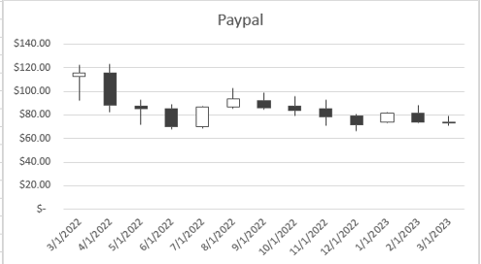

### Stacked Column Chart Option

1. Select C2:G15 **(do not select column H)** then on the **Insert** tab, click on Column in the Charts group, then select the Clustered Column option. (It is the first chart in the 2-D Column box)
   1. Move the chart to the right of the Stock History Data (Column J)
   2. Format the chart:
      1. Expand the **Vertical Axis** chevron, and **uncheck** the “**Display axis**” box

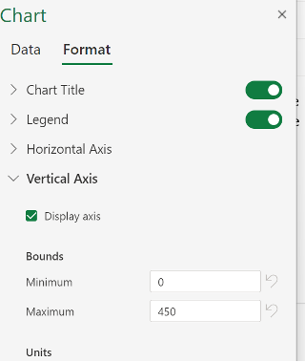

* + 1. Change the Chart Title to **Stock History: PayPal**

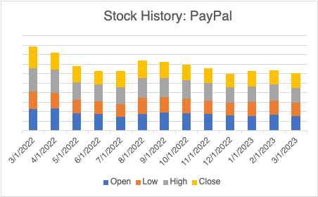

# Submit Your File

1. Save and submit your group’s file to the *Lab 4: Analysis With Excel* assignment in the online classroom. You only need to submit one file per group.

# Sources/References

* [Technical Analysis: Strategies for Beginners | Public.com](https://public.com/learn/technical-analysis)
* [How to Compare and Analyze Stocks in Excel: The Definitive Guide - Blog (wisesheets.io)](https://blog.wisesheets.io/how-to-compare-and-analyze-stocks-in-excel-the-definitive-guide/)
* [Excel Stock Data The Ultimate Guide - Wisesheets Blog](https://blog.wisesheets.io/excel-stock-data-the-ultimate-guide-to-real-time-and-historical-stock-data/)
* [STOCKHISTORY function - Microsoft Support](https://support.microsoft.com/en-us/office/stockhistory-function-1ac8b5b3-5f62-4d94-8ab8-7504ec7239a8)
* [Stock Data Types in Excel: Get Stock Prices Quickly | Finally Learn](https://finallylearn.com/stock-data-types-excel/)
* <https://www.techrepublic.com/article/track-stocks-like-a-pro-with-a-free-excel-add-in/>
* <https://tradingtuitions.com/how-can-you-use-excel-spreadsheets-for-stock-market-analysis/>
* <https://tradingtuitions.com/how-to-plot-a-candlestick-chart-in-an-excel-sheet/>
* <https://tradingtuitions.com/how-to-calculate-cagr-in-excel-sheet/>