**Note: Before downloading the software ensure you have oracle account**

**In case you have you ignore the below steps else create the account as shown below:**

* Below link will help you create oracle account

**https://www.oracle.com/** **Click on view account**

**Click on create account (Give the details as required)**

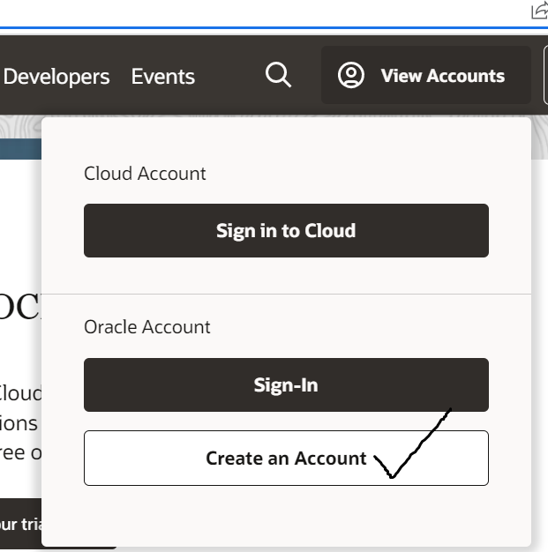

**The minimum hardware requirement for installing Oracle Database 19c on Windows 10 are as follow—**

* **Minimum 2GB free RAM.**
* **10GB of empty space on Hard Disk Drive**
* **A processor based on either Intel EM64T or AMD64 architecture.**
* **Display card with minimum resolution of 1024×768 pixels.**
* **16 GB SWAP (virtual memory) space if RAM is more than 16 GB. If RAM is in between 2 GB and 16 GB, then 1 time the size of the RAM**

**Download the Oracle 19c Software**

1. Download oracle 19c software from the given link

**https://www.oracle.com/in/database/technologies/oracle19c-windows-downloads.html**

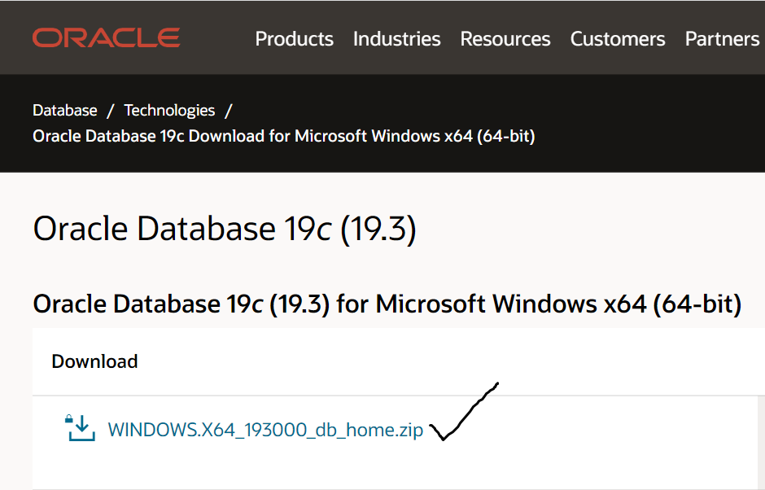

1. **unzip the package then copy it to the root of your disk;**

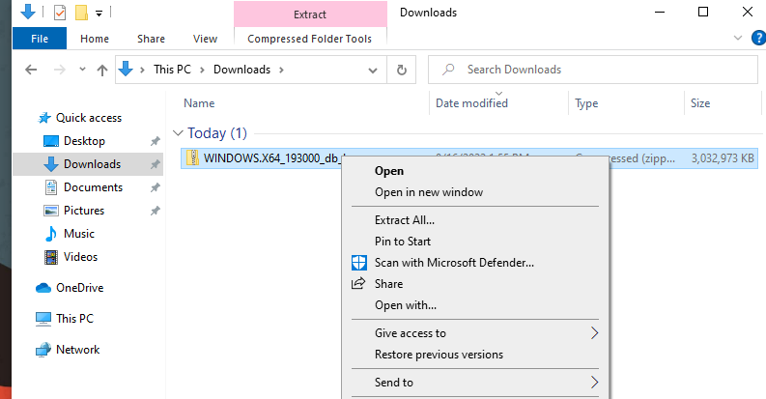

* rename the folder, choose a shorter name (e.g., *db_home*);
* then launch the setup.

**Note: the installation wizard may take several minutes to open. So be patient.**

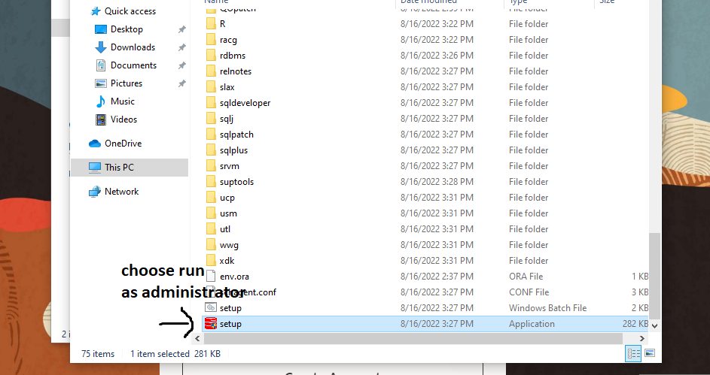

1. **Select Configuration option:**

Select “**Create and configure a single instance database**”

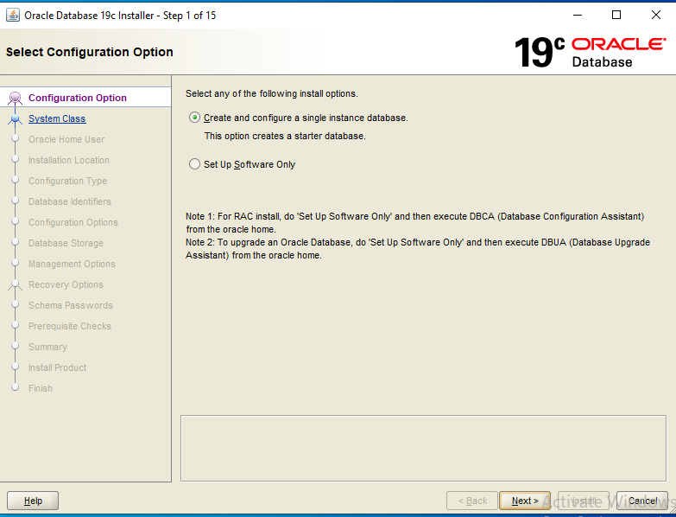

1. **Select System Class:** Select **“Desktop Class”**

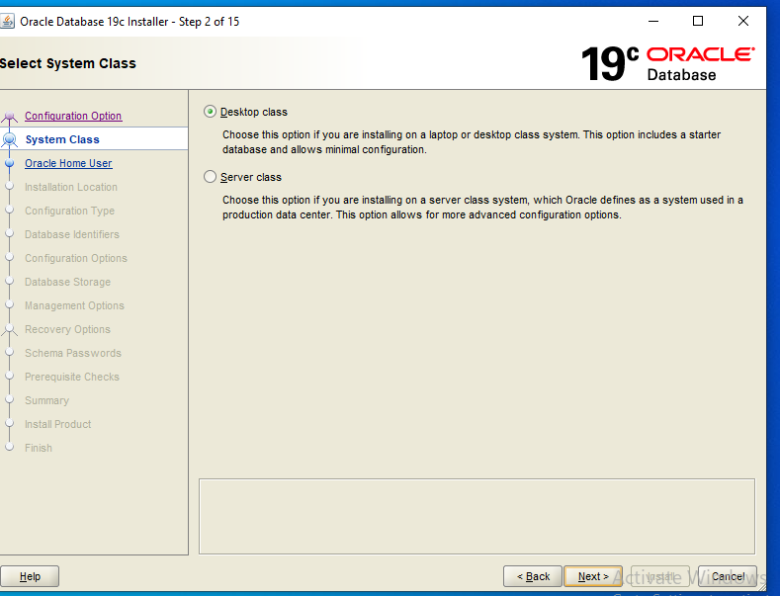

1. **Specify Oracle Home User.** Select “**Use Windows Built-In Account**”

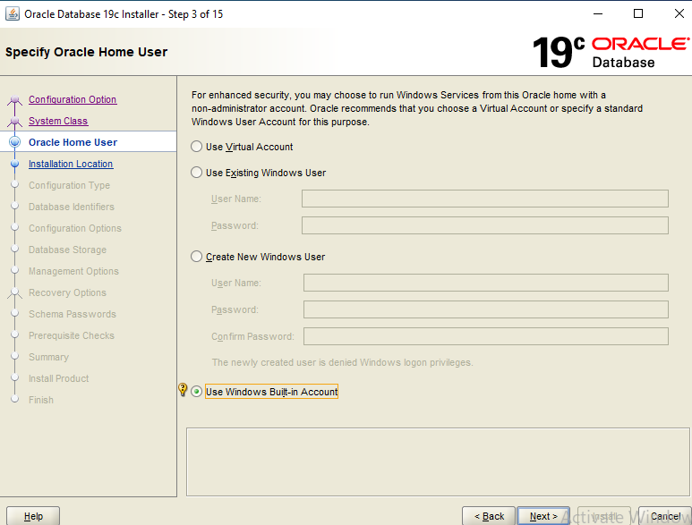

**Click Yes on the pop-up window to continue**

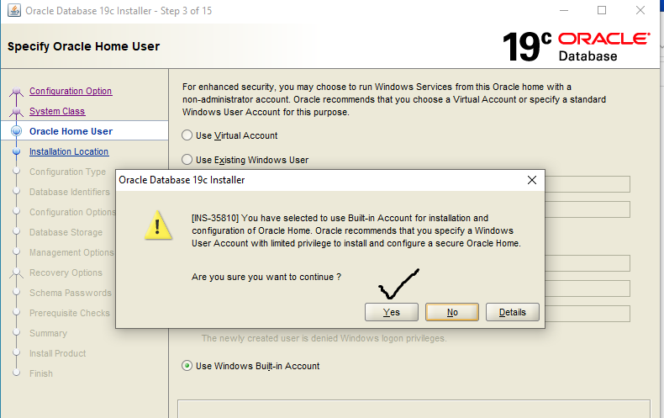

1. **Typical Installation Screen:**

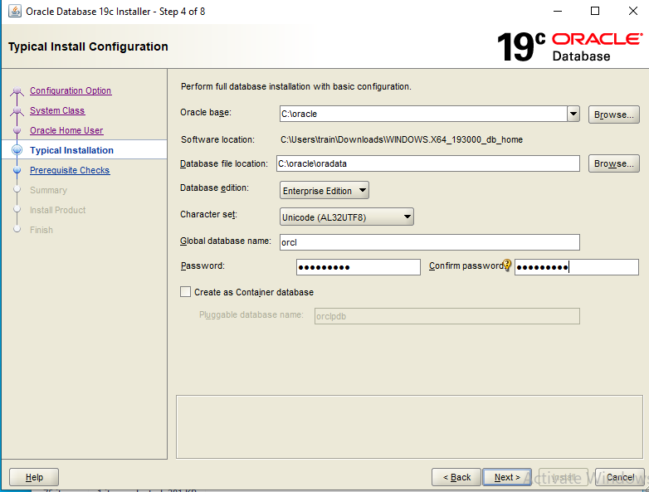

**Oracle Base:**

You have the freedom to either choose from the option given in the drop-down list or enter your desired directory location. **e.g., D:\Oracle**

Oracle Base is a base directory for all your Oracle Products. This will be the location where all the necessary will be stored.

**Software Location**:

This directory will be placed inside the Oracle Base. Also, it will be the directory where all the files and folders of Oracle Database 19c are placed.

**Database File Location**

Important files of Oracle Database 19c like Data files, redo log files, control files, server parameter files and the password files will be saved onto this directory. These files are most important and required for the proper directory**. Gets populated as D:\Oracle\Data**

### Database Edition: Select “Enterprise Edition”. Leave this to default

These editions of Oracle 19c are

* + - Oracle Enterprise Edition
    - Oracle Standard Edition 2

### Character Set: Leave this to default

As the name suggests, using this field you set the character set for your Database.

### Global Database Name (S.I.D.)

your database SID. You will need it while making a connection with your database using tools such as SQL Developer. **By default, it is set as ORCL**.(you can give name of your choice), I suggest you write it down somewhere as your Database SID.

### Password: (you may wish to give oracle_4U)

This will be the password for your Administrative user. Administrative users are special user. Using them you can alter the core of your Database. So, it’s always advisable to set a strong password for them.

### 

### Pluggable ****Database Name** (Select only if you need to work with container**

### **database)**. In our case we will select the same****

Note: In this field you will specify a unique name for your pluggable database. By default, it is set on ‘orclpdb’. This Pluggable Database (PDB) will work as a template for those PDBs which you will create in future.

1. **Prerequisite Checks**

In this step the OUI will check the prerequisites. We will be good to install it if everything goes well. If there is any error, then the OUI will show you here.

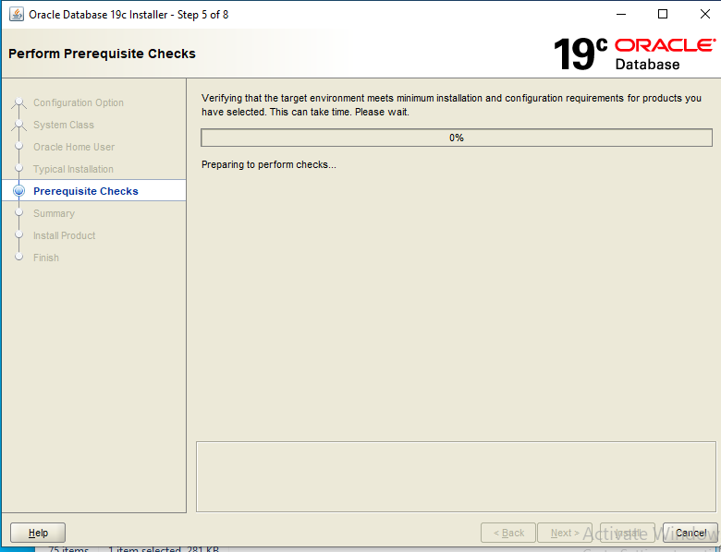

**8. Summary Page**

Click **Install** to proceed with Installation

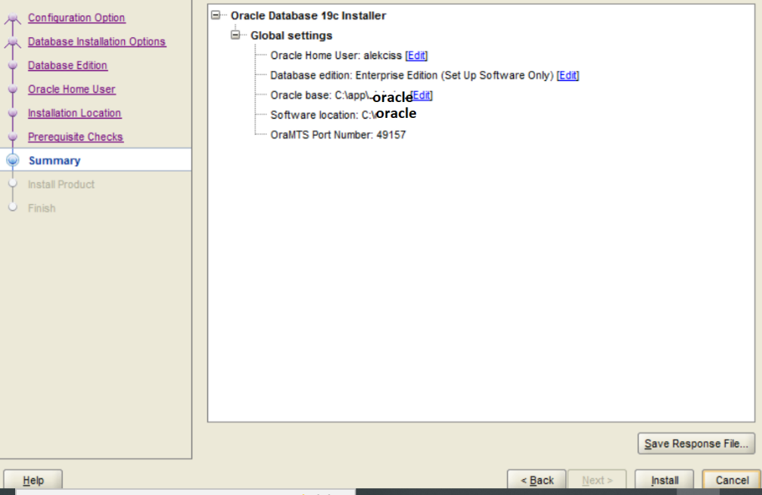

**Note: Once Precheck is done it will go ahead and install the product**

**9. Finish. Click on the close Button**

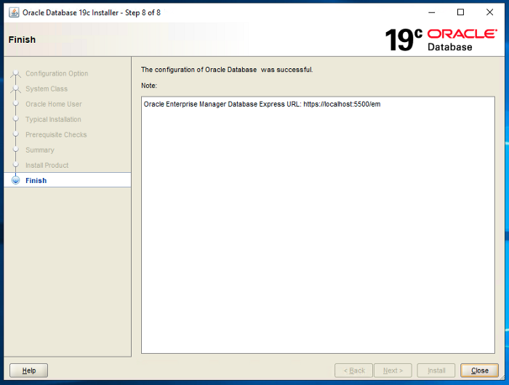

1. **Go the folder where oracle is installed and follow the steps in below screen.**
2. **Go the folder network/admin where oracle is installed.**

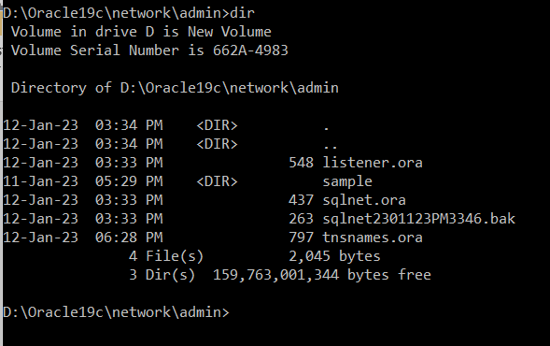

**Edit the file tnsnames.ora and “ADD” the below entry if not there**

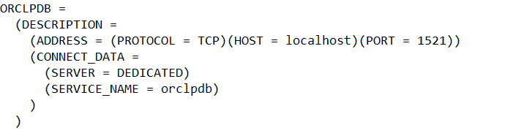

Try logging into database as per the steps below:

