**DAD 220 Analysis and Summary Template**

Replace the bracketed text in this template with your responses and any supporting screenshots. Then submit it to the Module Five Activity for grading and feedback. Rename this document by adding your last name to the file name before you submit.

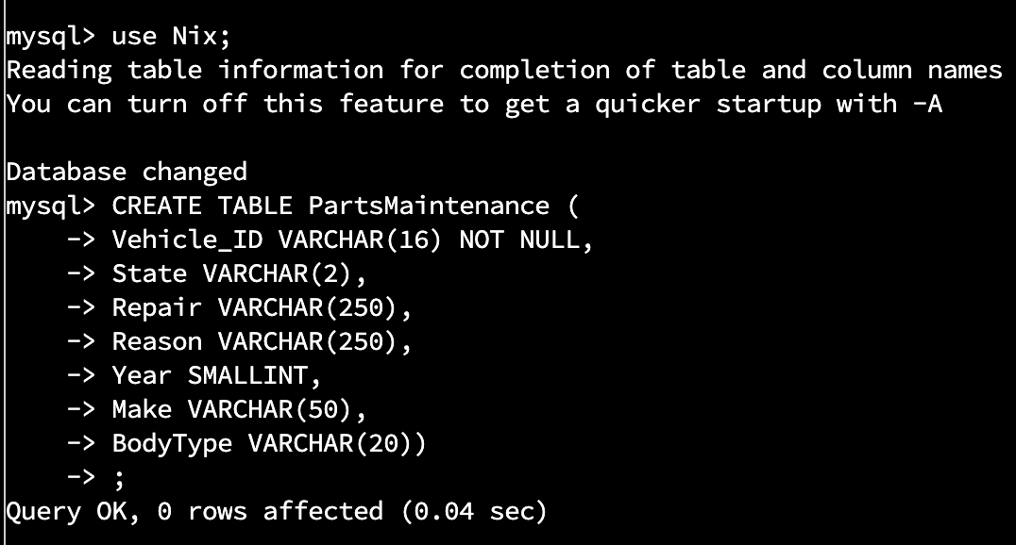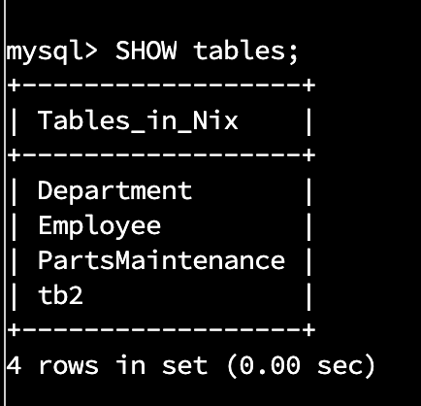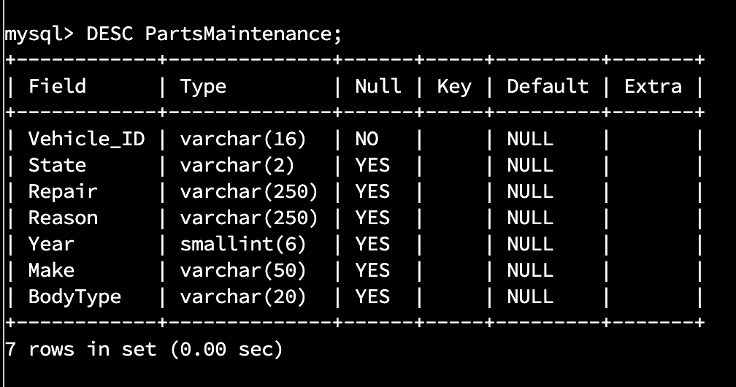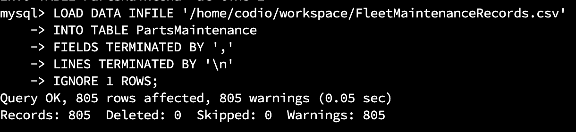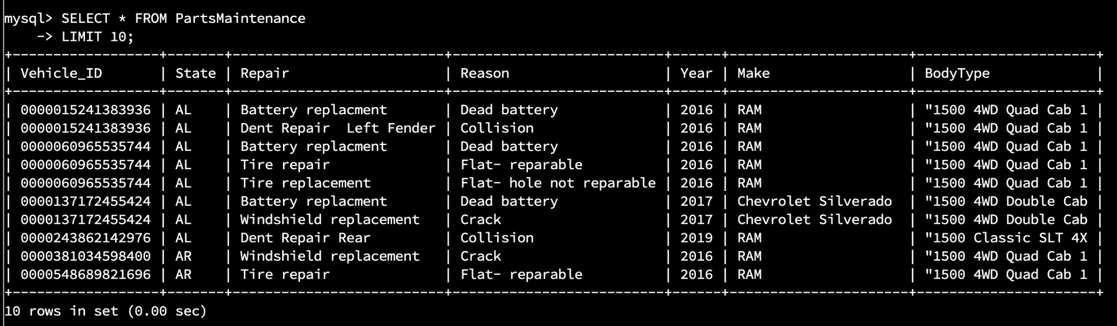

1. **Analyze the data** you’ve been provided with to **identify themes**:
   1. Which parts are being replaced most?
      1. Fuel tank - 95
   2. Is there a region of the country that experiences more part failures and replacements than others?
      1. Identify region:
         1. Midwest - 260
      2. How might the fleet maintenance team use the information to update its maintenance schedule?
         1. The maintenance team would supply the stores based on each of their repair history, stocking them with the appropriate parts.
   3. Which parts are being replaced most due to corrosion or rust?





* + 1. SELECT * FROM PartsMaintenance WHERE Reason IN ('Rust') AND
    2. **'Shocks'; - 47**
    3. **‘Struts’; - 51**
    4. **‘Fender Replacement’ - 54**
    5. **‘Wheel Arch’ - 54**
    6. **‘Cab corner panel’ - 49**
    7. **‘Rocker panel’ - 53**
  1. Which parts are being replaced most because of mechanical failure or accident, like a flat tire or rock through the windshield?

produced 63 Rows

produced 74 rows

1. **Write a brief summary of your analysis** thattakes the information from Step 1 and presents it in a way that non technical stakeholders can understand.
   1. Greetings to all stakeholders. Regarding the issue of repairs at our locations. Fuel tank and tire repair are the two most frequent services performed. An in-depth analysis of the data has indicated that two-thirds of fuel tank repairs occur in the Midwest and Northeast regions, where the winters are more severe. Massachusetts and Indiana each had 10 instances of fuel tank repair due to a hole, while Illinois and Iowa had 9 and 11 instances of fuel tank repair due to corrosion.

As for tire repair, roughly 54% of tire repairs occur in the southeast and southwest regions. The southwest region has 21 repairs, with Oklahoma and Arizona each having ten repairs. All tire repairs involved fixable flat tires.

Data analysis suggests that it would be proactive for the company to stock more fuel tanks in the Midwest and Northeast regions and more tire repair kits in both southern regions.

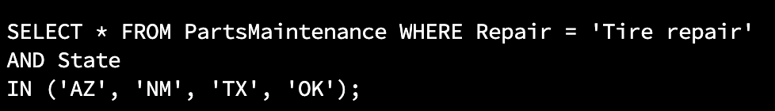

1. **Outline the approach** that you took to conduct the analysis.
   1. I began by conducting a broad query. I would examine the data and look for statistical proclivities. I would then narrow my results with the ‘WHERE’ clause. Using the ‘WHERE’ clause I would utilize the column(s) repairs, reasons, and state to pinpoint various data tendencies.



SELECT * FROM PartsMaintenance WHERE Repair =

* + 1. Tire repair - 74
    2. Transmission - 28
    3. Battery replacement - 56
    4. Windshield replacement - 63
    5. Fender replacement - 54
    6. Shocks - 47
    7. Struts - 51
    8. Brake line replacement - 52
    9. Fuel Tank - 95
    10. Wheel Arch - 55
  1. What are the benefits of using these queries to retrieve the information in a way that allows you to provide valuable information to your stakeholders?
     1. Using these queries allows one to specify specific data sets. You can narrow the options based on some or all of the column headers which isolates distinct data patterns.

1. **Explain how the functions in the analysis tool** allowed you to organize the data and retrieve records quickly.

1. **Faster Query Processing –**   
   Large amount of data is retrieved quickly and efficiently. Operations like Insertion, deletion, manipulation of data is also done in almost no time.
2. **No Coding Skills –**   
   For data retrieval, large number of lines of code is not required. All basic keywords such as SELECT, INSERT INTO, UPDATE, etc are used and also the syntactical rules are not complex in SQL, which makes it a user-friendly language.
3. **Standardized Language –**   
   Due to documentation and long establishment over years, it provides a uniform platform worldwide to all its users.
4. **Portable –**   
   It can be used in programs in PCs, server, laptops independent of any platform (Operating System, etc). Also, it can be embedded with other applications as per need/requirement/use.
5. **Interactive Language –**   
   Easy to learn and understand, answers to complex queries can be received in seconds.

REFERENCES

*Advantages and disadvantages of SQL*. GeeksforGeeks. (2021, July 7). Retrieved November 25, 2022, from [Advantages and Disadvantages of SQL - GeeksforGeeks](https://www.geeksforgeeks.org/advantages-and-disadvantages-of-sql/)