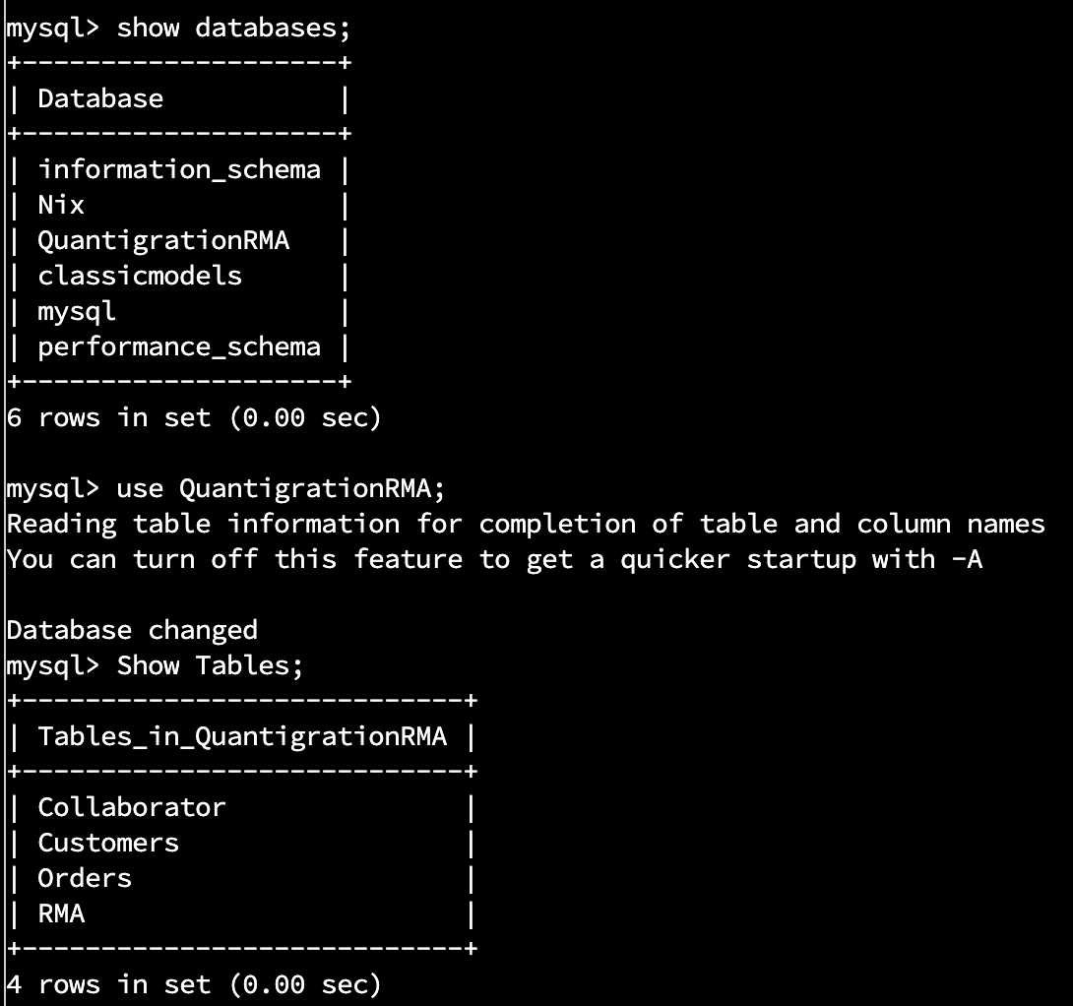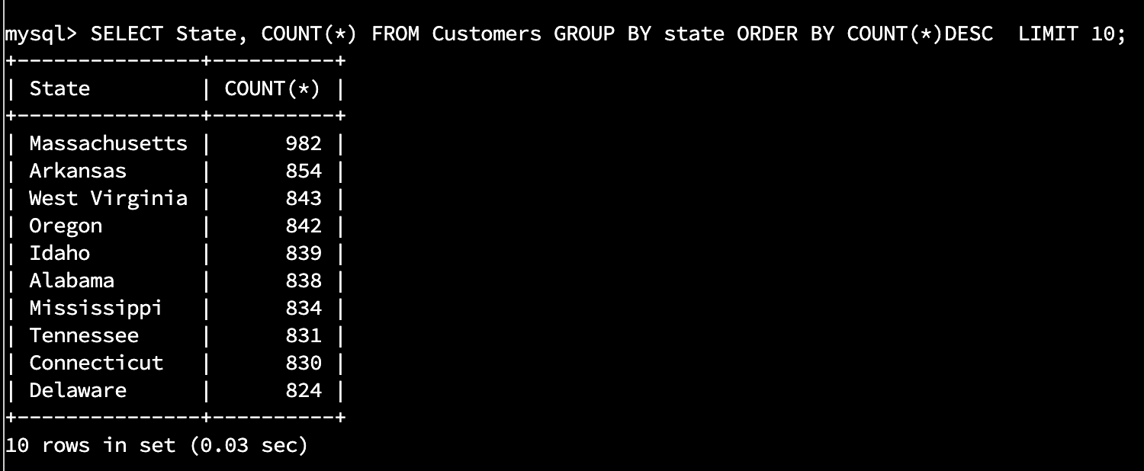

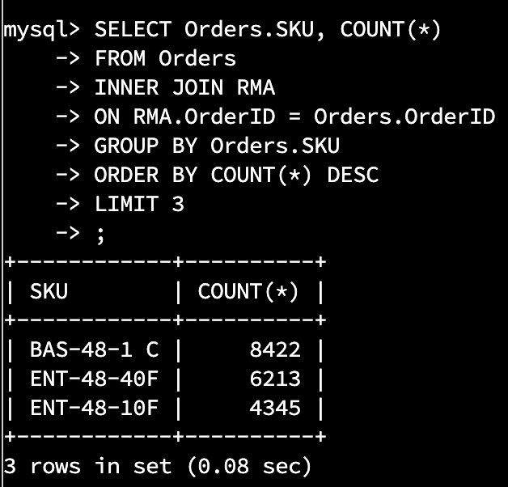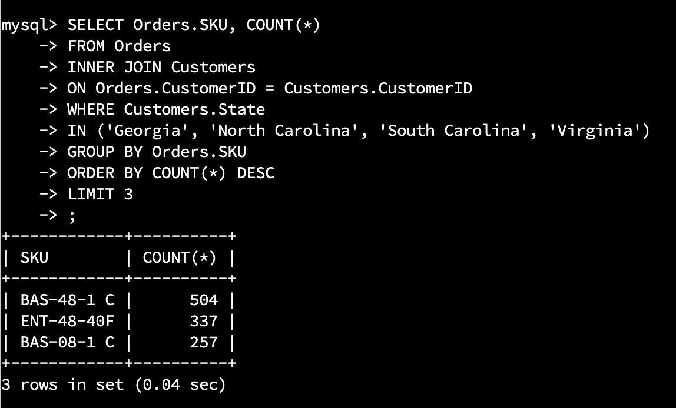

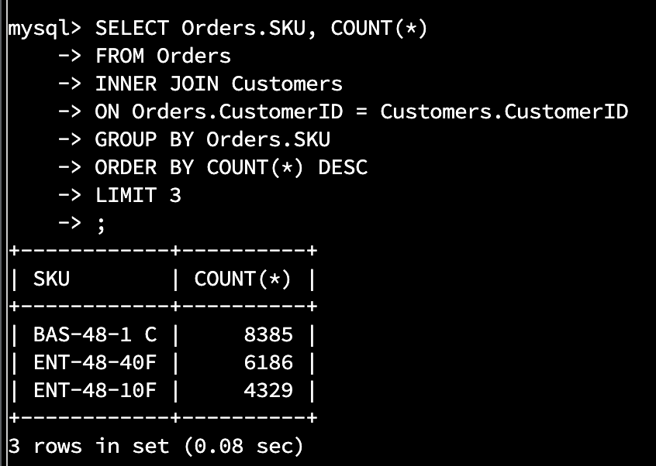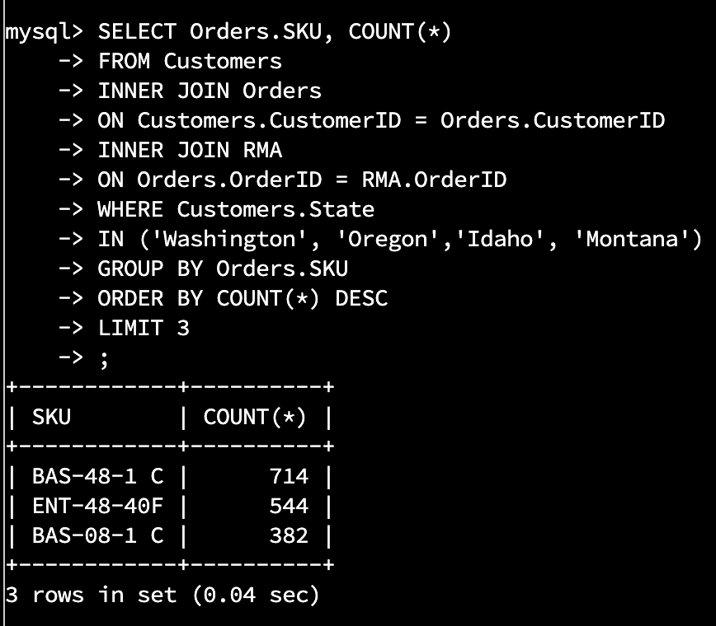

**Quantigration Report**

Quantigration has nationwide customer sales of approximately 38,000 orders. The top ten states for sales are displayed in the table below.

| **State** | **# of Orders** | **Region** |
| --- | --- | --- |
| Massachusetts | 982 | Northeast |
| Arkansas | 854 | Southeast |
| West Virginia | 843 | SouthEast |
| Oregon | 842 | Pacific |
| Idaho | 839 | Mountain |
| Alabama | 838 | SouthEast |
| Mississippi | 834 | Southeast |
| Tennessee | 831 | Southeast |
| Connecticut | 830 | Northeast |
| Delaware | 824 | SouthEast |

The chart indicates that the highest amount of orders is coming from the Southeast region with six of the top ten states. Within that Southeast region, in the states of Virginia, North Carolina, South Carolina, and Georgia, the top three selling products have the following SKUs.

**North Carolina, South Carolina, Virginia, Georgia**

| **SKU** | **# Sold** |
| --- | --- |
| **BAS-48-1 C** | **504** |
| **ENT-48-40F** | **337** |
| **BAS-08-1 c** | **257** |

These three SKUs, in this same order, also represent the top three products sold nationwide.

**Nationwide**

| **SKU** | **# Sold** |
| --- | --- |
| **BAS-48-1 C** | **8244** |
| **ENT-48-40F** | **6213** |
| **BAS-08-1 c** | **4345** |

As for returns, the top two selling products for the company are also the most returned items nationwide. The products with SKUs **BAS-48-1 C** and **ENT-48-40F** sold nationwideare being returned the most.

**Nationwide**

| **SKU** | **# Returned** |
| --- | --- |
| **BAS-48-1 C** | **8385** |
| **ENT-48-40F** | **6186** |
| **ENT-48-10F** | **4329** |

The Northwestern region within the state of Washington. Oregon, Idaho, and Montana also show the product SKUs **BAS-48-1 C** and **ENT-48-40F** as the most returned item.

**Washington, Oregon, Idaho, and Montana**

| **SKU** | **# Returned** |
| --- | --- |
| **BAS-48-1 C** | **714** |
| **ENT-48-40F** | **544** |
| **BAS-08-1 C** | **382** |