PSO-LocBact : a software for optimizing multiple classifier results for predicting subcellular localization of bacterial proteins

Manual of stand-alone program of PSO-LocBact

2018-06-10

Download link :

Introduction of PSO-LocBact
PSO-LocBact is a predictor based on Particle Swarm Optimization which predicts protein locations specifically in bacteria. This program can predict 5 distinct locations on gram-negative (Extracellular region, Outer membrane, Periplasm, Inner/Cytoplasmic membrane, Cytoplasm) and 4 distinct locations on gram-positive (Extracellular region, Cell wall, Inner/Plasma/Cytoplasmic membrane, Cytoplasm) bacterial data sets. It can solve inconsistency problem in gram-negative and gram-positive bacterial protein subcellular localization prediction. This program can be easily updated with new classifiers integration.

Installation
The PSO-LocBact package can be run on Linux, Mac, and Windows systems. Download the package from the link provided and extract it to a directory, for example, “~/usr”. To execute the PSO-LocBact in command line environment, navigate to the “~/usr/PSO-LocBact” directory and you will find four Python scripts (~.py), and one Perl script (GetResults.pl).
The Perl script in this directory is for re-arranging prediction result files from other classifiers, all at once, into a single CSV file containing score vector for each protein sequence in order of given subcellular locations. For example, in gram-positive score vector file, the first column will be score for extracellular region, next for cell wall, next for membrane and the last one will be cytoplasm. Four columns will be considered as the results from one classifier. If there are N classifiers considered, the number of columns in the vector file will be 4xN for gram-positive bacterial proteins and 5xN for gram-negative bacterial proteins.
Two Python scripts, normalizer.py and voter.py, contain necessary classes for the final results calculation in the other two Python scripts. The “train.py” is used to train the training vector file. And, the “pso_locbact.py” is used to calculate final results from given vector files according to the settings in “configuration.txt”.

Input formats
The input file for “pso_locbact.py” must be a score vector file in CSV format with “,” delimiters. For gram-positive bacterial proteins, four columns will be considered as resulting scores from one classifier. The order of locations are “extracellular region”, “cell wall”, “inner/plasma/cytoplasmic membrane”, and “cytoplasm”. For gram-negative bacterial proteins, five columns will be considered as resulting scores from one classifier. The order of locations are “extracellular region”, “outer membrane”, “periplasm”, “inner//cytoplasmic membrane”, and “cytoplasm”. If there are N classifiers considered, the number of columns in the vector file will be 4xN for gram-positive bacterial proteins and 5xN for gram-negative bacterial proteins.

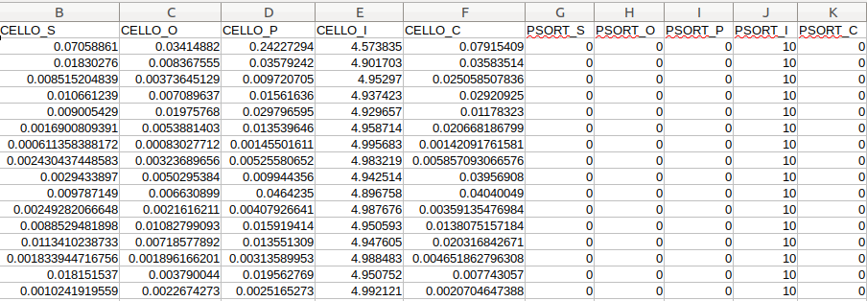An example of input format
In order to create a CSV file in this format, a Perl script “GetResults” is provided. All user needs to do is name all files with the same file name prefix with the program name as a postfix (ie, training.ngLoc, training.PSORTb3, training.LocTree3.html). However, for LocTree3, user will need to change a line in ~/Lib/GetLocTree3.
our $original = "gneg_training_data.fasta"; #change this
Just change the value “gneg_training_data.fasta” to the current directory and filename of the original FASTA file user used in other classifiers.
Then, user may simply open a command line on the working directory of PSO-BactLoc and type:
perl GetResults -gramneg prefix
The parameters prefix and -gramneg are the prefix of all files generated by other classifiers and a type of bacteria, respectively. If bacteria type is gram-positive, just change “-gramneg” to “-grampos”.
Please be noted that our GetResults script might not work properly. In that case, the order of classifiers for users to arrange the inputs by themselves is as follows: CELLO, PSORTb3, CELLO2Go, SOSUI-GramN, SLP-Local, ngLoc, Gneg-mPloc, PSLpred, and LocTree3 for gram-negative bacteria; CELLO, PSORTb3, CELLO2Go, ngLoc, Gpos-mPlc, and LocTree3 for gram-positive bacteria.
Output formats
The outputs from “pso_locbact” consist of two text files, one containing the prediction results along with weighted score vectors for all locations, and another containing summary information. If the “pie_chart” setting in “configuration.txt” is set to 1, a summary pie chart for number of predicted locations of the given data set will be generated in PNG format.

Configuration
The “configuration.txt” contains advanced setting for PSO-LocBact. It can be easily modified. However, PSO-LocBact developers do not worry about security problems, thus we are not responsible for any changes to the file made by end-users. If the file is incorrectly modified, PSO-LocBact may not run properly. The table below shows configuration variables for PSO-LocBact that users can configure.

Re-training
As mentioned above, the configuration file can be easily modified and PSO-LocBact works based on setting in this file. PSO-LocBact supports addition of classifiers and re-train. Users may just simply add the program name along with the weight to the configuration file and remove a classifier by inserting “#” in the end of the line for that classifier setting.
Re-training can be easily done by using “train.py”. The input file for “train.py” is slightly different from the one for “pso_locbact.py”. The first column will contain the class labels. Then, the other columns follow the same rules.
Once trained, a summary file with weights and accuracy and a prediction result file will be generated. If the results satisfy user’s expectation, user may change the setting in “configuration.txt” and PSO-LocBact will work based on the new configurations.
This feature enables users to update our method by themselves with ease.

