# Lab 2: Vyatta Firewall and Snort IDS

## Aim

The aim of this lab is to build on the basic Vyatta firewall configuration, adding firewalling, IDS, and other hardening capabilities.

## Time to Complete:

4 hours (two supervise hours in the lab, and two additional unsupervised hours).

## Activities:

* **Complete Lab 2:** Vyatta Firewall and Snort
* **Complete software lab.**

## Learning activities:

At the end of this lab, you should understand:

* How to use your own credentials to access the vSoC Cloud.
* How to remotely configure a Vyatta firewall for zones, and set up the firewalling.
* Set-up Snort IDS system on a host and create useful rules to detect potential attacks.
* How to use Wireshark to capture network packets for deep analysis, highlighting certain details such as the difference between the Telnet and SSH services

## Reflective statements (end-of-exercise):

What is the most important things when setting up a host, in order that it can connect with other networks?

Reflect on which types of attacks the firewall rules can mitigate, and which the IDS system can help highlight:

Reflect on the amount of work involved in keeping IDS rules up-to-date. Compare with an IPS.

## References:

Course Handbook - Unit 2 IDS

Background Reading: **Google Books** - search for “IDS” “Snort”

# Lab 2: Vyatta Firewall and Snort IDS

## Setting up the network

Figure 1 outlines the setup of the lab for routing, where we will assign three network addresses. Again, Interfaces which are connected to the Vyatta firewall will be able to route, but we have to use NAT to allow the DMZ and private networks to connect to the public network.

Our first task is to route through the Vyatta firewall to connect two networks. In the lab you will be assigned two networks in the form:

172.16.*x*.0/24 172.16.*y*.0/24

De[mo: http://youtu.be/8siHSSs3RQc](http://youtu.be/8siHSSs3RQc)

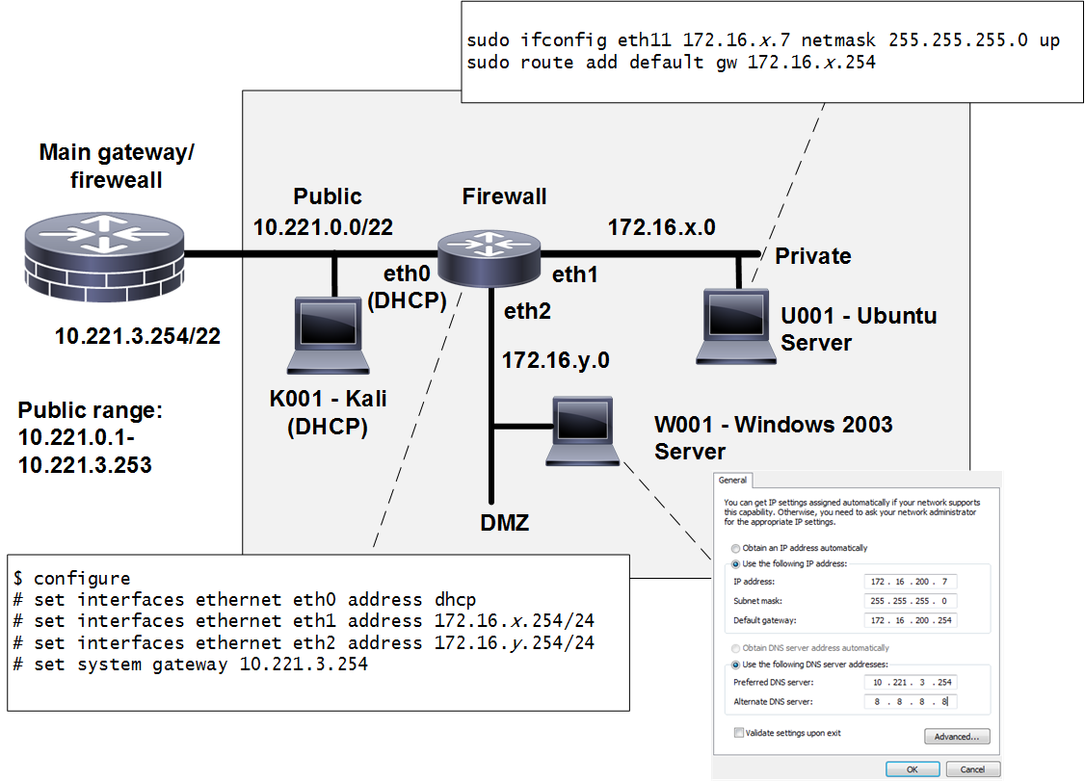

**Figure 1:** Lab setup (eth0 – Public, eth1 – Private, eth2 – DMZ)

Log into vSphere and locate the **CSN09412** folder. Locate your matriculation number and you will be allocated a group number:

Group Number:

80

Now lookup your IP addresses from the page:

<http://asecuritysite.com/csn09412/prep>

with **Allocation B.**

Draw your own network diagram here, by filling-in the blank boxes, with the allocated networks, subnets, and IP addresses:

172.16.159.254

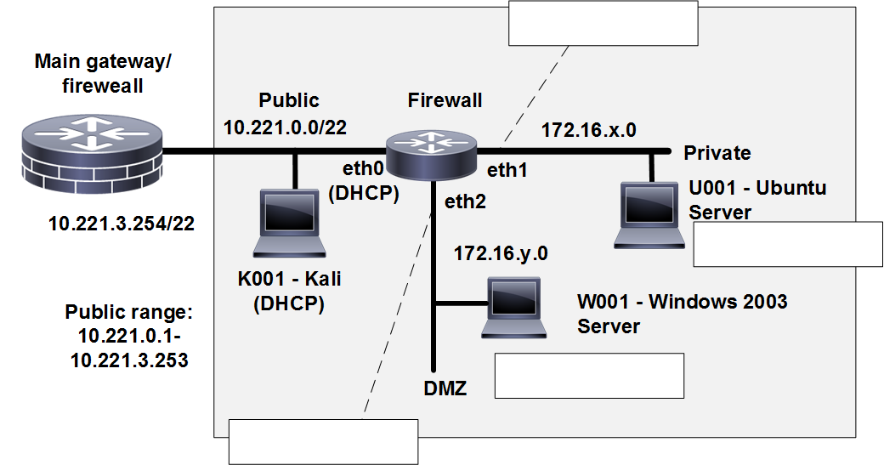

**Figure 2:** Your network setup (Note: **Gateway address is 10.221.3.254**)

## B Configure Router/Firewall for Remote Administration

We typically don’t use the console terminal of a firewall for configuration. In the following we will enable one port on the firewall, and then configure it through a remote connection. First configure your Vyatta firewall networking with the following:

$ configure

# set interfaces ethernet eth1 address 172.16.x.254/24  
# set system gateway 10.221.3.254

and then start the Telnet server on the Vyatta firewall:

# set service telnet

Check the configuration using:

# show config

# show interfaces

# show service

If everything is correct commit the changes, and review the configuration:

# commit

# show config

Cong

Now setup your Ubuntu host for networking on the same private network, and so it will be able to connect to the Vyatta firewall using remote admin with the Telnet service:

**sudo ifconfig eth11 172.16.x.7 netmask 255.255.255.0 up**

**sudo route add default gw 172.16.x.254**

Now from Ubuntu, check the connectivity using ping to your local connection and the gateway:

Can you ping them: [**Yes**] [No]

## C Configuring the firewall from Ubuntu

Now we will configure the firewall by creating a file, and copying-and-pasting the config from the file to the firewall via a remote admin session with Telnet.

First download the following config:

[http://asecuritysite.com/vpart01.txt](http://asecuritysite.com/vpart02.txt)

**Note you need to use the VMRC console for copy-and-paste to work**. Now edit the ‘x’ (Private) and ‘y’ (DMZ) values for your network:

set interfaces ethernet eth0 address dhcp

set interfaces ethernet eth1 address 172.16.x.254/24   
set interfaces ethernet eth2 address 172.16.y.254/24   
set system gateway 10.221.3.254

set nat source rule 1 outbound-interface eth0

set nat source rule 1 source address 172.16.x.0/24   
set nat source rule 1 translation address masquerade

set nat source rule 2 outbound-interface eth0

set nat source rule 2 source address 172.16.y.0/24   
set nat source rule 2 translation address masquerade

Now, from Ubuntu, create a Telnet connection to the default gateway on the firewall (172.16.x.254):

telnet 172.16.x.254

Now log into the firewall, and go into configuration mode and copy-and-paste the config from your config file, check the config, and then commit the changes if they are correct:

Login:

Password: ******

$ configure

# <paste-config>

# commit

Now setup your Windows host with 172.16.y.7 with a default gateway of 172.16.y.254.

From Ubuntu, can you ping the local network, the Windows host, the firewall ports and 8.8.8.8? [**Yes**][No]

From Windows, can you ping the local network, the Windows host, the firewall ports and 8.8.8.8? [**Yes**][No]

From Ubuntu and Windows, can you access Google.com from a browser [**Yes**][No]

Is everything working on your network? [**Yes**][No]

Now nmap from the Ubuntu host to the Windows host. Which ports are accessible:

**Many – too many**

Now nmap from the Windows host to the Ubuntu host. Which ports are accessible:

**21, 23, 80, 389, 5900**

## D Setting up Firewall Rules

Now we will setup firewall rules between **zones** (networks) connected to the firewall. In this case we will enable all the connections from the private network to the DMZ, but only allow TCP ports 80 and 443 to go through from the DMZ to the private network. All other connections will be disallowed. If we allow the connections from the private and the DMZ, we must remember the connection to allow it back from the DMZ to the private network, thus we define that we accepted established connections.

Now we will configure the next part of the firewall by copying-and-pasting the config to the firewall. First download the following config:

<http://asecuritysite.com/vpart02.txt>

set zone-policy zone private description "Inside"   
set zone-policy zone public description "Outside"   
set zone-policy zone dmz description "DMZ"

set zone-policy zone public interface eth0   
set zone-policy zone private interface eth1   
set zone-policy zone dmz interface eth2

set firewall name dmz2private description "DMZ to private"   
set firewall name dmz2private rule 1 action accept

set firewall name dmz2private rule 1 state established enable   
set firewall name dmz2private rule 1 state related enable

set firewall name dmz2private rule 10 action accept

set firewall name dmz2private rule 10 destination port 80,443   
set firewall name dmz2private rule 10 protocol tcp

set firewall name private2dmz description "private to DMZ"

set firewall name private2dmz rule 1 action accept

set zone-policy zone private from dmz firewall name dmz2private

set zone-policy zone dmz from private firewall name private2dmz

and paste it into your firewall, check the config, and then **commit**.

From Ubuntu, can you ping the local network, the Windows host, the firewall ports and 8.8.8.8? Outline what you can access:

Local network, Windows host NOT 8.8.8.8

From Windows, can you ping the local network, the Windows host, the firewall ports and 8.8.8.8? Outline what you can access:

The local network, and the firewall ports

From Ubuntu and Windows, can you access Google.com from a browser [Yes][No] Now nmap from the Ubuntu host to the Windows host. Which ports are accessible:

7,9,13,17,19,21,22,23,25,42,53,80,135,139,445,515,548,1025,1026,1029,1031,1033,1036,1038,3389,5900,8099

Now nmap from the Windows host to the Ubuntu host. Which ports are accessible:

80

Explain the operation of the network with the new network settings:

The Ubuntu host is effectively locked down by only allowing HTTP traffic and nothing else

## E Allowing access to the public network

You should not currently be able to connect from the private network to the public one. Now setup this connection:

<http://asecuritysite.com/vpart03.txt>

set firewall name private2public description "private to public"   
set firewall name private2public rule 1 action accept

set zone-policy zone public from private firewall name private2public

set firewall name public2private description "public to private"   
set firewall name public2private rule 1 action accept

set firewall name public2private rule 1 state established enable set firewall name public2private rule 1 state related enable

set zone-policy zone private from public firewall name public2private

commit

Now create your own config, and allow the DMZ to communicate with the public network.

You should now be able to connect from the private network to the public one.

Which configuration commands have you used:

set firewall name public2dmz description “public to dmz”

…

Set zone-policy zone dmz from public firewall name public2dmz

Can you connect your Windows host to the Google.com? [Yes][**No**]

## F Snort IDS

Snort is one of the most popular intrusion detection systems, where an agent is used to detect network threats. On the Windows and Ubuntu systems, create simple Snort rules files both called **mysnort.rules**, and add the following rules:

alert tcp any any -> any any (sid:999;content:"napier"; msg:"Napier detected")   
alert tcp any any -> any any (sid:1000;content:"fred"; msg:"Fred detected")

The format of Snort Detection Rules are as follows:

action protocol src-ip src-port > dest-ip dest-port (packet-payload-params output-msg)

[pass|log|alert] [ip|icmp|tcp|udp] [any|IP] [any|port] > [any|IP] [any|port] ([content:“searchstring”;], [nocase;], [msg:”alert message”;] sid:ruleid;)

This should detect outgoing traffic which has the word “napier” or “fred” in the payload. From the Windows system check the Snort options:

snort -?

Next run Snort using the required network interface: (Use the –W flag to check your available interfaces)

snort -c mysnort.rules -i 1 -p -l log -K ascii

From the Linux system run Snort (used ifconfig to see your interfaces):

snort -c mysnort.rules -i eth11 -p -l log -K ascii

Snort should now be running using the rules file to match against packets on the specified network interface, and write alerts and log information on any matches to the log folder.

## G Software Tutorial

Complete the software tutorial at:

<https://github.com/billbuchanan/csn09112/tree/master/week03_ns/labs/additional_lab>

## Appendix

configure

set interfaces ethernet eth0 address dhcp

set interfaces ethernet eth1 address 172.16.x.254/24   
set interfaces ethernet eth2 address 172.16.y.254/24   
set system gateway 10.221.3.254

set nat source rule 1 outbound-interface eth0

set nat source rule 1 source address 172.16.x.0/24   
set nat source rule 1 translation address masquerade

set nat source rule 2 outbound-interface eth0

set nat source rule 2 source address 172.16.y.0/24

snort set nat source rule 2 translation address masquerade

set zone-policy zone private description "Inside" set zone-policy zone public description "Outside" set zone-policy zone dmz description "DMZ"

set zone-policy zone public interface eth0   
set zone-policy zone private interface eth1   
set zone-policy zone dmz interface eth2

set firewall name dmz2private description "DMZ to private"   
set firewall name dmz2private rule 1 action accept

set firewall name dmz2private rule 1 state established enable   
set firewall name dmz2private rule 1 state related enable

set firewall name dmz2private rule 10 action accept

set firewall name dmz2private rule 10 destination port 80,443   
set firewall name dmz2private rule 10 protocol tcp

set firewall name private2dmz description "private to DMZ"   
set firewall name private2dmz rule 1 action accept

set zone-policy zone private from dmz firewall name dmz2private

set zone-policy zone dmz from private firewall name private2dmz

set firewall name private2public description "private to public"   
set firewall name private2public rule 1 action accept

set zone-policy zone public from private firewall name private2public

set firewall name public2private description "public to private"   
set firewall name public2private rule 1 action accept

set firewall name public2private rule 1 state established enable set firewall name public2private rule 1 state related enable

set zone-policy zone private from public firewall name public2private

[http://asecuritysite.com/vfinal.txt](http://asecuritysite.com/csn09112/software01)