## horizontal line

House Bid

## **Project WS 2017 (Milestone 2)**

**Team Number: 20**

Farzaneh Sabzi - 447690| [farzaneh.sabzi.f17@gmail.com](mailto:farzaneh.sabzi.f17@gmail.com)

Imam Bux - 347704

Vijay Bhaskar - 650205

Saad Noor - 350252

Farrukh Ahmed Khan - 147727

**Date : 16/11/2017**

**Revision History**

|  |  |  |  |
| --- | --- | --- | --- |
| **Date** | **Version** | **Description** | **Author** |
| 8/11/2017 | 0.1 | First draft | Farzaneh |
| 15/11/2017 | 0.2 | Update | Farzaneh,Farrukh,Vijay,  Saad |
| 16/11/2017 | 0.3 | Update | Imam |
|  |  |  |  |
|  |  |  |  |

0

**1. Use Cases** **1**

**2.Data Definition** **2**

**3. Functional Requirements** **3**

**4. UI Mockups and Storyboards** **8**

**4. High level Architecture, Database Organization** **18**

**5. High Level UML Diagrams** **19**

**6.Identify actual key risks for your project at this time 22**

# 1.Use Cases

**Saad wants to buy the house (unregistered user)**

Saad is new in Fulda town and would like to find a suitable house, He enters city and location in the search box and clicks on the search button , he will be shown listings matching his search criteria and choses the listing. However he will not be able to view the exact location of the address as he is unregistered.

**Saad wants to buy the house (registered user)**

Saad completes the registration form and logs in in our website. He searches for house which he wants to buy , after entering the search criteria he will select the desired listing and if he is interested he will click the contact button to drop a message to the concerned agent.

**Farrukh wants to expand real estate business (Registered Agent)**

Farrukh is an real estate agent who is planning to expand his real estate business through internet, He uses our website to achieve that by logging in as a registered Real estate agent who will get requests for potential sellers willing to sell their properties via the agent. He will be able to accept requests from sellers and negotiate with the buyer requests.

**Imam Want to sells his property (Unregistered Seller)**

Imam is planning to sell his house, He is not sure about the market value so he approached Mr. Farrukh who is an registered agent with our website. He will post his listing. Buyer will directly contact with agent if he is interested in property and Imam’s property will be sold by agent.

**Imam lets buyers bid for his property (Bidding Option)**

Imam is planning to sell his house, he is not sure about the price so he asks agent who is an registered agent with our website. Agent will post her listing and will give an option to the buyers to bid for the listing. With this feature Mr Farrukh will be able to quote the best selling price for his property among all the bids he received via the website.

# 2.Data Definition

**User**

In “House Bid”, a user is either a registered customer who wants to buy or sell a property or an agent.

1. Fields

A user entity comprises of mandatory and optional fields. The mandatory fields are name, email and password whereas the optional fields are contact, address, image.

*To see database structure of user fields, please refer to “Back end Architecture” of this document.*

1. User Types

A user is one who is facilitated on “House Bid”. Practically, there are 3 user types, namely; a visitor (also known as visitor), customer (registered user) and an agent (registered user).

1. Structure

“House Bid” considers customer or agent as one user. Only the user type differentiates the role. So, both the users are structured as one user.

1. Terms
   1. Customer

A registered user who can search the listings provided by agents. A customer can buy/sell listings. A customer can also modify the own profile. This role can also communicate with the agent of all listings.

* 1. Agent

An agent is a registered user who can post, update the status or delete the listing. An agent can view all the listings and the responses by the customers on his/her own dashboard. An agent can update the profile too.

1. Profile/Logo Image

Only registered user, a customer or agent, can upload the profile picture. Only one profile picture is served at a time. A user can also delete and the update the image too.

**Listing**

Real estate agents refer to property for sale as “listing”. A “listing” on “House Bid” shows information about the home.

1. Fields

A listing entity comprises of mandatory and optional fields. The mandatory fields are title, price, city and location whereas the optional fields are description, address, biddable and expiry date in case of biddable.

*To see database structure of listing fields, please refer to “Back end Architecture” of this document.*

1. Structure

A listing can be differentiated as biddable or not on “House Bid”. A listing which is not biddable will be a normal listing where an interested customer can contact the agent. Whereas, in the case of biddable listing, a customer will bid on that listing and this type of listing also has a expiry date after which the listing will be expired and no more will be available to customers to bid on.

1. Status

A listing has small life cycle in “House Bid”. This cycle is based on the status of the listing. When listing is posted for the first time, it’s status is “Available” which means it will be available for customers to browse on the site. When the agent updates his/her listing to “Inactive” then that listing is on hold and will not be available for customers until it is made “Available” again. A listing can also be “Delete” in which case, a listing will not be recovered.

1. Images

Every listing has images. Without images, a listing can be posted. Every listing can have multiple images. These images are stored on Database with BLOB format.

**Messaging**

Customer has to communicate with the agent regarding the particular listing. A customer can initiate the deal with the message, this option of “Send Message” is available for every available listing card and also on listing detail page.

1. Fields

A message entity comprises of only one field which is also mandatory. This field is “Message” where a customer will write down the message.

*To see database structure of message fields, please refer to “Back end Architecture” of this document.*

1. Structure

A message is in “House Bid” is one way communication. A customer sends a message to the agent. Where agent will then can visit customer profile to contact further in person.

**Bid**

The offering of particular price for listing is termed as “Bid”. One a customer finds the right listing, he/she can bid for that listing. Not every listing is biddable. This can decided by an agent while posting a listing. When the agent marks particular listing “Biddable” then he/she can also give the expiry date of that listing. The customers can offer their bid before the deadline. When the expiry date of the bid is reached the listing status is changed to “Expired” automatically.

# 3. Functional Requirements

**Priority 1**

**REGISTERED AND UNREGISTERED USERS**

1. **Searching/Filtering Listings**

Listings of properties can be filtered by the items like: city, location or area. Buyers can see the specific listings depending the area or city in which they are interested to buy. Registered (Customers) and Unregistered (Visitors) users both can search for the properties or projects published by our agents and can see the listings they are interested in. Of-course, we kept in mind about the other limitations of our unregistered users or visitors, that will be explained below.

* **Registered Users:** As a registered user, our users/customers will have almost every leverage on our site. As our site have some important roles for the users for example:

1. **Contacting Agents To Sell Property:** Registered users can easily contact our agents to sell the property they want, by giving the complete information about the property such as: price, address etc.
2. **Contacting Agents To Buy Property:** They can also contact our specific agents to buy the property they are interested in.
3. **Customer Registration:** Potential users who are willing to do buy properties via the website can become customers by providing some details about themselves: Fullname, email for username, password, photo, etc. Subsequently, they will be able to see more details of listings and contacts agent to buy properties.
4. **Location and Other Information:** The registered users can have the leverage of seeing the exact location and area of the property as well as they also can contact the agents and can have the full detailed information about the running projects and published properties.

* **Un-Registered Users/Visitors:** As normally, the unregistered users or the visitors cannot have everything available for them as mentioned above. Still, the visitors can have the leverage of seeing and searching for the specific properties. But they can’t be able to contact, bid or see the exact location of the property, if they have any interest of buying or selling the property they can write the proposal to our agents and bid after registering on our site.

**AGENTS**

As the name suggest an “Agent” is a person or a company who acts as an intermediary between sellers and buyers of real estate/real property. He can post the ads about property and buyer can contact with him if he is interested in buying the property. Let suppose if buyer is interested in property he will click on interested button and buyer information like Contact details will be sent to agent and he will contact with buyer.

**Priority 2**

1. **Searching/Filtering Listings**

Listings of properties can be filtered by the items like: city, location or area. Buyers can see the specific listings depending the area or city in which they are interested to buy. Registered (Customers) and Unregistered (Visitors) users both can search for the properties or projects published by our agents and can see the listings they are interested in. Of-course, we kept in mind about the other limitations of our unregistered users or visitors, that will be explained below.

* **Registered Users:** As a registered user, our users/customers will have almost every leverage on our site. As our site have some important roles for the users for example:

1. **Contacting Agents To Sell Property:** Registered users can easily contact our agents to sell the property they want, by giving the complete information about the property such as: price, address etc.
2. **Contacting Agents To Buy Property:** They can also contact our specific agents to buy the property they are interested in.
3. **Customer Registration:** Potential users who are willing to do buy properties via the website can become customers by providing some details about themselves: Fullname, email for username, password, photo, etc. Subsequently, they will be able to see more details of listings and contacts agent to buy properties.
4. **Location and Other Information:** The registered users can have the leverage of seeing the exact location and area of the property as well as they also can contact the agents and can have the full detailed information about the running projects and published properties.

* **Un-Registered Users/Visitors:** As normally, the unregistered users or the visitors cannot have everything available for them as mentioned above. Still, the visitors can have the leverage of seeing and searching for the specific properties. But they can’t be able to contact, bid or see the exact location of the property, if they have any interest of buying or selling the property they can write the proposal to our agents and bid after registering on our site.
* **Bidding**

Agents choose some properties for bidding. In a specific period of time the chosen properties can receives bids. At the end, the Agent will choose a bidder to buy the property. Only registered user can take part in bidding. Unregistered user can not have access for bidding.

**AGENTS**

As the name suggest an “Agent” is a person or a company who acts as an intermediary between sellers and buyers of real estate/real property. He can post the ads about property and buyer can contact with him if he is interested in buying the property. Let suppose if buyer is interested in property he will click on interested button and buyer information like Contact details will be sent to agent and he will contact with buyer.

**Priority 3**

1. **Searching/Filtering Listings**

Listings of properties can be filtered by the items like: city, location or area. Buyers can see the specific listings depending the area or city in which they are interested to buy. Registered (Customers) and Unregistered (Visitors) users both can search for the properties or projects published by our agents and can see the listings they are interested in. Of-course, we kept in mind about the other limitations of our unregistered users or visitors, that will be explained below.

* **Registered Users:** As a registered user, our users/customers will have almost every leverage on our site. As our site have some important roles for the users for example:

1. **Contacting Agents To Sell Property:** Registered users can easily contact our agents to sell the property they want, by giving the complete information about the property such as: price, address etc.
2. **Contacting Agents To Buy Property:** They can also contact our specific agents to buy the property they are interested in.
3. **Customer Registration:** Potential users who are willing to do buy properties via the website can become customers by providing some details about themselves: Fullname, email for username, password, photo, etc. Subsequently, they will be able to see more details of listings and contacts agent to buy properties.
4. **Location and Other Information:** The registered users can have the leverage of seeing the exact location and area of the property as well as they also can contact the agents and can have the full detailed information about the running projects and published properties.

* **Un-Registered Users/Visitors:** As normally, the unregistered users or the visitors cannot have everything available for them as mentioned above. Still, the visitors can have the leverage of seeing and searching for the specific properties. But they can’t be able to contact, bid or see the exact location of the property, if they have any interest of buying or selling the property they can write the proposal to our agents and bid after registering on our site.
* **Bidding**

Agents choose some properties for bidding. In a specific period of time the chosen properties can receives bids. At the end, the Agent will choose a bidder to buy the property. Only registered user can take part in bidding. Unregistered user can not have access for bidding.

* **Rent**

Register user can rent any kind of property depending upon on his interest. It can be a single room,double room,flat etc. register user will decide which property he want to be rented. Agent will contact with him if he is interested in any property.

**AGENTS**

As the name suggest an “Agent” is a person or a company who acts as an intermediary between sellers and buyers of real estate/real property. He can post the ads about property and buyer can contact with him if he is interested in buying the property. Let suppose if buyer is interested in property he will click on interested button and buyer information like Contact details will be sent to agent and he will contact with buyer.

# 

# 4. UI Mockups and Storyboards

**4.1 Unregistered user and Registered user accessing the site**

When an Unregistered user or a Registered user visits the website he will be able to search the listings and will also be able to view the details of any listing that he clicks on the results. What separates the registered and unregistered user is that the unregistered user cannot see the location of the listing on map and the full address of the listing. He will be shown only the city and location.

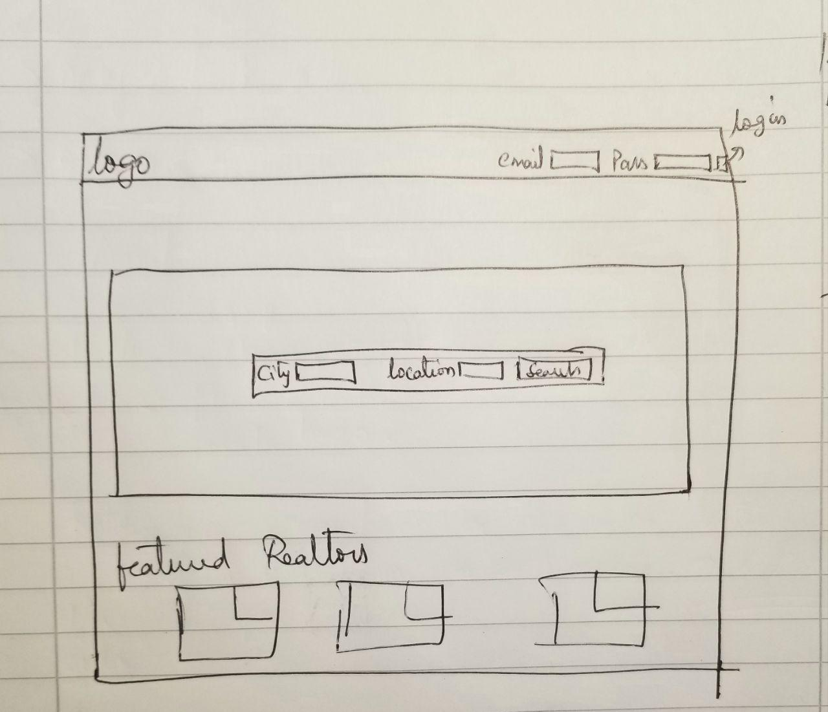

If the user clicks on search button he is presented with the search results matching his requirements. He will be able to browse the listings and click on it.

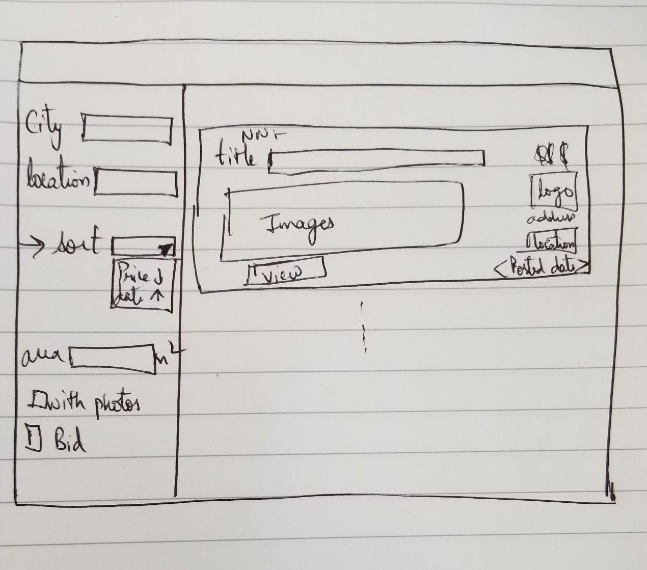

Once the user clicks on a listing he will be directed to the listing details page. Where he can see the price and additional details about the listing like photos, registered user can contact the agent for additional details.

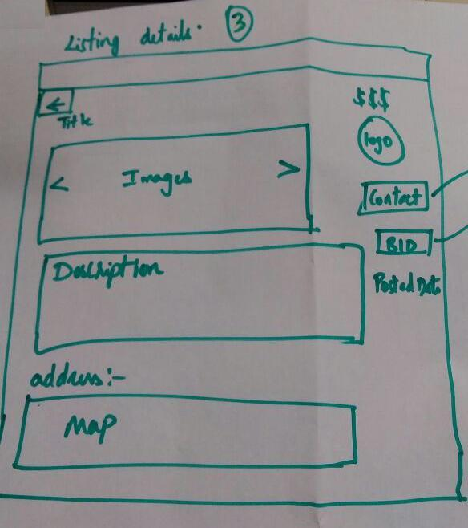

**4.2 Registered user clicks contact agent button.**

When a registered user clicks the bid button a pop up (modal) will show up which will ask the user send a message to agent to initiate the conversation.   
  
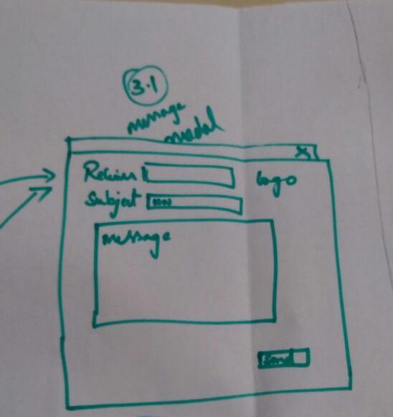

**4.3** **Registered user logins.**

When a registered user logins he will able to view his dashboard. In this dashboard he can manage the conversations he had with the agents. He can request for a posting and he can edit his profile.

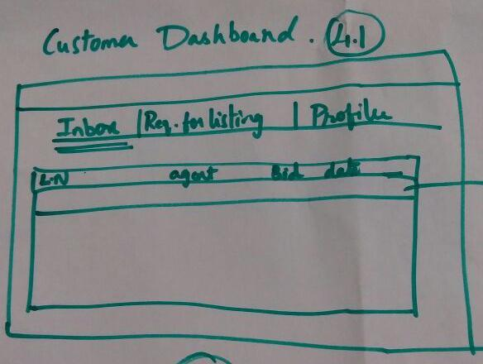

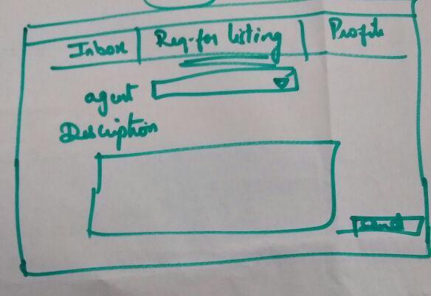

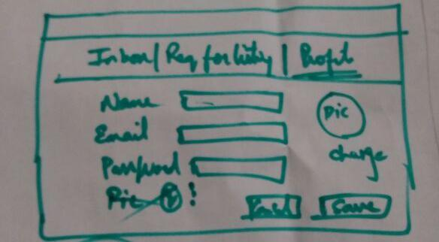

**4.4 Registered user wants to post his listing.**

When a registered user wants to post his listing he logs into the site and goes to his dashboard and then goes to Request for listing tab and then selects the prefered agent from the provided list and enters detailed information regarding the proposed listing.



**4.5 Agent logins.**

When Agent logins he will be able to view his dashboard. In this dashboard he can manage the conversations he has with customers, he will be able to post a listing and he can edit his profile and one tab for managing all his listings.

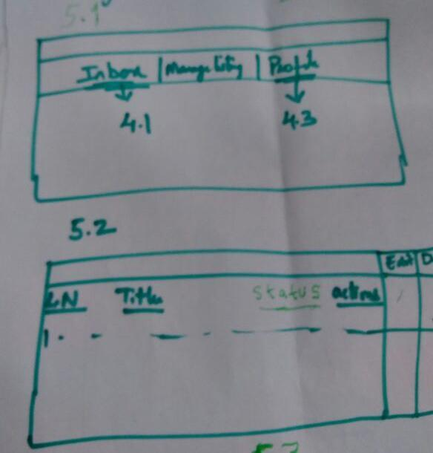

**4.6 Agent posts a listing.**

After a user has submitted his request for posting a listing the agent after verification will go to the post listing tab in his dashboard and fills out all the required details

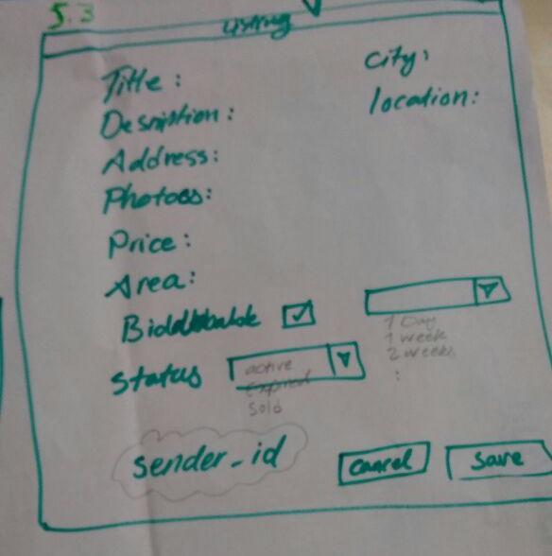

**4.7 Unregistered User wants to sign up**

When an user wants to register in the website he will click the signup button on the top navbar which will take him to this page.

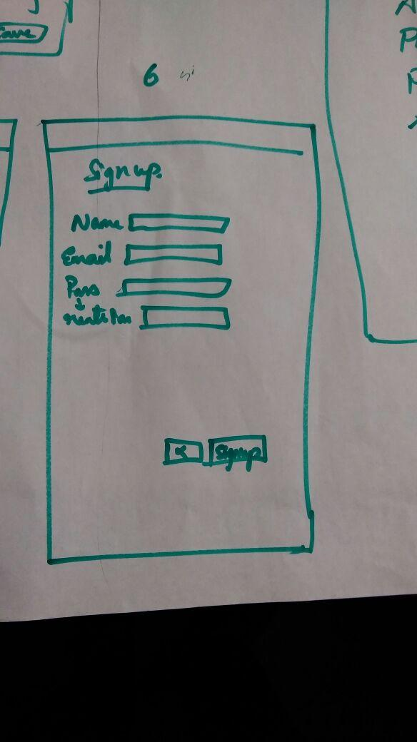

# 4. High level Architecture, Database Organization

**Back End:**

**MVC Framework**

* Model Components
  + There is an individual model for every individual entity. These models are created to take advantage of OO that is provided by JavaScript. The models corresponding to the entities are available at separate package named “model” named model with the following file names:
    - agent.js, user.js, listing.js, message.js
* View Components
  + Refer to the Front End Architecture described below.
* Controller Components
  + The server “app.js” uses only one file “router.js”. This router file communicates with the controller of every entity. This router file serves as the main controller which is responsible to communicate with sub-controllers, available at “controller” package, specific to agent, user, listing and message and this main controller also responds back to the server.
  + The sub-controllers communicate with database based on the API call and respond back to the main controller.

**Database Schema**

* Entities
  + User

Table Name: user

|  |  |  |  |
| --- | --- | --- | --- |
| Column | Type | Mandatory | Extra |
| user_id | int | yes | Primary key, Auto_increment |
| name | varchar | yes |  |
| email | varchar | yes |  |
| password | varchar | yes |  |
| contact | varchar | yes |  |
| address | varchar | no |  |
| image | blob | no |  |
| image_thumbnail | tinyblob | no |  |
| user_type | tinyint | no |  |

* + Listing

Table Name: listing

|  |  |  |  |
| --- | --- | --- | --- |
| Column | Type | Mandatory | Extra |
| listing_id | int | yes | Primary key, Auto_increment |
| title | varchar | yes |  |
| description | varchar | no |  |
| price | double | yes |  |
| is_biddable | tinyint | yes |  |
| area | int | no |  |
| status | tinyint | yes |  |
| address | varchar | no |  |
| listed_date | timestamp | yes | Current timestamp |
| expiry_date | timestamp | no |  |
| agent_id | int | yes | Foreign key |
| customer_id | int | yes | Foreign key |
| city | varchar | yes |  |
| location | varchar | yes |  |

Table Name: listing_images

|  |  |  |  |
| --- | --- | --- | --- |
| Column | Type | Mandatory | Extra |
| listing_id | int | yes | Foreign key |
| image | varchar | yes |  |
| image_thumbnail | varchar | yes |  |

* + Message

Table Name: message

|  |  |  |  |
| --- | --- | --- | --- |
| Column | Type | Mandatory | Extra |
| message_id | int | yes | Primary key, Auto_increment |
| message | varchar | yes |  |
| sender_id | int | yes |  |
| receiver_id | int | yes |  |
| date | timestamp | yes | Current timestamp |

* Media Storage
  + Currently, user profile and logos are stored in the user table with BLOB format. The listing images are stored in listing_images table with BLOB format too. There is also minified thumbnail of every image with TINYBLOB format for the efficient image processing.
* Search/Filter Implementation
  + As observed in the API call “GET: /search” is provided to search the listing which will accept the two parameters from client i.e. city and location. Based on the parameters, the result is provided back to the client with JSON format.
  + To filter the listing “GET: /search/sort:parameters” API call is provided. This call will accept all the parameters a listing has and will return back the filtered result with the JSON format.

**API Calls**

* Search
  + Listing
    - GET: /search:parameters
* User
  + Signup
    - POST: /signup
  + Login
    - POST: /user/login
  + Logout
    - DELETE: /user/logout
  + Dashboard
    - POST: /user/profile
* Listing
  + View
    - GET: /agent/listing:listing-id
  + View all Listings
    - GET: /agent/listings
  + Delete
    - DELETE: /agent/listing:listing-id
  + Add a Listing
    - POST: /agent/listing
* Message
  + Send
    - POST: /user/message
  + Inbox
    - GET: /user/messages:user-id
  + Sorting Inbox
    - GET: /user/messages/sort:parameters
  + Individual Message
    - GET: /user/message:message-id

**Front End:**

Dynamic UI - JavaScript / JQuery

* Interactive Front end.
* Dynamic coding scripts.

UI- Bootstrap

* Built in scaling for all sizes of screens.
* Responsive Design.
* Supports popular browsers.

Google API- Google Maps

* Interactive map to show accurate location.

Gulp

* Compiles sass to css.
* Bundles all the javascript files to a single javascript file.

Angulartics

//farrukh

# 

# 5. High Level UML Diagrams

# 

1. **Class Diagram**

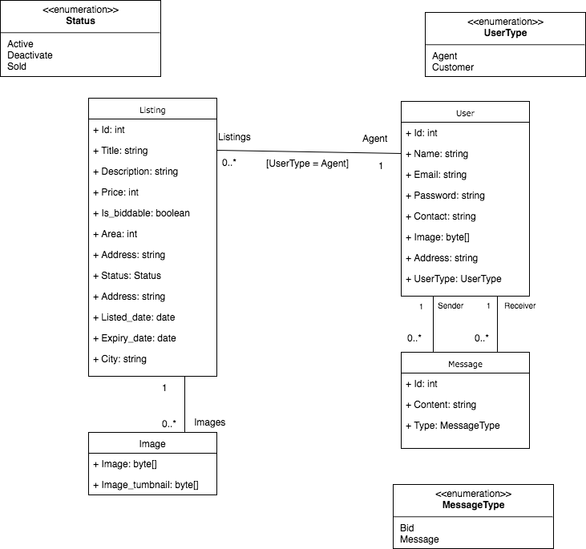

1. **Deployment Diagram**

# 

**6.Identify actual key risks for your project at this time**

|  |  |  |  |
| --- | --- | --- | --- |
| **Risk** | **Probability** | **Impact** | **Description** |
| **Time management** | High | High | All teammates are university students and beside working on this project they have other modules which need proper time. In addition,The workload for every milestone is almost high volume for all team members. |
| **Resource issues** | Medium | High | Number of team members is limited. Furthermore, there will be no external help if some person for any reason is not available. Moreover, The quality of individual tasks tightly depends on assignee person. It might impact final results specially documenting. |
| **Technical** | High | High | The technology stack was already defined before the team start working on it. As a result the current technology stack might not be very fast and easy to work with. It is also true of the methodology that is chosen for this project. It brings a tiring and monotonous workload for team members. |
| **Skills** | Medium | High | There are some skills and technologies that only one team member is familiar with. However some skills are listed in team members’ skills, they might not be expert at them. It slows down the development progress. |
| **External** | Low | Low | As this application is going to be used in Germany, there is possibility that our bidding terms and conditions or even the flow will be needed to change accordingly. |
| **Project team misunderstand requirements** | Medium | High | The requirements and decisions are not always clear. Therefore, it needs to be explained many times in different ways. |
| **Under communication** | High | High | Communication misunderstanding is very likely to happen because team Members come from different cultures and countries. Moreover, some team members prefer to rely on their own thoughts and understanding. |