**Data Summaries:**

**Bureau of Economic Analysis**

Gross Domestic Product by County, 2019 (Release Date: December 9, 2020)

* Gross domestic product by county is the value of goods and services produced by the county’s economy less the value of goods and services used up in production. GDP by county is the sub-state counterpart of the nation's gross domestic product, the Bureau's featured and most comprehensive measure of U.S. economic activity.

**Bureau of Labor Statistics**

American Time Use Survey (ATUS) includes the average amount of time per day in 2019 that individuals worked, did household activities, and engaged in leisure and sports activities. Additionally, measures of the average time per day spent providing childcare—both as a primary (or main) activity and while doing other things--for the combined years 2015-19 are provided.

* Average hours employed people spent working at home and at their workplace on days worked at these locations, 2019.
* Percent of employed people who worked at home and at their workplace on days worked, 2019.

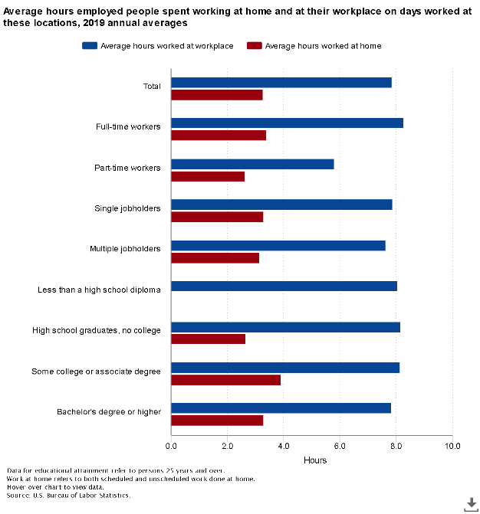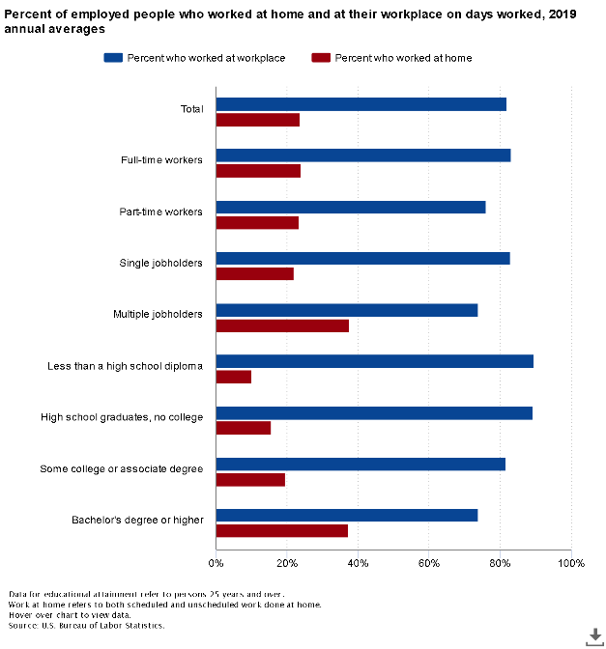

**FRED**

Millions of Chained 2012 Dollars, Seasonally Adjusted Annual Rate, Quarterly

* Real Gross Domestic Product by Industry: Private Industries: Construction for Florida (FLCONSTRQGSP)
* Real Gross Domestic Product by Industry: Private Industries for Florida (FLPIRQGSP)
* Real Gross Domestic Product by Industry: Private Industries: Information for Florida (FLINFORQGSP)
* Real Gross Domestic Product by Industry: Private services-providing industries for Florida (FLPRISERVPRORGSP)
* Real Gross Domestic Product by Industry: Private Industries: Finance, Insurance, Real Estate, Rental, and Leasing: Real Estate and Rental and Leasing for Florida (FLRERENTLEARQGSP)
* Real Gross Domestic Product by Industry: Private Industries: Wholesale Trade for Florida (FLWHOLERQGSP)
* Real Gross Domestic Product by Industry: Private Industries: Retail Trade for Florida (FLRETAILRQGSP)
* Real Gross Domestic Product by Industry: Private Industries: Finance, Insurance, Real Estate, Rental, and Leasing: Finance and Insurance for Florida (FLFININSRQGSP)
* Real Gross Domestic Product by Industry: Private Industries: Other Services, Except Government for Florida (FLOTHSERVERQGSP)
* Real Gross Domestic Product by Industry: Private Industries: Arts, Entertainment, Recreation, Accommodation, and Food Services: Accommodation and Food Services for Florida (FLACCOMDRQGSP)
* Real Gross Domestic Product by Industry: Private Industries: Educational Services, Health Care, and Social Assistance: Health Care and Social Assistance for Florida (FLHLTHSOCASSRQGSP)