LOL Engineers LTD | 5 Page Briefing Note

**Title: Virtual and Augmented Reality for Education and Climate Change**

**Author:** *Muchen He*

**Submission Date:** *2019-06-15*

**Spotlight SDGs:** SDG #4 Quality Education and SDG #13 Actions in Climate Change

**Sustainability Issue(s) Relevant to the Spotlight SDGs**:

SDG #4 involves providing quality and engaging education to everyone, including women and minorities. The quality education goal also seek to increase accessibility which means growth in supply of teachers and school staff. Quality education increases inclusion in schools. Quality also implies effectiveness of education, and the outcome is that people who are educated are more knowledgeable [12].

It is important that we focus on SDG #4 because it lays the foundation to help solve our sustainable problems by equipping the future generation with the skills and mindset they need. Focusing on education will also yield higher productivity and more educated and skilled employees in the long-term future.

For SDG #13, the goal is to take urgent actions against climate change, to mitigate climate-related hazards, and minimize further damage to the planet as well as the potential damages to what’s already done. Actions also include increasing the resilience and adaptive capacity, implementing regulations, and improve education, and direct actions to reduce emissions [11].

Climate action goes hand-in-hand with improving education and awareness of human impacts on the planet capacity. It is important to consider the policies and strategies that government can put into place to integrate climate change measures, and it could affect businesses greatly. Development of more efficient processes in businesses and industries could cut down costs and reduce emission, ultimately a direct action to combat climate change.

**Background on Spotlight SDGs:**

The focus on quality education is important because it is applicable to everyone in wide ranges of geography, age, race, and skill-level. Our clients which consist of many Canadian municipal and provincial governments are highly relevant to SDG #4 as many education institutions are public. This also means increased chances of government funding or subsidiaries for investing effort in this goal.

By increasing the education levels in the population, we also increase the number of jobs as well as pool of skilled and knowledgeable workers to contribute to sustainability.

The focus on climate actions is also important as it affects businesses, industries, and governments, all of which are our clients. While it is essential that we reduce our emissions and pollutions, and overall effects on the planet, government intervention is inevitable and will impact industries. As already demonstrated in Canada with the implementation of federal-level carbon tax, many industries such as agriculture are taking a hit [2].

It is possible to ease the impact to the economy if businesses have more efficient processes and better training to better circumvent the problems. Thus, it is extremely relevant to our clients because we should contribute to SDG #13 by providing technology that better transitions the population and businesses to contribute SDG 13.

**Current Global and National Status of Spotlight SDGs:**

The targets for quality education mainly consists of: accessibility and participation, gender equality, and effectiveness in primary, secondary, and post-secondary educations. Also part of the targets are all learners have adequate skills for employment, entrepreneurship, as well as to promote sustainable development.

In least developed countries, problems regarding education are resolved slowly. In the 2016 report, the majority of problems arise from no access to education due to disparities such as being female or poor. The completion rates for primary and secondary education increased steadily since 2000 in developing and developed regions: 72% and 91% respectively in 2013. The total financial assistance amounts to $1.2B [13].

In the 2017 report, the admission rate for primary and secondary schools gained significantly. However equity was still an issue as poor families could not afford to go to school. It is also reported that there are a shortage of trained teachers that hinders quality education. Only about 44%, 74% and 55% of the teachers are trained in pre-primary, primary, and secondary schools respectively. The total financial assistance decreased to $1.0B [14].

In the 2018 report, early childhood participation was reported to increase by 7% from 63% between 2010 and 2016. The percentage of trained teachers increased to 85% globally [15].

In Canada, the education of the population has generally increased. In 2016, 54% of Canadians have post-secondary education, a rise of 6% since 2006, this makes Canada highest proportion of graduates among OECD countries [7]. Similarly, participation of women in post-secondary education also increased from 32% to 41%.

Overall, the progression to the SDG #4 globally is very slow. The main problem are mostly lack of proper training and incentive for children to attend school. Due to poor engagement, participation, and lack of funding. However, Canada is leading by being one of the most educated countries, achieving most indicators specified by SDG #4.

Many developed countries around the world has initiative and programs to act on climate change and its hazards. Sweden instated a carbon tax since the 1990s and have since reduced the carbon emissions, slowing the rate of climate change [10]. Developing countries such as sub-Saharan African countries does not have the economic power to contribute towards SDG #13.

Canada has implemented a federal-level carbon-tax bill towards effort to reduce emission [5]. This is part of the national determined contributions (NDCs) defined at the Paris Agreement. Certain provinces such as British Columbia and Ontario implemented the carbon tax or cap-and-trade system earlier, and proved that regulation do help towards reducing total emission, and ultimately help us pursue SDG #13.

**Key Considerations:**

By merging the goals SDG #4 and SDG #13 together, we see that we need an engineered option that has two key considerations: provide process efficiencies and promote sustainable well-being while centered on education throughout.

We need to ensure that we promote education engagement by increasing content immersion, the result is increased productivity and greater output of well-performing students. Which leads to an increased education level amongst the population as well as the supply of quality teachers. This cycle makes education more affordable and accessible. The engineered option should also be affordable and accessible such that everyone have access to it. This enables wide adoption of the technology. The result is increased participation and admission of women and poorer families in education.

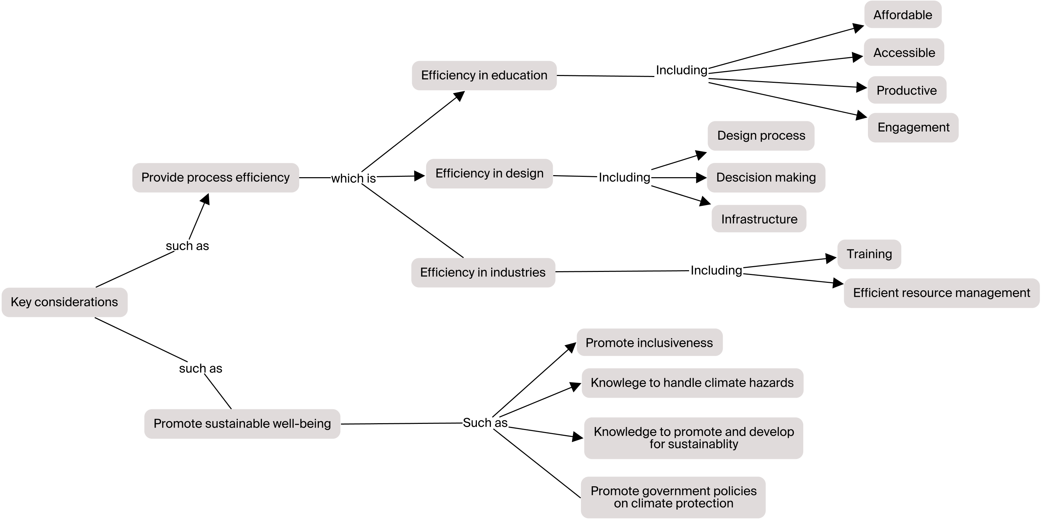

To better prepare for the consequences of climate change, the engineered option must engage in educating individuals on how to prepare and circumvent climate hazards such as flooding while at the same time promote sustainable actions such as reducing resource consumption. In the long term, overall awareness towards sustainable development and climate change increases.

Lastly, the technology must provide process efficiency to slow down the rate of climate change, assist individuals and businesses in combating with climate change, as well as provide immersive and efficient training. The result of doing all three leads to greater chance of succeeding in reaching goal #4 and goal #13. Thus making these key considerations which are critical to our clients.

**Engineered Option**:

Virtual reality (VR) and augmented reality (AR) technology is the engineered option to pursue SDG goals #4 and #13 as it fits the key considerations perfectly. VR is entirely virtual, while AR integrates the tracking and visualization overlaying real images. These can run on smartphones which make them affordable and accessible to everyone.

By utilizing AR/VR technology, we can enable future generations to be more aware and knowledgeable to climate change while at the same time improving quality of education. Kamarainen [1] argues that AR improves engagement in child’s field trips, which enables more accurate message regarding sustainability development. Sommerauer et. al’s findings [6] also supports AR over non-AR learning. Merchant et al.[3] found that VR increased effectiveness of learning in K-12 students. Using VR/AR, we can also educate people on how to prepare for climate-related hazards, a target of SDG #13 to increase resiliency.

AR and VR technology increases worker proficiency and training effectiveness in technical jobs. Nichols [4] explored the benefits of AR in field technicians for inspection and maintenance. This is useful for dirty industries by providing cleaner and more efficient development in projects. Steward [9] also sees the benefits of AR/VR in combination of artificial intelligence to make optimized decisions.

Lastly, Statuskis [8] showcases how VR could be used to increase public contribution to urban sustainable projects. By visualizing realistic scenes with low prototype cost and fast turnaround time, the VR is an efficient method to facilitate broader public involvement in urban design and increase social and economic sustainability of urban development process.

Development in said engineering option will directly benefit all of our clients. The government will use the technology to improve education in schools and training in city projects. And industries will utilize the technology to reduce carbon emissions and increase per worker productivity.

**A Systems View:**

Here is a system concept-map diagram that further emphasizes the positive contributions of AR and VR technology towards SDG #4 and #13.

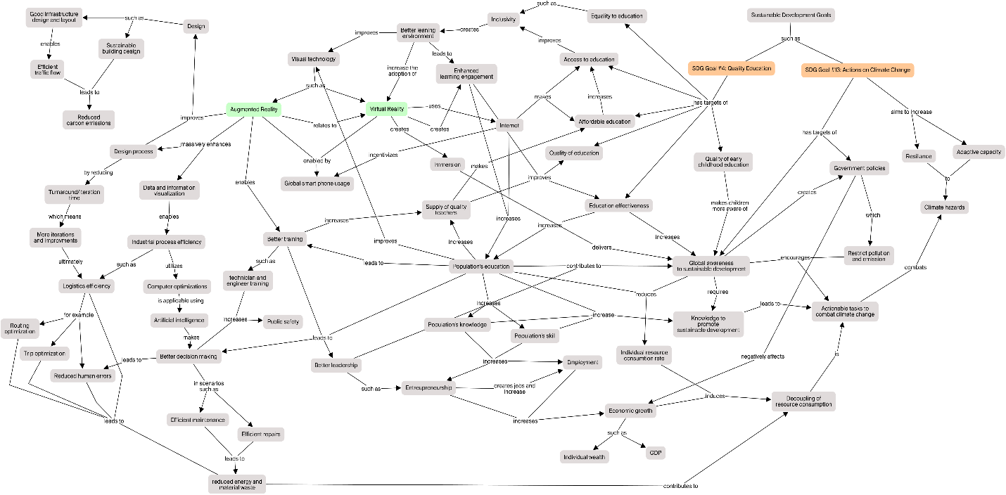

**Recommendation and Conclusion:**

Our clients, which consists of governments and industries are involved in areas of education and productivity. The key consideration is to pursue goal of quality and equity education and process efficiency. To perform both simultaneously as well as promoting sustainable development, I recommend investing and developing in AR/VR technology as it will significantly improve quality of education, local, and aboard because of its accessibility, effectiveness, and affordability.

In conclusion, SDG #4 and #13 synergizes well and I recommend developing AR/VR to best fit the need of our clients, and therefore maximizes our opportunities.

**APPENDIX 1: References**

1. Kamarainen, A. M., Metcalf, S., Grotzer, T., Browne, A., Mazzuca, D., Tutwiler, M. S., & Dede, C. (2013). EcoMOBILE: Integrating augmented reality and probeware with environmental education field trips. Computers & Education, 68, 545-556. doi:10.1016/j.compedu.2013.02.018, from <https://www.sciencedirect.com/science/article/pii/S0360131513000572>
2. Matejka, B. (2019, April 03). Carbon tax worries Saskatchewan farmers. Retrieved June 15, 2019, from <https://globalnews.ca/news/5124513/saskatchewan-farmers-carbon-tax/>
3. Merchant, Z., Goetz, E. T., Cifuentes, L., Keeney-Kennicutt, W., & Davis, T. J. (2014). Effectiveness of virtual reality-based instruction on students learning outcomes in K-12 and higher education: A meta-analysis. Computers & Education, 70, 29-40. doi:10.1016/j.compedu.2013.07.033, from <https://www.sciencedirect.com/science/article/pii/S0360131513002108>
4. Nichols, G. (2019, January 19). Use Case: Augmented Reality finds early adoption with field service technicians. Retrieved May 25, 2019, from <https://www.zdnet.com/article/use-case-augmented-reality-finds-early-adoption-with-field-service-techs/>
5. Nuccitelli, D. (2018, October 26). Canada passed a carbon tax that will give most Canadians more money. Retrieved June 15, 2019, from <https://www.theguardian.com/environment/climate-consensus-97-per-cent/2018/oct/26/canada-passed-a-carbon-tax-that-will-give-most-canadians-more-money>
6. Sommerauer, P., & Müller, O. (2014). Augmented reality in informal learning environments: A field experiment in a mathematics exhibition. Computers & Education, 79, 59-68. doi:10.1016/j.compedu.2014.07.013, from <https://www.sciencedirect.com/science/article/pii/S036013151400164X>
7. Statistics Canada. (2017, November 29). Education in Canada: Key results from the 2016 Census. Retrieved June 15, 2019, from <https://www150.statcan.gc.ca/n1/daily-quotidien/171129/dq171129a-eng.htm>
8. Stauskis, G. (2014). Development of methods and practices of virtual reality as a tool for participatory urban planning: A case study of Vilnius City as an example for improving environmental, social and energy sustainability. Energy, Sustainability and Society, 4(1), 7. doi:10.1186/2192-0567-4-7, from <https://energsustainsoc.biomedcentral.com/articles/10.1186/2192-0567-4-7>
9. Steward, T. (2018, July 05). How Augmented Reality Will Change the Field Service Industry. Retrieved May 25, 2019, from <https://www.dispatch.me/augmented-reality-will-change-field-service-industry/>
10. Sweden’s carbon tax. (n.d.). Retrieved June 15, 2019, from <https://www.government.se/government-policy/taxes-and-tariffs/swedens-carbon-tax/>
11. United Nations. (2015). Goal 13: Sustainable Development Knowledge Platform. (n.d.). Retrieved June 13, 2019, from <https://sustainabledevelopment.un.org/sdg13>
12. United Nations. (2015). Goal 4: Sustainable Development Knowledge Platform. (n.d.). Retrieved June 13, 2019, from <https://sustainabledevelopment.un.org/sdg4>
13. United Nations. (2016). Reports of the Secretary-General, “Progress towards the Sustainable Development Goals”. Retrieved June 14, 2019, from <https://www.un.org/ga/search/view_doc.asp?symbol=E/2016/75&Lang=E>
14. United Nations. (2017). Reports of the Secretary-General, “Progress towards the Sustainable Development Goals”. Retrieved June 14, 2019, from <https://www.un.org/ga/search/view_doc.asp?symbol=E/2017/66&Lang=E>
15. United Nations. (2018). Reports of the Secretary-General, The Sustainable Development Goals Report 2018/ Retrieved June 14, 2019, from <https://unstats.un.org/sdgs/report/2018>