Class SubSolverData

The search directions and the inner points are stored in the dictionary “data” (See figure below).

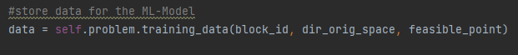

The training data is stored as following:

d, p = d: direction in original space, p: feasible point; type: ndarray

Corresponding directions and points are stored together in a tuple (d,p)

For each block a list is created to store all tuples [(d,p),(d,p),(d,p),…]

The complete training data is stored in a dictionary where the key indicates the block_id. The values of the dictionary contain list of tuples with corresponding directions and points.

Training data = {0 : [(d,p),(d,p),(d,p)], 1 : [(d,p),(d,p),(d,p)],…}

Ein Bild, das Text enthält.

The figure above shows the accumulation of training data (“Training Data generated 18; in Block 4”) and puts out the actual data arrays of the directions and points.