Retirement (FTIS FAv13 Write Off/Disposal)
- Go to Financials > Fixed Assets > Retirement.
- Specify the transaction type.
- Sales – Indicates an asset sold with a profit or loss. If you do not need to specify the customer information, use this type; otherwise, use an A/R invoice.
- Scrapping – Indicates a scrapped asset, with no revenue earned. SAP Business One posts the asset's remaining book value at the time of retirement as an expense.
- Specify Posting Date, Document Date, and Asset Value Date.
- Select Consolidate Journal Entry Rows by Projects if you want the journal Entry Split by Projects.
- Select Consolidate Journal Entry Rows by Distribution Rules if you want the journal Entry Split by Distribution Rules.

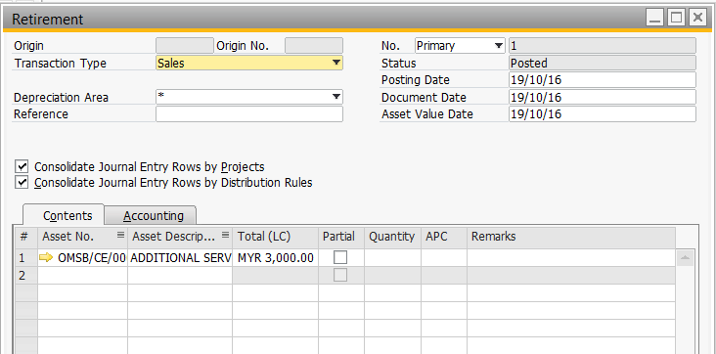

- The journal Entry after added as below.
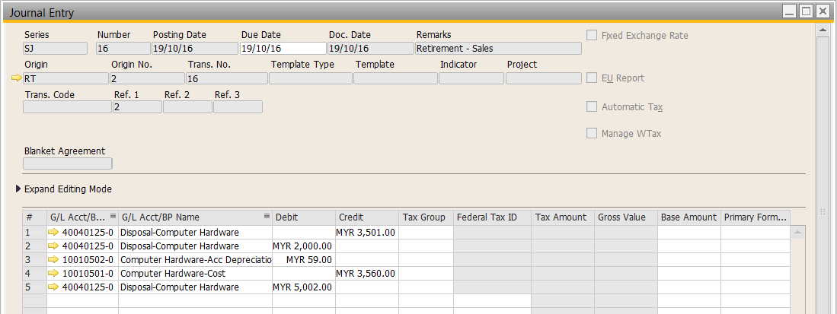
Note that the system will automatically create Retirement document if you created an AR Invoice to sell this asset.

