Fabrication notes for <Board 1-Pad and Pogo pin>

**Designer contact: Jacky Li,** [**jackymengyangli@uchicago.edu**](mailto:jackymengyangli@uchicago.edu)

Over All schematics:

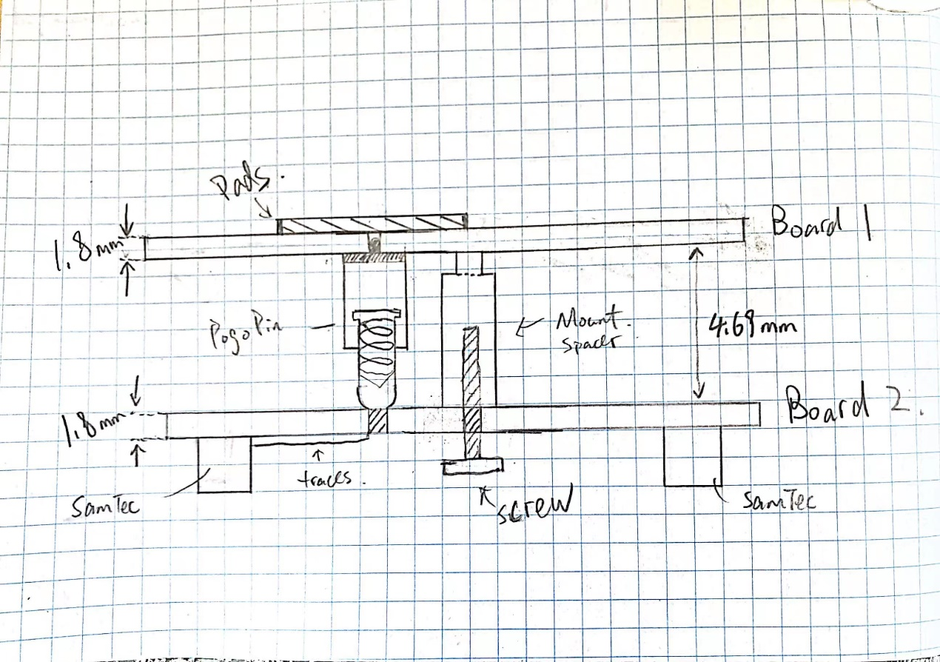

**Board stack info:** 2-layer board, 1.8mm thickness.

Pogo Pin details:

* Desired Length: ~4mm
* Product:
  + [Mill-Max 0906 SPRING-LOADED PIN WITH A STANDARD TAIL](https://www.mill-max.com/products/discrete-spring-loaded-pins/spring-loaded-pin-with-standard-tail/0906?s_term=0906&s_type=Quick%2FProduct%2FPart+Number+Search)
  + Part number: 0906-3 (to match the choice for spacer)
  + Part detail:
    - Length: 0.217in = 5.5mm
    - Mid Stroke: 0.0275in = 0.7mm
    - So the length at mid stroke is 4.8mm, full stroke is 4.1mm

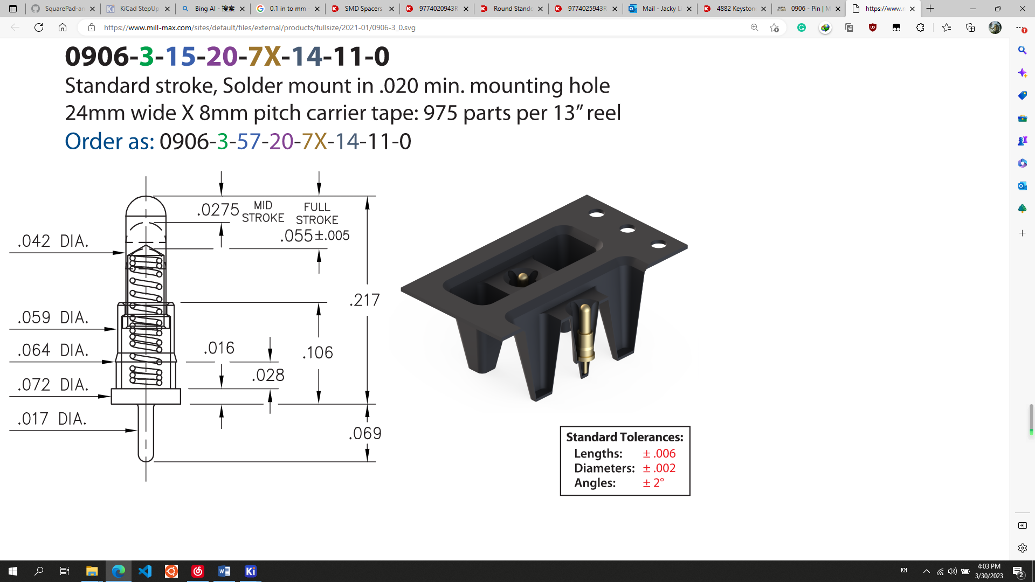

PROBLEM: The tail is 0.069in = 1.75mm which is longer than the default 1.6mm of the PCB!! 🡺 **INCREASED BOARD THICKNESS to 1.8mm**

Surface Mount:

* Desired Length: ~4mm
* Product:

We CANNOT dig holes, unless we give up the edges of the pads

* + [4882 Keystone Electronics | Hardware, Fasteners, Accessories | DigiKey](https://www.digikey.ch/en/products/detail/keystone-electronics/4882/6234712)
  + Product detail:
    - Full length 4.69mm, see below
    - #4-40 screw (2.85mm)

Im thinking maybe this part number: 3SSB-4.5. That uses a M3 screw. The equivalent 4-40, that part number is SSB-4.5（ 4-40）

From this company: Mac8

This link for drawing: [https://mac8usa.com/wp-content/uploads/2022/02/en_2022a_rev_ssb-series.pdf](https://urldefense.com/v3/__https:/mac8usa.com/wp-content/uploads/2022/02/en_2022a_rev_ssb-series.pdf__;!!BpyFHLRN4TMTrA!7msMJdRshhAGy-zZzV8nyRVRJcH4QOGeDg4x_iG_1Nj0PqXUWkQxGDvd-eXi7NFWSiGppI2_3Udz9fBOAiJDClTxMcTq$)

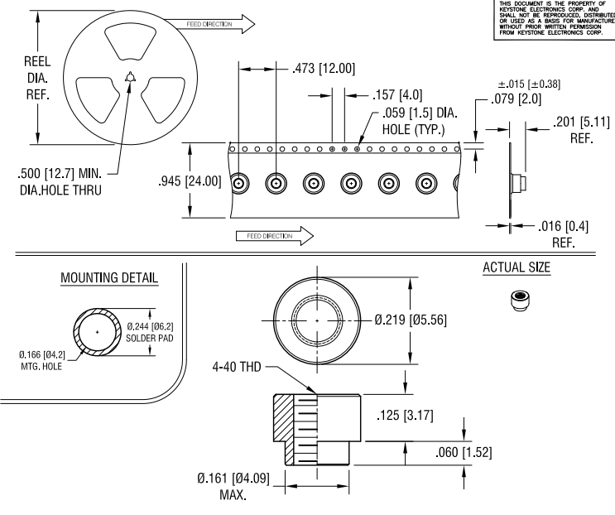

TO do:

make ground holes, connect grounds.

Change 4882’s mounting piece, make it a pad of 5.5mm. Does this need to be grounded? Currently it does.

1. Flip pogo pins
2. Change the standoff