Fabrication instructions for Stripline Anode

2-10-2023

contact: Evan Angelico, [eangelic@stanford.edu](mailto:eangelic@stanford.edu)

**Board stack info:** 6-layer board, 5.2 mm total thickness, 1/1 oz cu

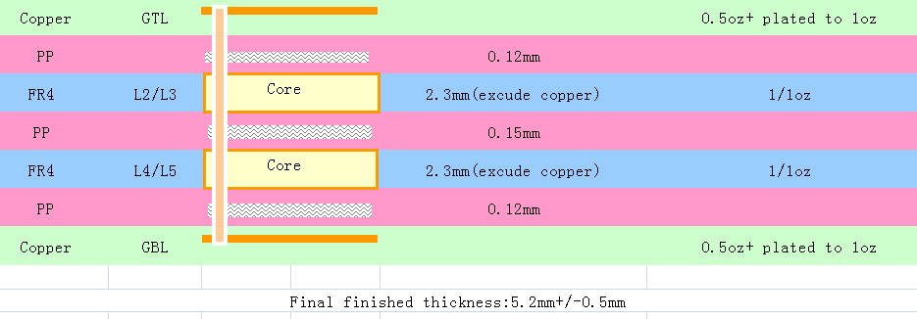

Layer description:

* GTL, L1, “F_Cu”: has a trace width transition where on one region of the board there are thin, 0.2 mm traces referencing L2 (“In1_Cu”) with 50 ohm impedance control 0.12mm away and **on another region** there are thick, 4.6mm traces that reference L3 (“In2_Cu”) about 2.32 mm away with 50 ohm controlled impedance. To join the two regions, there are tapered launchers.
* L2, “In1_Cu”: Ground reference layer for one region, thin traces, on L1
* L3, “In2_Cu”: Ground reference layer for one region, thick traces, on L1
* L4, “In3_Cu”: Ground reference layer for thick traces on L6
* L5, “In4_Cu”: Empty layer so as to build thickness for the 50 ohm impedance between thick traces on L6 and L4 reference
* L6, “B_Cu”: The thick traces from L1 wrap around and continue onto this bottom layer using vias at the end. These thick traces are 50 ohm impedance controlled to the layer L4 through approximately 2.32 mm of dielectric.

Note: On one region of the board there are SMD components and other ground pours on L1 and L6 that do NOT need impedance control; they are a DC high voltage circuit that will have max voltage rating of 3kV.

Specifications and details:

1. Board dimensions: 244.9 mm x 347.68 mm
2. Layers: 6
3. Material FR-4
4. Overall thickness: ~5.2 mm (subject to your own approval of thicknesses and impedance control)
5. Min trace/space: 6/6 mil
6. Min hole size: 0.7 mm
7. Solder mask: blue
8. Finished copper: 1 oz (subject to your approval of thicknesses and impedance control)

Our calculation of impedance control for your reference:

On L1:

* Thin traces on one region of the board are calculated with model microstrip, T = 0.035 mm, W = 0.2 mm, H = 0.11mm, epsilon = 4.29, we get 48.38 ohms
* Thick traces are calculated with model microstrip, T = 0.035mm, W = 4.62mm, S = 2.29mm, h = 2.4mm, epsilon = 4.29, we get 50.79

