Fabrication notes for Stripline Anode

（Produced Statistics）

Designer contact: Jacky Li, [jackymengyangli@uchicago.edu](mailto:jackymengyangli@uchicago.edu)

**Board stack info:** 6-layer board, 5.2 mm total thickness, 1/1 oz cu

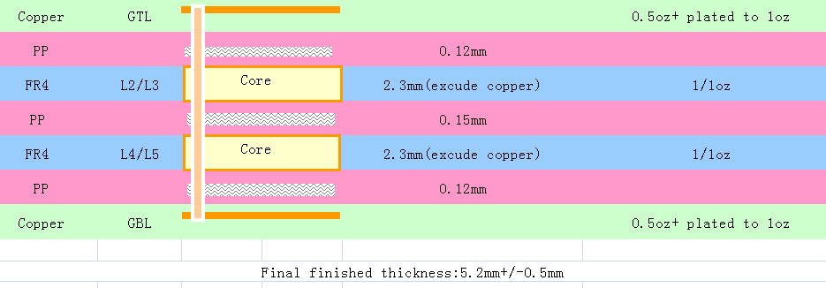

There are traces on L1 and L6 (GTL and GBL). We request impedance control on them.

We want the impedance of ALL tracing to be 50 ohms.

INCLUDING VIAS!! Please also make the vias to have 50 ohm impedance!

Trace Impedance Control Details:

There are two traces on L1: 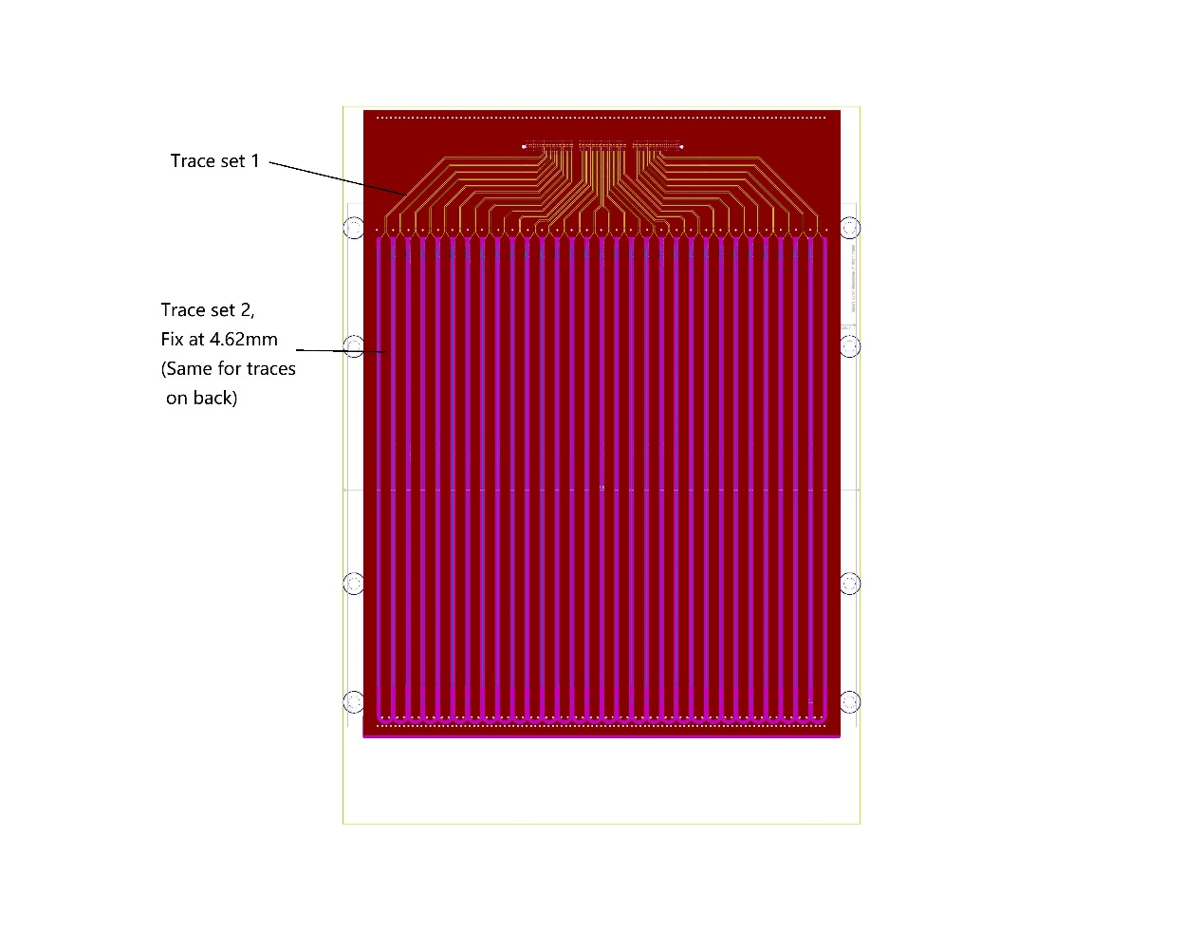

Trace set 1, couples to L2.

Trace set 2, couples to L3.

There are traces on L6:

They are same as Trace set 2 shown above. Couple them to L4, thus they are symmetric and should be easy for your production.

Following is my own calculation for your reference:

On L1 (or F.cu in gerber):

* Trace set 1 is calculated with model microstrip, T = 0.035 mm, W = 0.2 mm, H = 0.11mm, epsilon = 4.29, we get 48.38 ohms
* Trace set 2 is calculated with model Edge-coupled microstrip, T = 0.035mm, W = 4.62mm, S = 2.29mm, h = 2.4mm, epsilon = 4.29, we get 51.82 ohms (odd) and 48.29 ohms (even)

On L6 (or B.cu in gierber)

* The traces are calculated with model Edge-coupled microstrip, T = 0.035mm, W = 4.62mm, S = 2.29mm, h = 2.4mm, epsilon = 4.29, we get 51.82 ohms (odd) and 48.29 ohms (even)

